**N736 Homework 07 – Answer Key**

### Repeated Measures ANOVA and Multilevel (MIXED) Linear Models

For Homework 07, you will be using the HELP dataset, learn more at:

* <https://melindahiggins2000.github.io/N736Fall2017_HELPdataset/> &
* <https://github.com/melindahiggins2000/N736Fall2017_HELPdataset>

Refer to the repeated measures ANOVA and MLM lessons 21, 22 and 23. See

* Lesson 21 <https://github.com/melindahiggins2000/N736Fall2017_lesson21>
* Lesson 22 <https://github.com/melindahiggins2000/N736Fall2017_lesson22>
* Lesson 23 <https://github.com/melindahiggins2000/N736Fall2017_lesson23>

For the HELP dataset:

* OUTCOME VARIABLE: consider the 5 measurements of depressive symptoms (CESD) at baseline, 6m, 12m, 18m and 24m. Use variables cesd, cesd1, cesd2, cesd3, cesd4
* BETWEEN GROUP VARIABLE: Also consider the treatment group variable treat
* FYI: You will also need the id to
  1. properly restructure the data from WIDE to LONG format; and
  2. treat subjects as a random effect for the random intercepts approach to MLM

### For Homework 7, complete the following:

1. Perform a repeated measures analysis of variance (RM-ANOVA) for the 5 CESD measurements across time by treatment group.
   1. treat time as a continuous variable (not as a factor) - this is your WITHIN group effect
   2. treat the treatment group treat as a factor - this is your BETWEEN group effect
   3. TABLE: present the table of the intercept, time, treat and time*treat interaction effects including the tests of significance. [Remember this significance might change depending on the treatment group coding - try flipping the 0 and 1 and run the model again to see if the significance changes]
   4. FIGURE: make a plot of the CESD means across time by group - if you can make it an error bar plot which has the means and CI’s (confidence intervals) or SE’s (standard errors)
2. Repeat the “repeated measures/longitudinal” analysis using a random intercepts MLM model
   1. REMEMBER to restructure the data from WIDE to LONG format
   2. TABLE: present the table of the intercept, time, treat and time*treat interaction effects including the tests of significance. [Remember this significance might change depending on the treatment group coding - try flipping the 0 and 1 and run the model again to see if the significance changes]
3. Compare the results between the 2 approaches
   1. compare the sample size differences
   2. why do you think the results are different or are similar?

**RM-ANOVA for cesd over 5 time points (WITHIN subject effect) between 2 treatment groups (BETWEEN group effect)**

For the CESD, there were 98 subjects (out of 453, 21.6%) had complete data at all 5 time points. Here is the descriptive statistics for these subjects by group at each time point – only for the 98 completers. It looks like the CESD scores for both groups decrease over time with the biggest decrease occurring between baseline and 6 months.

|  |  |  |  |  |
| --- | --- | --- | --- | --- |
| **Descriptive Statistics** | | | | |
|  | treat Randomization Group | Mean | Std. Deviation | N |
| cesd CESD total score - Baseline | 0 usual care | 31.28 | 11.680 | 46 |
| 1 HELP clinic | 30.17 | 12.189 | 52 |
| Total | 30.69 | 11.905 | 98 |
| cesd1 CESD total score - 6mo | 0 usual care | 20.33 | 11.689 | 46 |
| 1 HELP clinic | 22.02 | 13.518 | 52 |
| Total | 21.22 | 12.656 | 98 |
| cesd2 CESD total score - 12mo | 0 usual care | 20.85 | 13.898 | 46 |
| 1 HELP clinic | 17.25 | 12.663 | 52 |
| Total | 18.94 | 13.311 | 98 |
| cesd3 CESD total score - 18mo | 0 usual care | 19.24 | 13.047 | 46 |
| 1 HELP clinic | 17.88 | 13.184 | 52 |
| Total | 18.52 | 13.070 | 98 |
| cesd4 CESD total score - 24mo | 0 usual care | 20.26 | 13.788 | 46 |
| 1 HELP clinic | 15.08 | 13.179 | 52 |
| Total | 17.51 | 13.648 | 98 |

Box’s M statistic to check for equal variances was not significant; F(15, 35,898.13)=0.747, p=.738) indicating that we cannot reject the null hypothesis that the observed covariance matrices are equal across the groups (i.e. the equal variance assumption is ok).

However, Mauchly’s Test of Sphericity was significant (W=0.563, χ2(9)=54.219, p<.001), indicating that the assumption of equal variances over time was not met. Between the Greenhouse-Geisser statistic = 0.798 and the Huynh-Feldt statistic = 0.837, both estimates are > 0.75 so either correction should be OK to use. [Read more at <https://statistics.laerd.com/statistical-guides/sphericity-statistical-guide-2.php> ]

In this case both corrected p-values are about 0.09 indicating that the interaction effect between time and group was not statistically significant. However, for the time effect both are statistically significant.

|  |  |  |  |  |  |  |  |
| --- | --- | --- | --- | --- | --- | --- | --- |
| **Tests of Within-Subjects Effects** | | | | | | | |
| Measure: MEASURE_1 | | | | | | | |
| Source | | Type III  Sum of Squares | df | Mean  Square | F | Sig. | Partial  Eta Squared |
| time | Sphericity Assumed | 11184.558 | 4 | 2796.139 | 35.139 | .000 | .268 |
| Greenhouse-Geisser | 11184.558 | 3.193 | 3503.218 | 35.139 | .000 | .268 |
| Huynh-Feldt | 11184.558 | 3.350 | 3338.939 | 35.139 | .000 | .268 |
| Lower-bound | 11184.558 | 1.000 | 11184.558 | 35.139 | .000 | .268 |
| time * treat | Sphericity Assumed | 671.211 | 4 | 167.803 | 2.109 | .079 | .021 |
| Greenhouse-Geisser | 671.211 | 3.193 | 210.236 | 2.109 | .095 | .021 |
| Huynh-Feldt | 671.211 | 3.350 | 200.377 | 2.109 | .092 | .021 |
| Lower-bound | 671.211 | 1.000 | 671.211 | 2.109 | .150 | .021 |
| Error(time) | Sphericity Assumed | 30556.495 | 384 | 79.574 |  |  |  |
| Greenhouse-Geisser | 30556.495 | 306.495 | 99.697 |  |  |  |
| Huynh-Feldt | 30556.495 | 321.574 | 95.022 |  |  |  |
| Lower-bound | 30556.495 | 96.000 | 318.297 |  |  |  |

Also the individual tests of equal variances between the 2 treatment groups at each time point are all non-significant, which is good for the assumption of equal variances.

|  |  |  |  |  |
| --- | --- | --- | --- | --- |
| **Levene's Test of Equality of Error Variancesa** | | | | |
|  | F | df1 | df2 | Sig. |
| cesd CESD total score - Baseline | .143 | 1 | 96 | .706 |
| cesd1 CESD total score - 6mo | 2.824 | 1 | 96 | .096 |
| cesd2 CESD total score - 12mo | 1.404 | 1 | 96 | .239 |
| cesd3 CESD total score - 18mo | .164 | 1 | 96 | .686 |
| cesd4 CESD total score - 24mo | .880 | 1 | 96 | .351 |
| Tests the null hypothesis that the error variance of the dependent variable is equal across groups. | | | | |
| a. Design: Intercept + treat  Within Subjects Design: time | | | | |

The treatment group effect was not significant.

|  |  |  |  |  |  |  |
| --- | --- | --- | --- | --- | --- | --- |
| **Tests of Between-Subjects Effects** | | | | | | |
| Measure: MEASURE_1 | | | | | | |
| Transformed Variable: Average | | | | | | |
| Source | Type III Sum of Squares | df | Mean Square | F | Sig. | Partial Eta Squared |
| Intercept | 224312.814 | 1 | 224312.814 | 435.600 | .000 | .819 |
| treat | 445.467 | 1 | 445.467 | .865 | .355 | .009 |
| Error | 49435.286 | 96 | 514.951 |  |  |  |

Note: Flipping the coding for treatment group yields the same results.

**Error Bar plot of CESD scores over time for 98 completers**

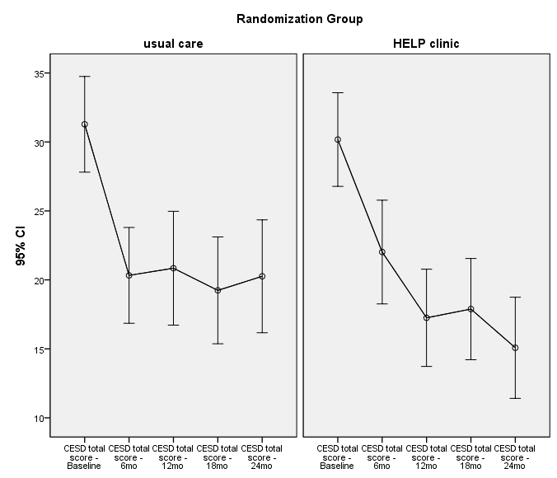

**Multilevel Linear Model (MLM) Approach – Use all available data**

When we retain all available data, we have values for 1422 measurements (62.8%) out of a possible (453*5) 2265 values. As the table below shows, 98 subjects had complete data with 0 missing values; 98 had 1 missing time point; 96 had 2 missing time points; 91 had 3 missing time points and 70 had 4 missing time points. This approach uses more data and accounts for the attrition over time (e.g. time dependent missingness).

|  |  |  |  |  |  |
| --- | --- | --- | --- | --- | --- |
| **nmiss_cesd** | | | | | |
|  | | Frequency | Percent | Valid Percent | Cumulative Percent |
| Valid | .00 | 98 | 21.6 | 21.6 | 21.6 |
| 1.00 | 98 | 21.6 | 21.6 | 43.3 |
| 2.00 | 96 | 21.2 | 21.2 | 64.5 |
| 3.00 | 91 | 20.1 | 20.1 | 84.5 |
| 4.00 | 70 | 15.5 | 15.5 | 100.0 |
| Total | 453 | 100.0 | 100.0 |  |

**MLM Model Effects**

The model effect tests yield the same results as the RM-ANOVA above for the 98 completers – namely the time effect is significant, but the group and group-by-time interaction effects are not statistically significant. The p-values are different, but the conclusions are the same.

|  |  |  |  |  |
| --- | --- | --- | --- | --- |
| **Type III Tests of Fixed Effectsa** | | | | |
| Source | Numerator df | Denominator df | F | Sig. |
| Intercept | 1 | 740.387 | 2519.898 | .000 |
| treat | 1 | 740.387 | .018 | .893 |
| time0 | 1 | 1087.359 | 231.914 | .000 |
| treat * time0 | 1 | 1087.359 | 1.230 | .268 |
| a. Dependent Variable: cesd CESD total score - Baseline. | | | | |

**Updated Error Bar plot – for all available data**

