Red Wine

Melinda K. Higgins, PhD.

February 16, 2017

## Read in data

NOTE: There are 2 formatting issues with the data as downloaded from the UCI data repository. Even though the filename extension is CSV (usually "comma-delimited" format),

1. the variable names have multiple words separated by spaces which many/most import routines will have problems with and
2. the "delimiter" or symbol used to separate data fields (aka, the columns) is the semicolon ; so we need to specify this.

If it was a simple comma-delimtied file the function read.csv() would work fine. However, to address the issue of the semicolon, we need to use read.table() and provide the delimiter specifically.

NOTE: read.table() also "fixes" the variable names such that the spaces are filled in using a period .. For example, the 1st variable "fixed acidity" is converted to fixed.acidity in the final dataframe.

redWine <- read.table("winequality-red.csv",  
 header=TRUE,  
 sep=";")

## Run a summary of the Red Wine Data

summary(redWine)

## fixed.acidity volatile.acidity citric.acid residual.sugar   
## Min. : 4.60 Min. :0.1200 Min. :0.000 Min. : 0.900   
## 1st Qu.: 7.10 1st Qu.:0.3900 1st Qu.:0.090 1st Qu.: 1.900   
## Median : 7.90 Median :0.5200 Median :0.260 Median : 2.200   
## Mean : 8.32 Mean :0.5278 Mean :0.271 Mean : 2.539   
## 3rd Qu.: 9.20 3rd Qu.:0.6400 3rd Qu.:0.420 3rd Qu.: 2.600   
## Max. :15.90 Max. :1.5800 Max. :1.000 Max. :15.500   
## chlorides free.sulfur.dioxide total.sulfur.dioxide  
## Min. :0.01200 Min. : 1.00 Min. : 6.00   
## 1st Qu.:0.07000 1st Qu.: 7.00 1st Qu.: 22.00   
## Median :0.07900 Median :14.00 Median : 38.00   
## Mean :0.08747 Mean :15.87 Mean : 46.47   
## 3rd Qu.:0.09000 3rd Qu.:21.00 3rd Qu.: 62.00   
## Max. :0.61100 Max. :72.00 Max. :289.00   
## density pH sulphates alcohol   
## Min. :0.9901 Min. :2.740 Min. :0.3300 Min. : 8.40   
## 1st Qu.:0.9956 1st Qu.:3.210 1st Qu.:0.5500 1st Qu.: 9.50   
## Median :0.9968 Median :3.310 Median :0.6200 Median :10.20   
## Mean :0.9967 Mean :3.311 Mean :0.6581 Mean :10.42   
## 3rd Qu.:0.9978 3rd Qu.:3.400 3rd Qu.:0.7300 3rd Qu.:11.10   
## Max. :1.0037 Max. :4.010 Max. :2.0000 Max. :14.90   
## quality   
## Min. :3.000   
## 1st Qu.:5.000   
## Median :6.000   
## Mean :5.636   
## 3rd Qu.:6.000   
## Max. :8.000

## Histogram of Fixed Acidity using ggplot()

ggplot(aes(fixed.acidity), data=redWine) +  
 geom_histogram()

## `stat_bin()` using `bins = 30`. Pick better value with `binwidth`.

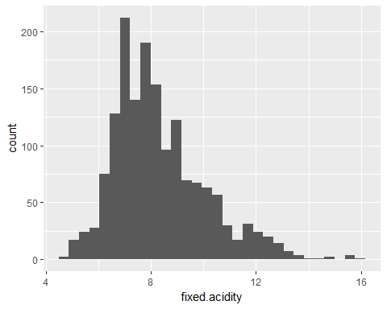

## Density Overlay with Histogram & add color

ggplot(aes(fixed.acidity), data=redWine) +   
 geom_histogram(aes(y =..density..),   
 breaks=seq(4, 16, by = 0.5),   
 col="red",   
 fill="green",   
 alpha = .2) +   
 geom_density(col=2) +   
 labs(title="Histogram for Fixed Acidity") +  
 labs(x="Fixed Acidity", y="Proportion")

