NRSG 741 - Homework 2 - ANSWER KEY

Melinda Higgins

03/25/2019

## INSTRUCTIONS

* Use this Rmarkdown file N741Homework02.Rmd to get started.
* Change the author to YOUR NAME
* Note: This Rmarkdown file has one R code chunk at the top that reads in the dataset and loads the R packages you will need.
* After each question below, insert an R code chunk to enter the R code needed to answer that question. Do this for each question.
* Outside of the R code chunk, type in any text needed to provide explanation or answer the questions further.

## *Due Date* is 13 February 2019

This homework is meant to further your dplyr and ggplot2 skills.

## Abalones Dataset from UCI Repository

For this homework, you will keep working with the abalone dataset from the UCI data repository at <https://archive.ics.uci.edu/ml/datasets/abalone>.

Use tools within the dplyr package as much as possible to answer the following questions.

##### **Question 1:** What kind of R object is the abalone dataset?

**ANSWER KEY**

You could use either the class() or str() functions to give you details about the abalone dataset object.

# insert R code here to answer question 1  
  
class(abalone)

## [1] "spec_tbl_df" "tbl_df" "tbl" "data.frame"

str(abalone)

## Classes 'spec_tbl_df', 'tbl_df', 'tbl' and 'data.frame': 4177 obs. of 9 variables:  
## $ sex : chr "M" "M" "F" "M" ...  
## $ length : num 0.455 0.35 0.53 0.44 0.33 0.425 0.53 0.545 0.475 0.55 ...  
## $ diameter : num 0.365 0.265 0.42 0.365 0.255 0.3 0.415 0.425 0.37 0.44 ...  
## $ height : num 0.095 0.09 0.135 0.125 0.08 0.095 0.15 0.125 0.125 0.15 ...  
## $ wholeWeight : num 0.514 0.226 0.677 0.516 0.205 ...  
## $ shuckedWeight: num 0.2245 0.0995 0.2565 0.2155 0.0895 ...  
## $ visceraWeight: num 0.101 0.0485 0.1415 0.114 0.0395 ...  
## $ shellWeight : num 0.15 0.07 0.21 0.155 0.055 0.12 0.33 0.26 0.165 0.32 ...  
## $ rings : num 15 7 9 10 7 8 20 16 9 19 ...  
## - attr(*, "spec")=  
## .. cols(  
## .. X1 = col_character(),  
## .. X2 = col_double(),  
## .. X3 = col_double(),  
## .. X4 = col_double(),  
## .. X5 = col_double(),  
## .. X6 = col_double(),  
## .. X7 = col_double(),  
## .. X8 = col_double(),  
## .. X9 = col_double()  
## .. )

**ANSWER KEY**

The abalone dataset is read in as a data.frame, using the read_csv() function from the readr package which is part of the tidyverse, actually makes it a "spec_tbl_df" "tbl_df" "tbl" "data.frame" - a tibble data frame. You can learn more at <https://www.tidyverse.org/articles/2018/12/readr-1-3-1/>.

##### **Question 2:** How many observations are in the abalone dataset?

**ANSWER KEY**

To answer this question, you can use either the str() or dim() functions.

dim(abalone)

## [1] 4177 9

**ANSWER KEY**

Based on either the str() output shown above or the dim() results, there are 4177 observations in the abalone dataset.

##### **Question 3:** For shucked weight, how many abalones weigh more than 0.8 grams?

**ANSWER KEY**

Using the filter() function from the dplyr package is useful for extracting cases (observations or rows) that meet the specified criteria defined inside the filter() function. Only rows for which the filter is TRUE are retained.

abalone %>%  
 filter(shuckedWeight > 0.8) %>%  
 dim()

## [1] 148 9

There are 148 abalones with a shucked weight > 0.8 grams.

##### **Question 4:** How many abalones have shucked weights larger than their whole weight?

*(HINT: create a new variable using mutate and then filter)*

**ANSWER KEY**

This problem could have been solved using either mutate() or the filter() function. Both approached should yield the same answer.

abalone %>%  
 mutate(shuckedHigh = shuckedWeight > wholeWeight) %>%  
 filter(shuckedHigh == TRUE) %>%  
 dim()

## [1] 4 10

# alternate approach without mutate  
  
abalone %>%  
 filter(shuckedWeight > wholeWeight) %>%  
 dim()

## [1] 4 9

There are 4 abalones with shucked weight greater than their whole weight which should not be correct. These abalones have measurement errors.

Create a subset containing only infants sex == "I"

##### **Question 5:** How many infants are in this subset?

**ANSWER KEY**

Create the subset first and then find the dimensions to get number of rows.

# Create subset  
abaloneI <- abalone %>%  
 filter(sex == "I")  
  
# Find dimensions  
dim(abaloneI)

## [1] 1342 9

There are 1342 infant abalones in this dataset.

Show off your dplyr skills with group_by()

##### **Question 6:** What is the average whole weight for each abalone sex (get whole weight means for females “F”, males “M” and infants “I” separately)?

**ANSWER KEY**

You can use either summarise() or summarise_all() functions from dplyr package.

abalone %>%  
 group_by(sex) %>%  
 summarise(meanwt = mean(wholeWeight))

## # A tibble: 3 x 2  
## sex meanwt  
## <chr> <dbl>  
## 1 F 1.05   
## 2 I 0.431  
## 3 M 0.991

abalone %>%  
 group_by(sex) %>%  
 select(wholeWeight) %>%  
 summarise_all(mean)

## Adding missing grouping variables: `sex`

## # A tibble: 3 x 2  
## sex wholeWeight  
## <chr> <dbl>  
## 1 F 1.05   
## 2 I 0.431  
## 3 M 0.991

##### **Question 7:** Get the means for the abalone length and height by sex?

**ANSWER KEY**

You can use either summarise() or summarise_all() functions from dplyr package. This is very similar to problem above, notice only the variable names get updated.

abalone %>%  
 group_by(sex) %>%  
 summarise(meanlt = mean(length),  
 meanht = mean(height))

## # A tibble: 3 x 3  
## sex meanlt meanht  
## <chr> <dbl> <dbl>  
## 1 F 0.579 0.158  
## 2 I 0.428 0.108  
## 3 M 0.561 0.151

abalone %>%  
 group_by(sex) %>%  
 select(length, height) %>%  
 summarise_all(mean)

## Adding missing grouping variables: `sex`

## # A tibble: 3 x 3  
## sex length height  
## <chr> <dbl> <dbl>  
## 1 F 0.579 0.158  
## 2 I 0.428 0.108  
## 3 M 0.561 0.151

## Test your graphing skills using ggplot2

Using the abalone dataset, create the following graphics/figures using ggplot() and associated geom_xxx() functions.

##### **Question 8:** Create a histogram of abalone whole weight

*What do you notice about the distribution (any outliers or skewness)?*

**ANSWER KEY**

You want to use the geom_histogram() function from the ggplot2 package. In the initial ggplot() step, you only have to define one aesthetic (aes) for wholeWeight.

# simple histogram  
ggplot(abalone, aes(x=wholeWeight)) +  
 geom_histogram()

## `stat_bin()` using `bins = 30`. Pick better value with `binwidth`.

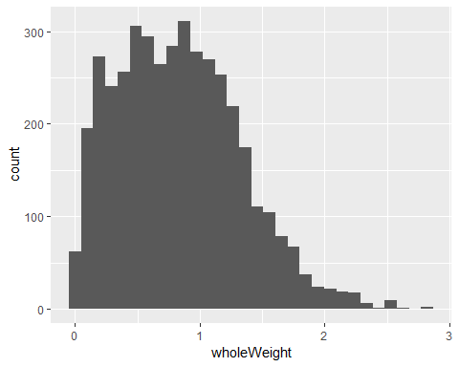

# optional - add colors and labels and a title  
ggplot(abalone, aes(x=wholeWeight)) +  
 geom_histogram(color = "black",  
 fill = "light blue") +  
 xlab("Whole Weight in grams") +   
 ylab("Frequencies") +   
 ggtitle("Histogram of Abalone Whole Weights")

## `stat_bin()` using `bins = 30`. Pick better value with `binwidth`.

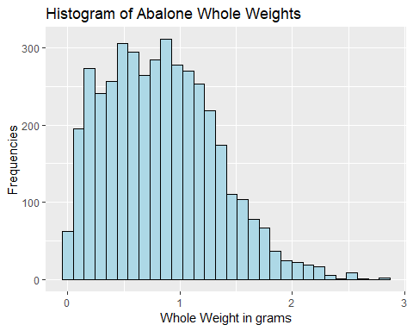

There are a few large abalones with weights above 2.5 grams.

##### **Question 9:** Create side-by-side boxplots of the number of rings by gender

*HINT use geom_boxplot with x = sex and y = rings*

**ANSWER KEY**

Use similar approach to above, but now you have two aesthetics (aes) instead of just one for the histogram above. The two aesthetics (aes) are sex and rings. You need geom_boxplot() to draw the boxplots.

ggplot(abalone, aes(x=sex, y=rings)) +  
 geom_boxplot()

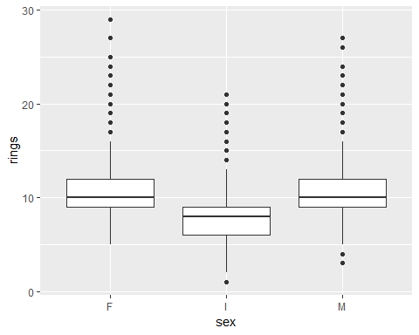

##### **Question 10:** Create a scatterplot of the whole weight on the X axis and shucked weight on the Y axis and color the points by sex

**ANSWER KEY**

Scatterplots also need two aesthetics (aes) - in this case are wholeWeight for “x” and shuckedWeight for “y”. You also need geom_point() and color the points by sex using aes(color) inside geom_point().

ggplot(abalone, aes(x=wholeWeight, y=shuckedWeight)) +  
 geom_point(aes(color = sex))

