Abalone Report

Melinda Higgins

2023-01-12

## Summary Statistics of Abalones’ - Dimensional Measurements

|  | Overall (N=4177) |
| --- | --- |
| **length** |  |
| Mean (SD) | 0.524 (0.120) |
| Range | 0.075 - 0.815 |
| **diameter** |  |
| Mean (SD) | 0.408 (0.099) |
| Range | 0.055 - 0.650 |
| **height** |  |
| Mean (SD) | 0.140 (0.042) |
| Range | 0.000 - 1.130 |

## Summary Statistics of Abalones’ - Weight Measurements

|  | Overall (N=4177) |
| --- | --- |
| **wholeWeight** |  |
| Mean (SD) | 0.829 (0.490) |
| Range | 0.002 - 2.825 |
| **shuckedWeight** |  |
| Mean (SD) | 0.359 (0.222) |
| Range | 0.001 - 1.488 |
| **visceraWeight** |  |
| Mean (SD) | 0.181 (0.110) |
| Range | 0.000 - 0.760 |
| **shellWeight** |  |
| Mean (SD) | 0.239 (0.139) |
| Range | 0.002 - 1.005 |

## Abalone Dimensional Measurements by Sex

|  | F (N=1307) | I (N=1342) | M (N=1528) | Total (N=4177) | p value |
| --- | --- | --- | --- | --- | --- |
| **length** |  |  |  |  | < 0.001 |
| Mean (SD) | 0.579 (0.086) | 0.428 (0.109) | 0.561 (0.103) | 0.524 (0.120) |  |
| Range | 0.275 - 0.815 | 0.075 - 0.725 | 0.155 - 0.780 | 0.075 - 0.815 |  |
| **diameter** |  |  |  |  | < 0.001 |
| Mean (SD) | 0.455 (0.071) | 0.326 (0.088) | 0.439 (0.084) | 0.408 (0.099) |  |
| Range | 0.195 - 0.650 | 0.055 - 0.550 | 0.110 - 0.630 | 0.055 - 0.650 |  |
| **height** |  |  |  |  | < 0.001 |
| Mean (SD) | 0.158 (0.040) | 0.108 (0.032) | 0.151 (0.035) | 0.140 (0.042) |  |
| Range | 0.015 - 1.130 | 0.000 - 0.220 | 0.025 - 0.515 | 0.000 - 1.130 |  |

## Abalone Weight Measurements by Sex

|  | F (N=1307) | I (N=1342) | M (N=1528) | Total (N=4177) | p value |
| --- | --- | --- | --- | --- | --- |
| **wholeWeight** |  |  |  |  | < 0.001 |
| Mean (SD) | 1.047 (0.430) | 0.431 (0.286) | 0.991 (0.471) | 0.829 (0.490) |  |
| Range | 0.080 - 2.657 | 0.002 - 2.050 | 0.015 - 2.825 | 0.002 - 2.825 |  |
| **shuckedWeight** |  |  |  |  | < 0.001 |
| Mean (SD) | 0.446 (0.199) | 0.191 (0.128) | 0.433 (0.223) | 0.359 (0.222) |  |
| Range | 0.031 - 1.488 | 0.001 - 0.773 | 0.006 - 1.351 | 0.001 - 1.488 |  |
| **visceraWeight** |  |  |  |  | < 0.001 |
| Mean (SD) | 0.231 (0.098) | 0.092 (0.063) | 0.216 (0.105) | 0.181 (0.110) |  |
| Range | 0.021 - 0.590 | 0.000 - 0.440 | 0.003 - 0.760 | 0.000 - 0.760 |  |
| **shellWeight** |  |  |  |  | < 0.001 |
| Mean (SD) | 0.302 (0.126) | 0.128 (0.085) | 0.282 (0.131) | 0.239 (0.139) |  |
| Range | 0.025 - 1.005 | 0.002 - 0.655 | 0.005 - 0.897 | 0.002 - 1.005 |  |

## Plot of Abalone Age by wholeWeight

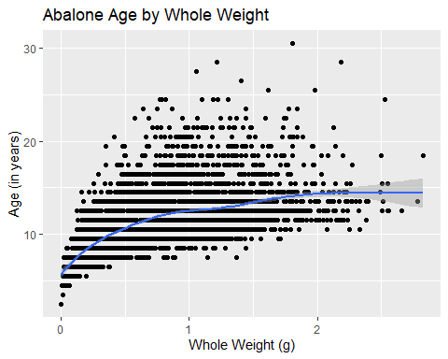

## Plot of Abalone Age by diameter - by sex - Option 1

Create a plot of abalone age by diameter in mm. Show the plot by sex - Option 1 add a color by sex or Option 2 a facet_wrap().

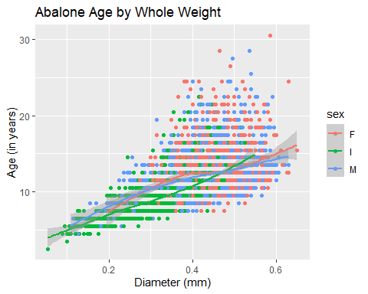

## Plot of Abalone Age by diameter - by sex - Option 2

Create a plot of abalone age by diameter in mm. Show the plot by sex - Option 1 add a color by sex or Option 2 a facet_wrap().

