|  |  |  |  |  |
| --- | --- | --- | --- | --- |
| Elemento |  |  |  |  |
|  |  |  |  |  |
|  |  |  |  |  |
|  |  |  |  |  |
|  |  |  |  |  |
|  |  |  |  |  |
|  |  |  |  |  |
|  |  |  |  |  |
|  |  |  |  |  |
|  |  |  |  |  |
|  |  |  |  |  |
|  |  |  |  |  |
|  |  |  |  |  |

Nombre: _________________________________ Carné: _____________ Fecha: ___/___/___

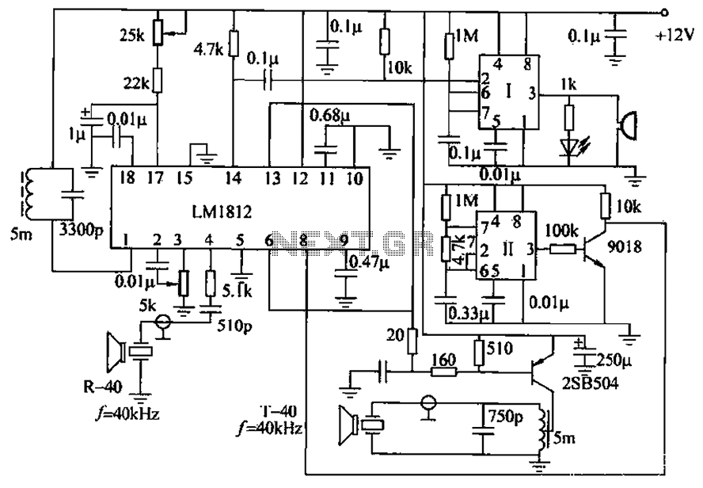

http://www.next.gr/uploads/113/LM1812-uses-ultrasonic-anti-collision-circuit-design.png