**CREATE ACCOUNT:**

**Click on person image**

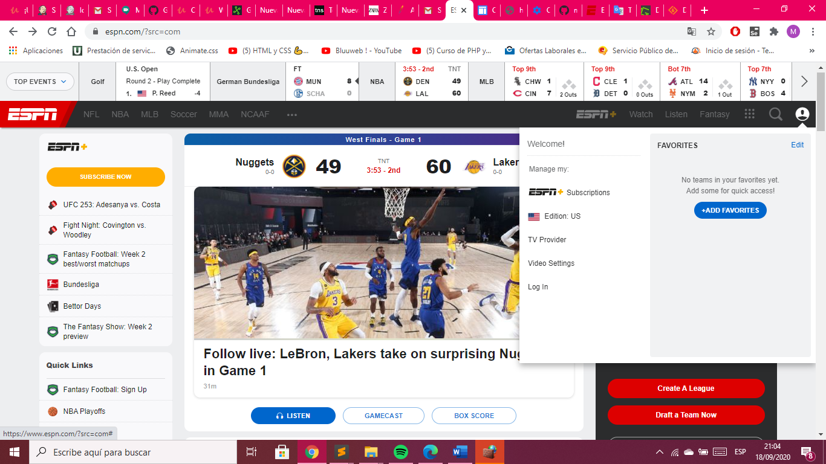

cssSelectos: #global-user-trigger

Click ok login

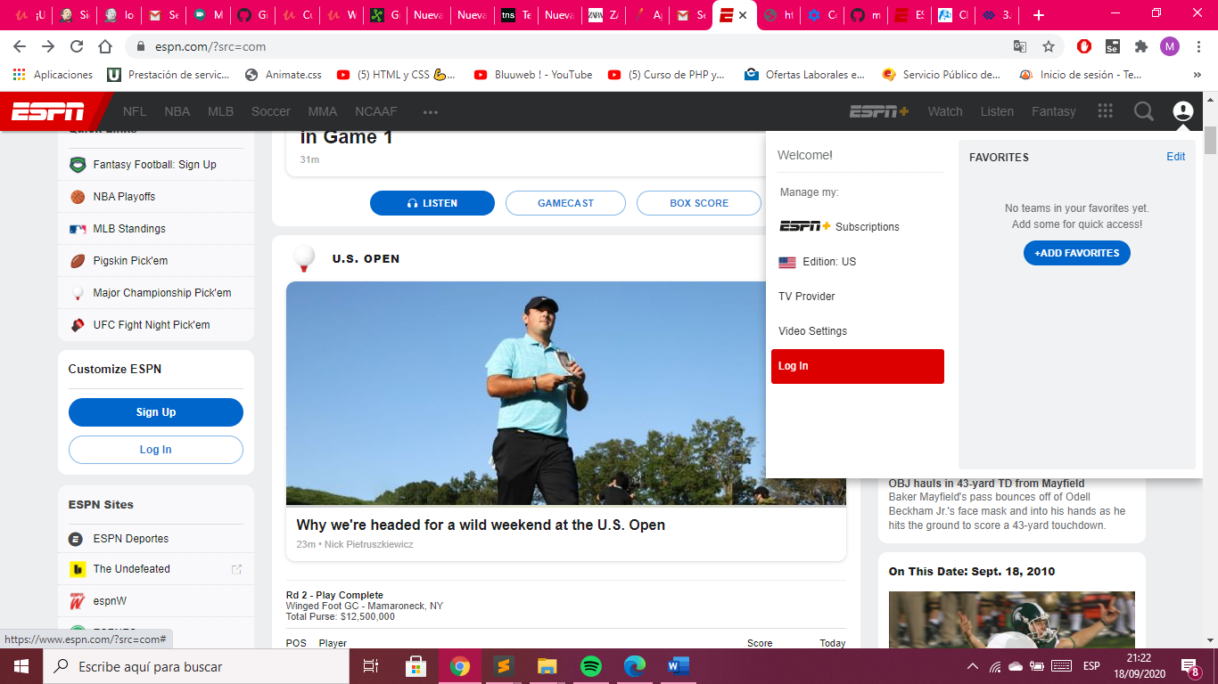

CssSelector: #global-user-trigger + div.global-user .account-management li a[data-affiliatename]

**Click ok Sing On**

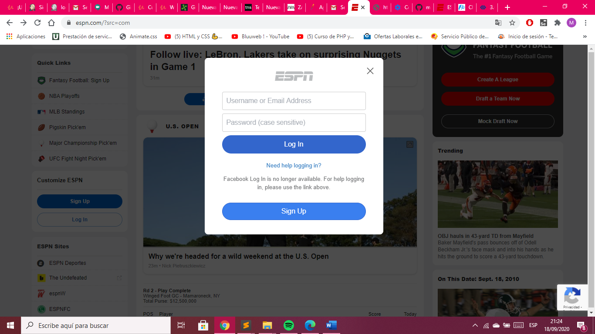CssSelector: a[class="btn btn-secondary ng-isolate-scope"]

Put the information

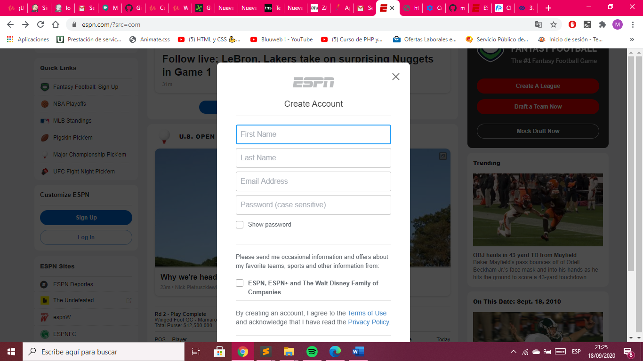

CssSelectos First Name: input[name="firstName"]

CssSelectos Last Name: input[name="lastName"]

CssSelectos Last Name: input[name="email"]

CssSelectos Last Name: input[name=" newPassword"]

**Click on Sign Up**

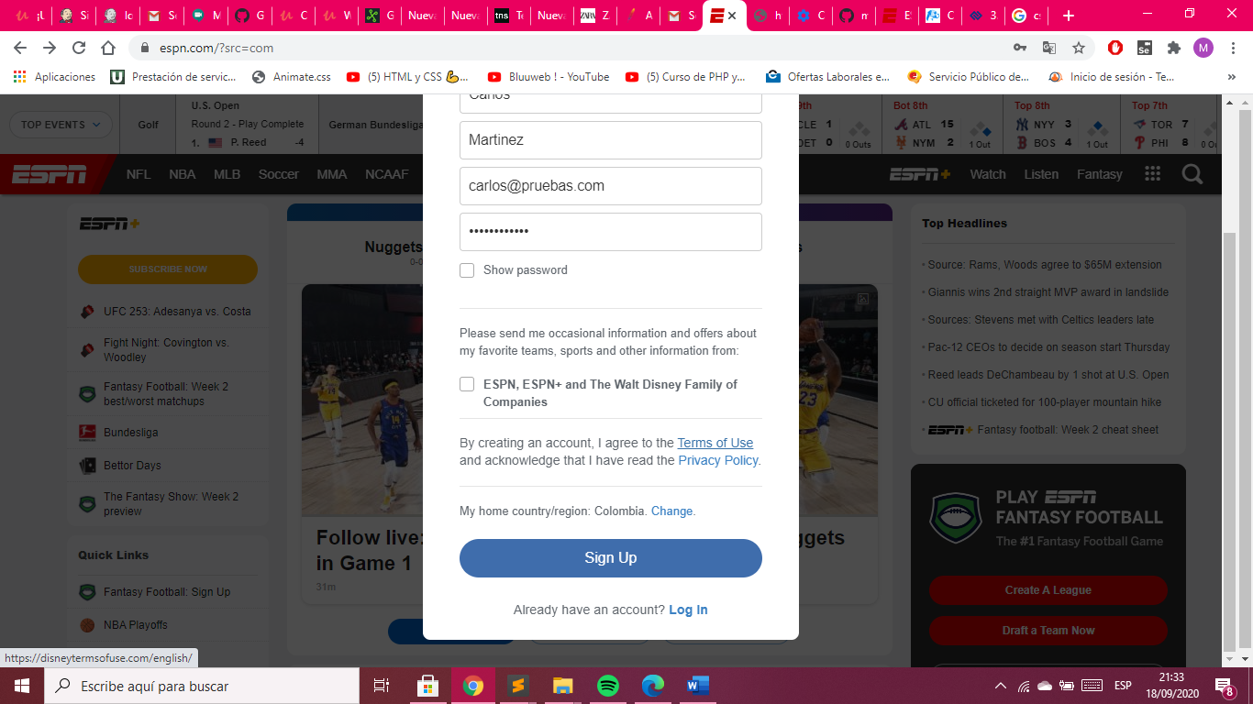

CssSelector: button[class="btn btn-primary ng-scope ng-isolate-scope"]

**LOGIN:**

**Click on person image**



cssSelectos: #global-user-trigger

Click ok login



CssSelector: #global-user-trigger + div.global-user .account-management li a[data-affiliatename]

Put the information

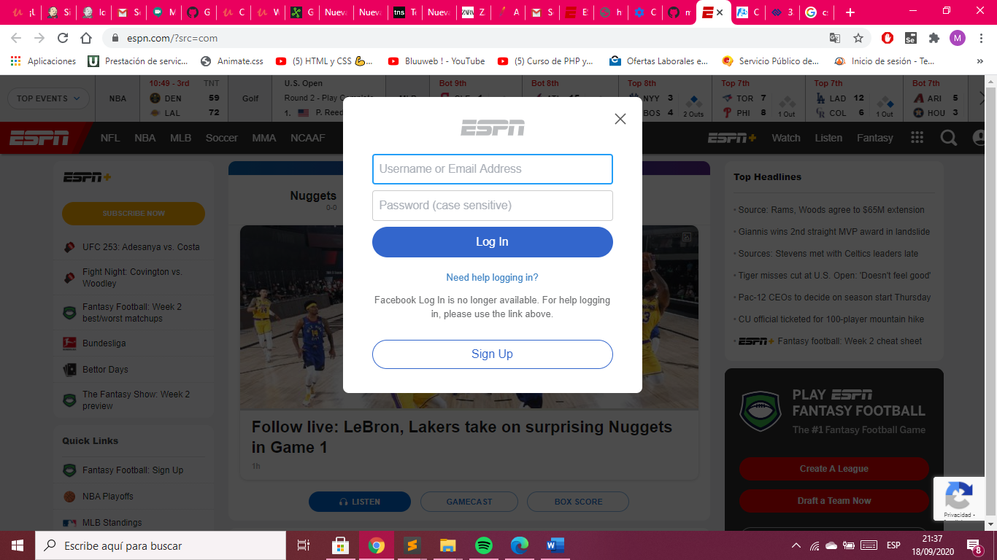

CssSelector Username: input[placeholder="Username or Email Address"]

CssSelector Password: input[placeholder="Password (case sensitive)"]

**Click on Log In**

CssSelector Log In: button[class="btn btn-primary btn-submit ng-isolate-scope"]

**LOGOUT:**



cssSelectos: #global-user-trigger

**Click on Log Out**

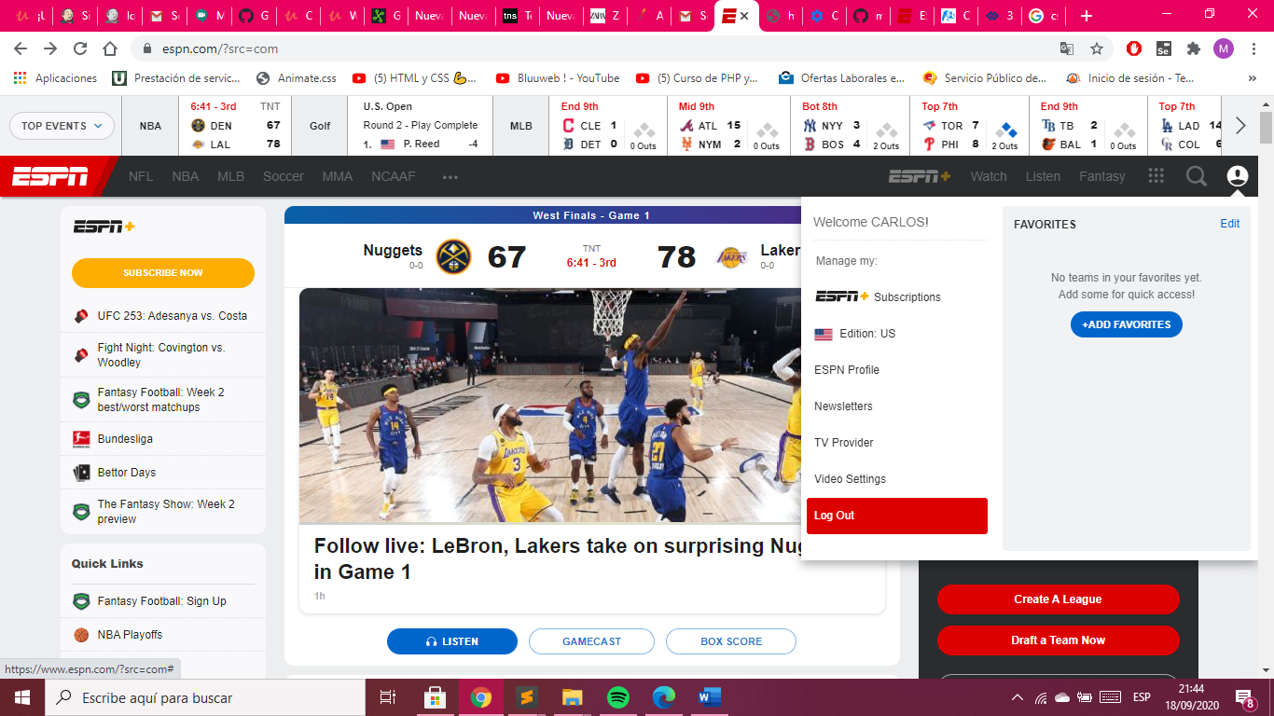

CssSelector Log Out: #global-user-trigger + div.global-user .account-management li a[onclick]

**DELETE ACCOUNT:**



cssSelectos: #global-user-trigger

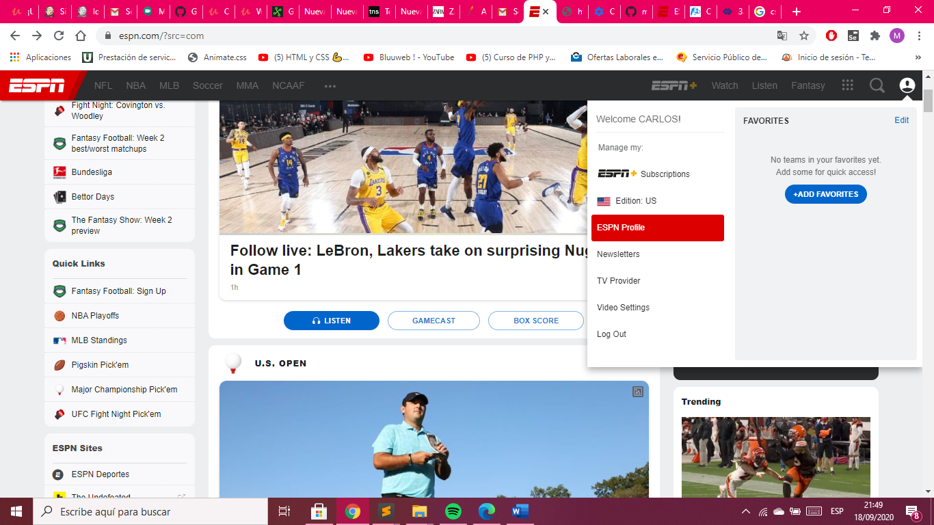

cssSelecto: #global-user-trigger + div.global-user .account-management li a[tref]

Click on delete account

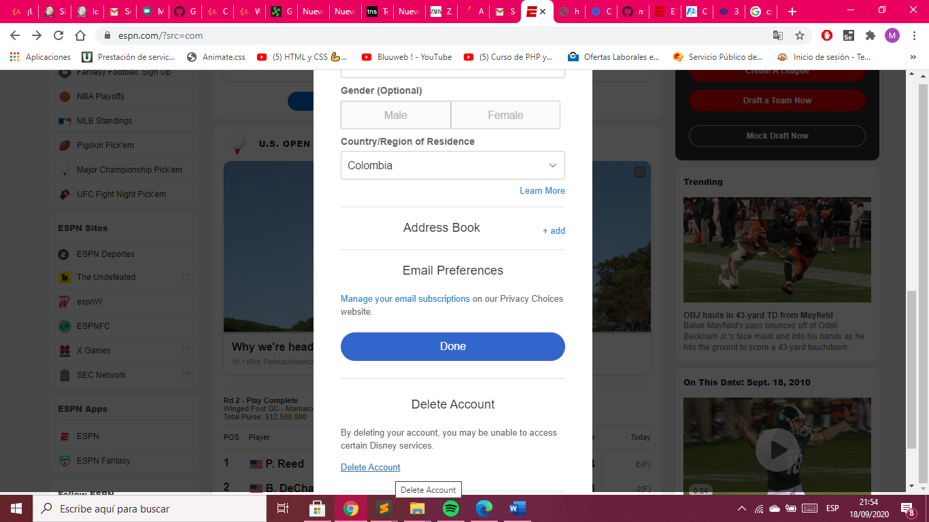

cssSelector Delet Account: #cancel-account

Click on confirmation

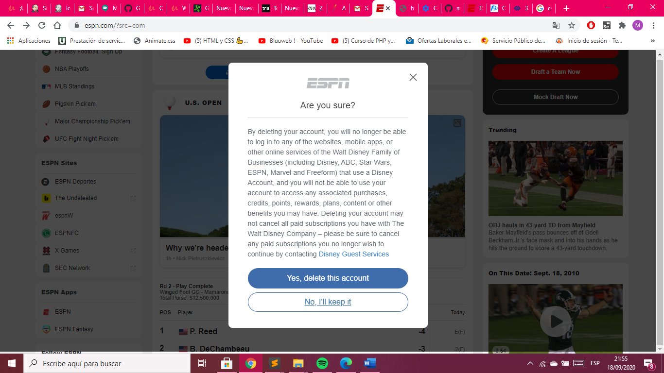

cssSelector: button[class="btn btn-primary ng-isolate-scope"]