Hapkit function GENIE!

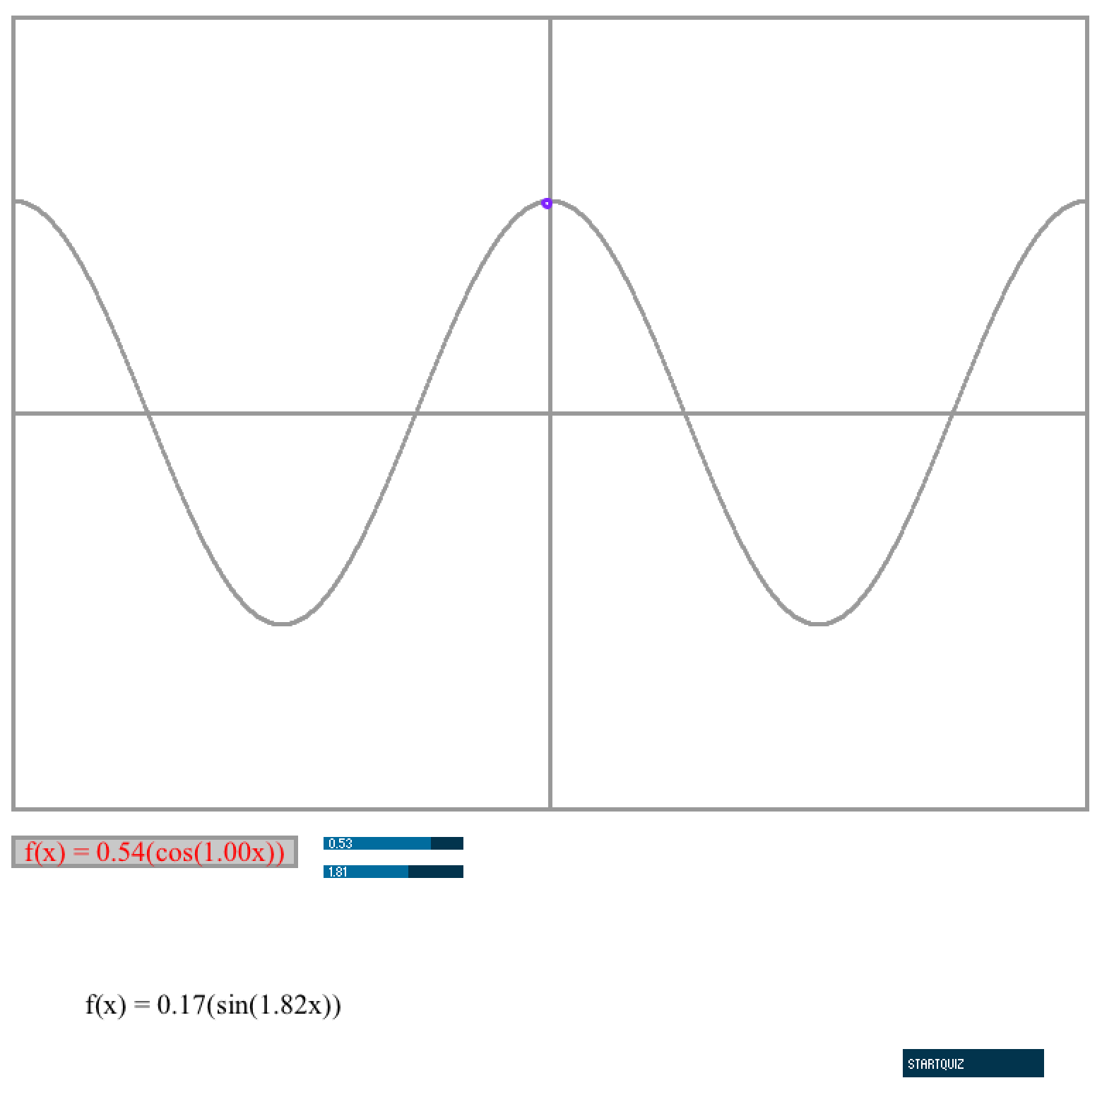

Description: 3

Program Structure: 3

1. Installation instructions: 4

a. On Hapkit: 4

b. On PC: 4

2. Usage: 5

a. HAPKIT function GENIE App parts: 5

1) Function Window: 6

2) Hapkit Ball: 6

3) Function Box: 6

4) Function Sliders: 6

5) Functions 6

6) Quiz Mode Button: 6

# Description:

Hapkit function GENIE is an App meant to be used as a teaching tool in a math class about functions.

The teacher should first describe functions to the students, their mathematical properties and show the students in play mode how to use the app and change function properties.

After the leasson, the teacher should instruct the students to change the mode to Quiz mode in which the students will learn by exploring and answering Quiz questions that the program will give them.

## Program Structure:

There are two main pieces to this App. The Arduino program which needs to be installed on the HAPKIT and the processing part which needs to run on a PC.

# Installation instructions:

## On Hapkit:

Please download the program ArduinoWaves to your HAPKIT. Without this program running on your hapkit and your hapkit connected to the PC, the Processing portion of the App will not run. For best performance, your hapkit should be calibrated. Instructions on how to do so are in:

<https://lagunita.stanford.edu/courses/SelfPaced/Haptics/2014/courseware/>

in the lab of Module 3.

## On PC:

Please open your processing App using the Processing software. The only thing you have to modify here is tell your PC, which serial port your hapkit is connected to.

There are several ways of finding this out. We will explain one of those.

In Arduino, click on the Tools Tab, and then Serial Port. A drop down list will pop up showing the list of components your computer has connected to its serial ports. Look at the one that says something like:

dev/tty.usbserial-A007282

Please note which number in the list it is.

Then, in the tab of your processing App called FunctionWindow, modify the serial communication variable SerialPort, to indicate that order number:

//Serial communication variables

import processing.serial.*;

int serialPort = 5; // modify this variable

And that is it! You should now be able to run your Hapkit Function GENIE!

# Usage:

When you run your HAPKIT function GENIE you first start with a hapkit with no functions. The force will be zero and you can see that your hapkit will track a purple ball (hapkit ball) moving around in the screen. With no force, it can only move along the x axis.

If you want to add a function to your window and feel it with the hapkit too, drag and drop one of the functions into the function box. Doing this will display the function on the screen, and you will see the hapkit ball move along the function as you move the hapkit. You will also feel the force increase and decrease in the negative and positive directions as you move the hapkit.

In order to change the frequency and amplitude of the functions on the screen, you should move the function and amplitude sliders.

And to go into Quiz mode you can press the quiz mode button.

## a. HAPKIT function GENIE App parts:

Your HAPKIT function GENIE is composed of these main parts:

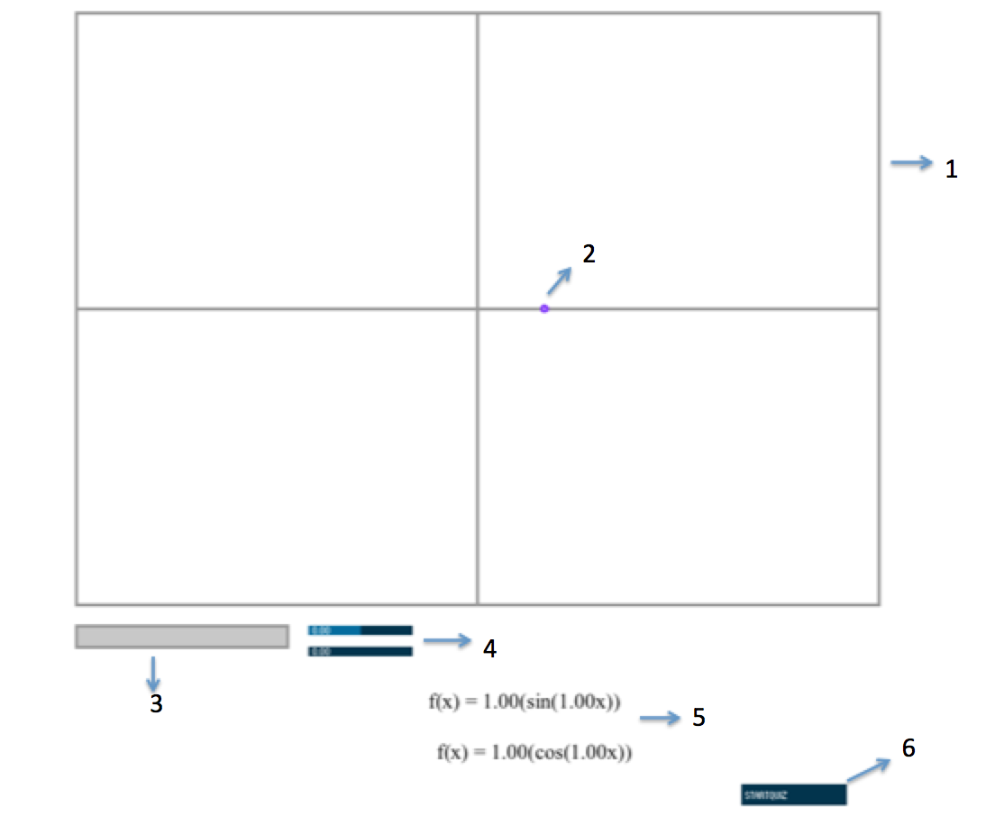

### Function Window:

This is the window that will display the functions dropped into the Function Box as well as the the Hapkit Ball. The functions are mapped to movement of the hapkit (x axis) and force displayed on the hapkit (y axis).

### Hapkit Ball:

The Hapkit Ball will display on the screen the physical movements of the hapkit.

### Function Box:

In order to have a function be displayed on the function window, it must be dragged and dropped into the Function Box.

### Function Sliders:

These control the Amplitude (top slider) and frequency (bottom slider) of the functions dropped into the function box.

### Functions

These are the functions that are available to be displayed in the function window. In order to select them one must drag and drop them into the function box.

### Quiz Mode Button:

Pressing this button will take you and navigate you through Quiz mode. In this mode you will be asked to answer some questions for your teacher based on different parts of the program not being available to you. You will be allowed to play with the parts of the program that are revealed.