Hapkit function GENIE!

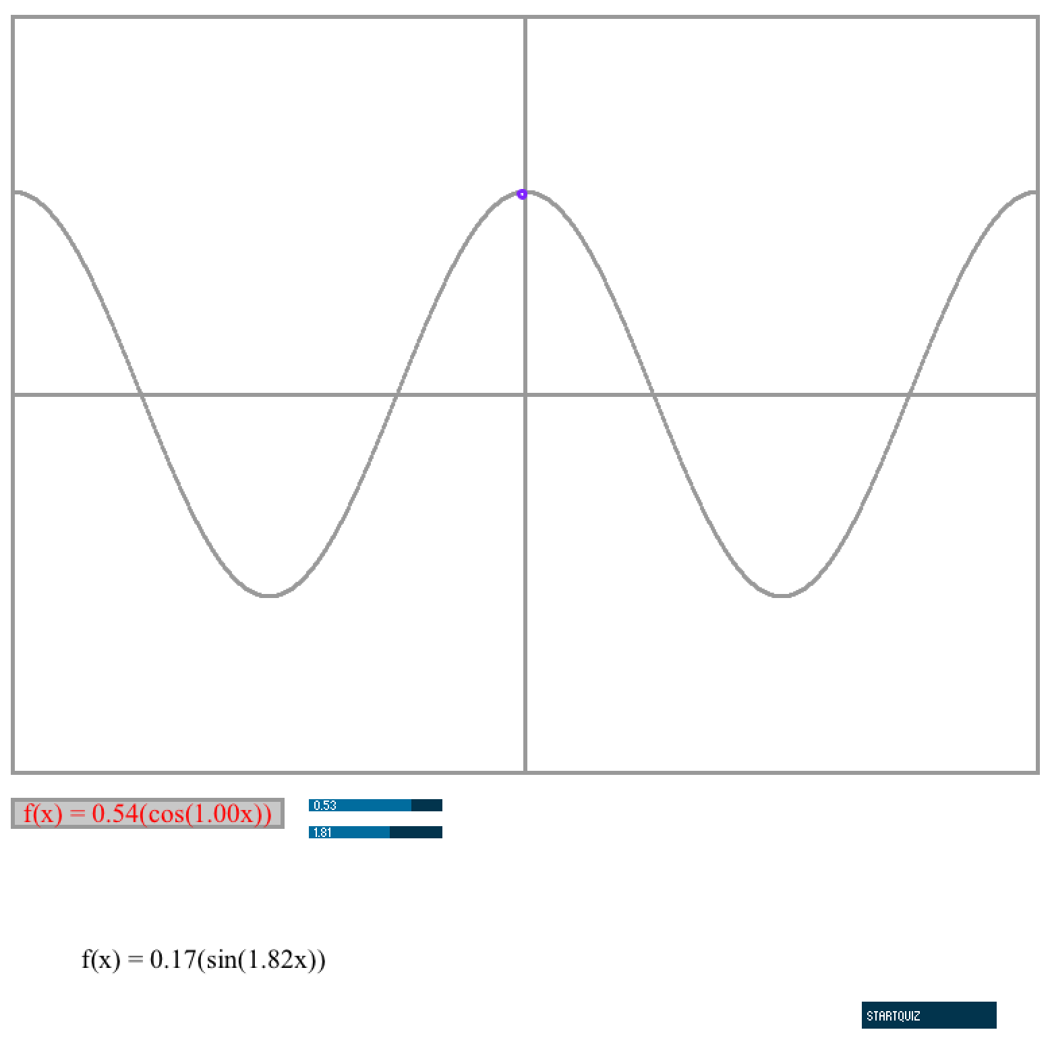

Description: 3

Program Structure: 3

1. Installation instructions: 4

a. On Hapkit: 4

b. On PC: 4

2. Usage: 5

a. HAPKIT function GENIE App parts: 5

1) Function Window: 6

2) Hapkit Ball: 6

3) Function Box: 6

4) Function Sliders: 6

5) Functions 6

6) Quiz Mode Button: 6

3. Lesson Plan: 7

a. Introduction: Functions and Graphs 7

1) What is a function? 7

2) Evaluating functions given their formula 7

3) Evaluating functions given their graph 8

b. Trigonometric functions 8

c. Amplitude and Frequency 8

# Description:

Hapkit function GENIE is an App meant to be used as a teaching tool in a math class about functions.

The teacher should first describe functions to the students, their mathematical properties and show the students in play mode how to use the app and change function properties.

After the leasson, the teacher should instruct the students to change the mode to Quiz mode in which the students will learn by exploring and answering Quiz questions that the program will give them.

## Program Structure:

There are two main pieces to this App. The Arduino program which needs to be installed on the HAPKIT and the processing part which needs to run on a PC.

# Installation instructions:

## On Hapkit:

Please download the program ArduinoWaves to your HAPKIT. Without this program running on your hapkit and your hapkit connected to the PC, the Processing portion of the App will not run. For best performance, your hapkit should be calibrated. Instructions on how to do so are in:

<https://lagunita.stanford.edu/courses/SelfPaced/Haptics/2014/courseware/>

in the lab of Module 3.

## On PC:

Please open your processing App using the Processing software. The only thing you have to modify here is tell your PC, which serial port your hapkit is connected to.

There are several ways of finding this out. We will explain one of those.

In Arduino, click on the Tools Tab, and then Serial Port. A drop down list will pop up showing the list of components your computer has connected to its serial ports. Look at the one that says something like:

dev/tty.usbserial-A007282

Please note which number in the list it is.

Then, in the tab of your processing App called FunctionWindow, modify the serial communication variable SerialPort, to indicate that order number:

//Serial communication variables

import processing.serial.*;

int serialPort = 5; // modify this variable

And that is it! You should now be able to run your Hapkit Function GENIE!

# Usage:

When you run your HAPKIT function GENIE you first start with a hapkit with no functions. The force will be zero and you can see that your hapkit will track a purple ball (hapkit ball) moving around in the screen. With no force, it can only move along the x axis.

If you want to add a function to your window and feel it with the hapkit too, drag and drop one of the functions into the function box. Doing this will display the function on the screen, and you will see the hapkit ball move along the function as you move the hapkit. You will also feel the force increase and decrease in the negative and positive directions as you move the hapkit.

In order to change the frequency and amplitude of the functions on the screen, you should move the function and amplitude sliders.

And to go into Quiz mode you can press the quiz mode button.

## a. HAPKIT function GENIE App parts:

Your HAPKIT function GENIE is composed of these main parts:

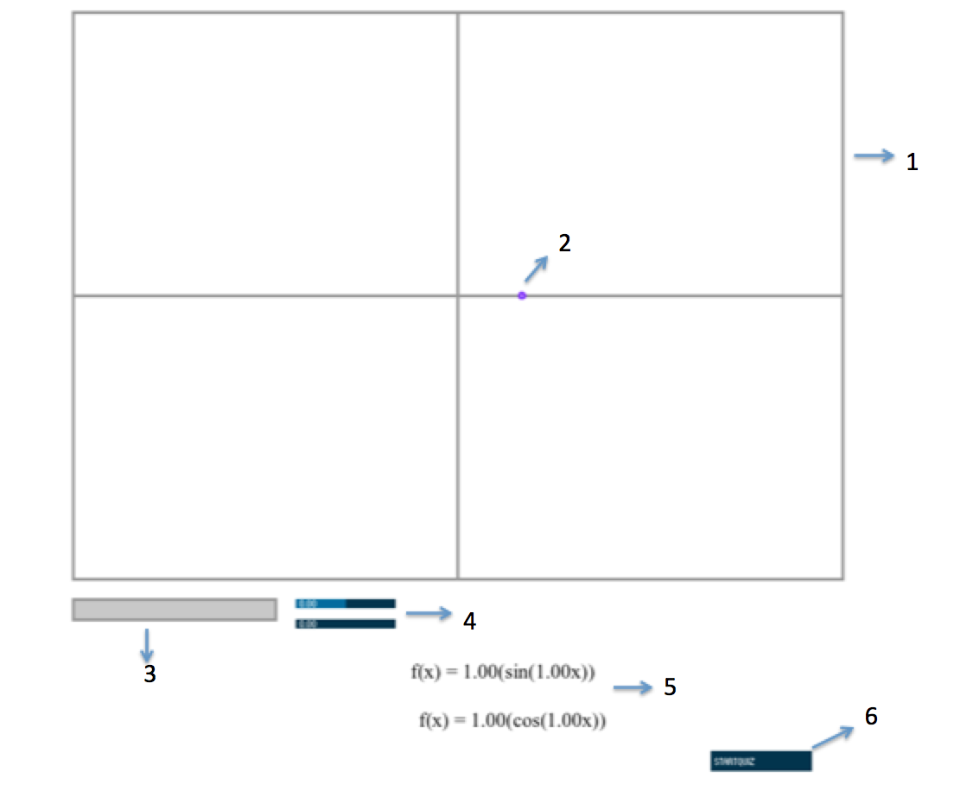

### Function Window:

This is the window that will display the functions dropped into the Function Box as well as the the Hapkit Ball. The functions are mapped to movement of the hapkit (x axis) and force displayed on the hapkit (y axis).

### Hapkit Ball:

The Hapkit Ball will display on the screen the physical movements of the hapkit.

### Function Box:

In order to have a function be displayed on the function window, it must be dragged and dropped into the Function Box.

### Function Sliders:

These control the Amplitude (top slider) and frequency (bottom slider) of the functions dropped into the function box.

### Functions

These are the functions that are available to be displayed in the function window. In order to select them one must drag and drop them into the function box.

### Quiz Mode Button:

Pressing this button will take you and navigate you through Quiz mode. In this mode you will be asked to answer some questions for your teacher based on different parts of the program not being available to you. You will be allowed to play with the parts of the program that are revealed.

# Lesson Plan:

This lesson plan is designed for students who have already learned about functions and graphs. We start by giving a brief introduction or reminder and then diving a bit deeper into trigonometric functions where they will use the hapkit to experiment and learn about trigonometric functions, amplitude and frequency.

## Introduction: Functions and Graphs

To start this lesson we will review a bit about functions and graphs and then show you cool new ways to use this functions and hopefully feel them.

### 1) What is a function?

(script to be accompanied by drawings and writing on board)

A function is something that will take an input and it will look at it, or do something to it, and based on that it will produce an output. An important thing is that it will produce only 1 output.

So what is an example of a function?

We can have something like f(x) is x^2 if x is even and it will be x + 5 if x is odd. So what would happen if we inputted 2 into this function? This is denoted as f(2).

Since 2 is even we will do 2^2 so f(2) = 4.

So what would be f(3)? Since 3 is odd it will be 3 + 5 which will be equal to 8.

Now you can think well this is an interesting way of defining a function. We used our traditional notations of equations and combined them using this curly bracket thing.

We could even do a function like this:

I could say h(a) = the next largest integer that starts with the same letter as variable a. And we will assume we are dealing in English.

Given that, what is h(two)? What is the next largest number integer that starts with a t? Well that would be three!

What would h(eight)? Eight starts with e, the next largest number that starts with e would be Eleven!

Now we see that functions are a very very general tool. This function is very wacky. But not all functions have to be that wacky. You guys have been dealing with functions for a long time. You have seen things like y = x + 1 which we can write as y is a function of x which is equal to x + 1 (f(x) = x+ 1)

### 2) Evaluating functions given their formula

And we can evaluate it by saying ok, what is y or f(x), so we can make a table and start evaluating. We say, ok, if x = 0, what is y? well then y = 1; if x = 2, then what is y? well then y = 3. And so we see that the point of writing formulas in function notation is to make it very clear that y or f(x) is a function which takes an input x, and transforms it to make something new. In our example it takes x and adds a 1 to it.

### 3) Evaluating functions given their graph

(Show a graph of a function on the board).

The function f(x) is graphed, find f(-1).

So this graph over here is essentially a definition of our function. It tells us, given the allowed inputs into our function, what would be the function output?

So here they are asking, what gets output if we input x =-1?

So x = -1 is right over here and when x=-1 we see that our function is 6. So we can write, f(-1) = 6.

## Trigonometric functions

(using hapkit)

## c. Amplitude and Frequency