# CS 115 - Introduction to Programming in Python

# Lab Guide 10A

**Lab Objectives:** Plotting, Experimental Data, Random Walk Simulation

1. 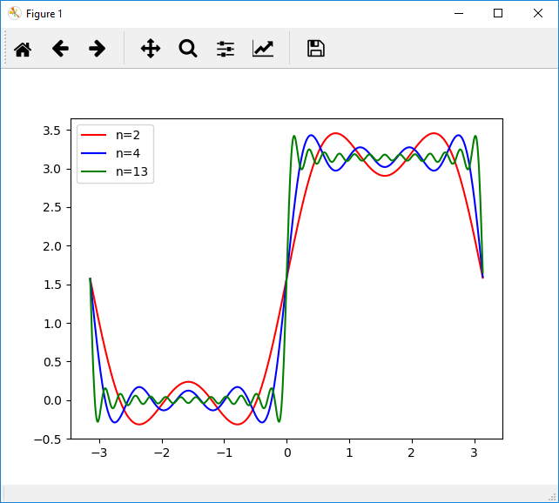****Plot the function *f(x)* in the interval ( $-π, π)$ with interval of 0.01, up to the sum of 2, 4 and 13 terms on the same plot with different colors.
2. An experiment measures and writes the penetration depth of a seed (d) every week for 15 weeks in a file called ‘seed.txt’. The results are as follows:

|  |  |  |  |  |  |  |  |  |  |  |  |  |  |  |
| --- | --- | --- | --- | --- | --- | --- | --- | --- | --- | --- | --- | --- | --- | --- |
| 8 | 20 | 31 | 42 | 55 | 65 | 77 | 88 | 95 | 97 | 89 | 72 | 68 | 53 | 44 |

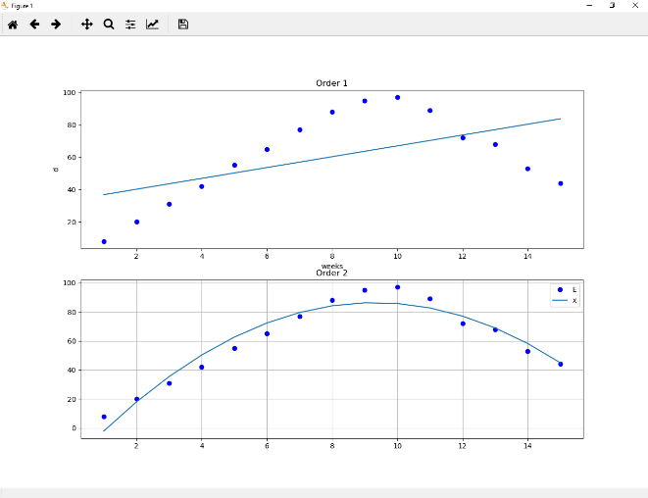Write the script that will read the above data from ‘seed.txt’ file and will compute the polynomials of curves of different orders fitting these measurements and produce plots of these different order polynomials’ curves in the format shown below in the first 2 subplots. All formatting should be arranged according to the figure below.

1. Download the classes: Location, Field, Drunk and the script Lab10A_Q3.py from Moodle. Using these classes, complete the following:
   1. Create a subclass of Drunk, EastWestDrunk. You should implement a method, takeStep(), that returns the x,y values of a random step. EastWest Drunks can only move one step to the east or west.
   2. Modify Lab10A_Q3.py to perform the following operations:
      1. Create 5 EastWestDrunks and add them to the field.
      2. Each drunk should take 10 walks of 100 steps. You should plot the location of each drunk, at the end of each walk. The final position of each drunk (for each walk) should be plotted, and the final position of each unique drunk should be plotted with a different color. For example, there are 5 drunks, so there will be 5 different colors, and for each color there will be 10 points. (Note: points may overlap, therefore the number of visible points may be less than 50).

Note: each walk of each drunk should start from the origin <0,0>

* + 1. For all walks of all drunks you should store the distance between the origin and the final location, and display the average, minimum and maximum distances.

**Sample Run:**

Average Distance:8.4

Max Distance:22.0

Min Distance:0.0

