# CS 115 - Introduction to Programming in Python

# Lab Guide 10B

**Lab Objectives:** Plotting, Experimental Data, Random Walk Simulation

1. Plot the function $f(x)$ in the interval ( $-π, π)$ with 500 equally spaced points, to the sum of 1, 3 and 13 terms on the same plot with different colors.

$$f\left(x\right)= \frac{π}{2} +\frac{1}{2}(\frac{\sin\left(2x\right)}{2}+\frac{\sin\left(4x\right)}{4}+\frac{\sin\left(6x\right)}{6}+…)$$

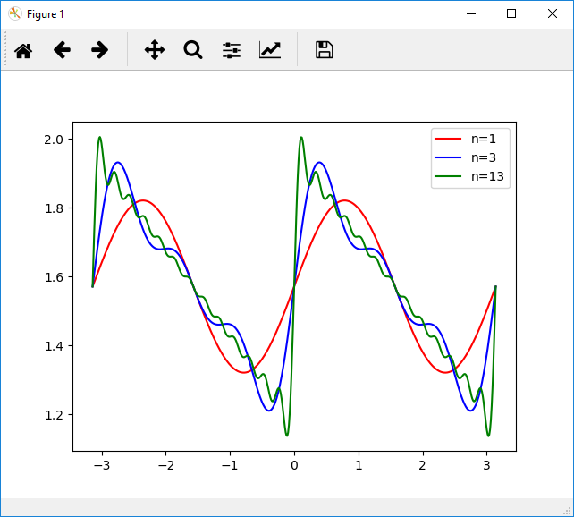

1. 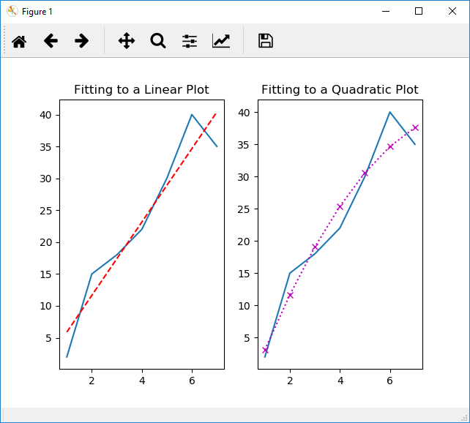 An experiment measures and writes the penetration depth of a seed (d) every day for 7 days in a file called ‘y.txt’. Write the script that will read the above data from ‘y.txt’ file and will compute the polynomials of curves of different orders fitting these measurements and produce plots of these different order polynomials’ curves in the format shown below in the first 2 subplots. All formatting should be arranged according to the figure below.
2. Download the classes: Location, Field, Drunk and the script Lab10B_Q3.py from Moodle. Using these classes, complete the following:
   1. Create a subclass of Drunk, ColdDrunk. You should implement a method, takeStep(), that returns the x,y values of a random step. ColdDrunks prefer to move south, so they may take either one step to the north, east or west, or two steps south.
   2. Modify Lab10B_Q3.py to perform the following operations:
      1. Create 7 ColdDrunks and add them to the field.
      2. Each drunk should take 5 walks of 1000 steps. You should plot the location of each drunk, at the end of each walk. The final position of each drunk (for each walk) should be plotted, and the final position of each unique drunk should be plotted with a different color. For example, there are 7 drunks, so there will be 7 different colors, and for each color there will be 5 points. (Note: points may overlap, therefore the number of visible points may be less than 35).

Note: each walk of each drunk should start from the origin <0,0>

* + 1. For all walks of all drunks you should store the distance between the origin and the final location, and display the average, minimum and maximum distances.

**Sample Run:**

Average Distance:250.2072400118781

Max Distance:334.0374230531663

Min Distance:162.15116404145854