College Survey Summary

weiran

June 20, 2016

## Sample overview

In October-November 2014, 4411 students, faculty, and staff are included in the final database of College Survey by Puget Sound Regional Council. The sample distribution among colleges are as follows.

#how many people by college in the survey  
## Bellevue.C Everett.C Green River.C Seattle.C U.W   
## 36 311 268 1254 2542

#how many trips by college in the survey  
## Bellevue.C Everett.C Green River.C Seattle.C U.W   
## 155 1317 1141 4944 11718

## Mode choice Share

Mode share of all trips in college survey and regional survey. People in college have about 3 times higher biking and walking trips, higher transit use and much lower single vehicle trips compared to the regional survey results. (mode has been grouped into newmode with less catagories)

## college survey regional survey  
## Bike 0.034 0.014  
## HOV 0.167 0.063  
## Other 0.009 0.032  
## SOV 0.271 0.721  
## Transit 0.165 0.048  
## Walk 0.355 0.123

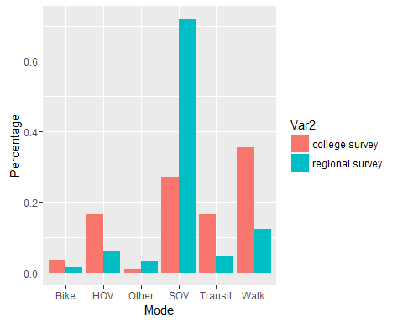

By College, UW has half of the trips are survey date are walking trips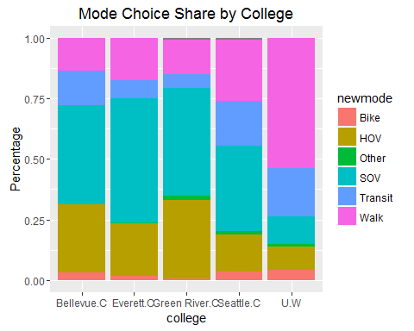

For transportation mode people chosen to commute to campus, 45% of them take transit, but student or staff from community college will drive more when travel to school.

## Bike HOV Other SOV Transit Walk   
## 0.057 0.076 0.013 0.247 0.451 0.156

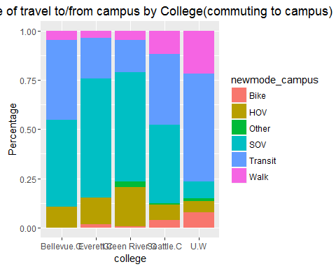

## 2.Trips per day, total and by purpose

College survey has an average 4.7 trips per day, while regional survey is 1 unit lower.

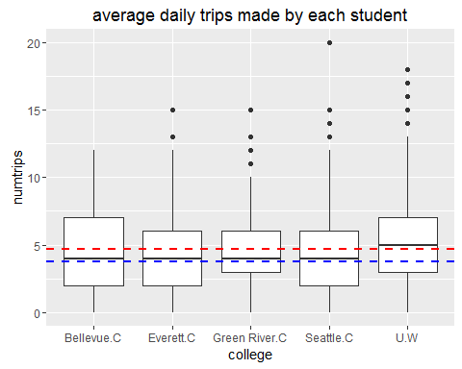

Here is the trips by destination. Looks like college people have more trips go to restaurant and less trips to, drop someone, doctor appointment or personal business. They also has less trips to recreational or social events.

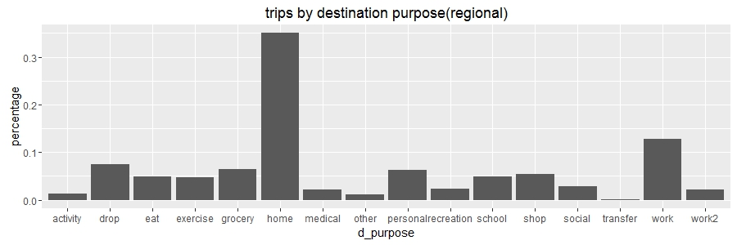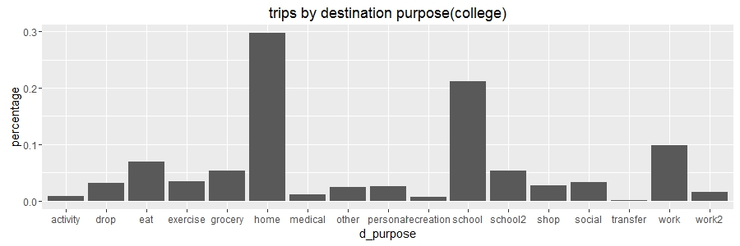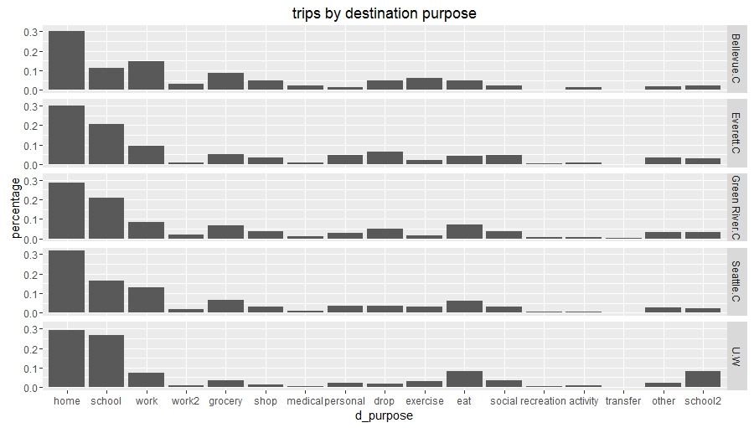

## trip length/distance summary

The average trip length/distance comparison are as follows. College people has less trip duration and much less trip distance

## trip_len_region trip_len_college  
## 1 20.603 22.796

## trip_dis trip_dis_college  
## 1 8.1 5.1

UW students and staff has much less time spent on commuting to campus due to large number of student live around campus.

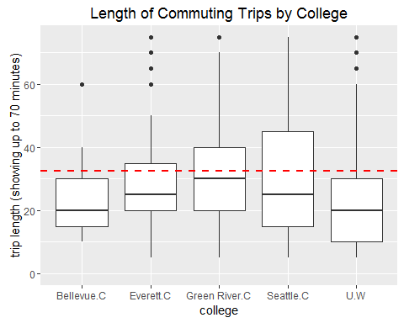

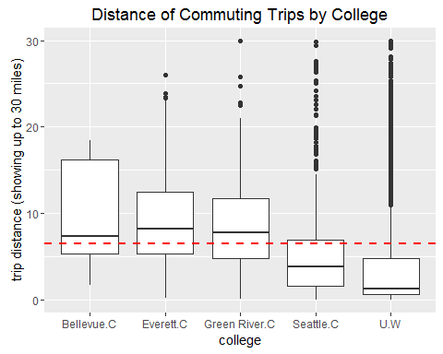

## VMT per day per person

College student has 8 times less VMT than the regional average.

## vmt vmt_college  
## 1 15.977 2.093

## walk/bike/transit frequency

Large portion of people surveyed in college use transit more than 4 times a week, and 30% of them walking everyday.

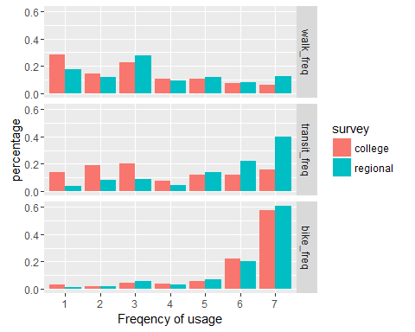

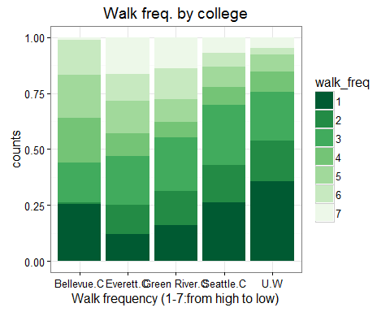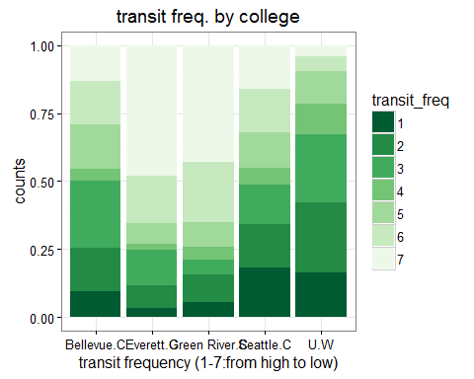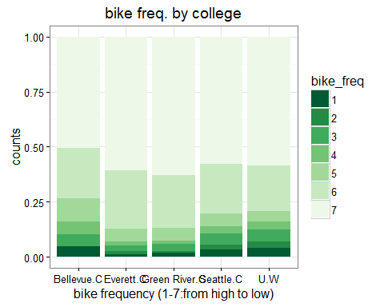

## Commute times by home location

Large number of student and staff live around UW or North Seattle.

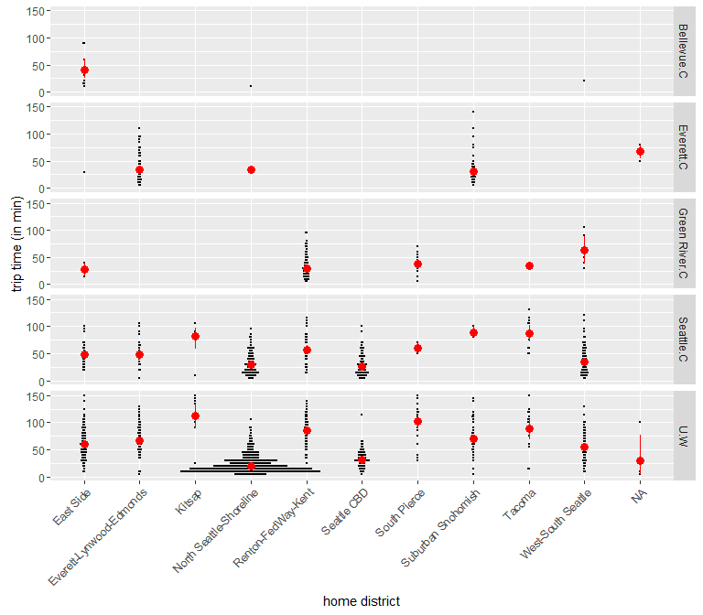

## carshare data vs. 2014 regional results

13.5% of college people has carshare membership while the regional percentage is 4.7%. Among the people has membership, lots of them are using car2go.

#college survey

## car2go zipcar relayrides other notmember  
## 0 0.927 0.956 0.998 0.992 0.135  
## 1 0.073 0.044 0.002 0.008 0.865

#regional survey in 2015

## car2go zipcar relayrides other notmember  
## 0 0.978 0.984 0.998 0.997 0.047  
## 1 0.022 0.016 0.002 0.003 0.953

## Parking pass ownership and lot usage by district or school

Compared to UW, other college people have more parking pass.

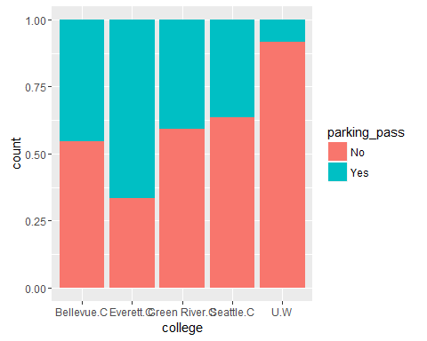

## Time of day travel distribution for different schools

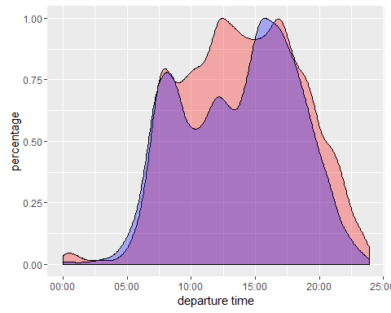

People in college did not have that rigorous commuting peak in the morning and afternoon.

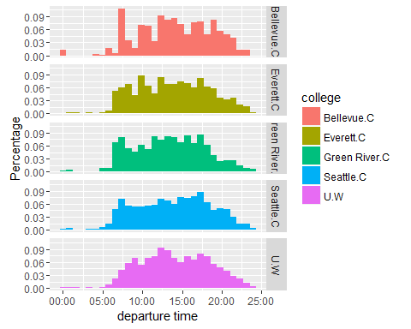

## taxi_type vs. region (regular cab vs. uber/lyft)

Colloge student and staff has most of their taxi trips carried by Uber or Lyft.

## regular uber/lyft  
## reginal 0.576 0.424  
## college 0.148 0.852