bike_ped_to_word_test

suzanne

2022-11-18

# Trends in Walking and Biking

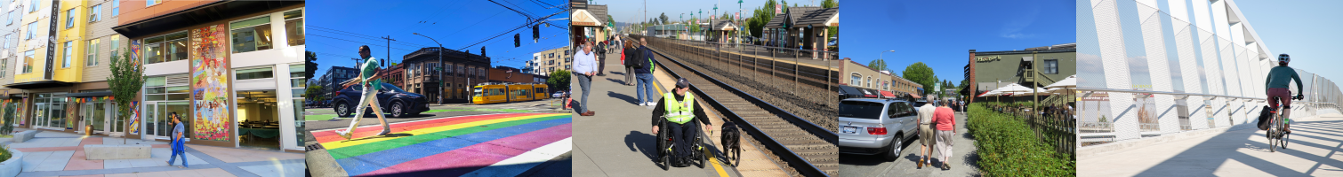

## People walked more and used transit less in 2021

