**Trends in Walking and Biking**

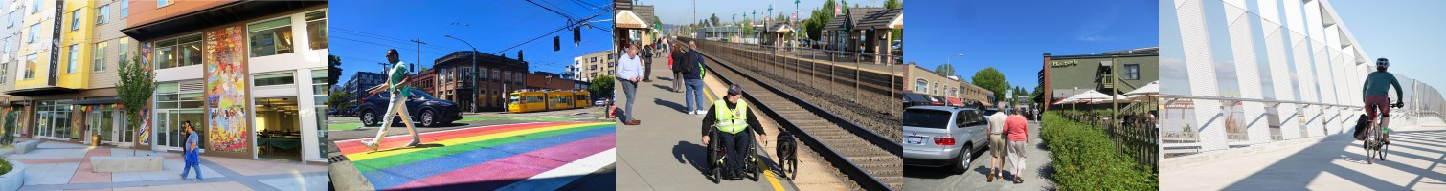

The 2021 regional travel survey collected day-to-day information from households in the central Puget Sound region: how we traveled, where we went, how long it took - even where we chose to live and whether we got home deliveries. This report compares household travel choices in 2021, during COVID-19 conditions to that in the previous years of 2017 and 2019. Learn more at the [PSRC household travel survey webpage.](https://www.psrc.org/our-work/household-travel-survey-program) You can also [view the full travel survey dataset here,](https://household-travel-survey-psregcncl.hub.arcgis.com/) including 2017, 2019, and 2021 data.

# People walked more and used transit less in 2021

In 2021, the regional walk mode share was 15% and the regional bike mode share was 1%. Compared to previous surveys, walking and biking trips increased and transit trips decreased.

The walk trip mode share was over 30% in 2021 for social, recreational, and meal trips. A greater proportion of trips was made for these purposes in 2021 when compared to 2017/2019 survey responses.

Driving remained around 80% of trips, consistent with previous years.

2017 and 2019 survey samples have been combined in this analysis to strengthen the statistical validity of the findings by increasing the number of respondents in each calculation.

|  |  |  |  |  |  |  |  |
| --- | --- | --- | --- | --- | --- | --- | --- |
|  | | | | | | |  |
|
|  | | | | | |  | |
|
|  | | | | | | | |
| |  |  | | --- | --- | |  |  | | | | | | | | | | |
|  | |  |  |  |  | | |
|  |  | |

## More Social-Recreation Trips, Less Work and School Trips

The average number of trips per day decreased modestly from 4.4 trips per person per day in 2017/2019 to 4.1 trips per person per day. The types of trips people took shifted towards social-recreation trips away from work and school.

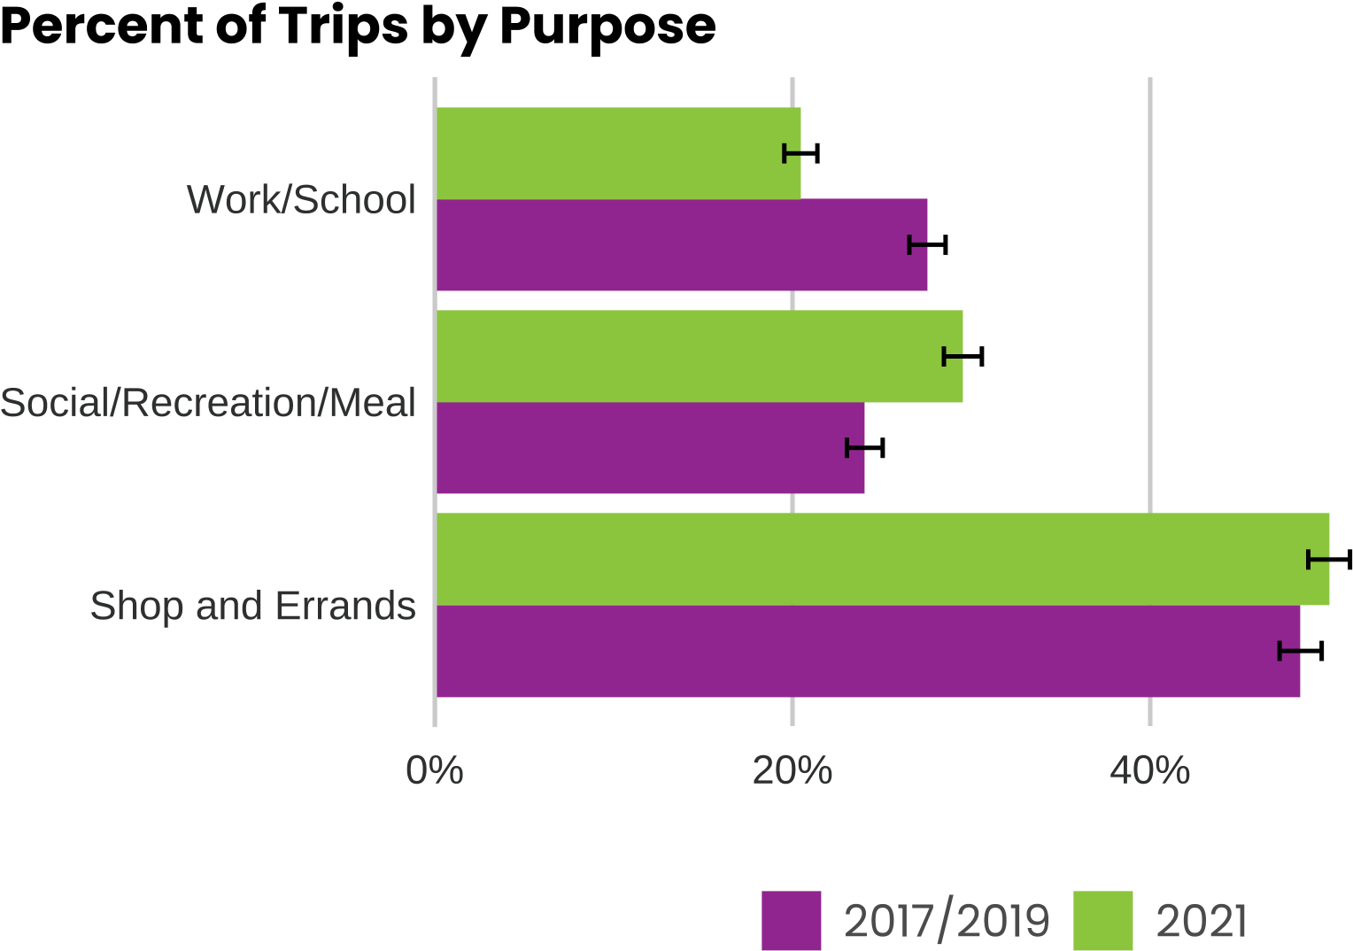

**A greater share of social-recreation trips were made by walking in 2021.**

Walking mode shares increased for social, recreation, and meal purposes but decreased for work and school purposes in 2021, as compared to 2017/2019.

In 2021, walking accounted for about one-third of social, recreation, and meal related trips up from one-fourth of these types of trips in 2017/2019.

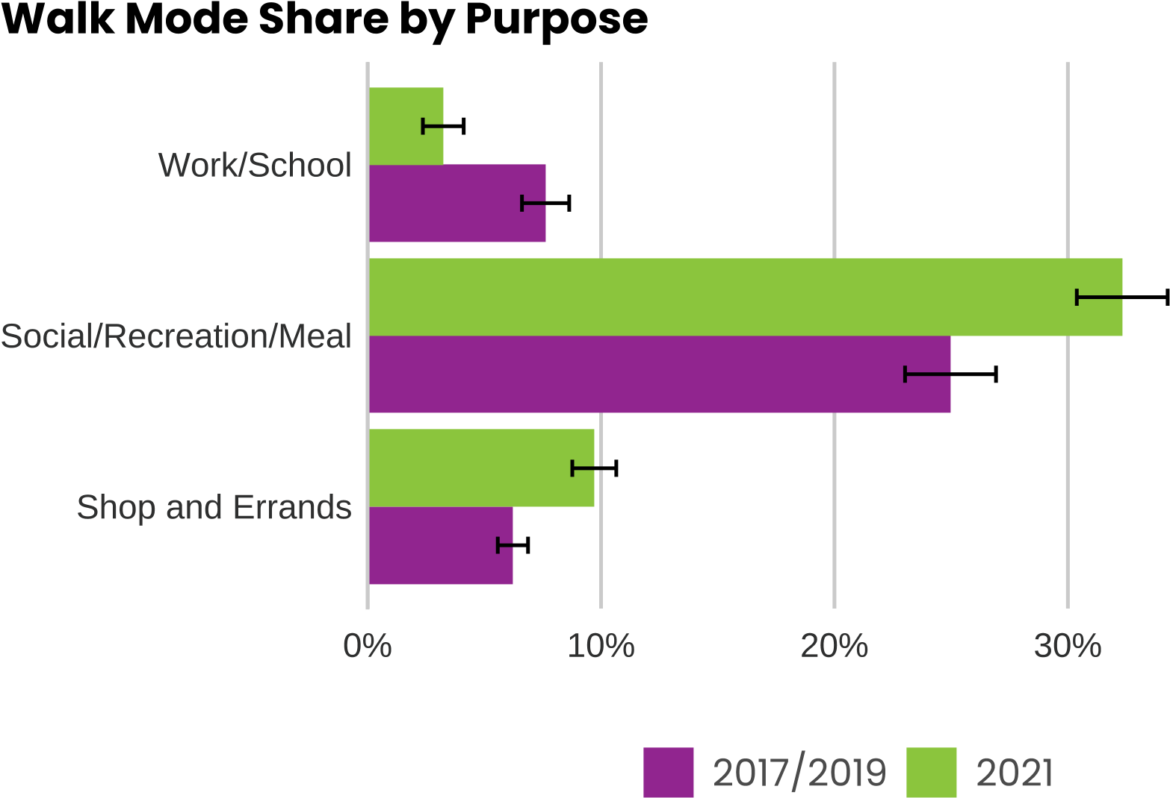

**75% of transit trips were accessed by walking.**

Approximately 75% of all transit trips were accessed by walk, jog, or wheelchair. Access by biking accounted for less than 5% of trips to transit in both years. The remaining trips are a combination of modes, including driving and parking, getting dropped off, and other.

## More people going for walks and bike rides

Most people, at around 70%, reported going for walks, even before COVID-19. During COVID-19 the share of people who reported going for walks increased about 10% to 85% of adults.

In 2021, the highest share of people reported walking 2-4 days/week, while in 2017/2019, the highest share of people reported never walking.

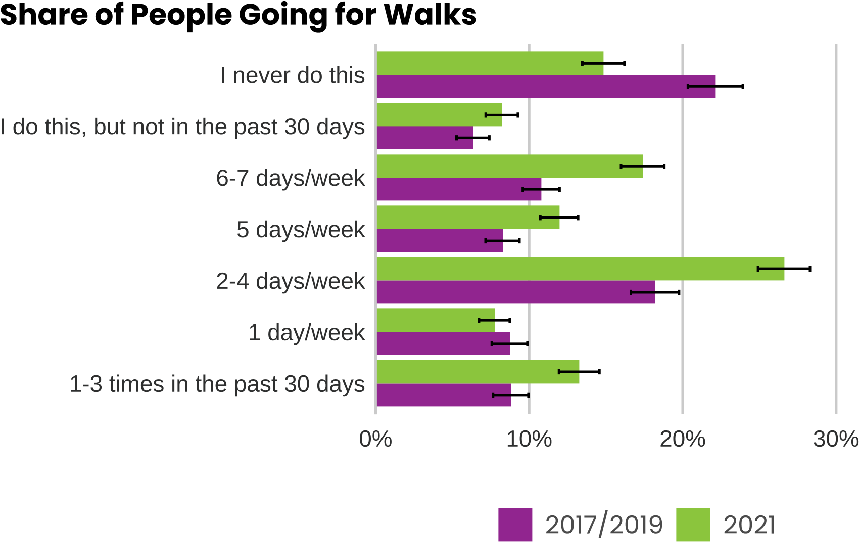

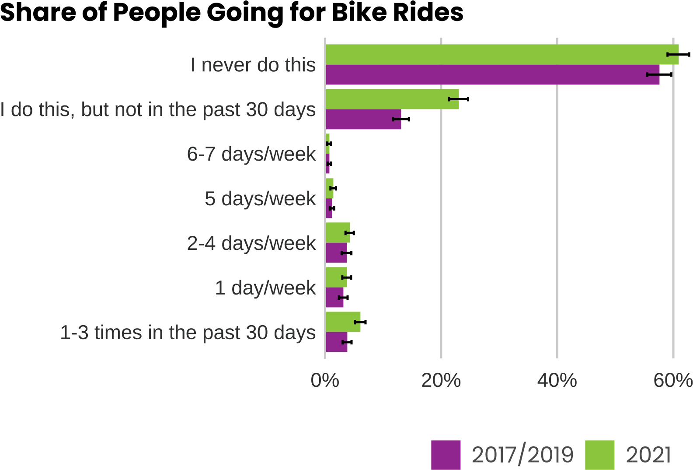

People were biking a little more frequently in 2021 than in 2017/2019. More people in the region biked sometimes, but less than monthly in 2021.

## More information

For a more detailed investigation of biking and walking by different demographics, including race and income, see [this presentation](https://www.psrc.org/media/6969) given to the Bike/Pedestrian Committee.