GALERIE DE ARTA

UNAL MELISSA

GRUPA 253

Galerie de arta

* Prezentarea modelului

Aceasta baza de date are ca scop gestionarea datelor legate de galerii de arta, operele din cadrul acestora, avand artistii aferenti, dar si de stocare a informatiilor cu privire la clienti si tranzactiile care au loc.

O galerie are un anumit numar de opere de arta fiecare facand parte dintr-un anumit curent artistic. Fiecare opera ii corespunde unui arstist, existand si mai multe opere la un singur artist. O pictura poate fi cumparata, sau nu, de catre un singur client, insa un client are posibilitatea de a cumpara mai multe opere de arta. O tranzactie poate fi realizata printr-o metoda de plata aleasa de catre cumparator.

* Diagrama entitate-relatie

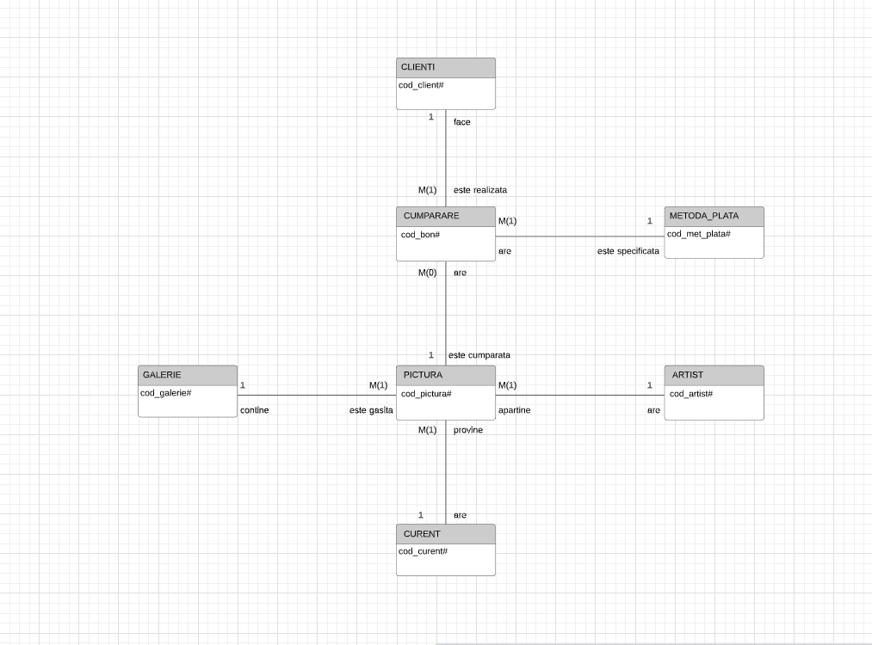

* Descrierea entitatilor, atributelor, cheilor, relatiilor si a cardinalitatilor

Tabelul PICTURA are ca si cheie primara cod_pictura, acest cod, precum toate celelalte din baza de date, fiind unic pentru fiecare opera in parte si servind ca scop determinarea operei respective. Ca si chei externe pentru acest tabel avem cod_artist ce este cheia primara din tabelul ARTIST, cod_galerie provenind din tabelul GALERIE, cod_curent ce se regaseste ca si cheie primara in tabelul CURENT, si cod_bon ce apartine tabelului CUMPARARE. Pe langa acestea, tabelul PICTURA are ca si atribute titlu, ce va stoca numele fiecarei opere in parte, si pret_vanzare reprezentand pretul la care se vinde opera respectiva.

In tabelul ARTIST, avem ca si cheie primara cod_artist, prin care poate fi gasit un anumit artist, si ca si atribute nume_artist, tara, data_nastere, data_deces care stocheaza informatiile aferente despre acestia. Relatia ARTIST-PICTURA este de one-to-many, deoarece un artist poate avea mai multe picturi, iar o pictura nu poate avea mai multi artisti.

Tabelul CURENT are ca si cheie primara cod_curent, prin care poate fi gasit fiecare curent in parte. Acest tabel mai are un atribut nume_curent, care va retine numele fiecarui curent in parte. Relatia CURENT-PICTURA este din nou de one-to-many, intrucat o pictura poate face parte dintr-un singur curent, iar dintr-un curent pot face parte mai multe opere artistice.

Tabelul GALERIE are ca si cheie primara cod_galerie care retine fiecare galerie in acest mod, iar pe langa aceasta cheie primara are si 2 atribute, respectiv nume_galerie si telefon care stocheaza datele evidente, acest tabel formand cu tabelul PICTURA o relatie one-to-many, deoarece o galerie poate avea mai multe picturi, insa o pictura nu poate fi gasita in mai multe galerii din cauza unicitatii acesteia.

CUMPARARE este un tabel ce contine ca si cheie primara cod_bon, ce retine codul tranzactiei respective, fiind facut special in functie de fiecare client. De exemplu, in cazul in care codul clientului este 420, atunci codul bonului va fi 1420, si asa mai departe. Ca si chei externe avem cod_client ce provine din tabelul CLIENTI, si cod_met_plata care retine metoda de plata prin care doreste clientul sa efectueze tranzactia, cea din urma cheie provenind din tabelul METODA_PLATA. Alte atribute din acest tabel sunt pret_cumparare, reprezentand pretul platit la momentul respectiv de catre client, si data_cumparare, fiind data la care s-a efectuat tranzactia. Relatia PICTURA-CUMPARARE este tot de one-to-many, insa aici minimul este 0, intrucat pot exista picturi care sa nu fie cumparate de niciun client.

Tabelul METODA_PLATA are ca si cheie primara cod_met_plata, fiind explicata mai sus, si un atribut nume_metoda ce retine numele fiecarei metode de plata. De asemenea, un client poate efectua mai multe tranzactii prin metode diferite.

Ultimul tabel este cel de CLIENTI, care are ca si cheie primara cod_client ce memoreaza codul clientului respectiv amintit si in exemplul de mai sus, si ca si atribute nume, prenume, numar_telefon.

* Diagrama conceptuala

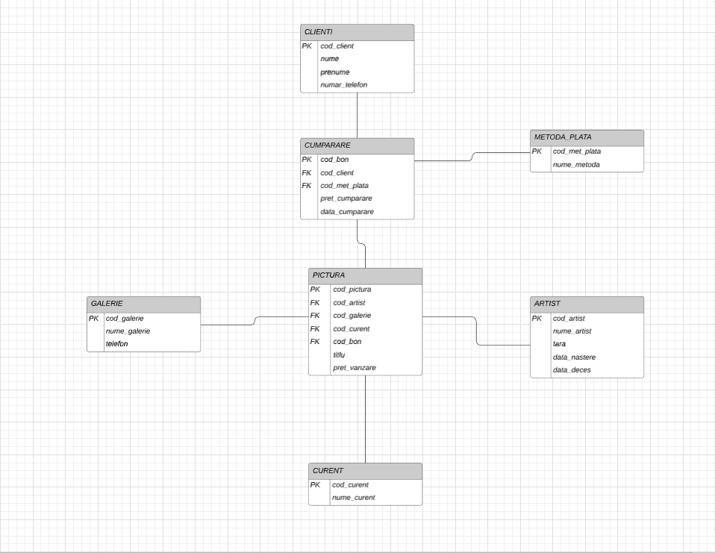

* Descrierea constrangerilor

Codurile mentionate din fiecare tabel trebuie sa fie unice, deoarece astfel se realizeaza identificarea clientului, a artistului, a operei, etc. De asemenea, informatiile clientilor nu pot fi nule, deoarece altfel nu se va mai putea face tranzactia. Fiind vorba despre niste opera de arta, livrarea acestora nu se poate face in cazul in care destinatarul este necunoscut. In plus, numarul de telefon al unei galerii trebuie sa fie unic, pentru a putea avea un mijloc de comunicare cu aceasta.

* Scheme relationale

In cazul in care o pictura este cumparata, codul acesteia va fi sters si va fi setat cu null, intrucat cod_pictura este reprezentatul unicitatii operei respective. Cod_artist va fi setat null in cazul stergerii, iar in tabelul PICTURA va fi sters cu optiunea ON DELETE CASCADE, intrucat daca nu exista un artist, nu poate exista nici operele acestuia. De asemenea, acest lucru se va intampla si la cod_curent in tabelul PICTURA, deoarece in cazul in care se va sterge un curent intreg, nu pot exista operele ce apartin de acesta.

* Crearea tabelelor

CREATE DATABASE Galerie_de_Arta;

create table GALERIE

(

cod_galerie integer,

nume_galerie varchar(30),

email char(20) unique,

constraint pk_cod_galerie primary key (cod_galerie)

);

alter table GALERIE

drop column email;

alter table GALERIE

add telefon varchar(20) unique;

create table ARTIST

(

cod_artist integer,

nume_artist varchar(50) not null,

prenume_artist varchar(15) not null,

tara varchar(30) not null,

data_nastere date not null,

data_deces date,

constraint pk_cod_artist primary key (cod_artist)

);

alter table ARTIST

drop column prenume_artist;

create table CURENT

(

cod_curent integer,

nume_curent varchar(30) unique,

constraint pk_cod_curent primary key (cod_curent)

);

create table CLIENTI

(

cod_client integer,

nume varchar(20) not null,

prenume varchar(20) not null,

numar_telefon varchar(25) unique,

constraint pk_cod_client primary key (cod_client)

);

create table METODA_PLATA

(

cod_met_plata integer,

metoda_plata varchar(15),

constraint pk_cod_met_plata primary key (cod_met_plata)

);

create table PICTURA

(

cod_pictura integer,

cod_artist integer,

cod_galerie integer,

cod_curent integer,

cod_bon integer,

constraint fk_coduri_artisti foreign key (cod_artist) references ARTIST(cod_artist)

ON DELETE CASCADE,

constraint fk_coduri_galerii foreign key (cod_galerie) references GALERIE(cod_galerie)

ON DELETE SET NULL,

constraint fk_coduri_curente foreign key (cod_curent) references CURENT(cod_curent)

ON DELETE CASCADE,

constraint fk_coduri_bonuri foreign key (cod_bon) references CUMPARARE(cod_bon)

ON DELETE CASCADE,

titlu varchar(50),

pret_vanzare decimal (13,2) constraint pret_vanzare_valid check (pret_vanzare>0),

constraint pk_cod_pictura primary key (cod_pictura)

);

create table CUMPARARE

(

cod_bon integer,

cod_client integer,

cod_met_plata int not null,

constraint fk_cod_client foreign key (cod_client) references CLIENTI(cod_client)

ON DELETE SET NULL,

constraint fk_met_plata foreign key (cod_met_plata) references METODA_PLATA(cod_met_plata),

pret_cumparare decimal (13,2) constraint pret_cumparare_valid check (pret_cumparare>0),

data_cumparare date not null,

constraint pk_cod_bon primary key (cod_bon)

);

insert into ARTIST

values(100,'Vincent Van Gogh','Tarile de Jos',str_to_date('30-03-1853','%d-%m-%Y'),str_to_date('29-07-1890','%d-%m-%Y'));

insert into ARTIST

values(101,'Pablo Picasso','Spania',str_to_date('25-10-1881','%d-%m-%Y'),str_to_date('08-04-1973','%d-%m-%Y'));

insert into ARTIST

values(102,'Leonardo da Vinci','Italia',str_to_date('15-04-1452','%d-%m-%Y'),str_to_date('02-05-1519','%d-%m-%Y'));

insert into ARTIST

values(103,'Claude Monet','Franta',str_to_date('14-11-1840','%d-%m-%Y'),str_to_date('05-12-1926','%d-%m-%Y'));

insert into ARTIST

values(104,'Rembrandt Harmenszoon van Rijn','Tarile de Jos',str_to_date('15-07-1606','%d-%m-%Y'),str_to_date('04-10-1669','%d-%m-%Y'));

insert into ARTIST

values(105,'Michelangelo Merisi','Italia',str_to_date('29-09-1571','%d-%m-%Y'),str_to_date('18-07-1610','%d-%m-%Y'));

insert into ARTIST

values(106,'Frederic Leighton','Regatul Unit',str_to_date('03-12-1830','%d-%m-%Y'),str_to_date('25-01-1896','%d-%m-%Y'));

insert into ARTIST

values(107,'Peter Paul Rubens','Tarile de Jos',str_to_date('28-06-1577','%d-%m-%Y'),str_to_date('30-05-1640','%d-%m-%Y'));

insert into ARTIST

values(108,'Gustav Klimt','Austria',str_to_date('14-07-1862','%d-%m-%Y'),str_to_date('06-02-1918','%d-%m-%Y'));

insert into ARTIST

values(109,'Edvard Muncht','Norvegia',str_to_date('12-12-1863','%d-%m-%Y'),str_to_date('23-01-1944','%d-%m-%Y'));

insert into ARTIST

values(110,'Jackson Pollock','Statele Unite ale Americii',str_to_date('28-01-1912','%d-%m-%Y'),str_to_date('11-08-1956','%d-%m-%Y'));

insert into ARTIST

values(111,'Aubrey Beardsley','Regatul Unit',str_to_date('21-08-1872','%d-%m-%Y'),str_to_date('16-03-1898','%d-%m-%Y'));

insert into ARTIST

values(112,'Piet Mondrian','Tarile de Jos',str_to_date('07-03-1872','%d-%m-%Y'),str_to_date('01-02-1944','%d-%m-%Y'));

insert into ARTIST

values(113,'David Hammons','Statele Unite ale Americii',str_to_date('24-07-1943','%d-%m-%Y'),NULL);

insert into ARTIST

values(114,'Alison Van Pelt','Statele Unite ale Americii',str_to_date('16-09-196metoda_plata3','%d-%m-%Y'),NULL);

insert into ARTIST

values(115,'Kurt Schwitters','Germania',str_to_date('20-06-1887','%d-%m-%Y'),str_to_date('08-01-1948','%d-%m-%Y'));

insert into ARTIST

values(116,'Sandro Botticelli','Franta',str_to_date('01-03-1445','%d-%m-%Y'),str_to_date('17-05-1510','%d-%m-%Y'));

insert into ARTIST

values(117,'Leon Dabo','Statele Unite ale Americii',str_to_date('09-07-1865','%d-%m-%Y'),str_to_date('07-11-1960','%d-%m-%Y'));

insert into ARTIST

values(118,'Andy Warhol','Statele Unite ale Americii',str_to_date('06-08-1928','%d-%m-%Y'),str_to_date('22-02-1987','%d-%m-%Y'));

insert into ARTIST

values(119,'Georges Seurat','Franta',str_to_date('02-12-1859','%d-%m-%Y'),str_to_date('29-03-1891','%d-%m-%Y'));

insert into ARTIST

values(120,'Jacques-Louis David','Franta',str_to_date('30-08-1748','%d-%m-%Y'),str_to_date('29-12-1825','%d-%m-%Y'));

insert into ARTIST

values(121,'Mikhail Fyodorovich Larionov','Rusia',str_to_date('03-06-1881','%d-%m-%Y'),str_to_date('10-05-1964','%d-%m-%Y'));

insert into ARTIST

values(122,'Francisco de Goya','Spania',str_to_date('30-03-1746','%d-%m-%Y'),str_to_date('16-04-1828','%d-%m-%Y'));

insert into ARTIST

values(123,'Willem de Kooning','Statele Unite ale Americii',str_to_date('24-04-1904','%d-%m-%Y'),str_to_date('19-03-1997','%d-%m-%Y'));

insert into ARTIST

values(124,'René Magritte','Belgia',str_to_date('21-11-1898','%d-%m-%Y'),str_to_date('15-08-1967','%d-%m-%Y'));

insert into ARTIST

values(125,'Edward Hopper','Statele Unite ale Americii',str_to_date('22-07-1882','%d-%m-%Y'),str_to_date('15-05-1967','%d-%m-%Y'));

insert into ARTIST

values(126,'John Cage','Statele Unite ale Americii',str_to_date('05-09-1912','%d-%m-%Y'),str_to_date('12-08-1992','%d-%m-%Y'));

insert into ARTIST

values(127,'Grant DeVolson Wood','Statele Unite ale Americii',str_to_date('13-02-1897','%d-%m-%Y'),str_to_date('12-02-1942','%d-%m-%Y'));

insert into ARTIST

values(128,'Paul Gauguin','Franta',str_to_date('07-06-1848','%d-%m-%Y'),str_to_date('09-05-1903','%d-%m-%Y'));

insert into ARTIST

values(129,'Marcel Duchamp','Franta',str_to_date('28-07-1887','%d-%m-%Y'),str_to_date('02-10-1968','%d-%m-%Y'));

insert into ARTIST

values(130,'Diego Rivera','Mexic',str_to_date('08-12-1886','%d-%m-%Y'),str_to_date('24-11-1957','%d-%m-%Y'));

insert into ARTIST

values(131,'Michelangelo Buonarroti','Italia',str_to_date('06-03-1475','%d-%m-%Y'),str_to_date('18-02-1564','%d-%m-%Y'));

insert into ARTIST

values(132,'Yves Klein','Franta',str_to_date('28-04-1928','%d-%m-%Y'),str_to_date('06-06-1962','%d-%m-%Y'));

insert into ARTIST

values(133,'Georges Braque','Franta',str_to_date('13-05-1882','%d-%m-%Y'),str_to_date('31-08-1963','%d-%m-%Y'));

insert into ARTIST

values(134,'Thomas Eakins','Franta',str_to_date('25-07-1844','%d-%m-%Y'),str_to_date('25-06-1916','%d-%m-%Y'));

insert into ARTIST

values(135,'Henri Matisse','Franta',str_to_date('31-12-1869','%d-%m-%Y'),str_to_date('03-11-1954','%d-%m-%Y'));

insert into ARTIST

values(136,'Pierre Bonnard','Franta',str_to_date('03-10-1867','%d-%m-%Y'),str_to_date('23-01-1947','%d-%m-%Y'));

insert into ARTIST

values(137,'Ferdinand Georg Waldmüller','Austria',str_to_date('15-01-1793','%d-%m-%Y'),str_to_date('23-08-1865','%d-%m-%Y'));

insert into ARTIST

values(138,'Paul Signac','Franta',str_to_date('11-11-1863','%d-%m-%Y'),str_to_date('15-08-1935','%d-%m-%Y'));

insert into ARTIST

values(139,'Edward Hicks','Statele Unite ale Americii',str_to_date('04-04-1780','%d-%m-%Y'),str_to_date('23-08-1849','%d-%m-%Y'));

insert into GALERIE

values(300,'Muzeul Luvru','+330140205104');

insert into GALERIE

values(301,'Muzeul de Arta Moderna','+3302127089400');

insert into GALERIE

values(302,'Muzeul Hermitage',' +78127109079');

insert into GALERIE

values(303,'Muzeul Tate Modern','+4402078878888');

insert into GALERIE

values(304,'Muzeul Metropolitan de Arta','+4402125357710');

insert into CLIENTI

values(400,'López','José','+34562758645');

insert into CLIENTI

values(401,'Rodríguez','Luisa','+34823465855');

insert into CLIENTI

values(402,'Ortiz','Pedro','+34777544176');

insert into CLIENTI

values(403,'Gonzales','Ricardo','+34765411203');

insert into CLIENTI

values(404,'Moreno','Bianca','+34462537757');

insert into CLIENTI

values(405,'Delgado','Fernando','+34428325435');

insert into CLIENTI

values(406,'Flores','Rodrigo','+34021350758');

insert into CLIENTI

values(407,'Salazar','Marisol','+34046340478');

insert into CLIENTI

values(408,'Medina','Manuel','+34435426857');

insert into CLIENTI

values(409,'Romero','Mirandapicturametoda_plata','+34221736522');

insert into CLIENTI

values(410,'Barrere','Marie','0690548863');

insert into CLIENTI

values(411,'Bernard','Romain','0694453522');

insert into CLIENTI

values(412,'Carrel','Theo','0692425433');

insert into CLIENTI

values(413,'Descamps','Mélanie','0693238045');

insert into CLIENTI

values(414,'Gagne','Pierre','0690412314');

insert into CLIENTI

values(415,'Gagneux','Charlotte','0692075220');

insert into CLIENTI

values(416,'Cour','Arthur','0690327896');

insert into CLIENTI

values(417,'Lefebvre','Florian','0694564290');

insert into CLIENTI

values(418,'Lafitte','Juliette','0690204979');

insert into CLIENTI

values(419,'Lenoir','Marine','0693403245');

insert into CLIENTI

values(420,'Smith','James','+15417543010');

insert into CLIENTI

values(421,'Johnson','Michael','+12642647362');

insert into CLIENTI

values(422,'Miller','Maria','+14413526998');

insert into CLIENTI

values(423,'Martinez','David','+13457562474');

insert into CLIENTI

values(424,'Wilson','Robert','+18095623745');

insert into CLIENTI

values(425,'Martin','Mary','+14735835235113');

insert into CLIENTI

values(426,'Thompson','Katherine','+17672456235893');

insert into CLIENTI

values(427,'White','Jessica','+15416294004232');

insert into CLIENTI

values(428,'Brown','Lola','+18294125934');

insert into CLIENTI

values(429,'Louis','Sam','+17674825724215');

insert into CLIENTI

values(430,'Schmidt','Maximilian','+491595558525');

insert into CLIENTI

values(431,'Schneider','Noah','+491625556257');

insert into CLIENTI

values(432,'Wagner','Sofia','+491575558240');

insert into CLIENTI

values(433,'Neumann','Hanna','+491605555606');

insert into CLIENTI

values(434,'Schwarz','Liam','+491625556089');

insert into CLIENTI

values(435,'Hoffman','Mila','+491595559437');

insert into CLIENTI

values(436,'Werner','Jacob','+491725555809');

insert into CLIENTI

values(437,'Krause','Lina','+491745559167');

insert into CLIENTI

values(438,'Meier','Mia','+491605559387');

insert into CLIENTI

values(439,'Hermann','Anton','+491595556324');

insert into METODA_PLATA

values(0,'cash');

insert into METODA_PLATA

values(1,'card');

insert into METODA_PLATA

values(2,'transfer bancar');

insert into METODA_PLATA

values(3,'rata');

insert into CURENT

values(200,'Postimpresionism');

insert into CURENT

values(201,'Cubism');

insert into CURENT

values(202,'Renastere');

insert into CURENT

values(203,'Impresionsim');

insert into CURENT

values(204,'Epoca de Aur a Olandei');

insert into CURENT

values(205,'Baroc');

insert into CURENT

values(206,'Academism');

insert into CURENT

values(207,'Baroc Flamand');

insert into CURENT

values(208,'Simbolism');

insert into CURENT

values(209,'Expresionism');

insert into CURENT

values(210,'Expresionism abstract');

insert into CURENT

values(211,'Estetism');

insert into CURENT

values(212,'De Stijl');

insert into CURENT

values(213,'Postmodernism');

insert into CURENT

values(214,'Hiperrealism');

insert into CURENT

values(215,'Dadaism');

insert into CURENT

values(216,'Renasterea veche');

insert into CURENT

values(217,'Tonalism');

insert into CURENT

values(218,'Pop Art');

insert into CURENT

values(219,'Neoimpresionism');

insert into CURENT

values(220,'Neoclasicism');

insert into CURENT

values(221,'Suprematism');

insert into CURENT

values(222,'Romantism');

insert into CURENT

values(223,'Abstractia gestuala');

insert into CURENT

values(224,'Suprarealism');

insert into CURENT

values(225,'Neorealism');

insert into CURENT

values(226,'Fluxus');

insert into CURENT

values(227,'Regionalism');

insert into CURENT

values(228,'Primitivism');

insert into CURENT

values(229,'Arta Conceptuala');

insert into CURENT

values(230,'Muralism Mexican');

insert into CURENT

values(231,'Inalta Renastere');

insert into CURENT

values(232,'Cinetism');

insert into CURENT

values(233,'Fauvism');

insert into CURENT

values(234,'Realism');

insert into CURENT

values(235,'Divizionism');

insert into CURENT

values(236,'Les Nabis');

insert into CURENT

values(237,'Biedermeier');

insert into CURENT

values(238,'Pointilism');

insert into CURENT

values(239,'Arta naiva');

insert into PICTURA

values(500,100,302,200,1400,'The Starry Night',1450000000);

insert into PICTURA

values(501,101,300,201,1400,'Guernica',110000000);

insert into PICTURA

values(502,102,304,202,NULL,'Mona Lisa',2670000000);

insert into PICTURA

values(503,103,300,203,NULL,'La Promenade',6500000);

insert into PICTURA

values(504,104,301,204,NULL,'The Night Watch',110000);

insert into PICTURA

values(505,105,303,205,NULL,'Supper at Emmaus',40000);

insert into PICTURA

values(506,106,300,206,NULL,'Lachrymae',50000);

insert into PICTURA

values(507,107,300,207,1405,'The Elevation of the Cross',650000);

insert into PICTURA

values(508,108,303,208,NULL,'The Kiss',800000);

insert into PICTURA

values(509,109,304,209,NULL,'Anxiety',770000);

insert into PICTURA

values(510,110,300,210,NULL,'Autumn Rhythm',860000);

insert into PICTURA

values(511,111,303,211,NULL,'The Peacock Skirt',700000);

insert into PICTURA

values(512,112,304,212,NULL,'Gray Tree',425000);

insert into PICTURA

values(513,113,302,213,1409,'Too Onvious',225000);

insert into PICTURA

values(514,114,301,214,1409,'Silver Horse',97000);

insert into PICTURA

values(515,115,300,215,1414,'Relief in relief',200000);

insert into PICTURA

values(516,116,300,216,1436,'The Birth of Venus',310000);

insert into PICTURA

values(517,117,301,217,1432,'The Seashore',400000);

insert into PICTURA

values(518,118,304,218,NULL,'Triple Elvis',550000);

insert into PICTURA

values(519,119,302,219,1418,'Circus Sideshow',120000);

insert into PICTURA

values(520,120,300,220,1403,'The Death of Marat',340000);

insert into PICTURA

values(521,121,303,221,1419,'Soldier on a Horse',120000);

insert into PICTURA

values(522,122,304,222,1400,'Saturno devorando a su hijo',130000);

insert into PICTURA

values(523,123,300,223,1428,'Woman I',170000);

insert into PICTURA

values(524,124,302,224,1402,'The Lovers',367000);

insert into PICTURA

values(525,125,301,225,1408,'Chop Suey',401000);

insert into PICTURA

values(526,126,300,226,1411,'The Missing Stone',18150);

insert into PICTURA

values(527,127,300,227,1429,'Daughters of Revolution',10850);

insert into PICTURA

values(528,128,304,228,1411,'The Yellow Christ',104560);

insert into PICTURA

values(529,129,300,229,1437,'Duchamp',234000);

insert into PICTURA

values(530,130,300,230,1433,'The Flower Carrier',500150);

insert into PICTURA

values(531,131,304,231,1434,'David',595000);

insert into PICTURA

values(532,132,301,232,1431,'Blue Monochrome',161045);

insert into PICTURA

values(533,133,300,233,1406,'Bottle and Fishes',120170);

insert into PICTURA

values(534,134,304,234,1404,'The Agnew Clinic',90900);

insert into PICTURA

values(535,135,303,235,1406,'The Snail',89500);

insert into PICTURA

values(536,136,301,236,1425,'The Bowl of Milk',100455);

insert into PICTURA

values(537,137,302,237,1413,'Time of roses',79900);

insert into PICTURA

values(538,138,304,238,NULL,'Women at the Well',86900);

insert into PICTURA

values(539,139,301,239,1424,'Peaceable Kingdom',78500);

insert into PICTURA

values(540,100,301,200,1427,'The Potato Eaters',89000000);

insert into PICTURA

values(541,100,303,200,NULL,'The Yellow House',78900000);

insert into PICTURA

values(542,101,304,201,NULL,'The Weeping Woman',110000000);

insert into PICTURA

values(543,102,300,202,NULL,'The Last Supper',23300000);

insert into PICTURA

values(544,102,302,202,NULL,'Salvator Mundi',450000000);

insert into PICTURA

values(545,103,300,203,1401,'Impression, soleil levant',32000000);

insert into PICTURA

values(546,104,301,204,NULL,'The Jewish Bride',450000);

insert into PICTURA

values(547,104,304,204,1426,'Hundrer Guilder Print',78000);

insert into PICTURA

values(548,105,303,205,1423,'The Cardsharps',3201500);

insert into PICTURA

values(549,105,300,205,1412,'Bacchus',12150000);

insert into PICTURA

values(550,106,301,206,1401,'The Bath of Psyche',870150);

insert into PICTURA

values(551,106,302,206,NULL,'Cymon and Iphigenia',782000);

insert into PICTURA

values(552,107,302,207,1439,'Samson and Delilah',450780);

insert into PICTURA

values(553,108,301,208,NULL,'Judith and Holofernes',650126);

insert into PICTURA

values(554,109,304,209,NULL,'The Dance of Life',130530);

insert into PICTURA

values(555,109,304,209,NULL,'Vampire',230000);

insert into PICTURA

values(556,110,304,210,NULL,'Blue Poles',110560);

insert into PICTURA

values(557,112,302,212,1438,'Broadway Boogie-Woogie',98560);

insert into PICTURA

values(558,112,303,212,NULL,'Tableau I',114520);

insert into PICTURA

values(559,112,301,212,NULL,'Victory Boogie Woogie',235000);

insert into PICTURA

values(560,116,302,216,1406,'Portrait of a Young Woman',980150);

insert into PICTURA

values(561,116,301,216,NULL,'Madonna of the Book',689000);

insert into PICTURA

values(562,120,300,220,1418,'The death of Socrates',1100000);

insert into PICTURA

values(563,120,300,220,NULL,'The Intervention of the Sabine Women',230560);

insert into PICTURA

values(564,121,301,221,1415,'Dancing Soldiers',785000);

insert into PICTURA

values(565,122,302,222,1418,'The Sleep of Reason Produces Monsters',210500);

insert into PICTURA

values(566,125,304,225,NULL,'Nighthawks',98150);

insert into PICTURA

values(567,127,303,227,1420,'American Gothic',110150);

insert into PICTURA

values(568,127,302,227,1407,'Spring in Town',300000);

insert into PICTURA

values(569,128,304,228,1430,'Ave Maria',575000);

insert into PICTURA

values(570,128,304,228,1405,'By the Sea',365000);

insert into PICTURA

values(571,130,300,230,1401,'Pan American Unity',89450);

insert into PICTURA

values(572,130,303,230,1415,'Agrarian Leader Zapata',235150);

insert into PICTURA

values(573,131,302,231,NULL,'Moses',1500000);

insert into PICTURA

values(574,131,301,231,1435,'Pieta',985000);

insert into PICTURA

values(575,131,301,231,NULL,'Deposition',205000);

insert into PICTURA

values(576,132,302,232,1417,'Fire Painting',565150);

insert into PICTURA

values(577,132,300,232,1422,'Blue Venus',320120);

insert into PICTURA

values(578,133,300,233,1410,'Fruit Dish and Glass',540150);

insert into PICTURA

values(579,133,304,233,NULL,'Glass on a Table',460000);

insert into PICTURA

values(580,134,304,234,1411,'Arcadia',256900);

insert into PICTURA

values(581,136,302,236,1402,'The Garden Steps',390400);

insert into PICTURA

values(582,136,303,236,1401,'Dining Room on the Garden',623150);

insert into PICTURA

values(583,137,300,237,1421,'The Birthday Table',452500);

insert into PICTURA

values(584,138,301,238,1416,'Port of La Rochelle',670400);

insert into CUMPARARE

values('1400',400,3,3866045000,str_to_date('12-05-2018','%d-%m-%Y'));

insert into CUMPARARE

values('1401',401,2,67738300,str_to_date('17-04-2017','%d-%m-%Y'));

insert into CUMPARARE

values('1402',402,1,1347400,str_to_date('30-03-2019','%d-%m-%Y'));

insert into CUMPARARE

values('1403',403,1,740000,str_to_date('02-04-2020','%d-%m-%Y'));

insert into CUMPARARE

values('1404',404,1,170900,str_to_date('06-12-2015','%d-%m-%Y'));

insert into CUMPARARE

values('1405',405,0,10775000,str_to_date('14-01-2013','%d-%m-%Y'));

insert into CUMPARARE

values('1406',406,2,1974820,str_to_date('02-01-2020','%d-%m-%Y'));

insert into CUMPARARE

values('1407',407,1,980000,str_to_date('19-12-2019','%d-%m-%Y'));

insert into CUMPARARE

values('1408',408,3,507000,str_to_date('04-08-2012','%d-%m-%Y'));

insert into CUMPARARE

values('1409',409,2,674000,str_to_date('25-05-2017','%d-%m-%Y'));

insert into CUMPARARE

values('1410',410,2,899150,str_to_date('14-12-2018','%d-%m-%Y'));

insert into CUMPARARE

values('1411',411,2,778610,str_to_date('23-10-2017','%d-%m-%Y'));

insert into CUMPARARE

values('1412',412,1,25350000,str_to_date('11-09-2016','%d-%m-%Y'));

insert into CUMPARARE

values('1413',413,0,152900,str_to_date('17-07-2019','%d-%m-%Y'));

insert into CUMPARARE

values('1414',414,3,900000,str_to_date('19-04-2009','%d-%m-%Y'));

insert into CUMPARARE

values('1415',415,3,1981150,str_to_date('20-03-2019','%d-%m-%Y'));

insert into CUMPARARE

values('1416',416,2,890400,str_to_date('21-07-2017','%d-%m-%Y'));

insert into CUMPARARE

values('1417',417,2,1200150,str_to_date('08-07-2015','%d-%m-%Y'));

insert into CUMPARARE

values('1418',418,2,2015500,str_to_date('21-01-2014','%d-%m-%Y'));

insert into CUMPARARE

values('1419',419,1,1355000,str_to_date('11-11-2010','%d-%m-%Y'));

insert into CUMPARARE

values('1420',420,0,10915150,str_to_date('01-10-2017','%d-%m-%Y'));

insert into CUMPARARE

values('1421',421,0,985500,str_to_date('08-01-2020','%d-%m-%Y'));

insert into CUMPARARE

values('1422',422,3,785120,str_to_date('24-12-2019','%d-%m-%Y'));

insert into CUMPARARE

values('1423',423,3,382770060,str_to_date('28-11-2018','%d-%m-%Y'));

insert into CUMPARARE

values('1424',424,1,150500,str_to_date('11-04-2016','%d-%m-%Y'));

insert into CUMPARARE

values('1425',425,2,270455,str_to_date('01-04-2017','%d-%m-%Y'));

insert into CUMPARARE

values('1426',426,0,155000,str_to_date('07-06-2017','%d-%m-%Y'));

insert into CUMPARARE

values('1427',427,3,268000000,str_to_date('06-03-2012','%d-%m-%Y'));

insert into CUMPARARE

values('1428',428,3,2370000,str_to_date('14-11-2011','%d-%m-%Y'));

insert into CUMPARARE

values('1429',429,0,59850,str_to_date('03-02-2009','%d-%m-%Y'));

insert into CUMPARARE

values('1430',430,1,874000,str_to_date('05-07-2017','%d-%m-%Y'));

insert into CUMPARARE

values('1431',431,3,1739046,str_to_date('25-05-2011','%d-%m-%Y'));

insert into CUMPARARE

values('1432',432,2,900000,str_to_date('17-04-2008','%d-%m-%Y'));

insert into CUMPARARE

values('1433',433,2,855150,str_to_date('23-08-2009','%d-%m-%Y'));

insert into CUMPARARE

values('1434',434,3,47038560,str_to_date('11-09-2018','%d-%m-%Y'));

insert into CUMPARARE

values('1435',435,2,1785000,str_to_date('13-04-2010','%d-%m-%Y'));

insert into CUMPARARE

values('1436',436,1,974000,str_to_date('14-04-2017','%d-%m-%Y'));

insert into CUMPARARE

values('1437',437,2,1034000,str_to_date('30-11-2014','%d-%m-%Y'));

insert into CUMPARARE

values('1438',438,3,201560,str_to_date('24-11-2012','%d-%m-%Y'));

insert into CUMPARARE

values('1439',439,0,1808780,str_to_date('15-01-2009','%d-%m-%Y'));