- Download this vs extension:
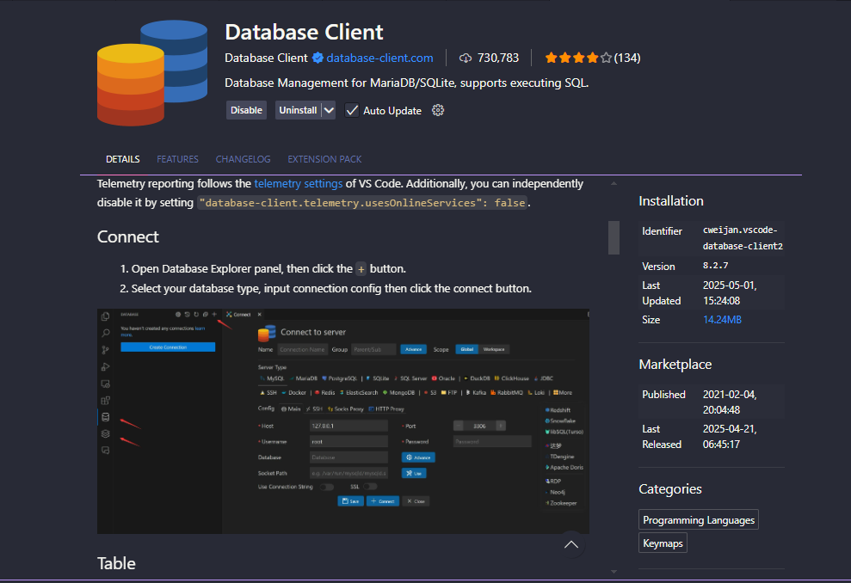
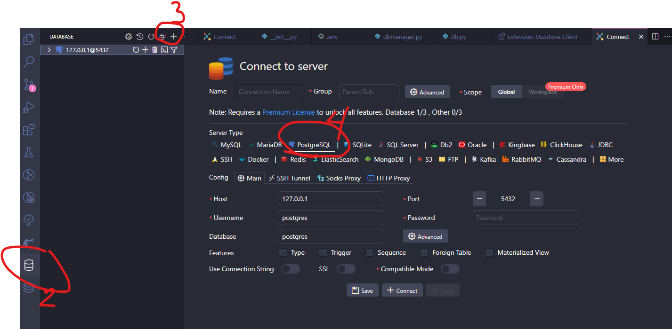
change Username (if you changed it, but postgres is the default)
-Database if there is a specific database you want
In my case I put it in AddressApp_demo. postgres would be the default
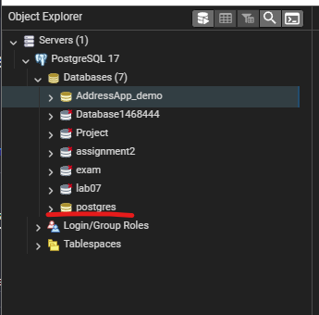

Before running flask debug
On the vs terminal, need to set up:
$ set DBUSER=postgres
$ set DBPWD=your_password
$ set DBNAME= postgres(or if you changed database)
$ set DBHOST=localhost
$ set DBPORT=5432

