Lab 3

Melissa Ly, Sawandeep Kaur, Alan Chen

A11908353, A11601962, A12045305

To connect the modules, we began by declaring variables for every wire that would connect between modules. Then, we instantiated each module and assigned their inputs and outputs to the variables declared.

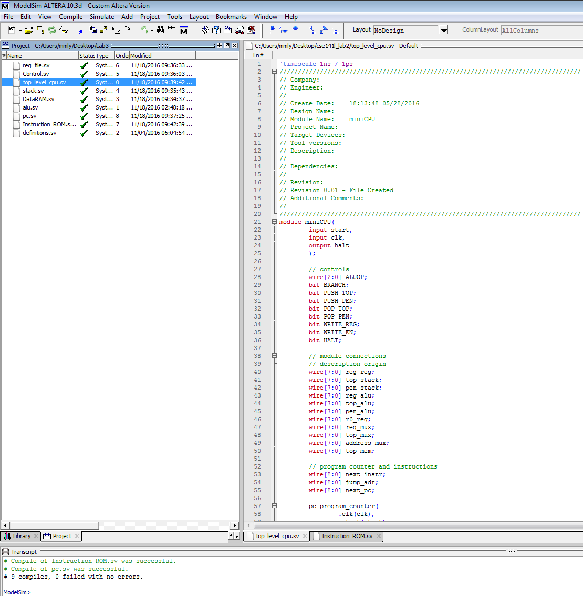

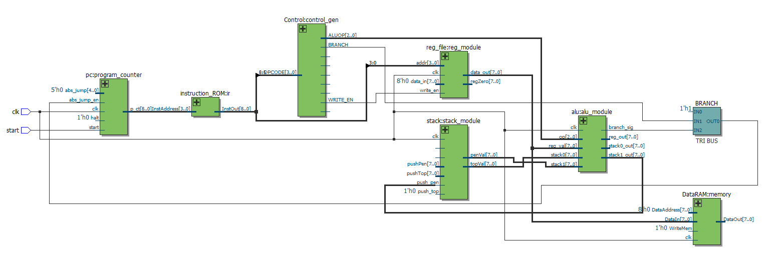

**Assembly Code:**

**Multiplier:**

push_immediate 0

set r1 // i = 0

set r2 // lowSumAB = 0

set r3 // upperSumAB = 0

set r4 // sumLowerLowerABC = 0

set r5 // sumUpperLowerABC = 0

set r6 // sumUpperABC = 0

set_memory_ptr 1 // push A onto stack

set_memory_ptr 2 // push B onto stack

// ----------------------------------------------------------------------------------------------------------------

A*B: // B is on the top of the stack, with A right below it

and_and_shift r1 // sum = A[i] & B; push sum >> 8-1, push sum << i

push r2

add r2// sumLowerAB = sum << i + r2; pop sum<<i and r2 and set overflow

add_overflow r3// if sumLower += results in overflow, add it and sum >> 8-i to upper sum, pop

inc r1 // i++

// check for branch

push r1

push_immediate 7

// state of the stack: 7, i, B, A, 0

blt A*B // branch to beginning of loop unless i > 7 (i == 8)

// -------------------------------------------------------------------------------------------------------------------

push 0

set r1 // i = 0

set_memory_ptr 3 // push C onto stack

push r2 // push the lower bits of A*B onto stack

// current state of the stack: lowerAB, C, 0

// there are more, but we'll forget about them for now because there are no requirements for memory leaks

// -----------------------------------------------------------------------------------------------------------------

lowerAB*C: // same routine as before

and_and_shift r1 // sum = lowerAB[i] & C; push sum >> 8-1, push sum << i

push r4

add r4// sumLowerLowerABC = sum << i + r4; pop sum<<i and r4 and set overflow

add_overflow r5 // if sumUpLowABC += results in overflow, add it and sum >> 8-i to upper sum, and pops

inc r1 // i++

// check for branch

push r1

push_immediate 7

// state of the stack: 7, i, C, lowerAB, 0

blt lowerAB*C // branch to beginning of loop unless i > 7 (i == 8)

// --------------------------------------------------------------------------------------------------------------------

push 0

set r1 // i = 0

set_memory_ptr 3 // push C back onto stack instead of popping; fewer instructions and less chance

//for mistakes

push r3 // push the upper bits of A*B onto stack

// current state of the stack: upperAB, C, 0

// -------------------------------------------------------------------------------------------------------------------------

upperAB*C: // same routine as before

and_and_shift r1 // sum = upperAB[i] & C; push sum >> 8-1, push sum << i

push r6

add r6// sumLowerLowerABC = sum << i + r6; pop sum<<i and set overflow

// don't care about the rest because it's overflow

inc r1 // i++

// check for branch

push r1

push_immediate 7

// state of the stack: 7, i, B, A, 0

blt upperAB*C // branch to beginning of loop unless i > 7 (i == 8)

// r7 will be the upper bits in location 4

push r5

push r6

add r7 // r7 = r5 + r6, or upper + upperLower

// r4 will remain the lower bits

set_memory_ptr 4 // move r0 to 4

store r7 // stores r7 into [r0]

set_memory_ptr 5

store r4 // stores r4 into [r0]

**Machine Code**

0101_00000

0100_00001

0100_00010

0100_00011

0100_00100

0100_00101

0100_00110

0000_00000

0000_00001

1001_00001

0010_00010

0011_00010

1010_00011

1000_00001

0010_00001

0101_00111

0111_00000

0010_00000

0100_00001

0000_00010

0010_00010

1001_00001

0010_00100

0011_00100

1010_00101

1000_00001

0010_00001

0101_00111

0111_00001

0010_00000

0100_00001

0000_00010

0010_00011

1001_00001

0010_00110

0011_00110

1000_00001

0010_00001

0101_00111

0111_00010

0010_00101

0010_00110

0011_00111

0000_00011

0001_00111

0000_00100

0001_00100

**String Match**

push_immediate 0

set r1 //bit index

push_immediate 0

set r2 //number of matches in the array of strings

//push_immediate 32

push_immediate 0

set r3 // i = 0

set_memory_ptr 6 // 4-bit string

set_memory_ptr 32 //arr[0]

set_memory_ptr 64 //array length

push r3

loop:

pop 2

contains next

inc r2

next:

set_memory_ptr 6

set_memory_ptr 32

inc r0

set_memory_ptr 64 //array length

inc r3

push r3

blt loop

set_memory_ptr 7

store r4

**Machine Code**

0101_00000

0100_00001

0101_00000

0100_00010

0101_00000

0100_00011

0000_00101

0000_01001

0000_01010

0010_00011

0110_00010

1011_00100

1000_00010

0000_00101

0000_01001

1000_00000

0000_01010

1000_00011

0010_00011

0111_00011

0000_00110

0001_00100

**Closest Pair**

set_memory_ptr 255

set r1 //r1 = closest

push_immediate 0

set r2 //r2 = i

push_immediate 1

set r3 //r3 = 1

push_immediate 19

set r4 //r4 = 19 = arr.length - 1

push_immediate 20

set r5 //r5 = 20 = arr.length

set_memory_ptr 128

set r6 //r6 = a[0]

outerloop:

push r3

push r2

//branch if i < 1, so that if i = 0 the memory pointer is not incremented since it is already at 128 and //a[0] is at 128

blt incj

//set the memory pointer to the right location by incrementing the pointer until it reaches index i so //that it is at a[i]

set_memory_ptr 128 //reset memory pointer location to a[0]

push_immediate 0

set r7 // r7 = 0 (counter)

incarray:

inc r0 //increment memory location to the appropriate location by looping

set r6 //until r7 = r2(counter = i)

inc r7

push r2

push r7

blt incarray //branch if r7 < r2 (counter < i )

incj:

push r2

push r3

add r8 //r8 = i + 1 = j

//loop through the array subtracting a[j] from a[i] and if it is less than the value stored in r1 (closest) //set r1 to this difference, continue looping while j < array length

innerloop:

push r6 //r6 = a[i]

inc r0 //r0 = a[j]

sub r9 //r9 = a[j] - a[i]

abs r9 //r9 = abs(a[j] - a[i])

push r1 //r1 = closest

blt endinner //branch if r1 < r9 (closest < abs(a[j] - a[i]))

push r9

set r1 //set r1 to r9 (closest = abs(a[j] - a[i])

endinner:

push r5

inc r8 //j++

push r8

blt innerloop //branch if r8 < r4 (j < 20)

//increment i and continue looping through the array if it is less than array length - 1 since the last //element in the array will already have been compared to the rest of the elements

push r4

inc r2 //i++

push r2

blt outerloop //branch if r2 < r4 ( i < 19)

//put the calculated closest distance into memory location 127

set_memory_ptr 127 //sets memory pointer to 127

store r1 //stores r1 to location 127 (r1 = closest)

**Machine Code**

0000_01101

0100_00001

0101_00000

0100_00010

0101_00001

0100_00011

0101_10011

0100_00100

0101_10100

0100_00101

0000_01100

0100_00110

0010_00011

0010_00010

0111_00101

0000_01100

0101_00000

0100_00111

1000_00000

0100_00110

1000_00111

0010_00010

0010_00111

0111_00110

0010_00010

0010_00011

0011_01000

0010_00110

1000_00000

1100_01001

1101_01001

0010_00001

0111_00111

0010_01001

0100_00001

0010_00101

1000_01000

0010_01000

0111_01000

0010_00100

1000_00010

0010_00010

0111_01001

0000_01011

0001_00001