**CHAPTER III  
  
  
METHODOLOGY**

This chapter contains the project design, project development, and operation and testing procedure.

**Project Design** The project design is meant to describe the representation of the developed system in terms of its flow, entities, and existing relationship. Discussed below are the Data Flow Diagram, Visual Table of Contents, and Entity Relationship Diagram.

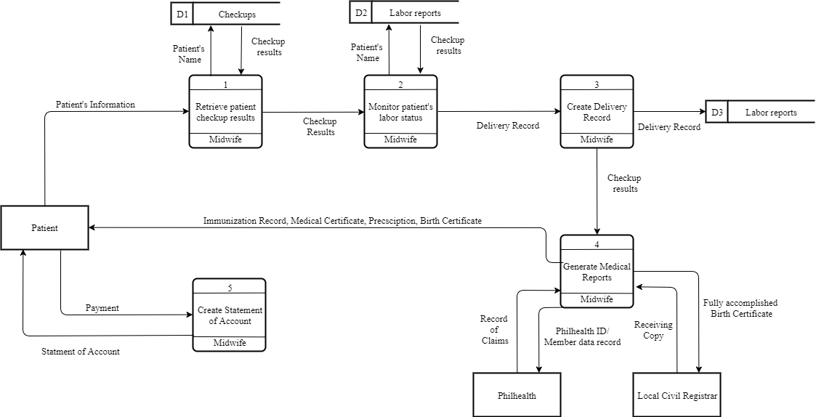

***Figure1***. *Context Level Diagram*

Figure 1 presents the context level diagram of the existing system of Jewel’s First Maternity Clinic. Patient’s records are sent to the manual pen-and-paper system and it will be stored in a file cabinet. Laboratory samples are sent in an external entity and it will receive the laboratory result. PhilHealth and Local Civil Registrar receive data about the pregnant and infant patients.

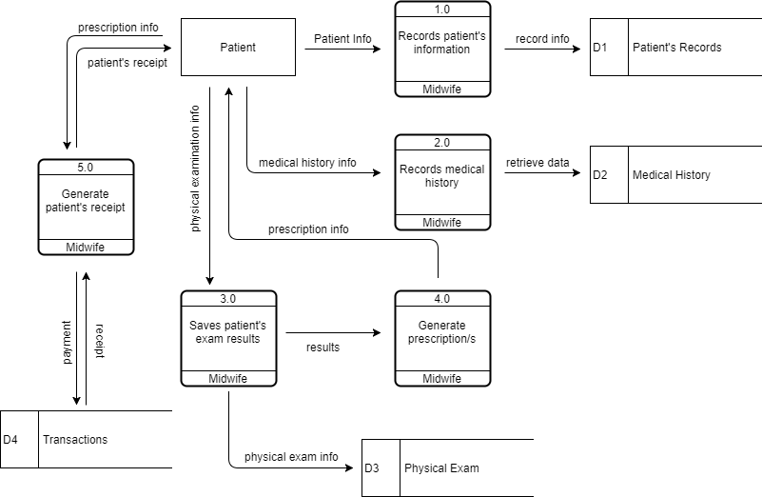

***Figure2.*** *Prenatal checkup process*

Figure 2 shows the prenatal process of old and new patients. New patients will undergo profiling before recording the medical history, physical examination, and to be followed by the prescription and receipt from the clinic. Additionally, the patients will pay the checkup fee.

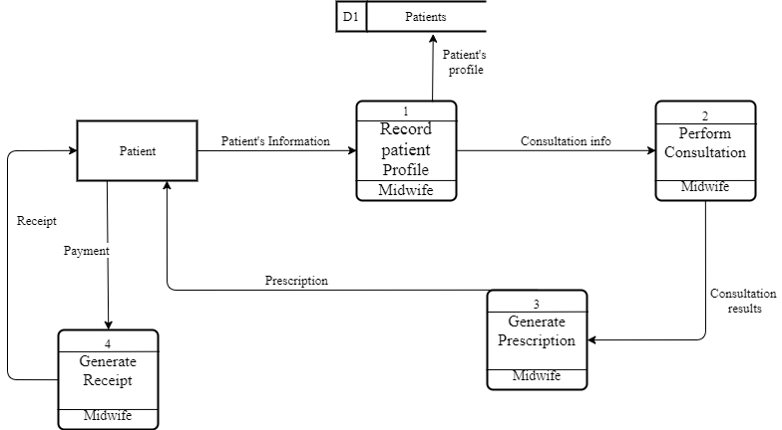

***Figure3.*** *Consultation process*

Figure 3 shows the process of the infant during the consultation process. Clinic’s midwife will retrieve the data of patient in their medical records. After checking patient’s info, consultation process performs. Before generating prescription for patient, consultation results are needed because of data dependency. After receiving the prescription given by the clinic, patent will undergo payment-receipt process.

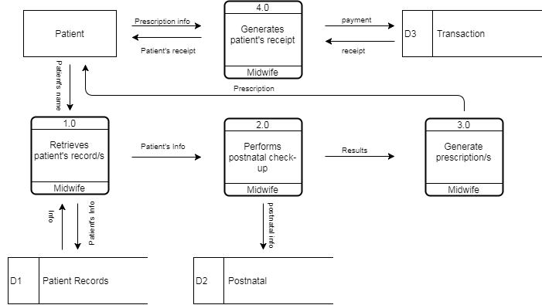

***Figure4.*** *Postnatal Process*

At the end of the quarter of being pregnant the next process is postnatal. Patient’s record will be checked again, if the data exist, midwife will perform postnatal check-up to the patient. Before generating prescriptions, check-up results are needed because of data dependency. Patient receives the prescription and payment-receipt process happens.



***Figure5.*** *Childbirth Process*

After getting pregnant, childbirth process occurs. First again, patient’s record will be retrieve by midwife in their medical records, next, midwife will perform monitoring on patient’s labor status. Delivery record will be created depends on patient’s labor status. Clinic’s midwife will receive check-up results of their patient and medical reports will be generated. Immunization record, medical record, prescription and birth certificate of patient’s child will be given to clinic’s patient.

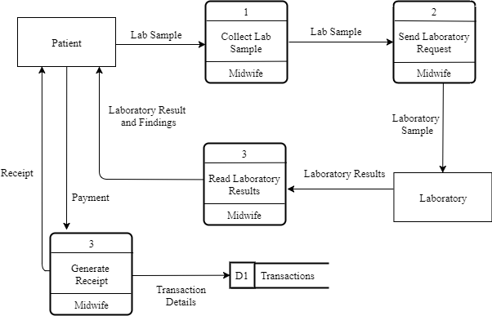

***Figure6.*** *Laboratory request process*

Laboratory request process is a clinical process wherein the patient will undergo some experiments, getting blood platelets and blood pressure. Midwife will collect the patient’s lab sample and will send laboratory request. After examining patient’s lab sample, laboratory will produce results and clinic’s midwife will present it to their patient. Payment-receipt process will be happen after receiving laboratory results.

**Project Development**  
 For the project development, the researchers have decided to use the waterfall method from the System Development Life Cycle (SDLC). Figure 8 shows the detailed flowchart of waterfall method.

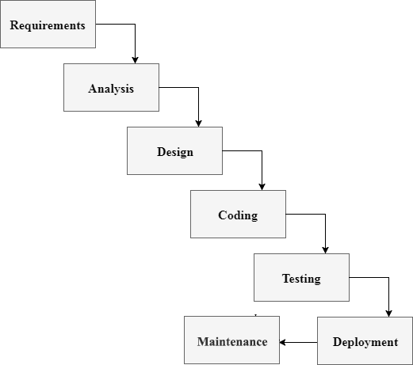

***Figure7.*** *Flowchart for the project development*

1. *Requirements*

Gathering data from a client in development process would actually help the system to reach its desired functionality. Therefore, every system development comes to this, data requirements. In this phase, every data required are gathered as functional and non-functional requirements. It is important because of system’s modules dependency to its client’s information. This will be the basis of input and output process of the system. In clinic patient’s management, data are gathered as planned in order to manipulate the modules inside the system. As the data are given for system’s module as follows; patient record management system, clinic item monitoring system, scheduling system, online appointment, billing system and report generator for medical records , prenatal and postnatal check-up results.

*2. Analysis*

Analysis is detailed examination of the elements or structure of something, typically as a basis for discussion or interpretation. Most of organizations use business process automation to improve workflow and end-to-end business process. This type of strategy begins with an actual analysis of a “physical process” or manual process inside the organization in which the services are done or given. As a dependent phase, it will rely on what is present and dramatically improve the processes by proposing some improvements in order to provide satisfying services. A new technology alone is not enough to say that it is a project success but also endorsing the improvements of business processes inside the organization in such a way that users trust the system and find it easy enough to use. As related in systems analysis, clients will give information about their manual processes and eventually offers automation corresponds to their concern. This will help to provide such services in order to reach their goals in a way that technology is involved.

*3. Design*

In this phase the system and software design is prepared from the requirements specifications which is studied and gathered in the first phase. The system design specifications serve as input for the next phase of the model. In every system development this phase is important because of its functionality and usefulness in creating a system. Data flow diagram (DFD) is a type of business process in which the data is flowing. Inside of it are high level diagram and low level diagram. These processes are shown inside the DFD in where the data gathered are designed as data flows. With relying on client’s data, database designs are created. Database are consisting of multiple of tables wherein the input and output process began. Also, the tables are the container of input data. Without it, the data flow and database design will actually crash.

*4.Coding* In this phase as receiving the system design documents, the work of dividing it into modules and actual coding is started. Since, in this phase the code is produced so it is the main focus for the developer. This is actually the longest phase of software development cycle. Coding phase is actually the creation of the system itself with a dependency in system designs and information. If the design is performed in detailed and organized manner, code generation can be accomplished without much hassle. Every organization has way in using programming languages in order to develop a system. The programming language is chosen with respect to the type of software being developed.

*5. Testing*

In this phase the testing of the developed system happens. Quality assurance is important in order to give a feedback to a developer on which and where the errors occurs. Also, in this phase the communication between the Quality Assurance and Developer becomes more compact because of the improvement of the system that they’re working on. Testing a developed system before it is getting deployed is important in an organization because it is showing the needed improvements before the deployment phase.

*6. Deployment*

The deployment phase is the moment that the system is get tested and ready to be deployed. User Acceptance Testing (UAT) is talking about the deployment of the system in an organization wherein the improvements and debugging are still occurring because of the users’ suggestions and needs. These suggestions are reported directly into the developer team in order to update all the necessary concerns that the user are concern for. After the *beta testing* the actual deployment of the developed system in the market will happens after all the needed and mandatory testing are done.

*7. Maintenance*

Making sure that the application/software is up and running in the respective environment is talking about maintenance. Maintenance is the last phase wherein the system are already deployed and then the actual problems comes up and need to be solved from time to time. Every organization must still have a communication to their client in order to solve each problems and any other concern in their product. This process where the care is taken for the developed product is known as maintenance.

**Use Case Diagram**

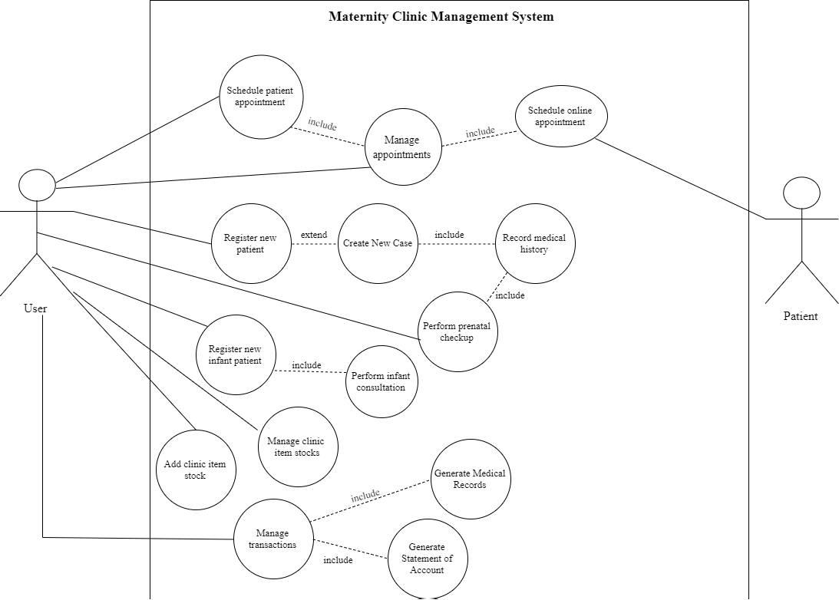

***Figure8.*** *Use Case diagram of the proposed system*

**Database  
 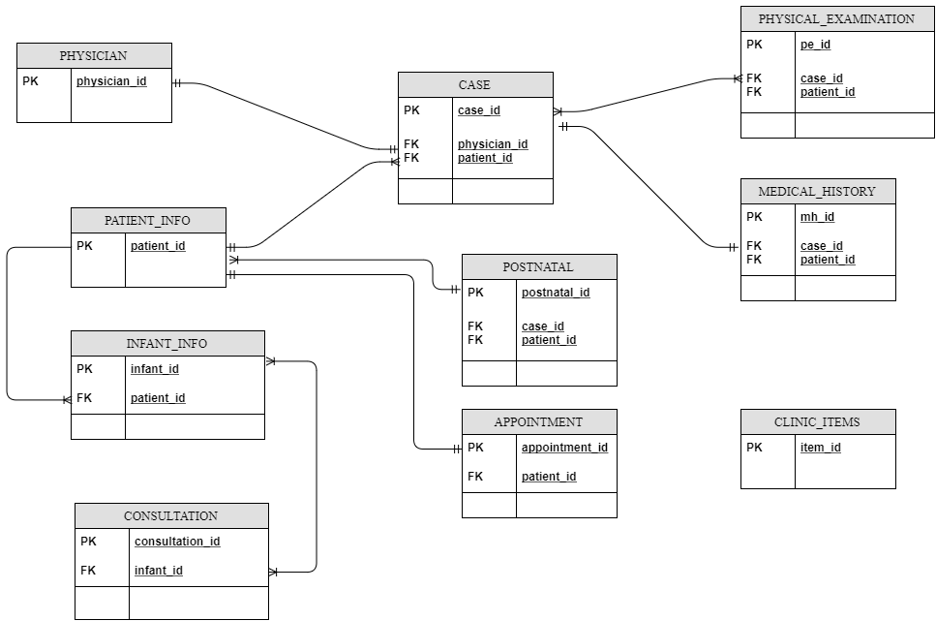**

***Figure9.*** *Entity Relationship Diagram of the proposed system*

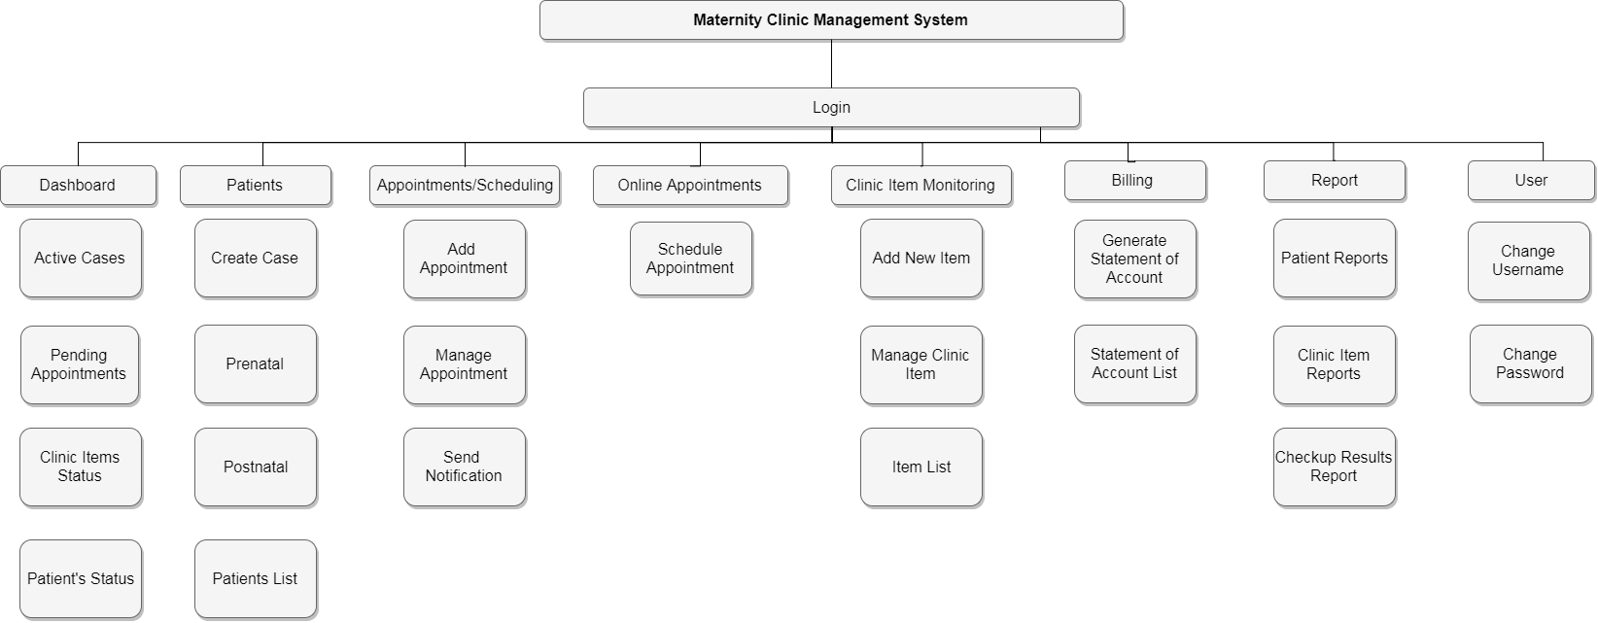**Virtual Table of Contents**  The Virtual Table of Contents (VTOC) represents the hierarchy of data. Figure 2 shows the menus and submenus of Maternity Clinic Management System. Each menu consists of the system’s modules and the submenus consist of the activity in the system.

***Figure10.*** *Virtual Table of Contents of the Proposed System*

**Operation and Testing Procedure** For the operation and testing of the system, the following steps will be conducted by the researchers.

**Table 1***Testing Procedures*

|  |  |  |
| --- | --- | --- |
| Modules | Steps Undertaken | Expected Results |
| Patient record management module | 1. Click “Add New Case”  2. Select “New Patient”  3. Populate required fields for profiling  4. Submit form and proceed to Medical History  5. Populate required fields for Medical History  6. Submit form and proceed to Physical Examination  7. Submit form | An alert message will prompt “New Case Added!” |
| Patient profiles module | 1. Click “Patients” in the navigation bar  2. Search patient’s name in the search bar  3. Click “View Profile” | The system will show the patient’s information, her timeline about the patient’s maternal case, and settings for the profile. |
| Scheduling module | 1. Click “Schedule” in the navigation bar  2. Click “Add new schedule” button  3. populate the required fields  4. select the available time and date  5. submit the form | An alert message will prompt: “New appointment added!” and the appointments in calendar will be updated. |
| Online appointment module | 1. Click “Schedule an appointment” button in the website  2. Populate the required fields  3. Select available time and date  4. Enter the Verification Code that will be sent through SMS  5. Enter the verification code in the text box | An alert message will prompt: “You have now schedule an appointment. Thank you!” |
| Medical report module | 1. Click “Reports” in the navigation bar  2. Search the name of the patient and click “Create medical report” button  3. A modal will appear and click “Prenatal checkup results” button | Check the downloaded .pdf file in the downloads bar of the browser. |
|  |  |  |

Table 1 shows the series of procedures taken during the testing procedure. Each module of the system undergo through a series of steps.