PCC Budget History Analysis

Melissa Anderson

2024-07-24

only_salary_long %>%  
 group_by(classification, year) %>%  
 summarize(mean_salary = mean(salary, na.rm = TRUE))%>%  
 kable()

## `summarise()` has grouped output by 'classification'. You can override using  
## the `.groups` argument.

| classification | year | mean_salary |
| --- | --- | --- |
| Salary_Doctorate_Max | 2017 | 115879.97 |
| Salary_Doctorate_Max | 2018 | 119738.74 |
| Salary_Doctorate_Max | 2019 | 123217.67 |
| Salary_Doctorate_Max | 2020 | 124761.71 |
| Salary_Doctorate_Max | 2021 | 129366.03 |
| Salary_Doctorate_Max | 2022 | 136467.85 |
| Salary_Doctorate_Max | 2023 | 146656.26 |
| Salary_MA30_10_11 | 2017 | 87454.62 |
| Salary_MA30_10_11 | 2018 | 90153.01 |
| Salary_MA30_10_11 | 2019 | 92752.94 |
| Salary_MA30_10_11 | 2020 | 94026.75 |
| Salary_MA30_10_11 | 2021 | 97438.76 |
| Salary_MA30_10_11 | 2022 | 103046.68 |
| Salary_MA30_10_11 | 2023 | 110384.07 |
| Salary_MA60_20_21 | 2017 | 107343.83 |
| Salary_MA60_20_21 | 2018 | 110669.19 |
| Salary_MA60_20_21 | 2019 | 113685.68 |
| Salary_MA60_20_21 | 2020 | 115163.29 |
| Salary_MA60_20_21 | 2021 | 119374.97 |
| Salary_MA60_20_21 | 2022 | 126035.46 |
| Salary_MA60_20_21 | 2023 | 135415.25 |
| Salary_MA_0_1 | 2017 | 58253.50 |
| Salary_MA_0_1 | 2018 | 60109.14 |
| Salary_MA_0_1 | 2019 | 61922.85 |
| Salary_MA_0_1 | 2020 | 62815.81 |
| Salary_MA_0_1 | 2021 | 65159.69 |
| Salary_MA_0_1 | 2022 | 69048.74 |
| Salary_MA_0_1 | 2023 | 73841.68 |
| Salary_MA_5_6 | 2017 | 70193.22 |
| Salary_MA_5_6 | 2018 | 72310.88 |
| Salary_MA_5_6 | 2019 | 74465.88 |
| Salary_MA_5_6 | 2020 | 75518.56 |
| Salary_MA_5_6 | 2021 | 78300.50 |
| Salary_MA_5_6 | 2022 | 83008.49 |
| Salary_MA_5_6 | 2023 | 88746.79 |

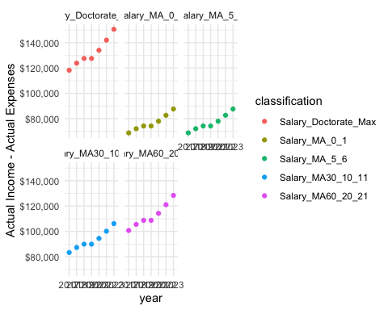

#Import and organize Budget Data  
budget_differential <- budget_data %>%  
 mutate(Actual_Cost_minus_expenses = `Actual Total Income`- `Actual Total Expenses`,  
 Budget_Cost_minus_expenses = `Budget Total Income`- `Budget Total Expenses`)  
  
budget_clean <- pivot_longer(data = budget_differential,   
 cols = 'Actual Total Income':'Budget_Cost_minus_expenses',  
 names_to = "Category",  
 values_to = "Amount")  
  
actual_differential <- budget_clean %>%   
 filter(Category %in% c("Actual_Cost_minus_expenses"))  
  
  
actual_differential <- actual_differential%>% filter(!is.na(Amount))

## The District’s Income Has Significantly Exceeded Its Expenses Since 2015

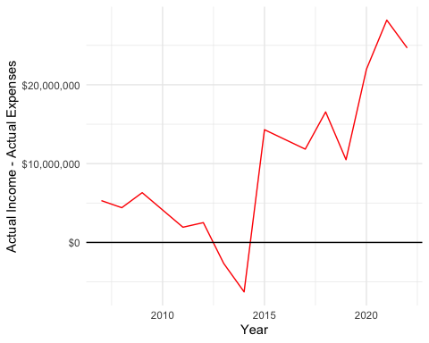

**Figure 1:** Difference between the Total Actual Income and the Total Actual Expenses from 2007 to 2024. *Source:* [*https://pasadena.edu/business-administrative-services/fiscal-services/budget-forecast-analysis.php*](https://pasadena.edu/business-administrative-services/fiscal-services/budget-forecast-analysis.php)