PRODUCT REQUIREMENTS DOCUMENT
TenderMind
Company Memory & Tender Intelligence Platform · v2.0 — aligned to UI prototype
Owner | Tendermind team | Due | Today, 3:00 PM
For | Hackathon engineering team | Bidder / demo company | Northstar
Design ref. | TenderMind clickable prototype (this session) | Fixture tender | EBTSL 7187-EBTSL-0001

1. What We're Building & Why
TenderMind is built around one durable asset — Company Memory: a provenance-tracked, continuously-updated knowledge base of Northstar's own capabilities, certifications, insurance, commercial rules and past submissions. Every tender uploaded is analyzed against that memory, not against a blank slate, producing a cited Bid / No-Bid / Conditional recommendation, a requirement-by-requirement gap check, a contract risk register, a live pricing model, and drafted questionnaire answers — each traceable back to an exact source document and page.
What changed from v1.0
The team has since built a full clickable prototype (uploaded this session). This revision replaces the earlier generic 4-agent framing with the product exactly as designed: Company Memory as the persistent core, and a per-tender workspace with 8 tabs. Scope is now split per your instruction — Company Memory and Tender Upload/Analysis are real, AI-backed builds; Marketing site and Settings & Integrations are static/mock for the hackathon.

2. Scope — Build Tiers

Tier 1 — Real, AI-backed (hackathon must-build)
- Company Memory: document ingestion → fact extraction with provenance → contradiction detection → coverage scoring. This is the foundation every other screen reads from.
- Tender Upload & Analysis: New Tender intake → orchestrated multi-agent analysis against Company Memory → populates the Bid Pipeline list and every tab in the per-tender workspace (Overview, Requirements, Risk, Commercial, Contract, Response, Decision, Sources).

Tier 2 — Static / mock (hackathon: UI only, no backend logic)
- Marketing site (Landing, Pricing, Signup) — presentational only; no real payment or account creation needed.
- Settings & Integrations — SharePoint/Google Drive connectors, approval-rule config, SSO and audit-log panels render as static UI; no live sync or auth backend required.
- Team page — treated as a static roster for the demo (flagged as an assumption in Section 8 — say if it needs real assignment logic).
Everything below is organized the same way, so engineering can see at a glance what needs real logic versus what needs to look right.

3. Screen Inventory
Area | Screen | Tier | Purpose
Marketing | Landing / Pricing / Signup | 2 · Static | Public-facing site
Workspace | Overview | 1 · Dynamic | Cross-tender summary dashboard
Workspace | Company Memory | 1 · Dynamic | Northstar's knowledge base — profile facts, commercial rules, memory health
Tenders | Bid Pipeline | 1 · Dynamic | List of live tenders with value, win prob., margin, risk, decision, owner
Tenders | Commercial / Legal / Sources (rollups) | 1 · Dynamic | Cross-tender views of the same tabs found inside each tender
Tender workspace | Overview · Requirements · Risk · Commercial · Contract · Response · Decision · Sources | 1 · Dynamic | 8-tab per-tender analysis — see Section 6.2
Drawers | Add to Company Memory · New Tender · Fact provenance | 1 · Dynamic | The two upload flows plus the cross-cutting citation panel
Org | Team & approvals | 2 · Static (assumption) | Seat roster and approval routing
Org | Settings & integrations | 2 · Static | Document sources, approval rules, data & security

4. Architecture
The pipeline sketched by the team (Figure 1) still holds — it now maps onto the prototype's screens as follows. Company Memory generalizes the earlier “bid history / bidder qualification” input into a persistent, document-fed, cross-tender store that every agent reads from on every run.
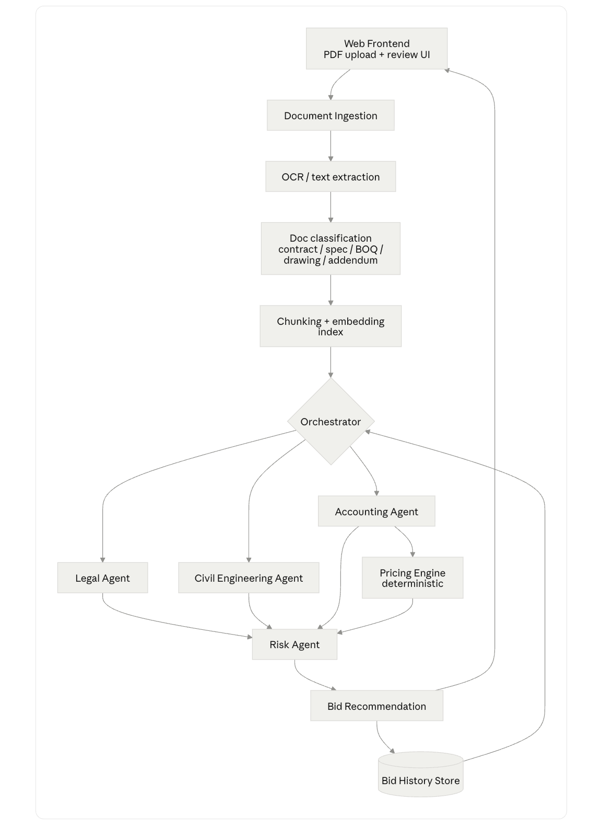
Figure 1 — original pipeline sketch, now mapped to product screens below
Pipeline component | Product surface it powers
Document Ingestion → OCR → Classification → Chunk/Embed | Shared by both upload flows: Add-to-Memory drawer and New-Tender drawer
Orchestrator | “Analyze against Company Memory” action in the New Tender drawer
Legal Agent | Contract tab (clause viewer + AI commentary + redlines) and legal-origin entries in Risk
Civil Engineering Agent | Requirements tab (scope/technical asks vs. Northstar capability) and Overview scope narrative
Accounting Agent + Pricing Engine | Commercial tab — True Cost model, adjustable assumptions, scenario save/compare
Risk Agent | Risk tab (Contract Risk Register) and the risk-exposure tile on Overview
Bid Recommendation | Decision tab — recommendation, confidence score, conditions checklist, multi-party approval chain
Bid History Store | Generalizes into Company Memory (capability/commercial facts) plus a comparable-submissions store that drives win-probability on Bid Pipeline
— new in this revision — | Response Agent: drafts questionnaire answers from Company Memory; withholds rather than fabricates when evidence is missing
— new in this revision — | Fact Provenance: cross-cutting — every fact/rule/drafted sentence anywhere in the product opens to its exact source doc + quote + location
— new in this revision — | Ingestion Diff Engine: on each Company Memory upload, classifies new vs. updated vs. contradictory facts; contradictions are surfaced, never silently merged

5. Reference Fixtures
Two fixtures are available; pick one before Phase 1 starts so effort isn't split (see Section 8, Q3).
Fixture |  | Source | Best for
EBTSL 7187-EBTSL-0001 — Salaya marine terminal EPC tender |  | Real documents you supplied (Annexures A/B/D/F, Note.docx) | Proving extraction accuracy against real, messy source documents
Network Rail — Southern Region Maintenance Framework, £42M |  | Bundled demo data already inside the prototype (612pp RFP, Commercial_Schedule.xlsx, T&Cs) | Live demo — the UI already renders this end-to-end with realistic numbers
EBTSL target output (unchanged from v1.0)
CONDITIONAL BID — financial criteria met standalone; technical/experience criterion not met but closeable via JV/consortium (tender permits it); LD capped at 10%, security+retention lock up to 15% of contract value. Recommend pursuing, contingent on securing a qualifying JV partner before 07 Sep 2026.

6. Functional Requirements
MoSCoW-prioritized. Tier 1 sections (6.1–6.2) are the hackathon's real engineering effort. Tier 2 (6.3) is explicitly scoped down — build the pixels, skip the backend.

6.1 Company Memory
ID | Requirement | Pri
FR-1 | Ingest documents by drag-and-drop upload (PDF/DOCX/XLSX/PPTX/CSV). SharePoint/Drive connector buttons and “Paste text” may be UI stubs. | Must
FR-2 | User tags each upload with a document type from a fixed taxonomy (e.g. Legal/contract, Commercial policy, Certification, Insurance) before ingest. | Must
FR-3 | Extract structured profile facts (operating regions, core services, capacity, margin floor, insurance limits, certifications) — each with a source count and click-through provenance. | Must
FR-4 | Extract commercial rules (min. margin, preferred/max payment terms, mobilization allowance, contingency rate, legal-review liability threshold) as machine-usable values applied automatically to every tender. | Must
FR-5 | On each ingest, classify every affected fact as new, updated, or contradictory versus current memory; show counts (e.g. “31 new · 6 updated · 2 contradictions”). | Must
FR-6 | Contradictions are surfaced with both conflicting values and their sources side by side; user picks a resolution (e.g. “use newer policy”) — never auto-merged or averaged. | Must
FR-7 | Compute overall memory coverage % and per-category coverage (Contracting, Pricing, Operational, Compliance, Cybersecurity); list missing-information gaps in plain language. | Must
FR-8 | Onboarding checklist (N of 6 steps complete) to guide first-time memory building; dismissible/re-openable. | Should
FR-9 | Fact provenance panel: clicking any fact or rule anywhere in the product opens its exact source document(s), the quoted passage, and page/section location. | Must

6.2 Tender Upload & Analysis
ID | Requirement | Pri
FR-10 | New Tender intake: name, upload tender documents (multi-file), submission deadline, owner. | Must
FR-11 | “Analyze against Company Memory” runs the orchestrated pipeline (Section 4) and populates all 8 tabs; show elapsed/typical-runtime feedback during the run. | Must
FR-12 | Bid Pipeline list: tender name, buyer, deadline, value, win probability, modeled margin, risk, decision, owner — sortable. | Must
FR-13 | Win probability is derived from comparable historic submissions in Company Memory; a simple heuristic (e.g. similarity-weighted past win rate) is acceptable for the hackathon. | Should
FR-14 | Overview tab: value / modeled margin / risk-exposure summary tiles, a short cited assessment (3–5 findings, each tagged with its memory or tender-doc source), key dates, and a discussion/comment thread. | Must
FR-15 | Requirements tab: full requirement matrix — tender ask vs. Northstar capability vs. evidence vs. status (Meets / Attention / Gap / Unknown) — filterable by status. | Must
FR-16 | Risk tab: Contract Risk Register — each flagged clause with severity, owner, financial exposure model, the clause language, comparison to Northstar's standard clause, and a suggested redline. | Must
FR-17 | Commercial tab: True Cost model — itemized cost lines recomputed live from adjustable assumptions (labour, materials, contingency, credits, payment terms); user can save/compare named scenarios. | Must
FR-18 | Contract tab: clause-by-clause document viewer (left: clause list with risk flags; center: full text; right: AI commentary — assessment, deviation from standard, suggested redline, actions). | Must
FR-19 | Response tab: draft answers to tender questionnaire questions using only Company Memory evidence; when evidence is insufficient, withhold the draft and state what's missing rather than generating unsupported content. | Must
FR-20 | Decision tab: recommendation + confidence score, a decision-factor breakdown, a conditions-before-approval checklist, an Approve/Conditional/No-bid selector, and a multi-party approval chain (e.g. Legal/Finance/Ops) with per-approver status. | Must
FR-21 | Sources tab: every source document with origin, page count, facts extracted, and index timestamp — the audit trail for the whole run. | Must

6.3 Marketing Site + Settings & Integrations + Team (static)
ID | Requirement | Pri
FR-22 | Landing, Pricing, Signup render as static pages; no real billing or account-creation backend. | Could
FR-23 | Settings shows document-source connectors, approval rules, and a data-&-security panel as static content (no live SharePoint/Drive sync or SSO backend required). | Could
FR-24 | Team page renders a static seat roster; no real assignment/permission logic required unless Section 8 Q1 says otherwise. | Could

7. Non-Functional Requirements
- Provenance is universal, not just for Legal: every fact, commercial rule, and drafted response sentence resolves to a specific source document + page/section — no exceptions, no unlabeled claims.
- Contradictions are surfaced, never silently resolved — Company Memory must never merge or average conflicting source values without a human decision.
- Response drafting withholds rather than fabricates — an answer with insufficient Company Memory evidence is marked “insufficient evidence,” not generated.
- All currency/percentage/threshold math (True Cost, LD exposure, retention) is deterministic, never LLM free-form.
- Company Memory and every tender run are isolated per workspace/tenant; one agent failure degrades gracefully rather than blocking the run.

8. Build Order (cut from the bottom if time is short)
- Company Memory ingestion — upload, classify, extract facts + commercial rules, provenance panel, coverage scoring. Nothing else works without this.
- New Tender intake + orchestrated analysis producing Overview, Requirements, and Risk tabs — the core decision-support value.
- Commercial tab (True Cost model) + Contract tab (clause viewer/redlines).
- Response tab (drafting with withhold-on-insufficient-evidence) + Decision tab (recommendation + approval chain).
- Bid Pipeline list + Sources tab + contradiction-detection polish on ingest.
- Only if time remains: Marketing site + Settings & Integrations + Team static pixels.
Demo pass bar
Company Memory is pre-loaded and shows real coverage/gap data; a new tender upload runs end-to-end against it; the Overview, Requirements, Risk, and Decision tabs show cited, non-generic findings a judge can click through to source. Clicking any fact opens real provenance — that single interaction is the clearest proof this isn't a templated demo.

9. Open Questions
# | Question | Owner
1 | Team page: confirm static roster is acceptable, or does it need real seat/assignment/permission logic? | Product
2 | Settings connectors (SharePoint/Drive): pure UI stub okay, or does at least file-upload-via-connector need to work? | Product
3 | Which fixture to demo on — EBTSL (real docs, proves extraction) or the prototype's bundled Network Rail data (already wired in the UI)? Pick one to avoid split effort. | Product
4 | Win-probability model (FR-13): heuristic acceptable for hackathon, or is a real comparable-submissions match required? | Eng
5 | OCR/embedding/LLM provider choice — engineering's call; only hard constraints are FR-9 (provenance) and FR-6 (contradictions surfaced, not merged). | Eng

