PRODUCT REQUIREMENTS DOCUMENT
AI Bid / No-Bid Advisor for Construction Tenders
Working title: Tendermind · v1.0 — engineering build spec
Owner | Ajith — BA / Product Lead | Due | Today, 3:00 PM
For | Hackathon engineering team | Reference tender | EBTSL 7187-EBTSL-0001

1. What We're Building & Why
EPC tender packages (150–500+ pages of contract terms, technical annexures, drawings, BOQs) force a bid team to manually find liquidated-damages caps, retention terms, and qualification gaps under a tight submission clock. Tendermind is a multi-agent system that ingests the package and outputs one cited, defensible Bid / No-Bid / Conditional Bid call in minutes instead of days.

Success bar
Metric | Target
Upload → recommendation, ~150pp package | < 10 min (demo) / < 5 min (v2)
Clause + qualification extraction recall | 100% on reference tender; ≥95% held-out
Every extracted fact cites its source page | 100% — non-negotiable
Correctly flags known qualification gap in reference tender | Required for demo pass

2. Scope

In (MVP / hackathon)
- Upload PDF + ZIP tender package → ingest, OCR, classify, index.
- 4 agents (Legal, Civil Engineering, Accounting, Risk) + deterministic Pricing Engine, per Section 4.
- One consolidated, cited Bid Recommendation + review UI with drill-down and human override.
- Bid History Store: persist every run, queryable by future runs.

Out (Phase 2)
- Bid document generation/submission. Full CAD/drawing takeoff (drawings are classified & indexed, not quantity-extracted). Multi-tenant/SSO. Live ERP integration for bidder financials (MVP = manual entry). E-procurement portal scraping.

3. Architecture
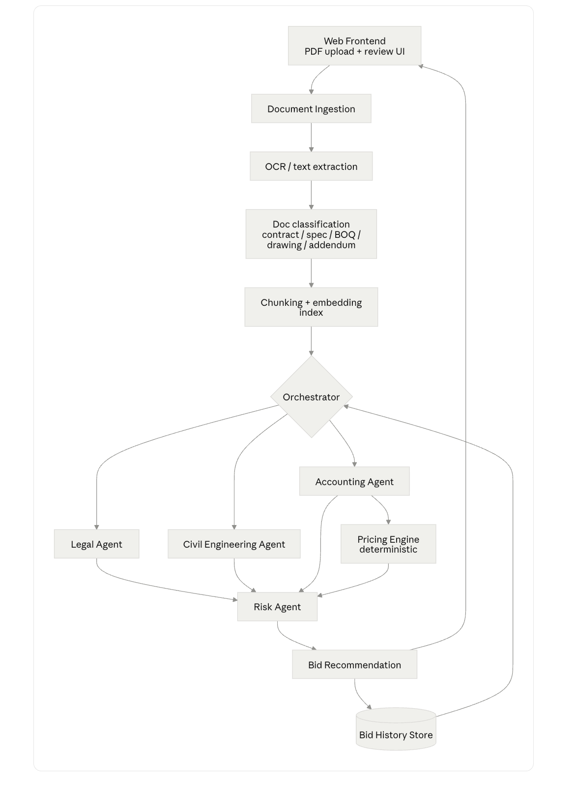
Figure 1 — pipeline as sketched by the build team
Component | Role
Web Frontend | Upload + review UI
Ingestion → OCR → Classification → Chunk/Embed | Normalizes the package into a per-run indexed, cited corpus (contract / spec / BOQ / drawing / addendum)
Orchestrator | Fans out to agents in parallel; sequences Accounting → Pricing Engine → Risk; assembles output
Legal Agent | Submission mechanics, LD, termination, force majeure, warranty, indemnity, arbitration — all cited
Civil Engineering Agent | Scope of work, site/timeline facts, drawing/BOQ archive classification
Accounting Agent | Financial + experience qualification criteria; evaluates bidder data as Met/Not Met; payment terms
Pricing Engine (deterministic) | Fixed-arithmetic LD exposure, retention/security capital lock-up, threshold pass/fail — never LLM-generated
Risk Agent | Aggregates Legal + Civil + Pricing into one risk profile with qualification-gap verdicts
Bid Recommendation | Bid / No-Bid / Conditional Bid + rationale, cited
Bid History Store | Persists every run; feeds similar-tender context back into the Orchestrator
Hard rule: all currency/percentage/threshold math routes through the deterministic Pricing Engine — never free-form LLM output. Every stated fact carries a document + page/article citation, or it isn't stated.

4. Reference Fixture — EBTSL Tender
Use as the dev/test/demo fixture (files in AI_Hackathon_Files). Build to reproduce this output exactly, with citations.
Field |  | Value | Source
Turnover / solvency thresholds |  | INR 150 Cr avg. 5-yr turnover; INR 100 Cr solvency | Annexure A
Similar work experience |  | ≥50% of bid value, 1 completed project — NOT MET (bidder's own note); JV/consortium explicitly allowed | Note.docx + Annexure A
Liquidated damages |  | 1%/week of contract price, capped at 10% | Annexure B, Art. 6
Performance security |  | 10% of contract price, BG through defect liability period | Annexure B, Art. 44.1.1
Retention |  | 10% per RA bill, capped at 5% of contract price | Annexure B, Art. 44.1.2
Submission date |  | 07 Sep 2026 | Note.docx
Target output for this fixture
CONDITIONAL BID — financial criteria met standalone; technical/experience criterion not met but closeable via JV/consortium (tender permits it); LD capped at 10%, security+retention lock up to 15% of contract value — price accordingly. Recommend pursuing, contingent on securing a qualifying JV partner before 07 Sep 2026.

5. Functional Requirements
MoSCoW-prioritized, grouped by component. Build Must rows first; Should/Could only if time allows.

5.1 Ingestion → OCR → Classification → Index
ID | Requirement | Pri
FR-1 | Accept multi-file PDF + ZIP upload; unpack ZIPs into individual files; preserve filenames/page numbers end-to-end for citation. | Must
FR-2 | Extract text natively where possible; OCR fallback for scanned/image pages; flag low-confidence extraction for review, don't guess. | Must
FR-3 | Classify each doc/section: contract / instructions-to-bidders / spec / BOQ / drawing / addendum. | Must
FR-4 | Chunk long contracts at clause/article boundaries (not fixed length); tag every chunk with source doc + page. | Must
FR-5 | Per-run index isolation — never leak one tender's content into another's retrieval. | Must
FR-6 | Extract tabular annexures (e.g. similar-work-done grids) as structured rows, not flattened text. | Should

5.2 Orchestrator
ID | Requirement | Pri
FR-7 | Dispatch Legal / Civil Engineering / Accounting agents in parallel post-indexing. | Must
FR-8 | Sequence Accounting → Pricing Engine → Risk (Pricing Engine numbers must exist before Risk aggregates). | Must
FR-9 | Surface a failed/partial agent run explicitly — never emit a silent partial recommendation. | Must
FR-10 | Query Bid History Store for similar past tenders and pass as agent context. | Should

5.3 Legal Agent
ID | Requirement | Pri
FR-11 | Extract submission date/validity/currency/JV-eligibility rules, each cited. | Must
FR-12 | Extract & cite LD (rate + basis + cap), termination, suspension, force majeure. | Must
FR-13 | Extract warranty/defect-liability period, indemnity, insurance, dispute resolution (arbitration seat, governing law). | Must
FR-14 | Flag one-sided/non-standard clauses (no reciprocal LD, unlimited liability, etc.) for reviewer attention. | Should

5.4 Civil Engineering Agent
ID | Requirement | Pri
FR-15 | Summarize scope of work into a structured checklist from the technical narrative. | Must
FR-16 | Extract location, site conditions, key milestone dates. | Must
FR-17 | Classify/index drawing-BOQ archive contents (filenames, sheet titles, discipline) as searchable reference. | Should

5.5 Accounting Agent + Pricing Engine
ID | Requirement | Pri
FR-18 | Extract financial thresholds (turnover, net worth, solvency) and required certificates. | Must
FR-19 | Extract experience/technical qualification rule (e.g. ≥50% of bid value) as a checkable rule, separate from financial. | Must
FR-20 | Accept bidder-supplied qualification data (manual entry, MVP); evaluate each criterion Met / Not Met / Partial with gap explained. | Must
FR-21 | Extract RA-bill, retention, advance, and final-bill payment mechanics. | Must
FR-22 | Pricing Engine: compute max LD exposure (currency + % of input bid value) via fixed arithmetic, not LLM. | Must
FR-23 | Pricing Engine: compute performance-security + retention capital lock-up (amount, duration). | Must
FR-24 | Pricing Engine: evaluate numeric thresholds pass/fail against bidder figures; show inputs/formula inline. | Must

5.6 Risk Agent + Bid Recommendation
ID | Requirement | Pri
FR-25 | Aggregate Legal + Civil Engineering + Pricing Engine into one risk profile by category (legal, commercial, technical/qualification, schedule). | Must
FR-26 | Verdict per qualification criterion: Met / Not Met, and whether a gap is closeable (e.g. via JV) or disqualifying. | Must
FR-27 | Emit Bid / No-Bid / Conditional Bid with plain-language rationale citing the specific findings behind it. | Must
FR-28 | For Conditional Bid: state exactly what must be resolved and by when. | Must
FR-29 | Overall Low/Medium/High risk rating, traceable to source findings. | Must

5.7 Web Frontend + Bid History Store
ID | Requirement | Pri
FR-30 | Top-level view: recommendation + one-paragraph rationale + risk rating, no scrolling needed. | Must
FR-31 | Every rationale line expands to source agent finding + page citation. | Must
FR-32 | Qualification checklist view (Met/Not Met/Partial) and financial summary view (LD/retention/security, inline formula). | Must
FR-33 | Per-document ingestion/classification status while a run is in progress. | Should
FR-34 | Human can approve/override with a reason; override stored in Bid History Store. | Should
FR-35 | Persist per run: sources, agent outputs, Pricing Engine figures, recommendation, override — queryable by client/value/scope. | Must

6. Non-Functional Requirements
- No citation, no claim — every extracted fact traces to a document + page/article.
- All numeric/currency calculations are deterministic (Pricing Engine), never LLM free-form.
- Low-confidence OCR/classification is flagged for review, not passed downstream silently.
- Per-tender data/index isolation (confidentiality); one agent failure degrades gracefully, doesn't block the run.
- Every recommendation + its evidence + any override must be reconstructable later (audit trail).

7. Build Order (cut from the bottom if time is short)
- Pipeline skeleton — upload, ingest, OCR, classify, chunk/embed on the reference tender.
- Thin slice — Orchestrator + Legal Agent + Risk Agent + Recommendation, hard-target: reproduce Section 4's output end-to-end.
- Accounting Agent + deterministic Pricing Engine, wired into Risk aggregation.
- Civil Engineering Agent — scope summary + drawing/BOQ classification.
- Bid History Store + review-UI drill-down/override + demo polish.
Demo pass bar
Reference tender uploads and processes end-to-end unattended; recommendation matches Section 4's target output with live-checkable citations; the qualification-gap flag is correctly surfaced — the clearest proof the system is reading the documents, not templating a generic answer.

8. Open Questions
# | Question | Owner
1 | Confirm hard build deadline beyond this doc's 3PM cutoff — adjust Section 7 cut line accordingly. | Product
2 | Drawing/BOQ (Annexure C1–C4) — classification/indexing only for MVP, correct? | Product
3 | Bidder qualification data: manual entry acceptable for demo, or prep a mock profile? | BA
4 | OCR/embedding/LLM provider choice — engineering's call; only hard constraint is FR-5 (index isolation) + FR-4 (citation metadata). | Eng

