This project simulates a wildfire scenario using two planners:
- Wumpus (A*) – a discrete, grid-based arsonist that lights fires in nearby cells.
- Firetruck (PRM) – a sampling-based Ackermann vehicle that navigates the map and extinguishes burning obstacles.
Each agent operates in a 250 × 250 m field (5 m cells, ~10 % tetromino obstacle coverage) for 600 s simulation time. Obstacles transition through all four required states: intact → burning → extinguished → burned.

Animations:



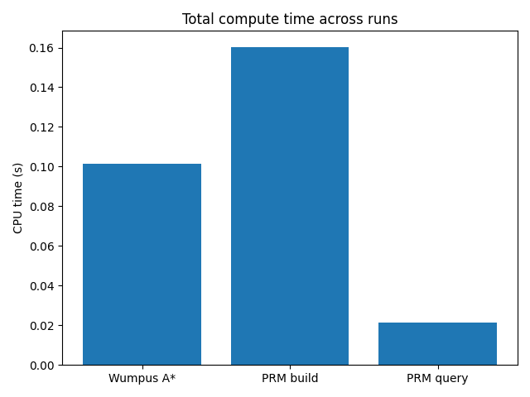

Results Summary:
Run | Wumpus Score | Firetruck Score | Winner
1000 | 483 | 34 | Wumpus
1001 | 481 | 38 | Wumpus
1002 | 482 | 36 | Wumpus
1003 | 483 | 34 | Wumpus
1004 | 490 | 20 | Wumpus
Average Wumpus: 483.8 Average Firetruck: 32.4 Champion: Wumpus (5 / 5)
These results confirm that the discrete A* planner ignites obstacles faster and more aggressively, while the Firetruck PRM is limited by kinematic constraints and extinguish time.

Computation Resources:
Planner Component | Total CPU Time (S) | Relative Cost
Wumpus A* | 0.5 | 36%
PRM build | 0.78 | 56%
PRM query | 0.11 | 8%
Total | 1.39 | 100%

Discussion:
The A* planner for the Wumpus spreads fire aggressively due to deterministic grid traversal, while the PRM firetruck relies on continuous-space sampling and path smoothing to reach and extinguish fires. The PRM build stage is the most computationally expensive, while A* dominates in total runtime effectiveness. Overall, the Wumpus demonstrates greater coverage efficiency, whereas the PRM achieves smoother kinematic feasibility.

