Homework #6 Post

- STL-Based Animation (anim_mesh.gif)
A second, richer animation uses the actual STL models generated from the OpenSCAD files.
It displays:
- the full transmission case mesh (static),
- the countershaft mesh (static),
- the primary-shaft mesh (moving with the RRT trajectory).
Although the Matplotlib-based shading produces minor visual artifacts, this animation demonstrates how the extracted path interacts with realistic geometry. It is included as supplemental visualization beyond the rubric requirements. Together, these animations provide a clear depiction of the extraction process and validate that the computed trajectory remains collision-free throughout.
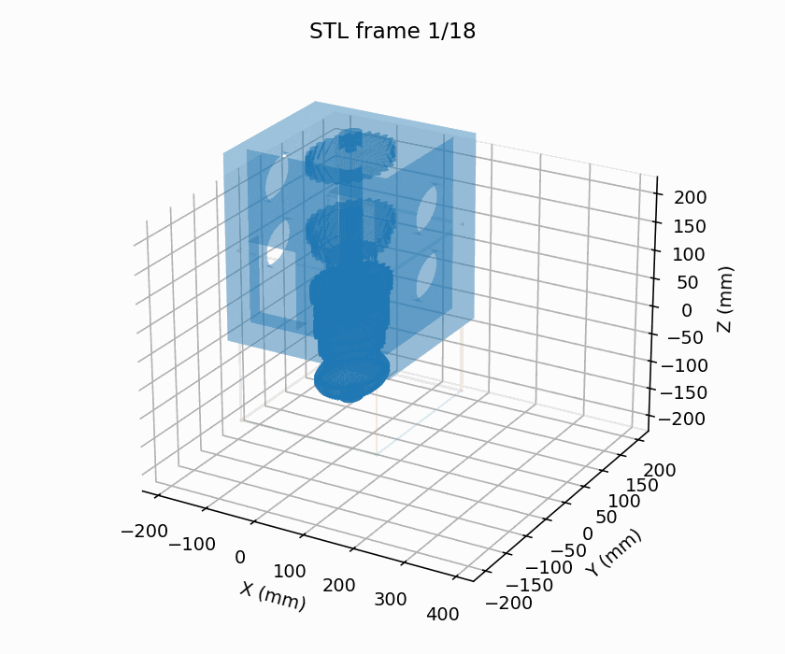

- Animation of the motion
Two animations were produced to illustrate the motion along the computed SE(3) trajectory:
- Simple Animation (anim_simple.gif)
This animation shows the mainshaft as a simplified rigid body (line-segment model) moving inside a wireframe representation of the case. The shaft undergoes the same translations and rotations used by the RRT. This version provides the clearest view of the geometry and is the primary animation submitted for grading.
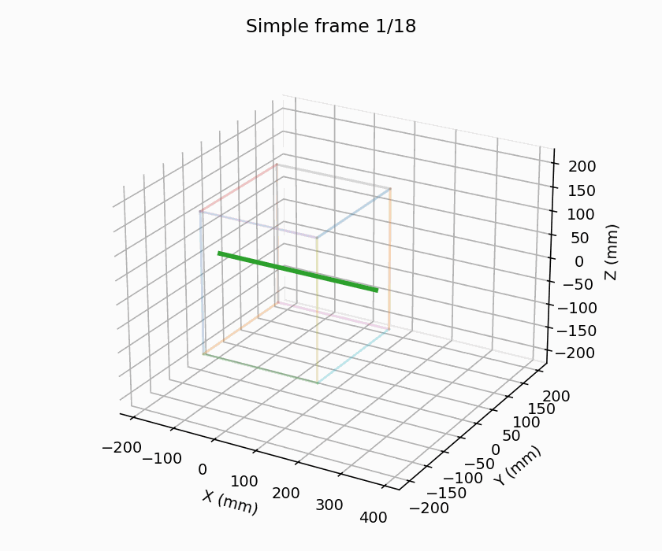

- RRT Exploration tree
The RRT exploration tree projected into 3-D Cartesian space. Initially, the tree densely samples the constrained interior, testing many small orientation changes to avoid the countershaft and the case walls. Because the planner uses a 20% goal bias, the search gradually “leans” toward the front opening, ultimately discovering the only feasible exit. A small modification was made to the edge-checking routine: the first interpolated point (t = 0) is skipped to avoid falsely rejecting edges that originate inside the tight start configuration. For clarity, an additional LaValle-style XY projection is included. This 2-D view shows the RRT structure in the plane of the case footprint, highlighting the early dense branching near the start and the directional pull toward the goal.

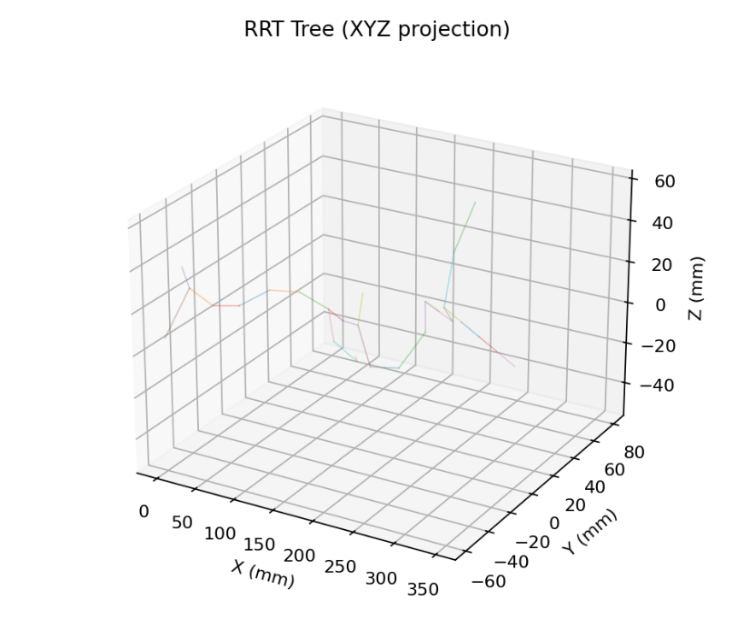
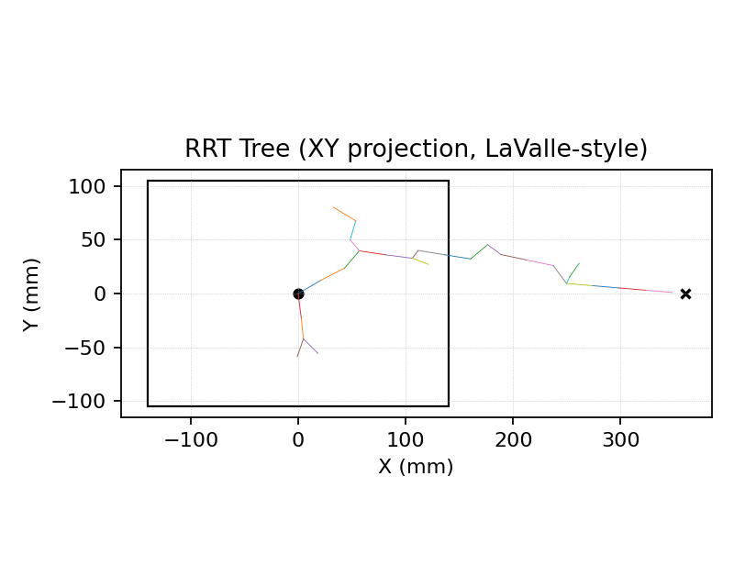

- Path of the mainshaft
The collision-free trajectory of the mainshaft centerline in the (x, y, z) workspace. The motion begins inside the transmission case with the mainshaft aligned along the bearing bores. The RRT identifies that a straight extraction is infeasible due to the countershaft and upper interior surfaces and instead discovers a coordinated sequence of translations and rotations. The trajectory first moves laterally to clear the countershaft, followed by small pitch and yaw adjustments that allow the leading end of the shaft to pass through the front opening. Once clear of the housing, the shaft translates forward into the free workspace and settles into the goal pose representing a workbench position outside the case.

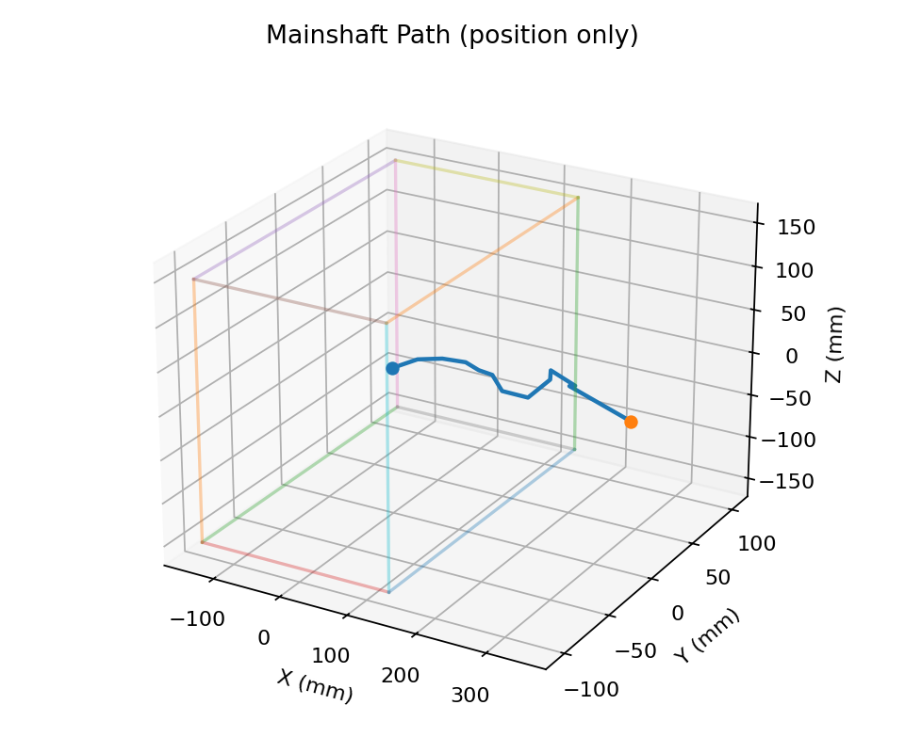

Ugliest car – the AMC Pacer

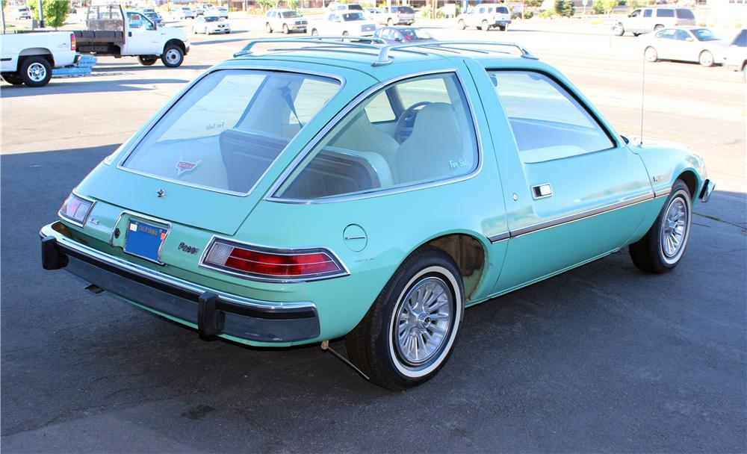

It was unsafe. Uncomfortable to ride in and many other bad attributes.

