Practices for Secure Software Report
Artemis Financial | CS 305 Project Two

Document Revision History
Version 1.1 | October 24, 2026 | Melanie Jarrard
Updated with execution, certificate, HTTPS, dependency-scan evidence, and the supplied assessment diagram.

Client
Artemis Financial

Developer
Melanie Jarrard
This project adds a SHA-256 checksum demonstration and HTTPS to the supplied Artemis Financial application. Layered protection combines a standard hash implementation, TLS configuration, focused tests, dependency assessment, and manual review. The application demonstrates secure communication locally; a production deployment also requires protected private keys, a trusted certificate, and controls appropriate to real client data.

Algorithm Cipher
I recommend AES-256 in Galois/Counter Mode (GCM) for authenticated encryption, delivered through a maintained TLS implementation for web traffic. AES is a symmetric block cipher with a 128-bit block size; the recommendation uses a 256-bit secret key. GCM supplies both encryption and an authentication tag. The server enables TLS 1.2 and TLS 1.3; the client and server negotiate an allowed cipher suite, so the configuration does not guarantee that every connection selects AES-256. TLS 1.3 commonly uses AES-GCM or ChaCha20-Poly1305 (IETF, 2018).
SHA-256 is the separate hash algorithm implemented for the checksum requirement. It creates a 256-bit digest represented as 64 hexadecimal characters and offers approximately 128-bit generic collision resistance. It has no encryption key and cannot decrypt data. TLS cipher suites may use SHA-256 or SHA-384 in key derivation; those hashes are distinct from the application checksum (NIST, 2015).
Symmetric encryption uses a shared secret for efficient data protection. Asymmetric cryptography uses a public and private key pair for functions such as certificate signatures and authentication. The local certificate uses RSA-3072 with a SHA256withRSA signature; TLS negotiates its key exchange separately. Secure random generation supports key creation, ephemeral keys, and session values. AES-GCM nonces must not repeat with the same key. The JDK and TLS provider manage these operations rather than custom random or encryption code.
Earlier deployments used DES and 3DES, while older integrity schemes relied on MD5 and SHA-1. These legacy choices are unsuitable for new secure designs. AES replaced DES as a modern encryption standard, and SHA-2 and SHA-3 provide modern hash families. HTTPS should use supported TLS versions and maintained libraries rather than obsolete SSL protocols (Microsoft, n.d.).

Certificate Generation
Java Keytool generated a self-signed RSA-3072 key pair in a PKCS12 keystore, then exported the public certificate as certificates/artemis-local.cer. The certificate identifies localhost and includes subject alternative names for localhost and 127.0.0.1. The issued demonstration certificate is valid for 365 days and uses SHA256withRSA. The CER contains the public certificate; the P12 also contains a private key and must be protected.
The uploaded exported CER was inspected with Java Keytool. Its SHA-256 certificate fingerprint is 529d81e7b5e6d942fd42fe887ae9494cdfc4507464da1b6157916b496d185ce8, matching the browser certificate in Figure 1. This establishes that the exported file represents the displayed certificate. The included keystore and its published password are only for localhost coursework; production requires a new private key and an appropriate trusted certificate. The certificate was generated during preparation using Keytool; the supplied evidence does not document Keytool generation inside Eclipse.
Certificate evidence is shown in Figure 1; the exported artemis-local.cer is included in the accompanying project ZIP.

Deploy Cipher
ChecksumService uses MessageDigest.getInstance("SHA-256") with explicit UTF-8 encoding. HexFormat preserves all 32 digest bytes, including leading zeroes. A new MessageDigest is created for each call to avoid sharing mutable digest state between requests. The /hash endpoint returns my name, a unique data string, the calculated checksum, an independently precomputed expected checksum, and a verification result. Comparison decodes the expected digest and uses MessageDigest.isEqual; invalid digest syntax is rejected.
The demonstration string is Melanie Jarrard | Artemis Financial | CS305 Project Two | 2026-10-24 | AF-MJ-8F29C4. Verification should return true for this exact string and false after a change. Real financial-file verification must hash the exact received file bytes and obtain the expected digest through an authenticated channel or verify a digital signature. A bare checksum alone does not establish the sender's identity.
See Figure 2 for my name, unique string, matching SHA-256 digests, and verified true.

Secure Communications
application.properties enables HTTPS on port 8443 with a PKCS12 keystore and an environment-supplied password. TLS 1.2 and TLS 1.3 are enabled; the server binds to 127.0.0.1 for the course demonstration. The URL is https://localhost:8443/hash. No HTTP connector is added. Error responses exclude stack traces and exception messages, and the checksum response includes no-store and nosniff headers.
A self-signed certificate initially produces a browser trust warning. A warning bypass does not prove authenticated HTTPS. For local evidence, verify the certificate and trust only the exported course CER in the current user certificate store, following README.md, then inspect the browser connection status. Production requires a certificate issued by an appropriate trusted CA.
See Figure 3 for the browser confirmation that the connection is secure and the certificate is valid.

Secondary Testing
The supplied POM used Spring Boot 2.2.4.RELEASE and Dependency-Check 5.3.0. The refactored POM uses Spring Boot 4.1.2, Java 17, and Dependency-Check 13.0.0. The unused Spring Data REST dependency was removed to reduce unnecessary dependency exposure. Hashing relies on the JDK and introduces no external cryptographic library. The scanner runs in the Maven verify phase and produces HTML and JSON reports. Scanner errors fail the build; findings with CVSS scores of 7 or higher also fail the build, while all reported findings still require review.
The local automated test run completed with three tests and no failures, errors, or skipped tests. The subsequent Eclipse Maven verify run completed successfully on October 24, 2026, at 11:08 a.m. Pacific time. Dependency-Check 13.0.0 scanned 39 dependencies (17 unique) and reported zero vulnerable dependencies, zero vulnerabilities found, and zero suppressions. NVD data was last checked that morning; Maven reused the recent cached data. No findings required remediation in this run. Sonatype OSS Index analysis was disabled because credentials were missing, so that source was not included. These results support that the scanner found no known dependency vulnerabilities within its enabled coverage; they do not prove the application is free of vulnerabilities. See Figures 4 and 5. Dependency-Check examines third-party components, so manual review and behavioral tests also remain necessary (OWASP, n.d.).
See Figure 4 for the successful Eclipse Maven verify run and Figure 6 for successful HTTPS application startup.
See Figure 5 for the Dependency-Check report overview with scan date and zero findings.

Functional Testing
Manual review checked the added service, controller, properties, and POM for syntax, logic, and security behavior. The service uses explicit UTF-8 encoding, validated 64-character hexadecimal input, and the standard Java cryptographic provider. It does not log secrets or accept file paths, arbitrary HTML, or financial data from a request. The endpoint is read-only and uses fixed public demonstration data. The configured password comes from the environment; the published bundled keystore is explicitly limited to local demonstration.
The automated suite checks the published SHA-256 vectors for an empty string and abc; rejects changed data, malformed checksums, null, and an incorrect 64-character checksum; and verifies that the endpoint returns a successful response with my name and a true verification result. All three test methods passed. A live HTTPS request also returned HTTP 200 and verified true with the exported certificate used as the trust anchor and hostname verification enabled. Browser trust must still be checked on the submission computer. These checks do not establish that the entire application is free of vulnerabilities.
See Figure 6 for successful application startup, Figure 2 for the endpoint result, and Figure 4 for successful Maven execution.

Summary
I used the supplied Vulnerability Assessment Process Flow to guide architecture review, manual review, testing, and the summary of findings. Its seven assessment areas are Input Validation, APIs, Cryptography, Client / Server, Code Error, Code Quality, and Encapsulation (Southern New Hampshire University, n.d.). The changes and review addressed each area as described below.
Input Validation: The public endpoint accepts no user-supplied paths or financial content. The checksum comparison method rejects null and malformed expected digests before decoding. A future file-upload feature would require size, type, and content validation beyond this fixed-string demonstration.
APIs: The controller exposes a read-only GET /hash route with a JSON response. Hashing uses the standard JDK MessageDigest API and explicit UTF-8 encoding. Review checked the response contract and avoided adding external cryptographic APIs.
Cryptography: SHA-256 supplies the application checksum, while the PKCS12 certificate and TLS supply encrypted transport. The reviewed settings enable TLS 1.2 and 1.3. AES-GCM is the recommended encryption mode; actual TLS algorithms are negotiated.
Client / Server: The server listens on localhost port 8443 using HTTPS. The browser screenshot confirms a trusted connection and a valid certificate. This local demonstration does not add client authentication or authorize access to financial records.
Code Error: Server configuration excludes detailed exception messages and stack traces from responses. The service handles the checked unavailable-algorithm exception with a generic failure; it does not return secrets or implementation traces to the browser.
Code Quality: Focused tests check published SHA-256 vectors, altered input, invalid expected hashes, and the controller result. Maven compilation, packaging, and the Eclipse verify execution succeeded. Dependency analysis complements these checks.
Encapsulation: Checksum logic is separated from the controller in a final utility class with a private constructor. Digest state is local to each invocation. Configuration supplies the runtime password through the environment; the bundled private key remains demonstration material only.
The layers protect different properties. Trusted HTTPS protects data in transit and authenticates the local server; the checksum detects changes relative to the fixed expected digest; tests check implementation behavior; and dependency analysis checks for known third-party vulnerabilities. The live browser and Eclipse evidence show successful operation, while the completed dependency report shows no findings within the enabled scanner coverage. The lack of OSS Index credentials limits that coverage. A production deployment still requires a new protected private key, a trusted CA-issued certificate, access controls, and continued assessment.

Industry Standard Best Practices
The implementation uses standard JDK cryptography rather than a custom hash, explicitly selects UTF-8, avoids a shared mutable digest, and separates checksum logic from the HTTP controller. It minimizes dependencies, uses maintained framework releases, restricts protocols to TLS 1.2 and TLS 1.3, keeps runtime passwords out of application.properties, limits detailed errors, and avoids sensitive data in URLs and logs. The demo certificate is clearly separated from production credential requirements. No scan findings are hidden to produce a passing result.
For Artemis Financial, these practices reduce opportunities for data disclosure, tampering, and service disruption. They make defects easier to identify and reproduce, support consistent reviews, and reduce recovery and maintenance costs. Protecting financial information also supports customer confidence and business continuity. Continued patching, certificate renewal, access control, and periodic reassessment remain necessary as the system and threat landscape change.

Code File Attachments
The accompanying CS305_Project_Two_Refactored.zip contains the complete project folder. README.md explains Eclipse import, Keytool commands, certificate trust, test execution, and scanning. Key files are pom.xml, application.properties, ChecksumService.java, HashController.java, SslServerApplication.java, SslServerApplicationTests.java, and the demonstration certificate files. The ZIP is supplied as a separate attachment with this report.

References
NIST. (2015). Secure Hash Standard (SHS), FIPS 180-4. https://csrc.nist.gov/pubs/fips/180-4/upd1/final
IETF. (2018). The Transport Layer Security (TLS) Protocol Version 1.3, RFC 8446. https://www.rfc-editor.org/rfc/rfc8446
Microsoft. (n.d.). Microsoft SDL cryptographic recommendations. https://learn.microsoft.com/en-us/security/engineering/Cryptographic-Recommendations
OWASP. (n.d.). Dependency-Check. https://owasp.org/projects/Dependency-Check
Spring. (2026, October 23). Spring Boot 4.1.2 available now. https://spring.io/blog/2026/10/23/spring-boot-4-1-2-available-now
OWASP. (n.d.). Dependency-Check Maven usage. https://dependency-check.github.io/DependencyCheck/dependency-check-maven/index.html
Southern New Hampshire University. (n.d.). CS 305 Vulnerability Assessment Process Flow [Course diagram].

Figure 1 Localhost certificate details
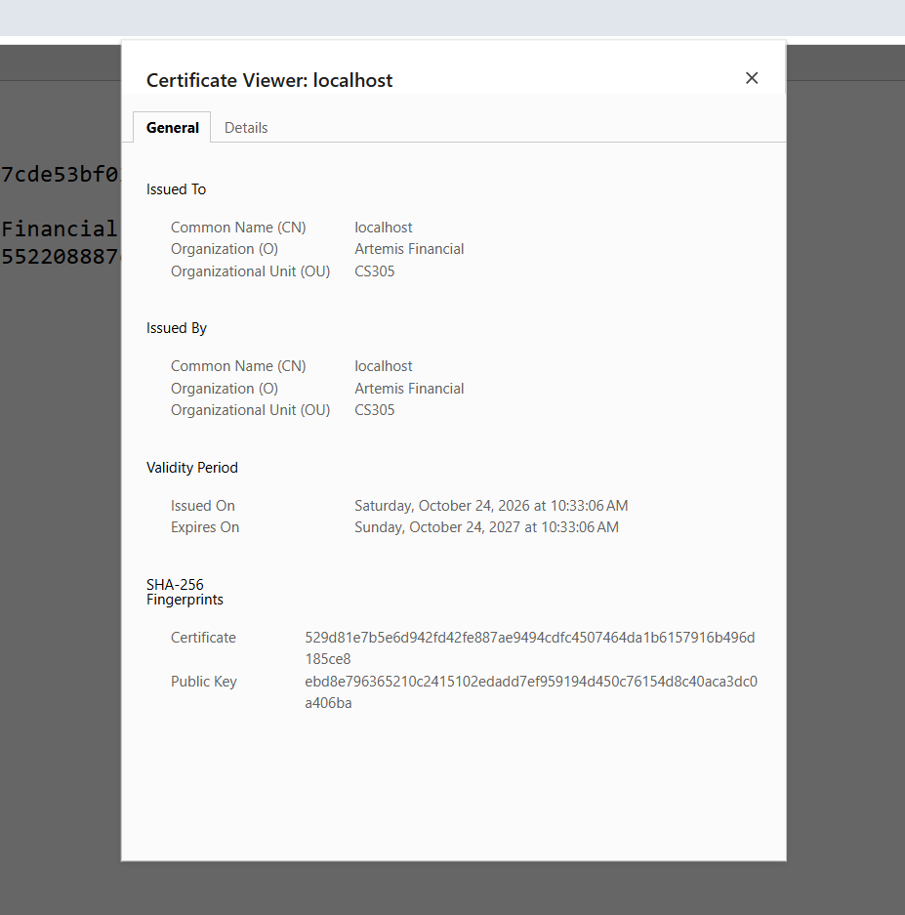
The browser certificate identifies localhost and Artemis Financial, with matching issuer and subject. Its certificate fingerprint matches the uploaded exported CER.

Figure 2 SHA256 checksum verification
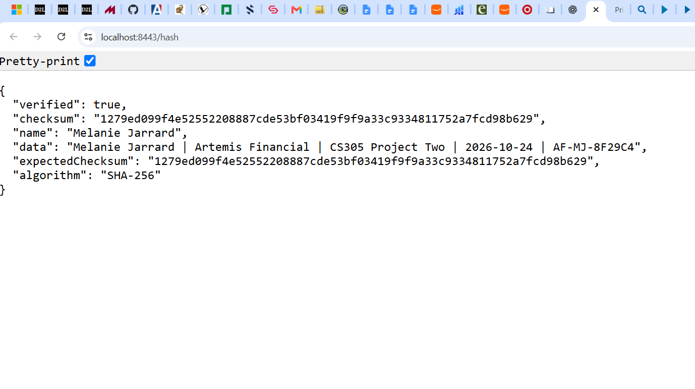
The endpoint displays Melanie Jarrard, the unique demonstration string, equal calculated and expected checksums, and verified true.

Figure 3 Trusted HTTPS connection
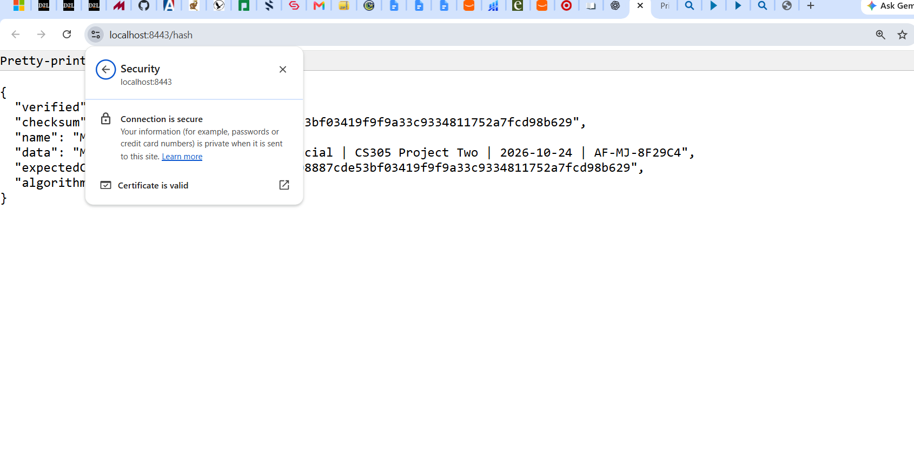
Chrome reports Connection is secure and Certificate is valid for localhost port 8443.

Figure 4 Successful dependency scan execution
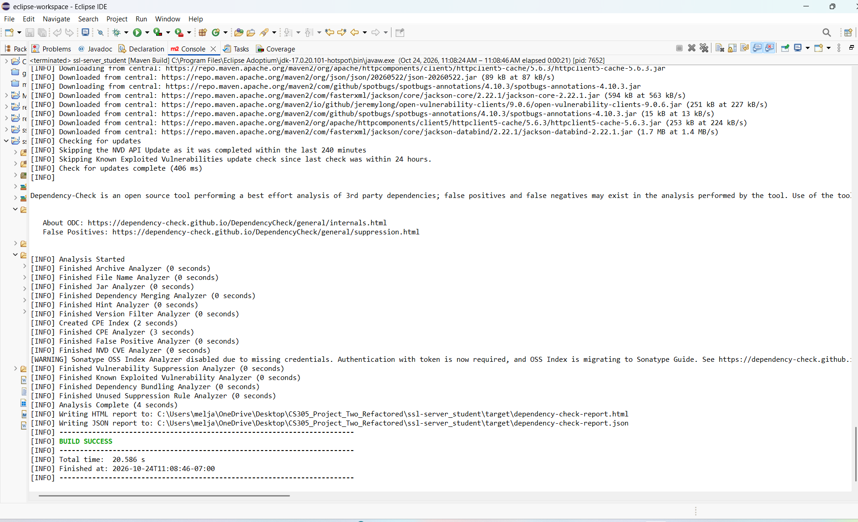
Eclipse shows analysis completion, report output paths, and BUILD SUCCESS. The OSS Index credentials warning limits scanner coverage.

Figure 5 Dependency scan results
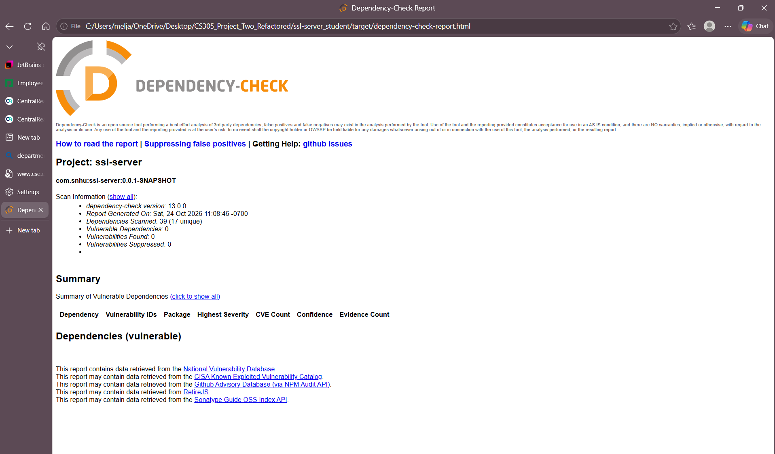
Dependency-Check reports 39 dependencies scanned, 17 unique, zero vulnerable dependencies, zero findings, and zero suppressions.

Figure 6 Successful application startup
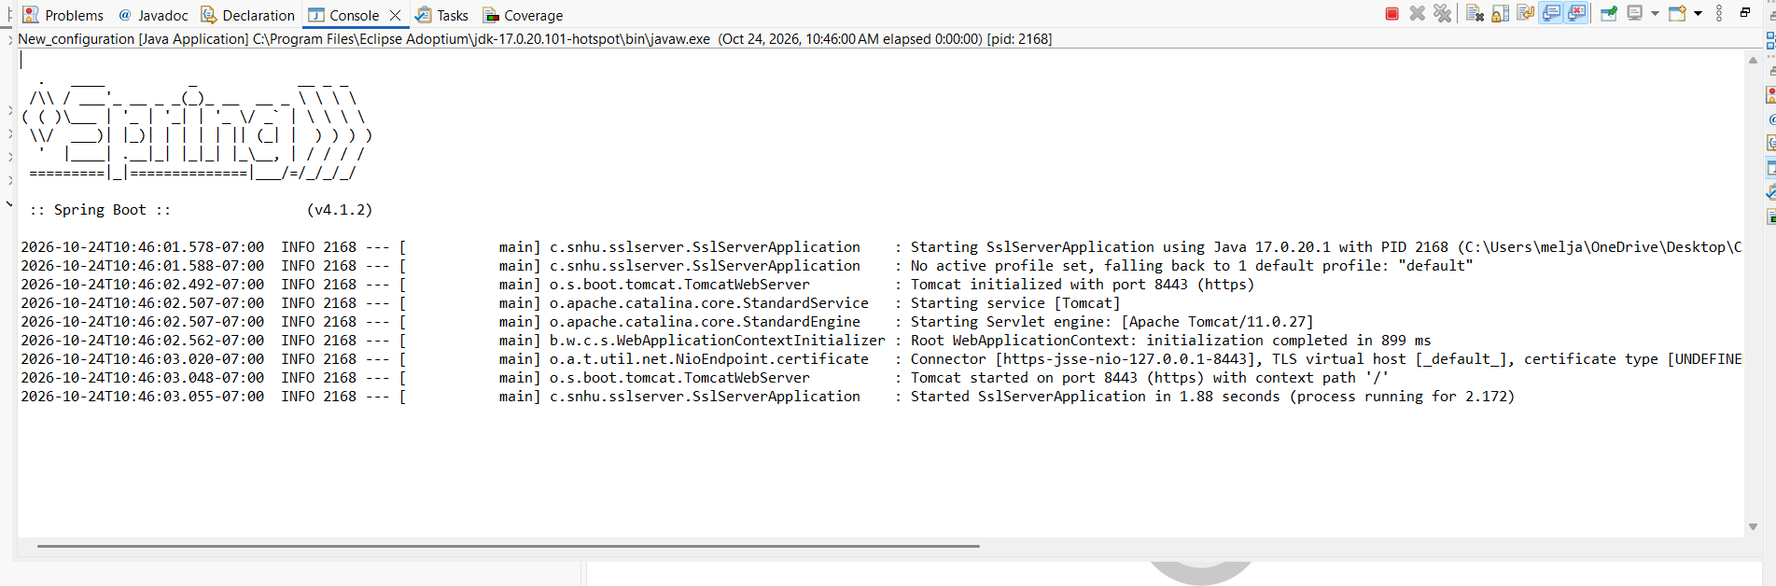
Eclipse shows Tomcat starting on port 8443 with HTTPS and successful application startup without a visible startup error.

