ESDROS THEOLOGICAL SEMINARY
Student Information & Learning Management System (SIS-LMS)
COMPREHENSIVE MULTI-PORTAL USER MANUAL & SYSTEM GUIDE
Version 1.0 • Published May 2026
Prepared for: Administrators, Registrar, Faculty Instructors, and Enrolled Students

1. Platform Overview & Portals
Esdros Theological Seminary features a unified Student Information System (SIS) and Learning Management System (LMS) designed to automate registration, student profiles, attendance logs, numerical grade submission, official transcript delivery, and secure multi-tenant settings configuration. The platform organizes access rights across distinct dashboards based on secure system roles.

2. Public Portal & Admissions Form
• Marketing Page (/): Provides structural details of Theology and Geez language tracks, degree programs, and administrative contacts.
• Online Apply Form (/apply): Prospective applicants fill out personal credentials, track details, and faith statements. Submitted records immediately spawn PENDING applications inside the Admin CRM pipelines.
• Enrollment Control: Administrators can toggle settings to open or lock public applicant registrations at any time.

3. Student Portal operations (/dashboard/student)
• Course Registration: Enables students to enroll in course sections active inside the current term term.
• Financial Invoices: View detailed ledger balances, tuition fees, scholarship records, and secure invoice lists.
• Two-Factor MFA Security: Logins enforce strong passwords (length > 7, uppercase, lowercase, numbers, and symbols) and scan a secure time-based TOTP QR code at setup to enforce secure logins.
• Request Withdrawal: Students can submit a withdrawal request outlining reasons. Once approved by the registrar, their user account transitions into secure read-only mode.
• Unofficial Transcripts: Generate and view instant cumulative GPA audits with letter conversions.

4. Faculty Portal operations (/dashboard/faculty)
• Cohort Schedules: Faculty can view their assigned sections, classrooms, time schedules, and matriculation limits.
• Roster & Attendance Matrix: Log daily classroom attendance. Graduated, dismissed, or withdrawn students are automatically omitted from these rosters.
• Grade Submission Console: Instructors record student grade evaluations out of 100, which are automatically translated into GPA scale letters (A, B, C) in database tables.
• Faculty Announcement Center: Faculty receive direct alerts from the administration board to coordinate grading calendars.

5. Administrator Console operations (/dashboard/admin)
The Administrative console acts as the primary telemetry center of Esdros Theological Seminary. The home dashboard provides real-time enrollment footprints, cohort distribution, and CRM pipelines.
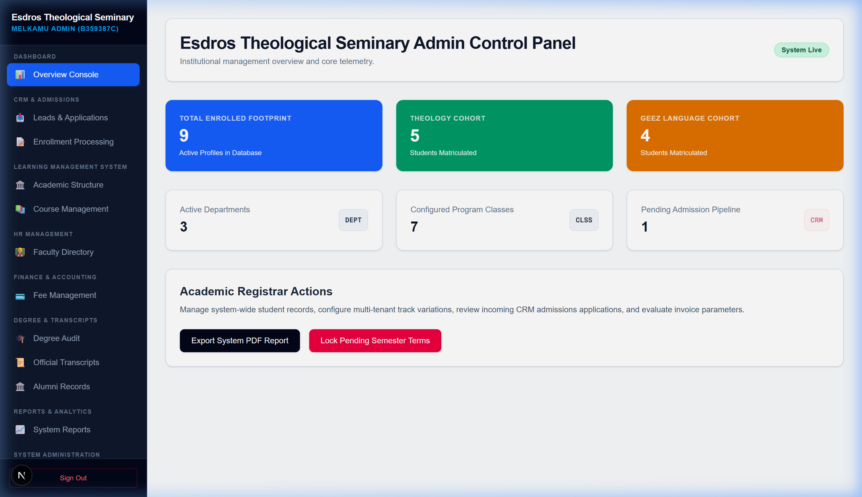
Figure 5.1: Esdros Seminary Admin Telemetry Overview Console

5.1 Manage Admins & clearance Tiers
The Access Control system segregates operations across three tiers. Super Admins can promote or demote standard and restricted administrators directly from the directory list:
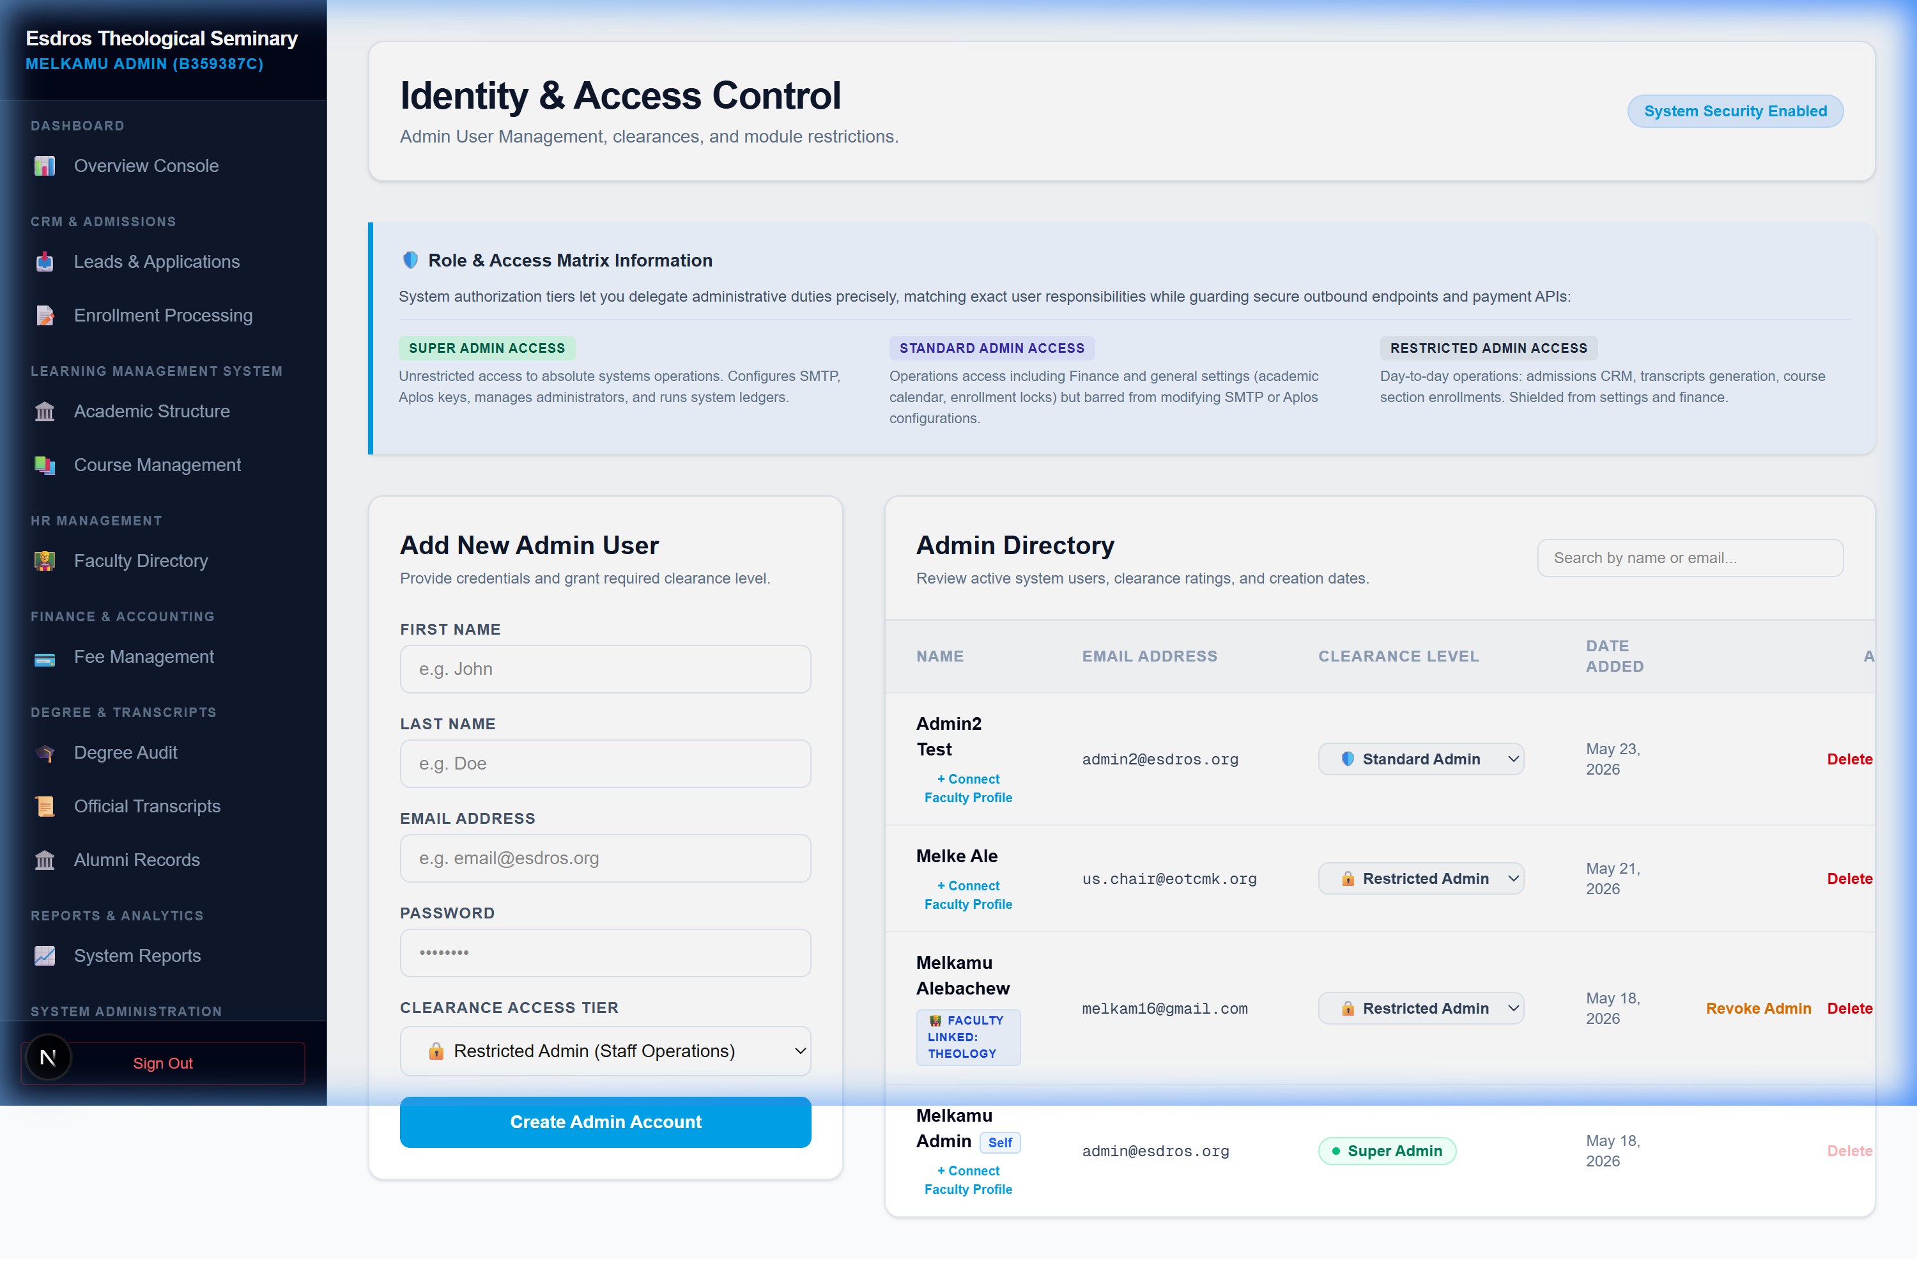
Figure 5.2: Directory Interface for Dynamic Clearance Promotion & Demotion

5.2 System Settings & External Integrations
Super Administrators configure core outbound SMTP email relays and Aplos sync setups locally without executing code. Sub-cards isolate sections, letting you update parameters independently:
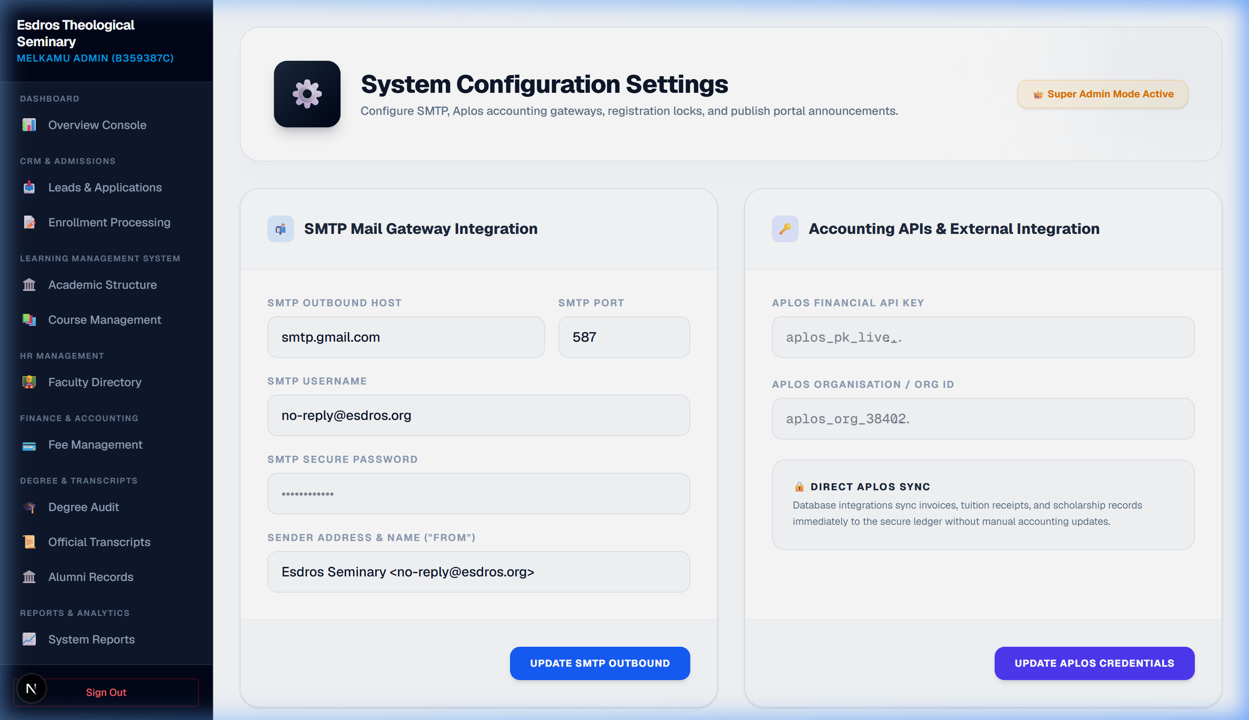
Figure 5.3: SMTP Outbound Mail & Accounting API Integrations Settings Portal

5.3 Student Records, Transcripts & Withdrawals
The Registrar processes withdrawal requests, reviews academic files, deactivates profiles of dismissed students, and schedules dynamic transcript distribution catalogs:
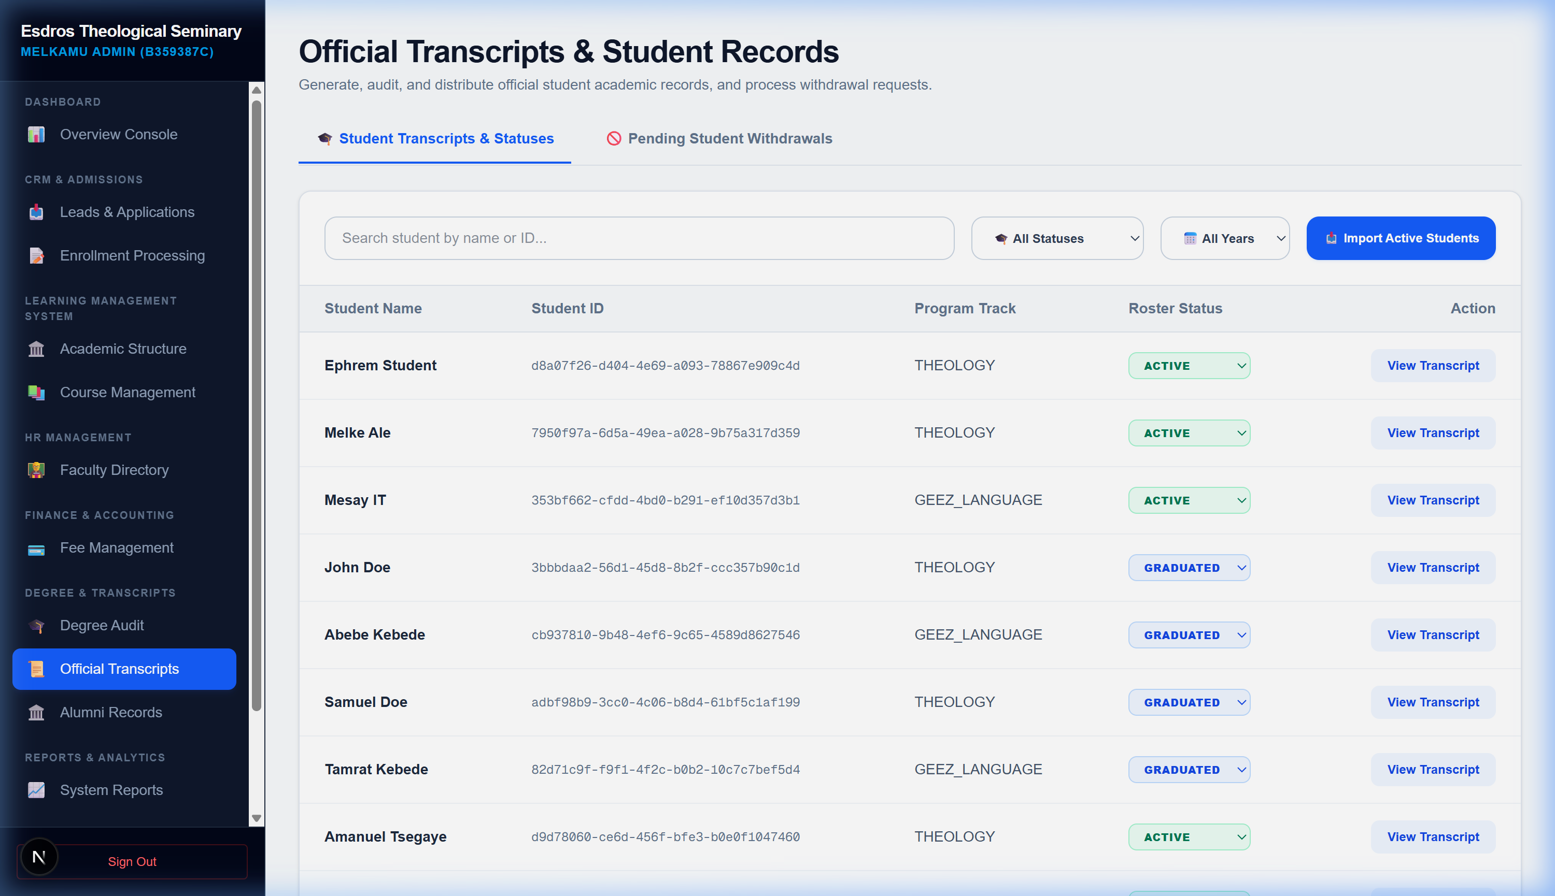
Figure 5.4: Official Transcripts Management & Withdrawal Request processing

