ESDROS THEOLOGICAL SEMINARY
Student Information & Learning Management System (SIS-LMS)
COMPREHENSIVE MULTI-PORTAL USER MANUAL & WORKFLOW GUIDE
Version 1.1 • Published May 2026
Prepared for: Administrators, Registrar, Faculty Instructors, and Enrolled Students

1. Platform Overview & Unified Architecture
Esdros Theological Seminary features a highly premium, unified Student Information System (SIS) and Learning Management System (LMS) that coordinates enrollment lifecycle, CRM admissions scoring, class scheduling, attendance tracking, numerical grading, and official PDF transcript distribution. All operations are strictly divided across three secure portals—Student, Faculty, and Admin—integrated dynamically under centralized ACID database transaction rules.

2. Public Marketing Website & Portal Navigations
The institutional front page offers direct links to seminary portals, contact details, curriculum calendars, and academic tracks. Sub-pages detail structured programs:
• Theology Track (/programs/theology): Covers Orthodox dogmatic theological curriculums.
• Geez Language Track (/programs/geez): Details classical Geez language grammar and syntactic studies.
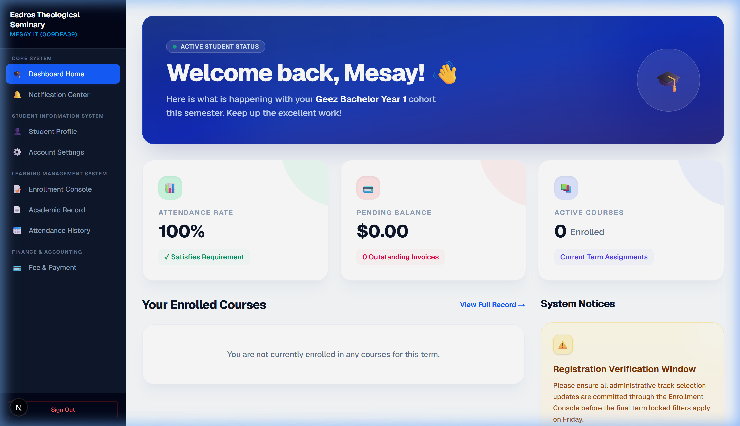
Figure 2.1: Esdros Seminary Public Landing Website
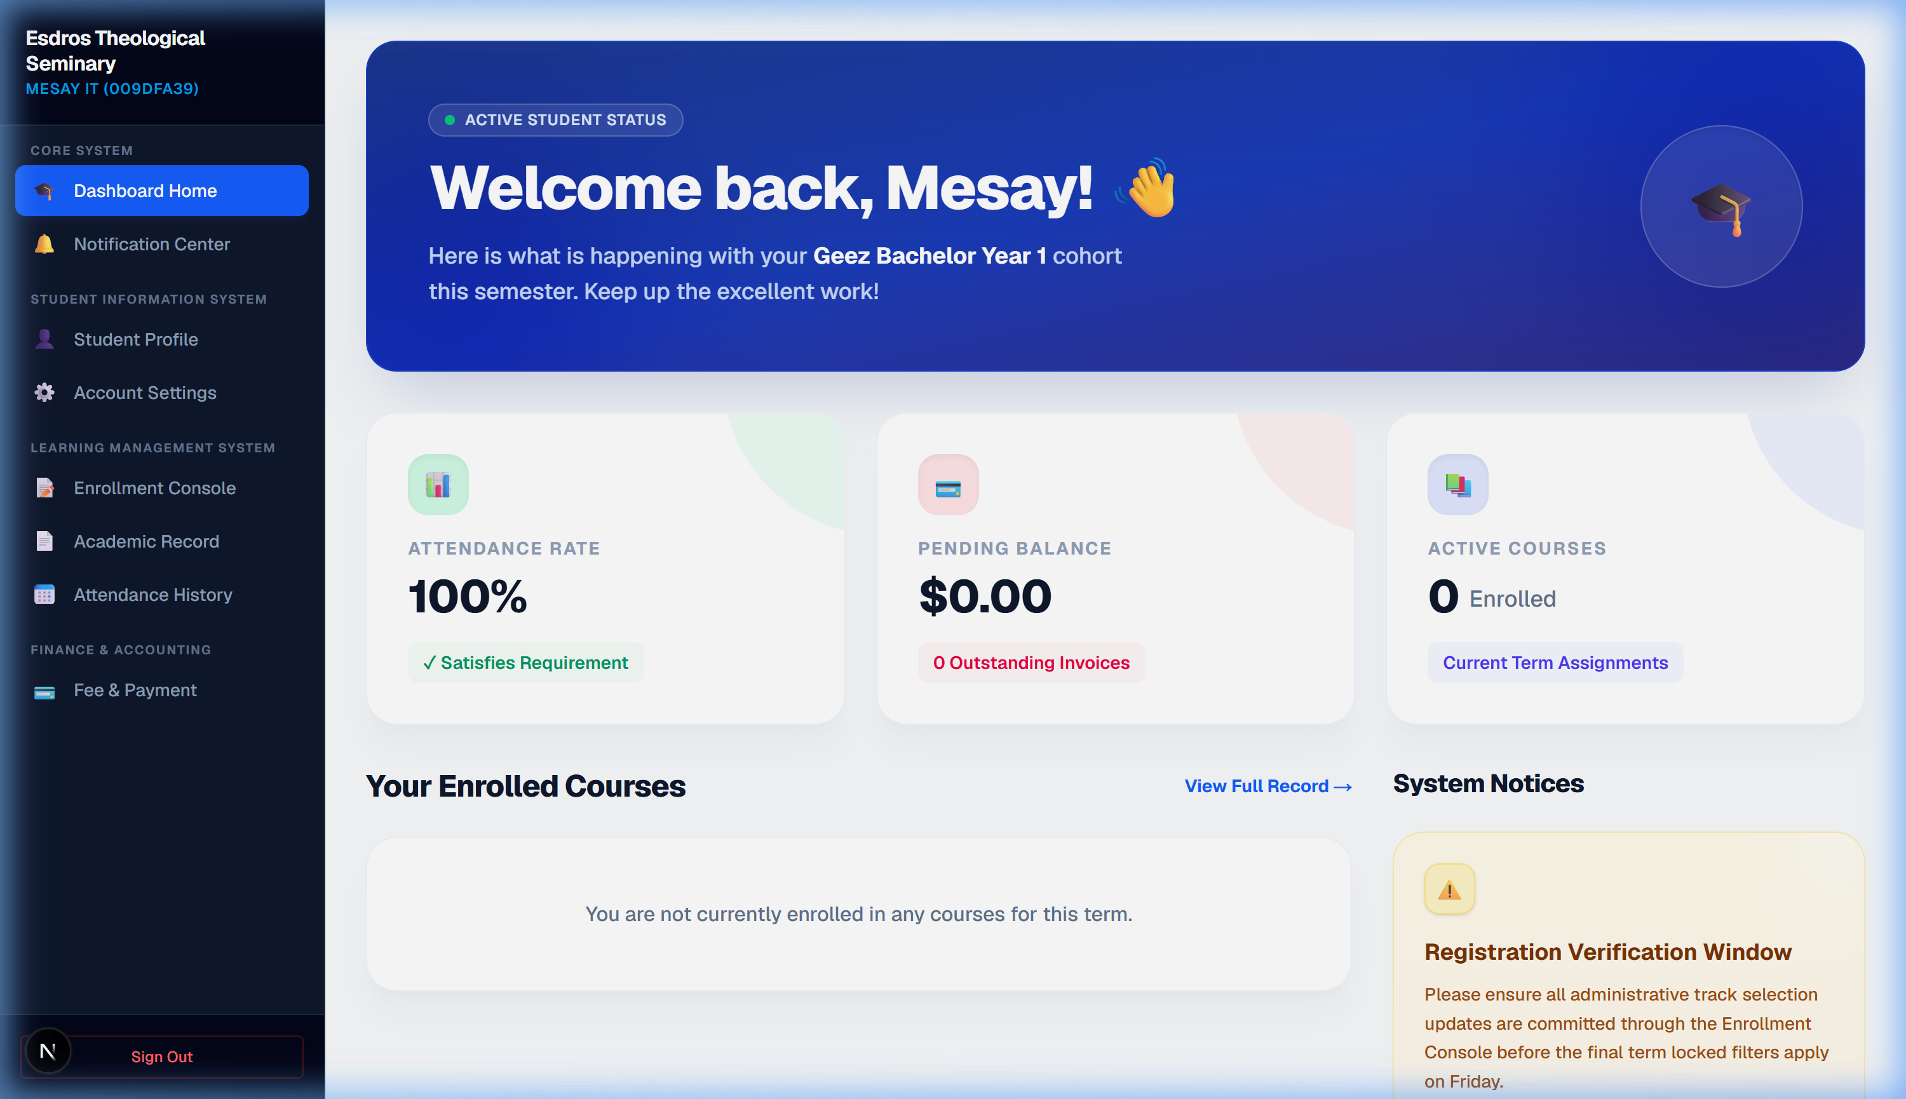
Figure 2.2: Orthodox Theology Program Curriculum Page

3. Gateway Authentication & Security Control
The portal entry (/login) maintains strict user security rules:
1. Enforce Password Policy: Passwords must be greater than seven characters and must contain an uppercase letter, lowercase letter, number, and special character.
2. Two-Factor Authentication (MFA): Implements secure time-based authenticator apps (Google Authenticator, Microsoft Authenticator) using TOTP protocols. During signup, users scan a QR code and must enter their 6-digit verification pin to register. Subsequent logins automatically require their username, password, and active 6-digit TOTP pin.
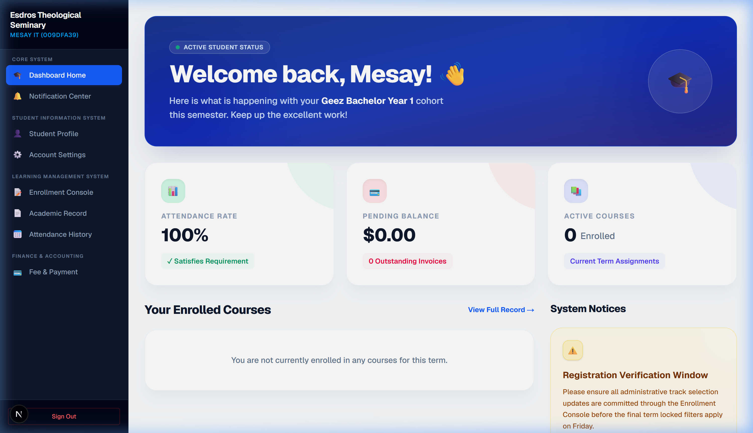
Figure 3.1: SIS-LMS Secure Multi-Factor Gateway Login Console

4. Student Dashboard & Portal Operations
Enrolled students access tools to register in cohort groups, review semester progress reports, make payments, and manage profile security settings.
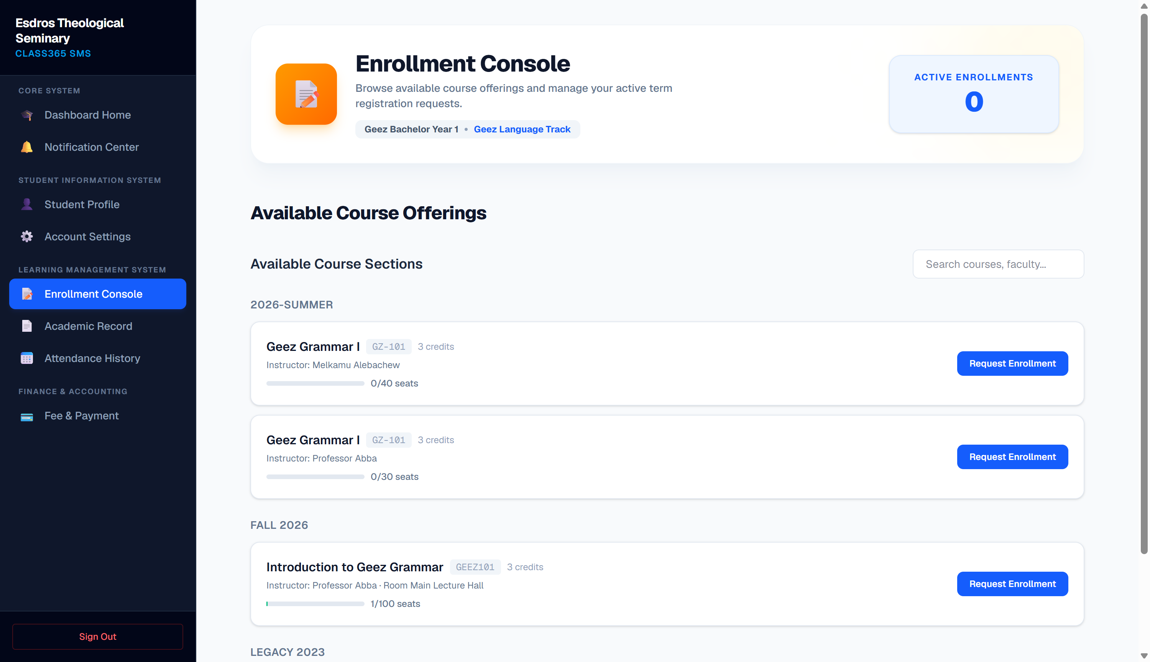
Figure 4.1: Student Portal Overview Console Home

4.1 Course Registration & Academics subpages
• Course Registration (/dashboard/student/enrollment): Displays sections active during the semester term. Students select subjects, view remaining spots, and request enrollments.
• Academics Progress (/dashboard/student/academics): Provides an unofficial transcript view listing completed classes, active credits, and overall cumulative GPA score matrices.
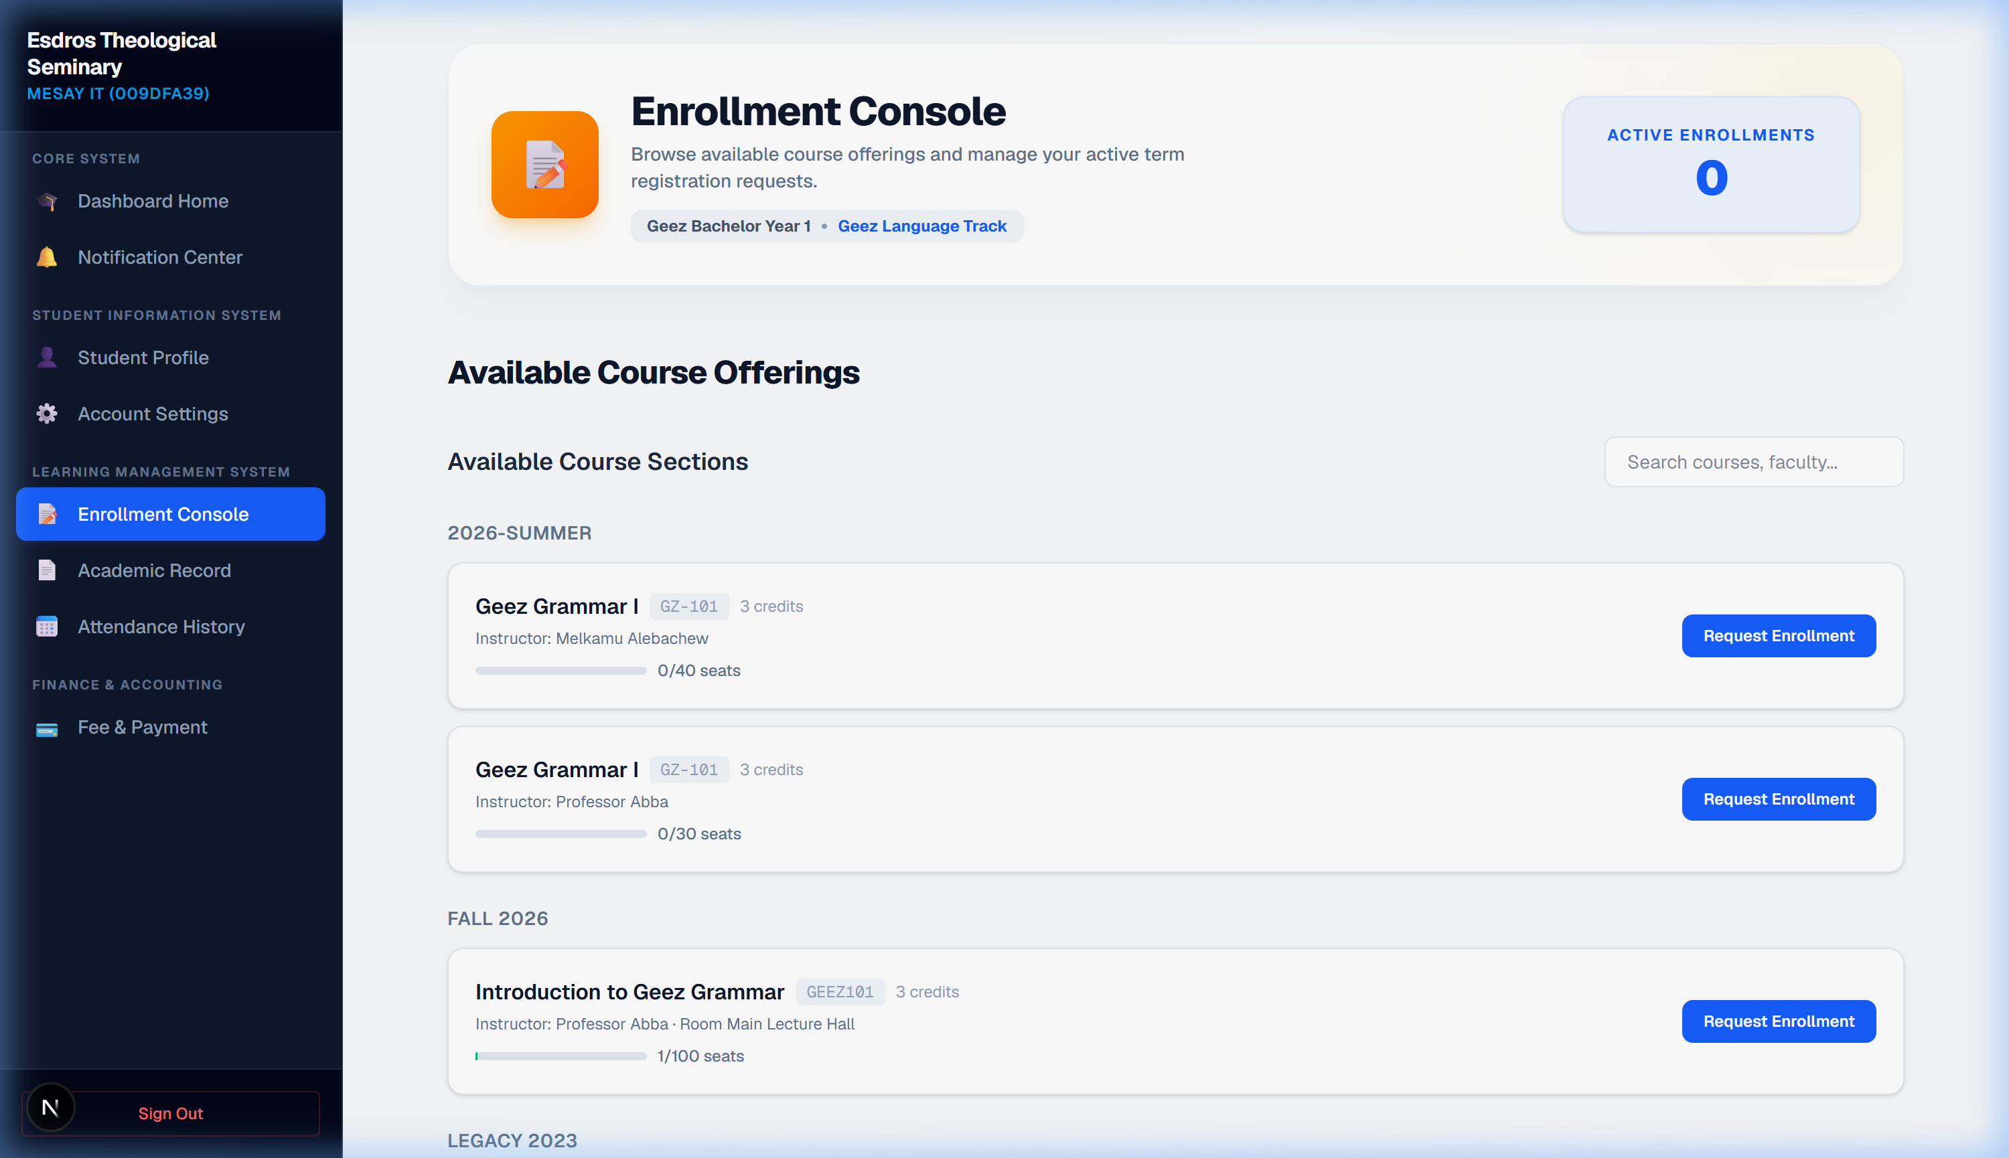
Figure 4.2: Course Section Registration Panel
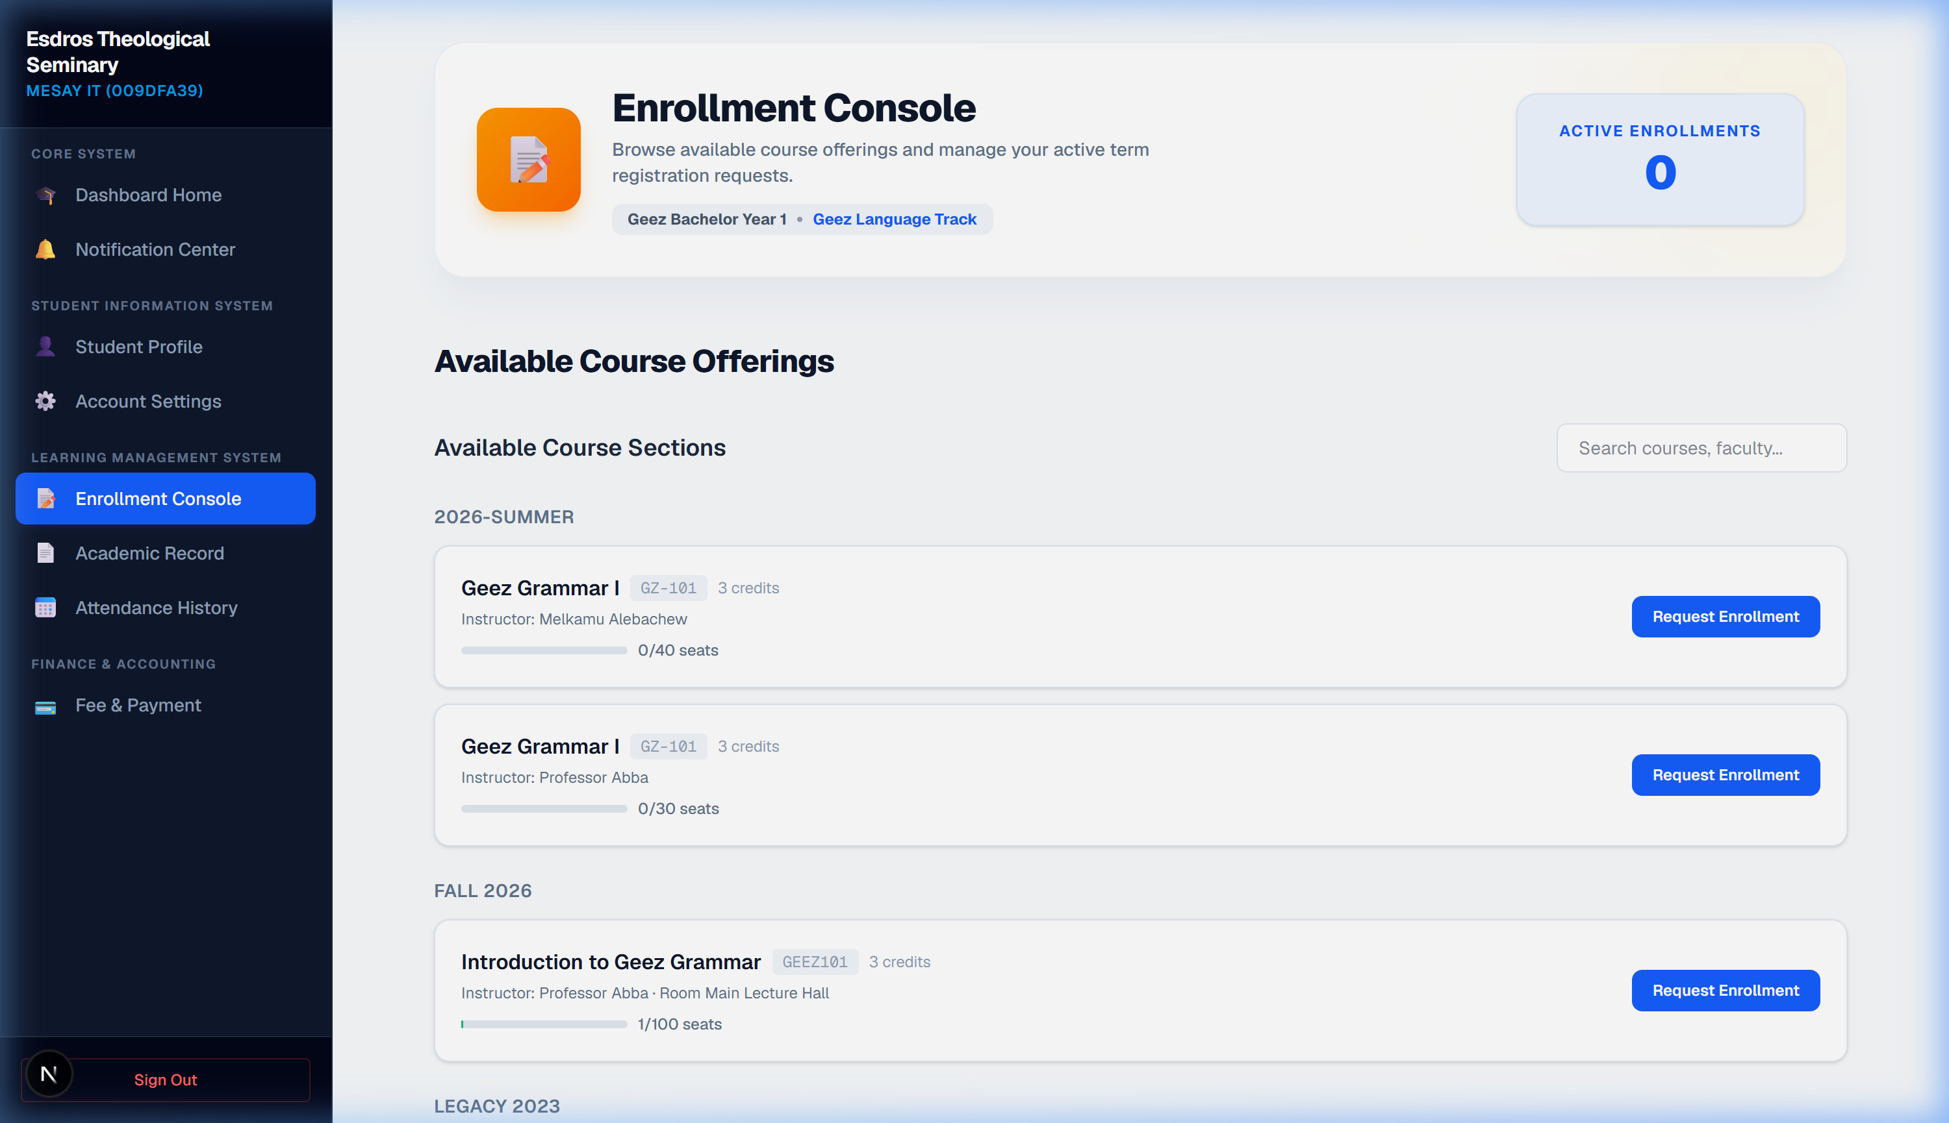
Figure 4.3: Unofficial Transcript and Cumulative GPA Display

4.2 Attendance, Ledger Financials, and Security Settings
• Attendance Monitor (/dashboard/student/attendance): Real-time attendance logs showing present/absent classes and attendance percentages.
• Ledger Finance (/dashboard/student/finance): Direct look at tuition fee balances, active scholarship grants, and structural seminary invoice registries.
• Security / Profile Settings (/dashboard/student/settings): Reset passwords matching complexity parameters, toggle two-factor auth (MFA), and request programmatic student withdrawals (which puts the account in a read-only state upon registrar confirmation).
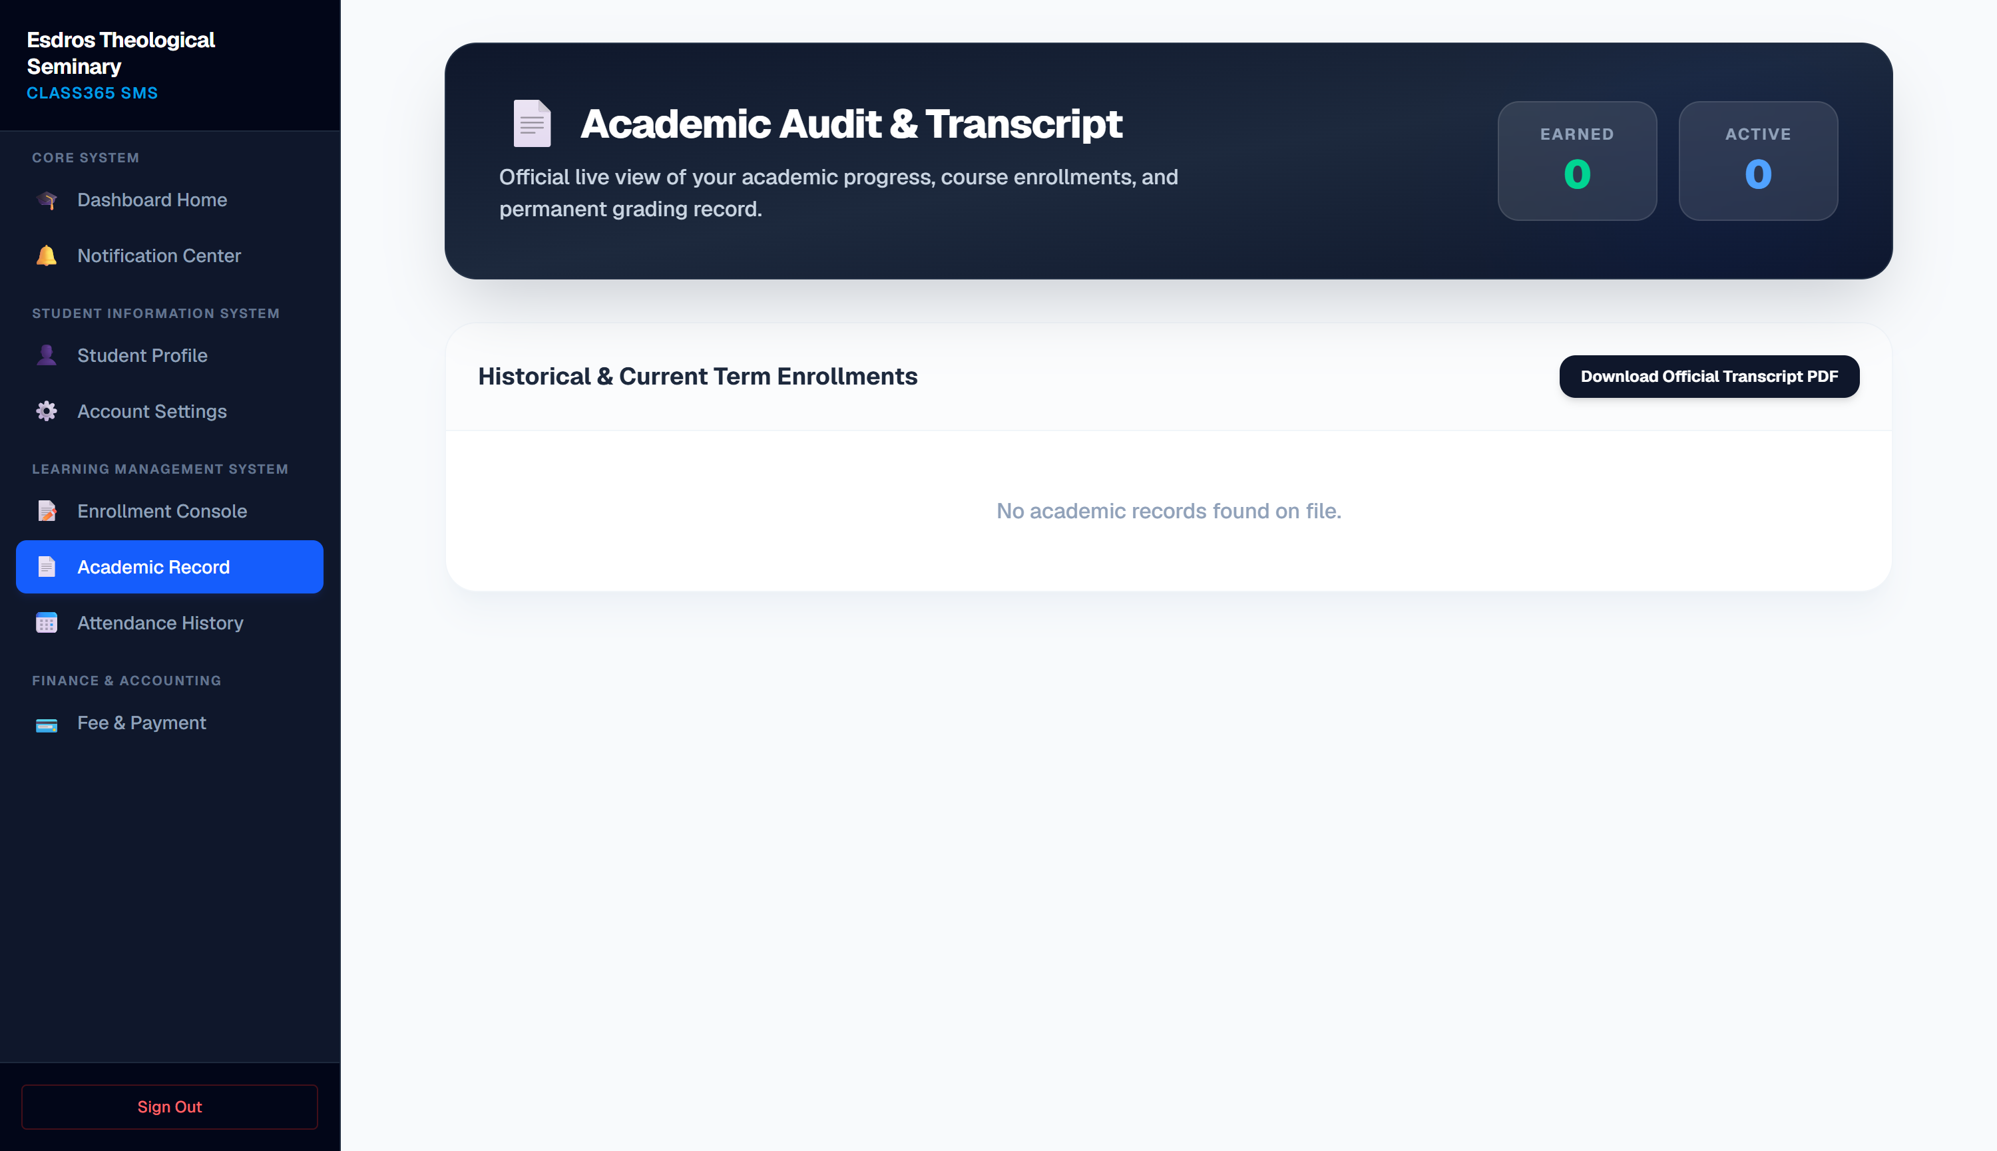
Figure 4.4: Real-Time Classroom Attendance Tracker Dashboard
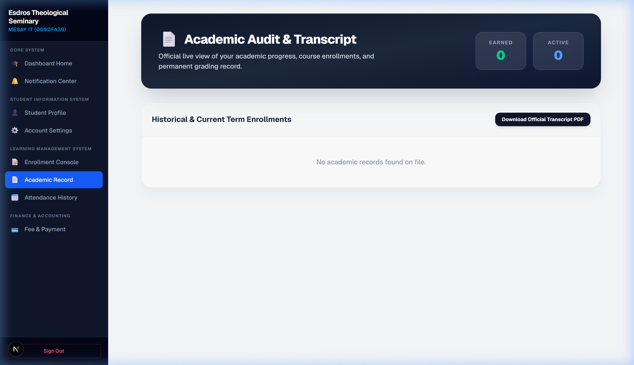
Figure 4.5: Student Tuition Balance Ledgers & Invoice Center
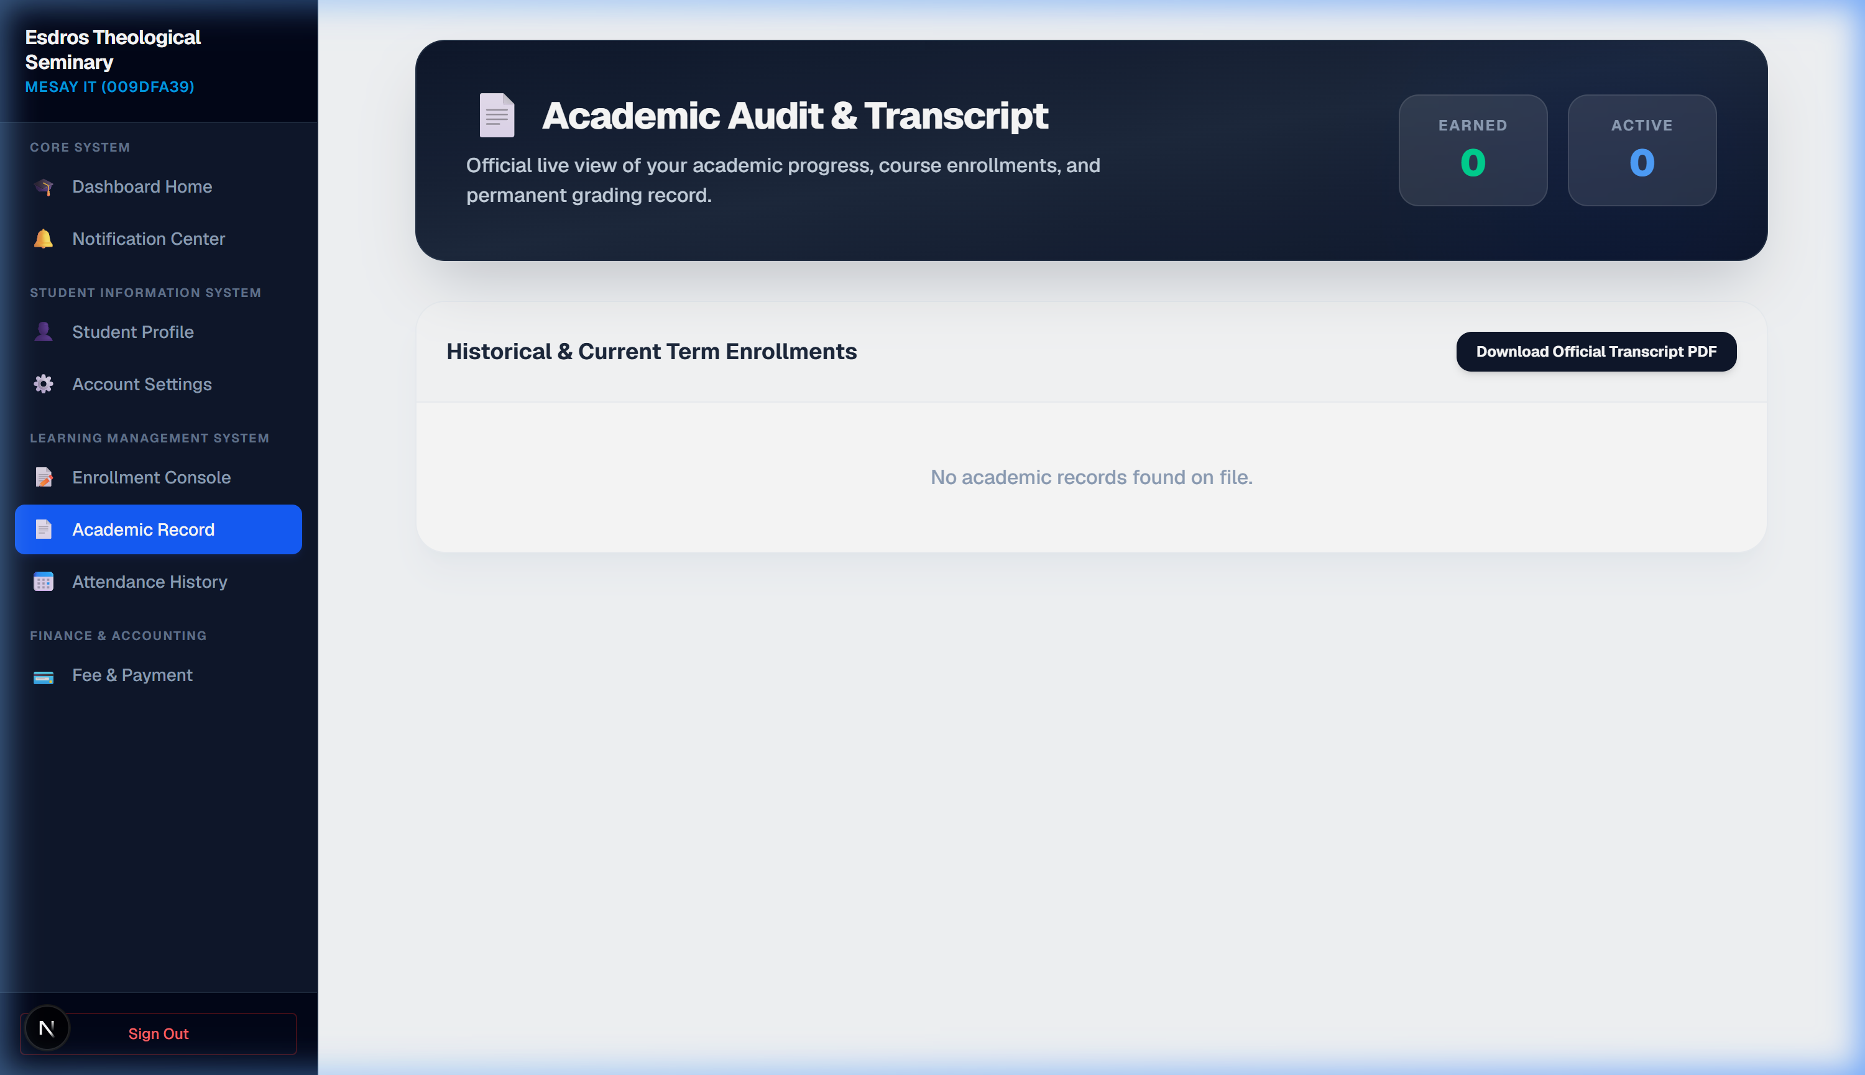
Figure 4.6: Security settings, password resets, and withdrawal portal page

5. Faculty Portal Operations & Academic Tools
Instructors coordinate student section attendance, register grades out of 100, and coordinate schedule calendars directly with seminary chairs.
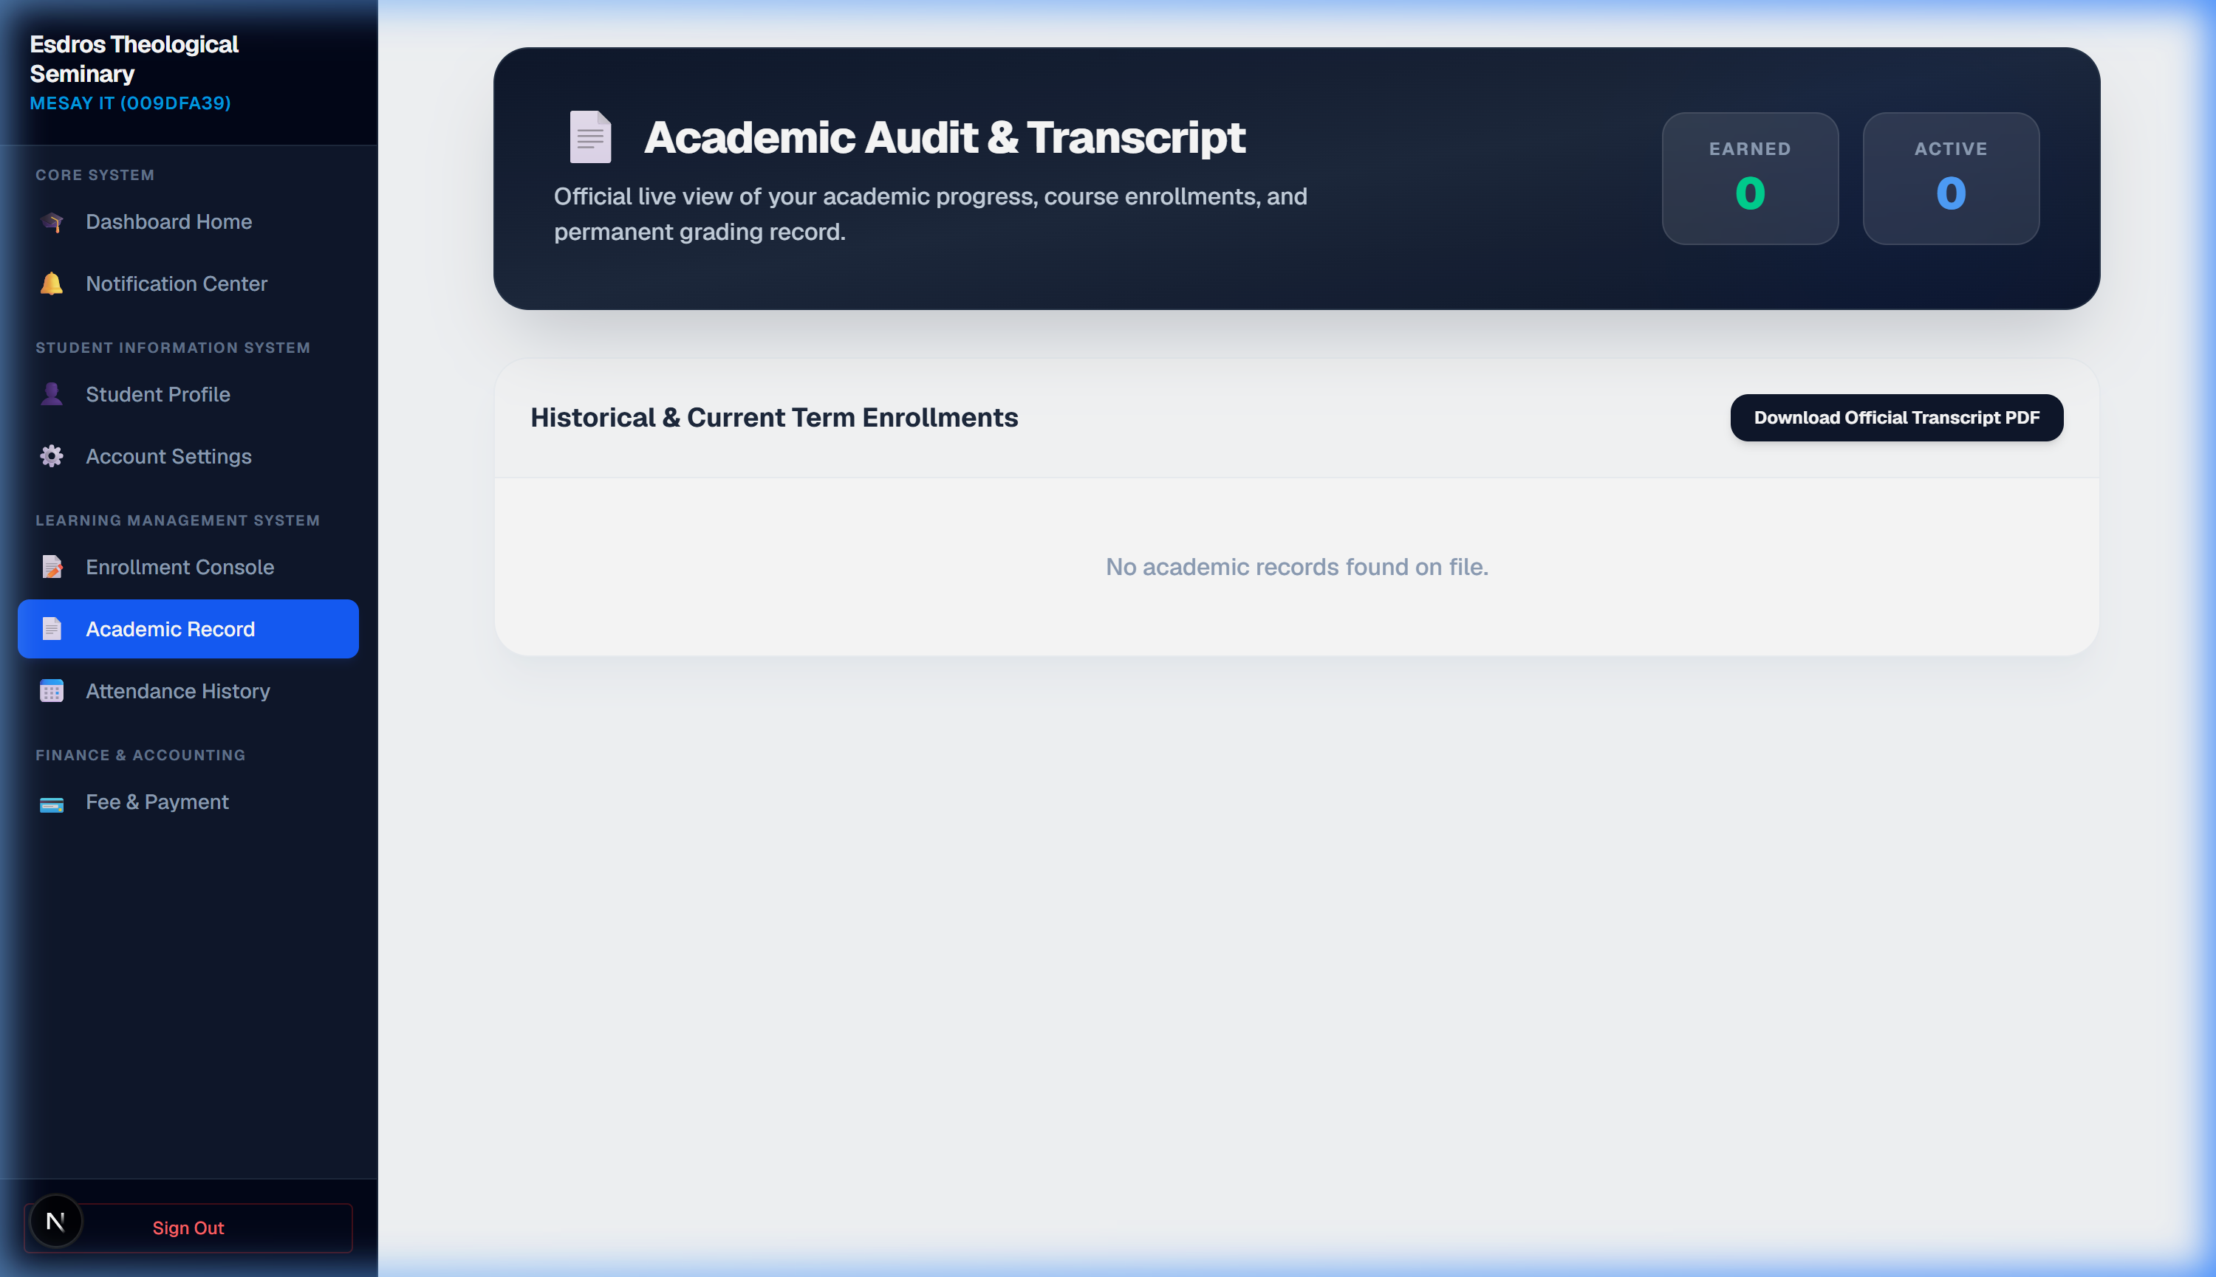
Figure 5.1: Faculty Portal Home & Active Classroom Telemetry Overview

5.1 Attendance rosters & Grade submissions
• Classroom Attendance (/dashboard/faculty/attendance): Allows logging student attendance logs. Important: Students who are graduated, dismissed, or withdrawn are automatically excluded from the roster list.
• Gradebook Submissions (/dashboard/faculty/gradebook): Instructors enter numerical score values out of 100. The system automatically converts numbers into letter grades (A, B, C) in the backend tables, preventing arbitrary grade entry errors.
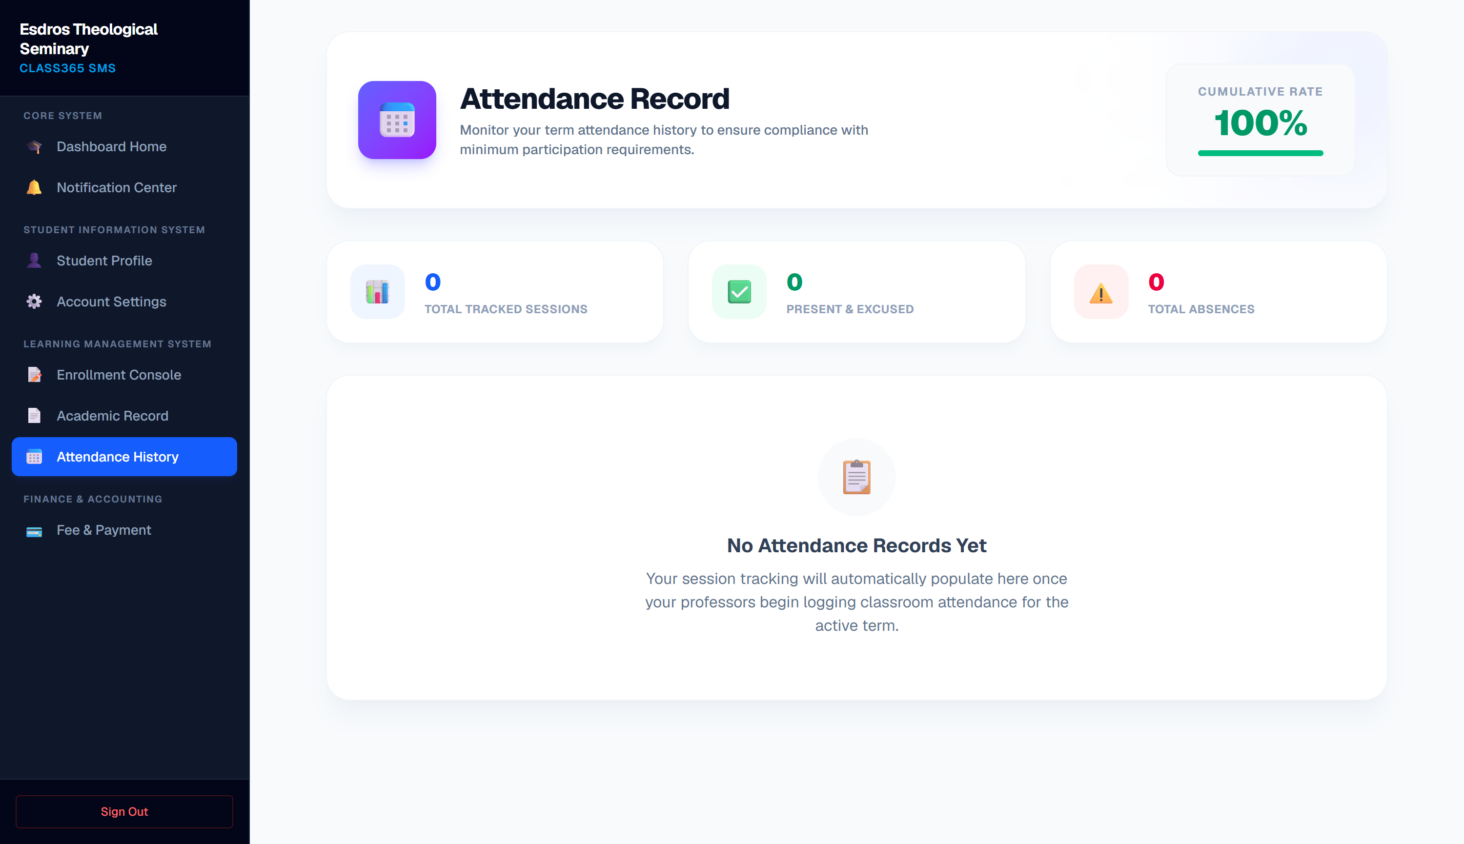
Figure 5.2: Faculty Student Classroom Daily Attendance Log
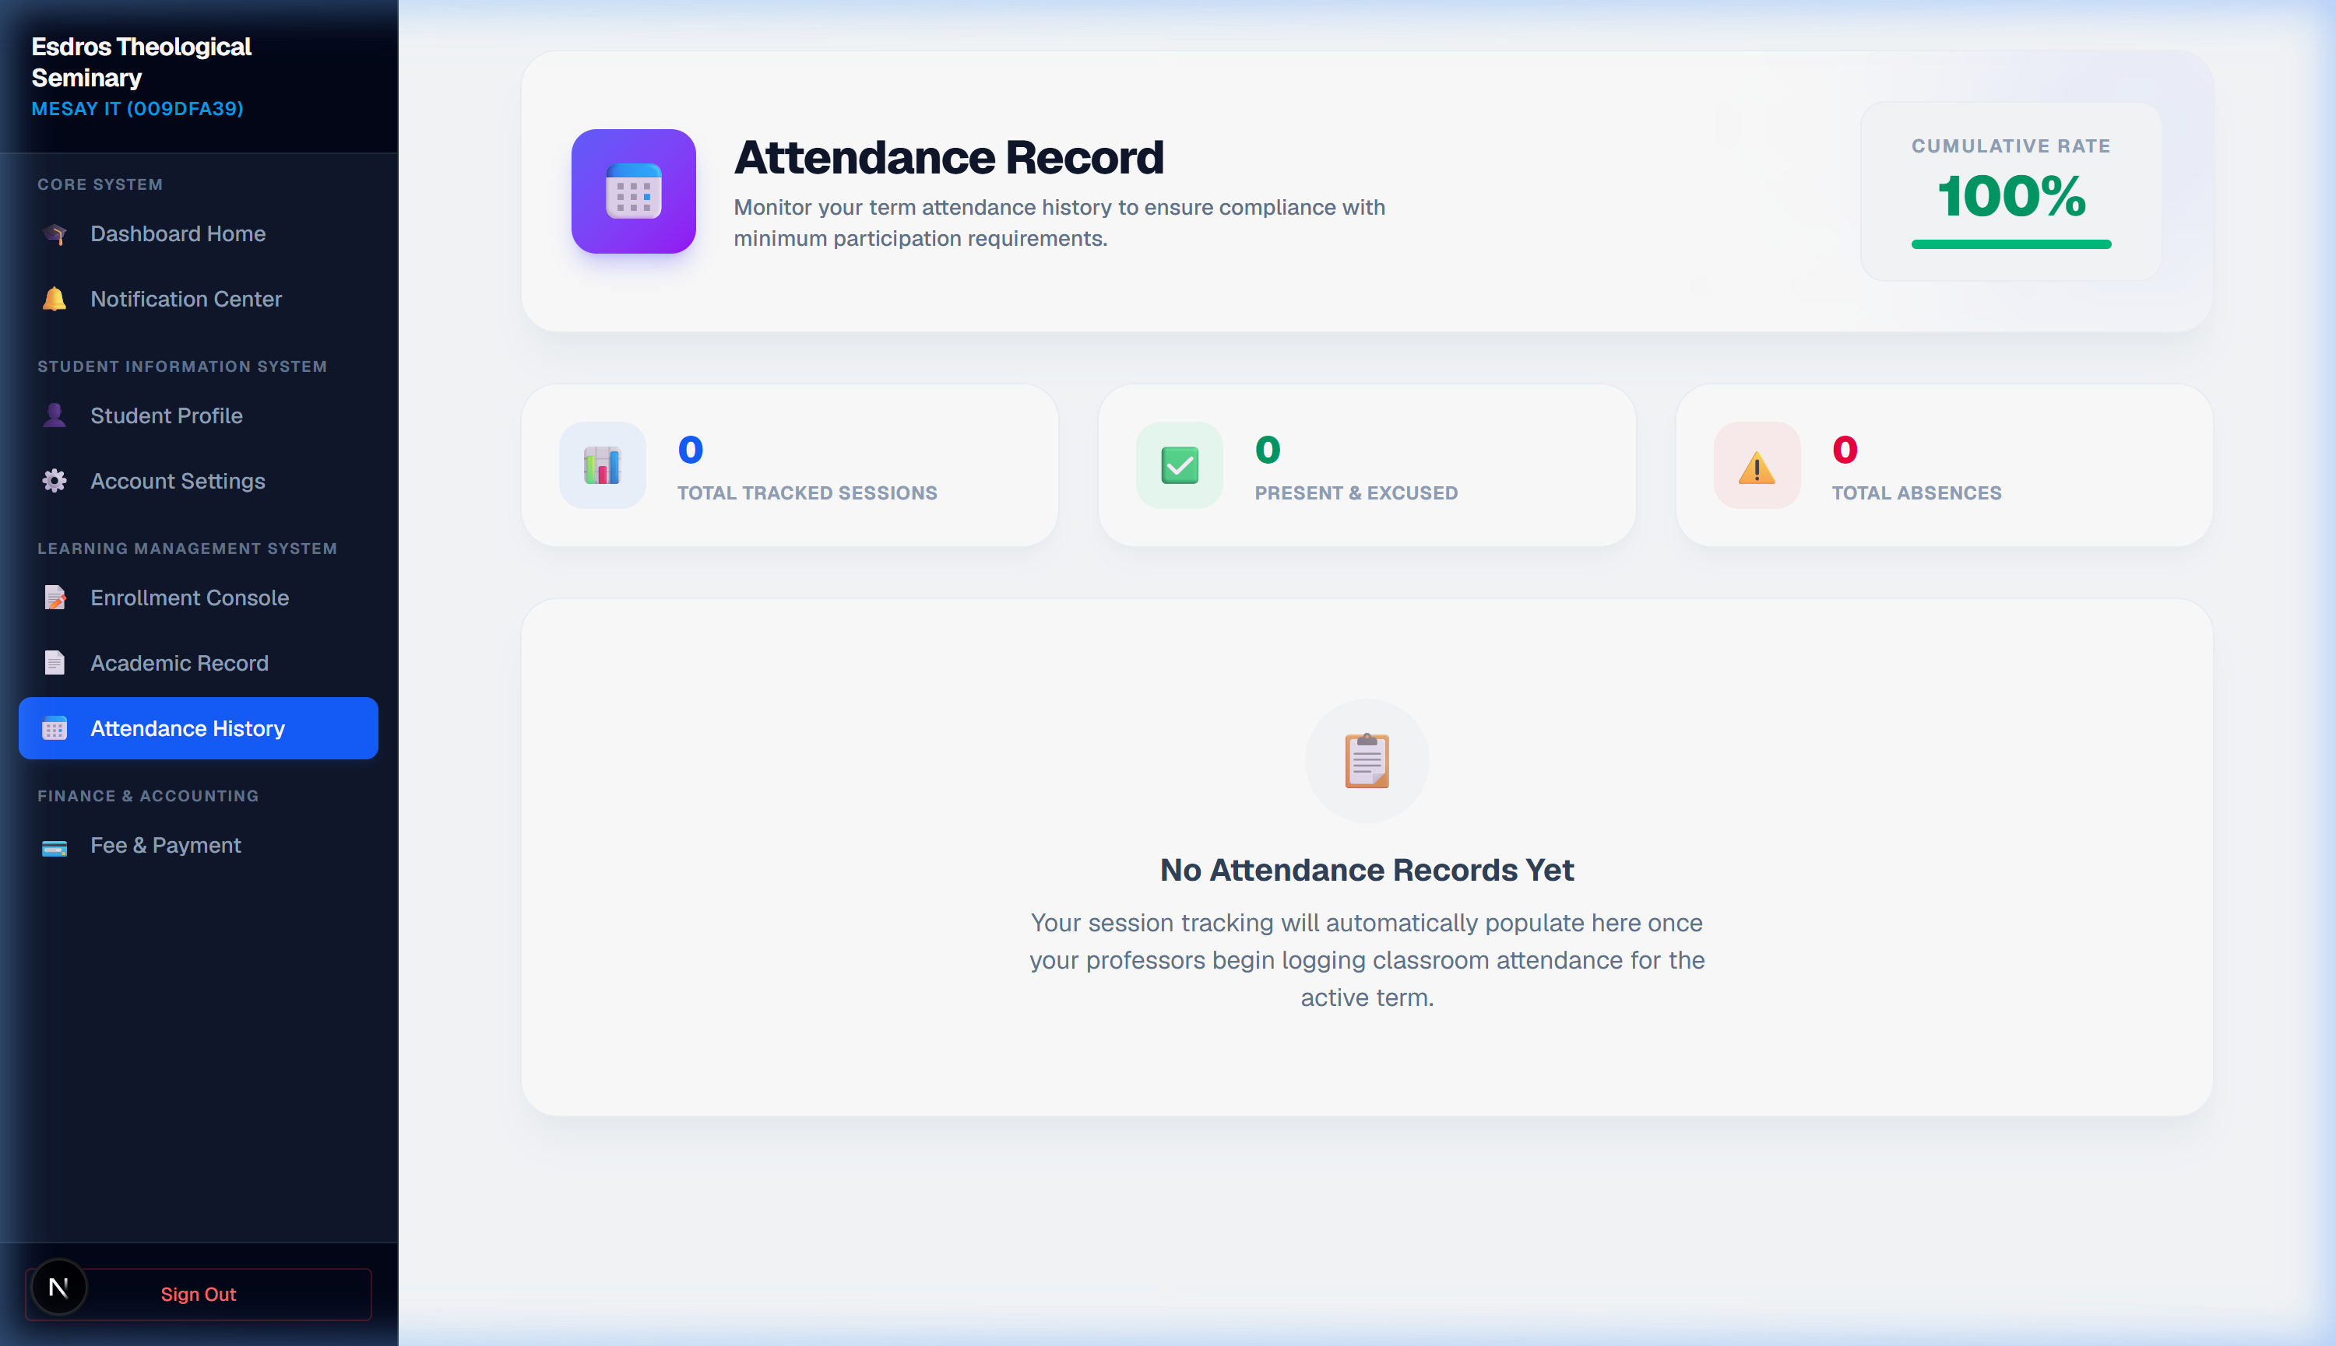
Figure 5.3: Faculty Student Grade Entry Dashboard Console
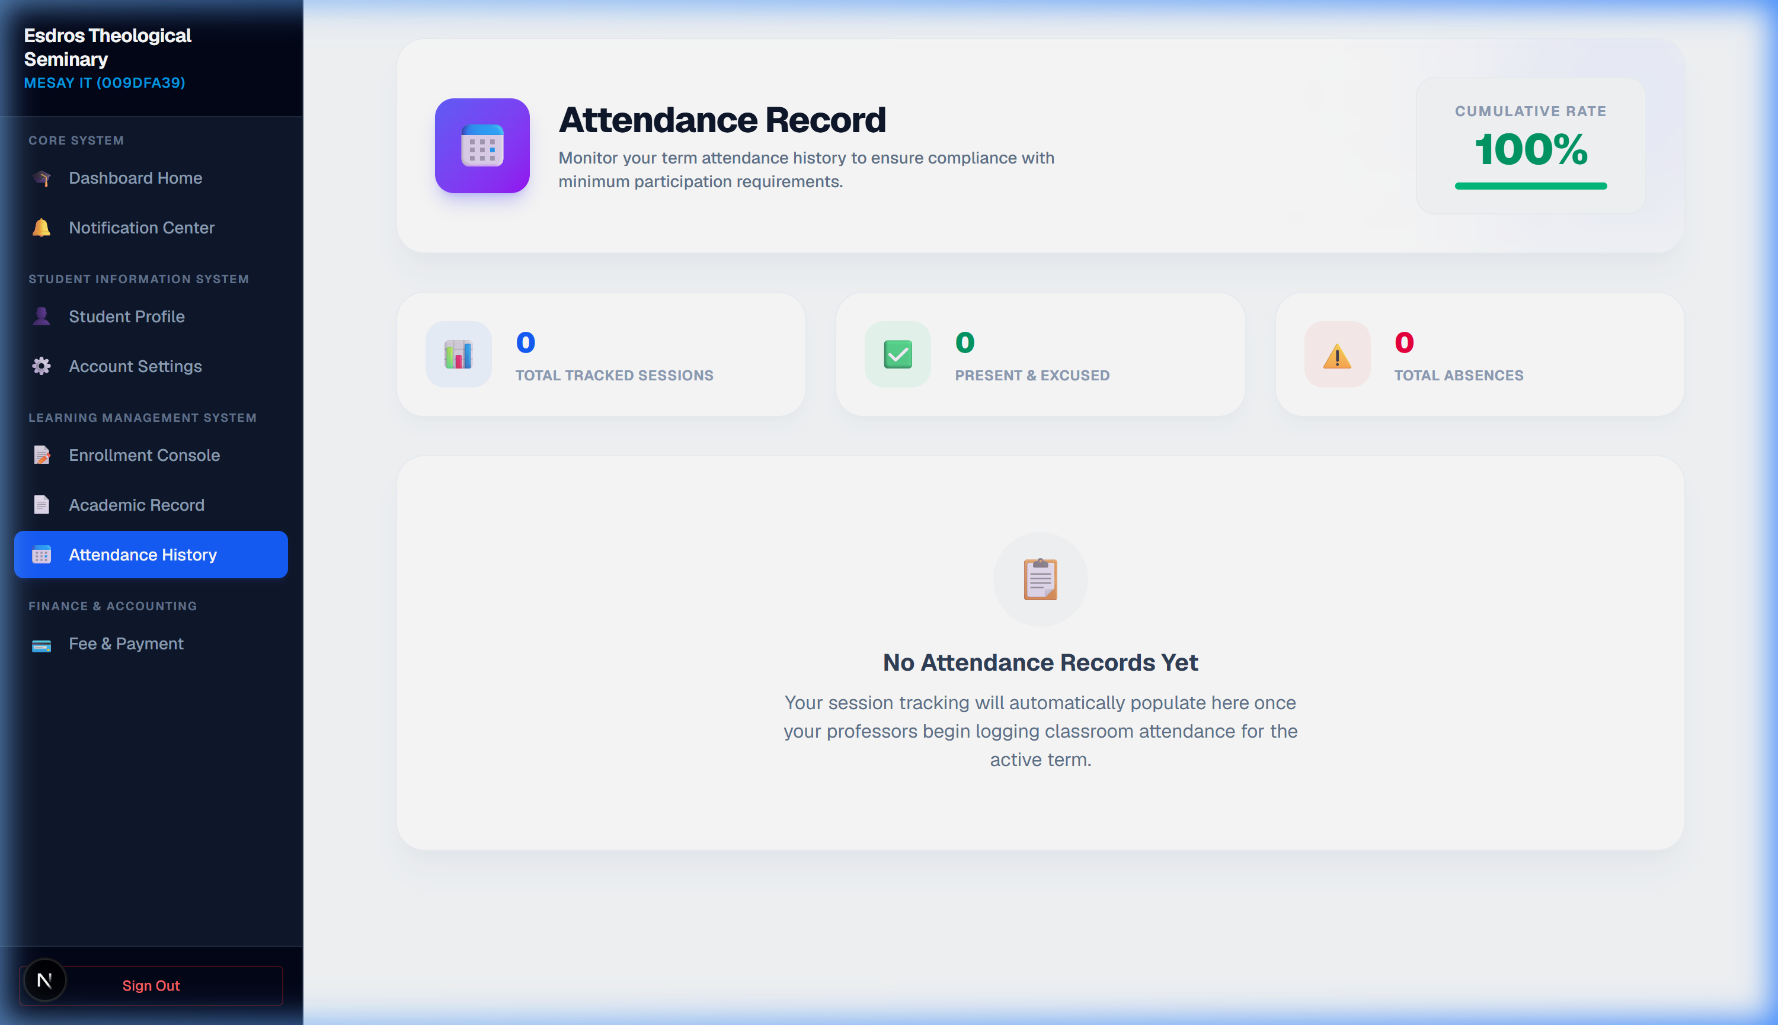
Figure 5.4: Faculty Profile Configuration Dashboard Panel

6. Administrator Portal & Telemetry Console
The administrator panel coordinates system settings, admissions CRM review pipelines, dynamic official transcripts delivery, and structural academic bulk Excel imports.
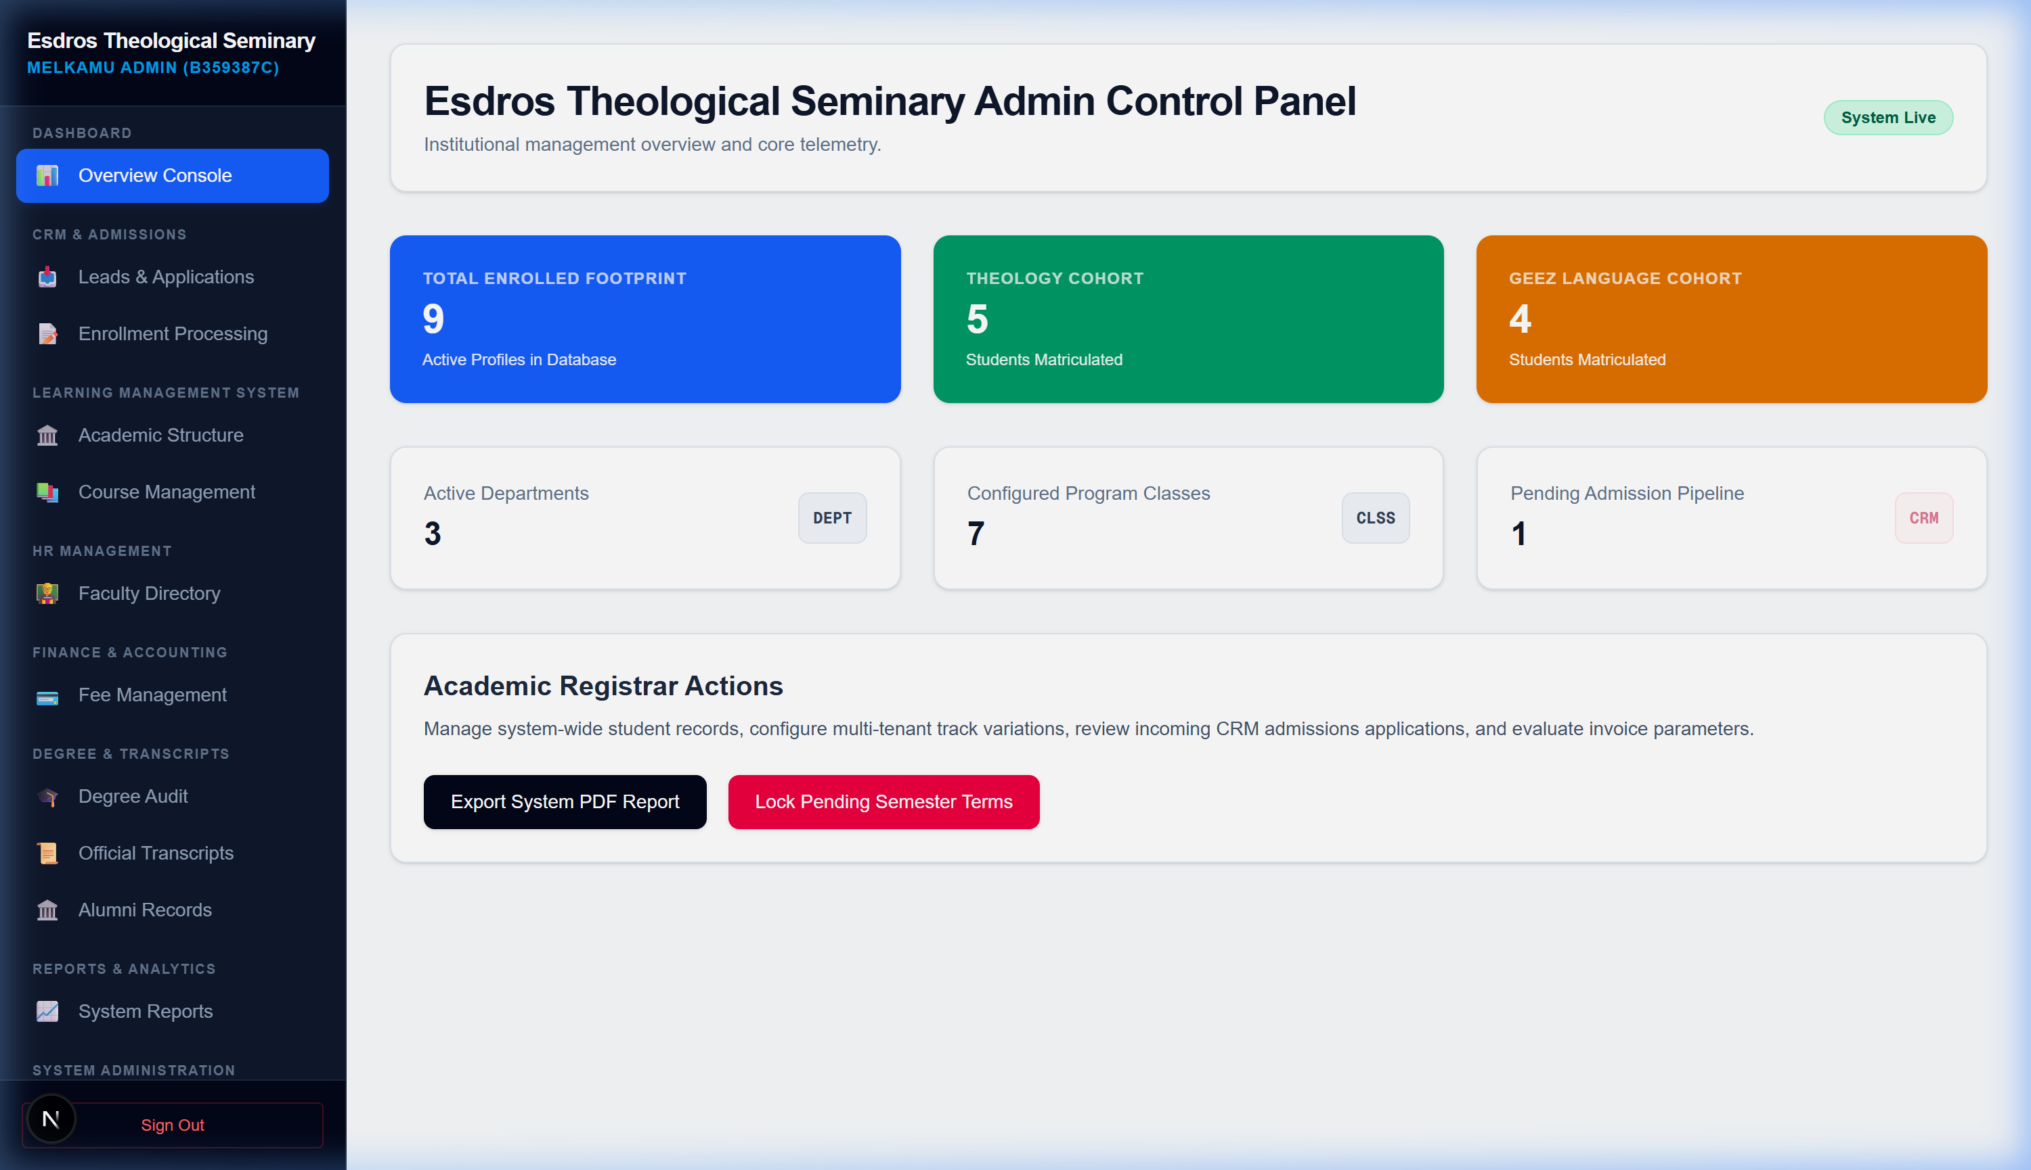
Figure 6.1: Administrative Main Console Overview

6.1 Access Control, Settings, and Official Transcripts subpages
• Access Control Tiers (/dashboard/admin/manage-admins): Super Admins promote/demote Standard and Restricted Admins dynamically without code edits.
• Integrations Settings (/dashboard/admin/settings): Define SMTP outbound mail gateways and synchronizations for external accountants like Aplos. Note: Restricted admins cannot access or edit this page.
• Records & Transcripts (/dashboard/admin/transcripts): Review student withdrawal requests and process official, printable academic transcripts directly to dynamic distribution lists.
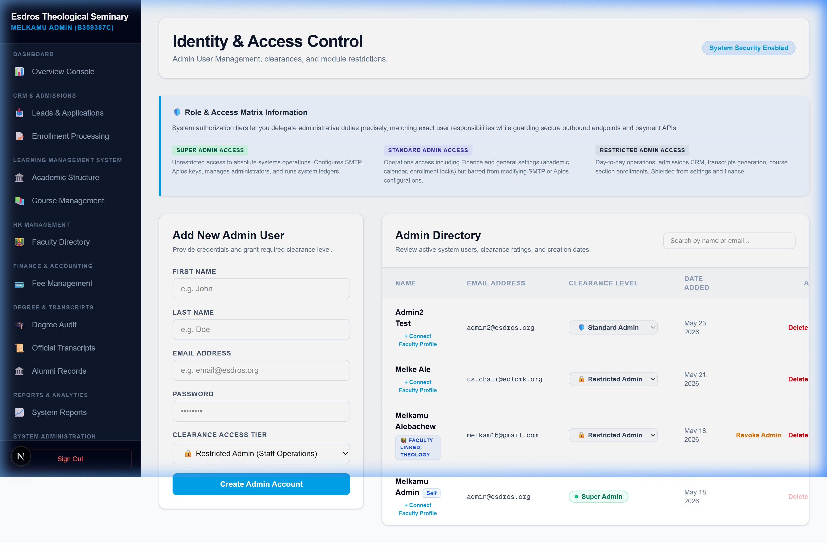
Figure 6.2: Access Tiers Directory Console for Clearance Promotion & Demotion
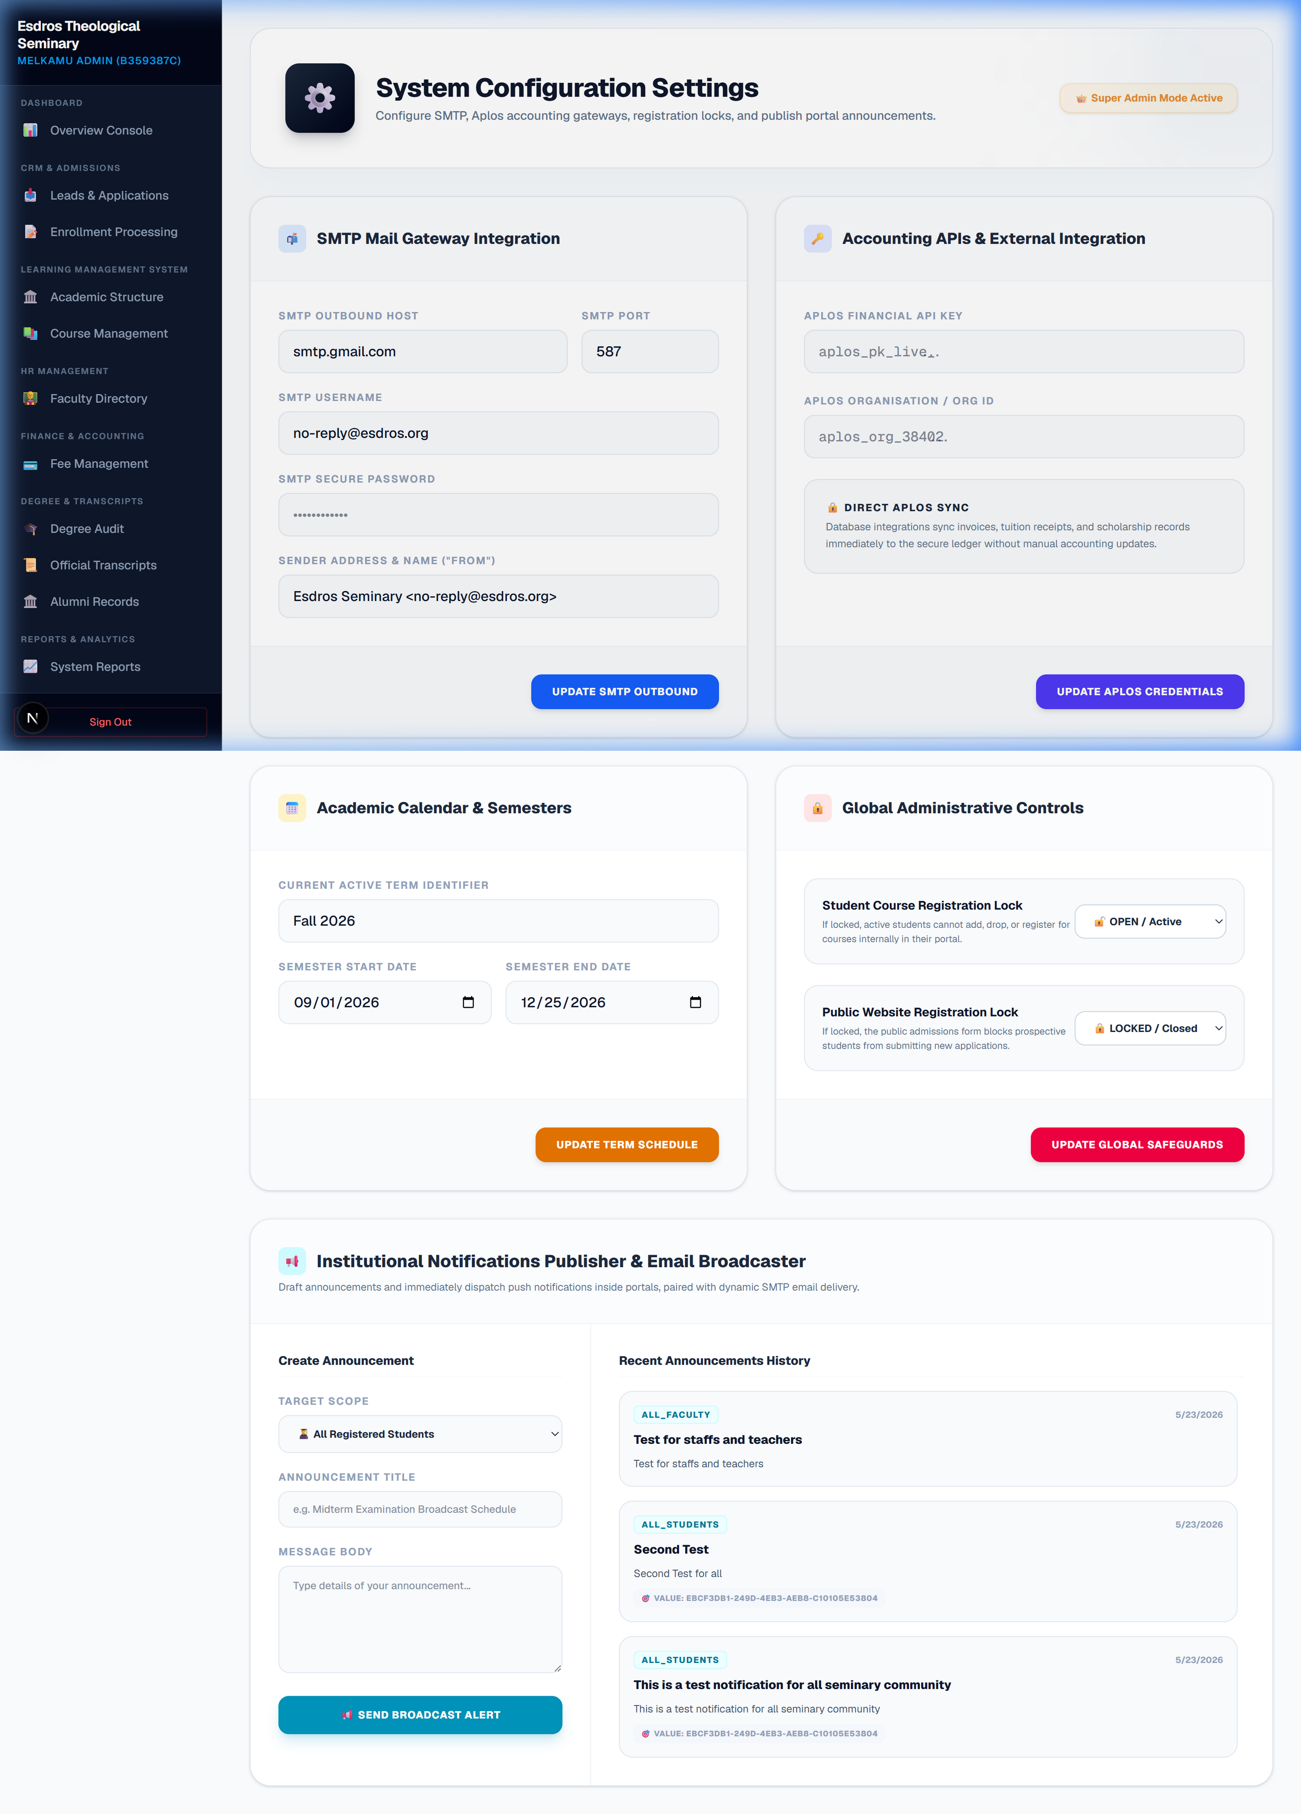
Figure 6.3: Integrations outbound SMTP & accounting system configurations console
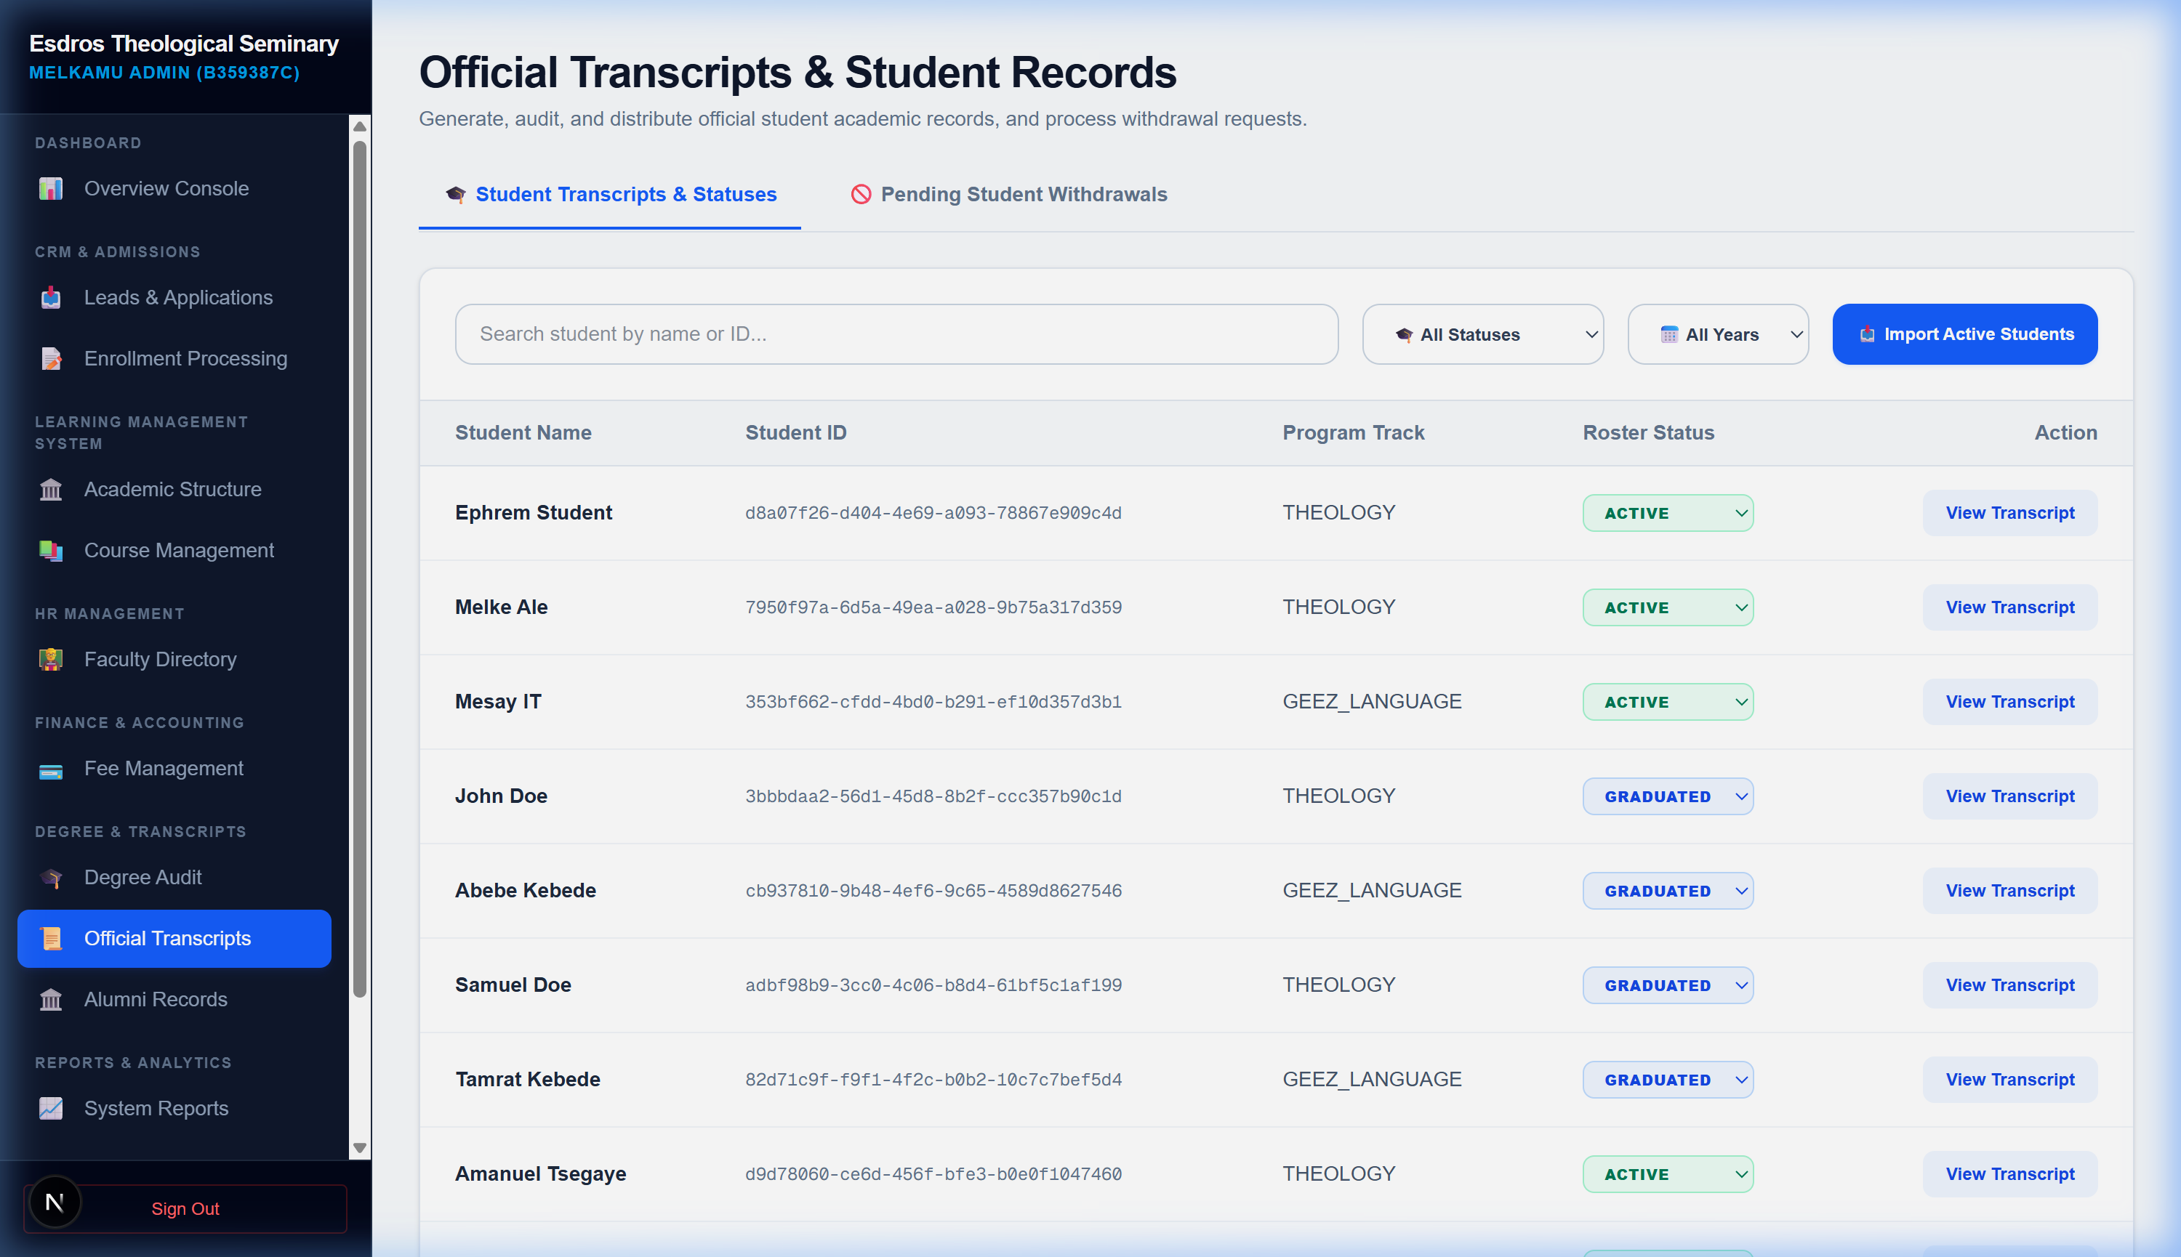
Figure 6.4: Official Transcripts Management and Withdrawal process console

6.2 Bulk Academic Structure Excel Import System
Located at the top of Setup Academics page (/dashboard/admin/academics), this system enables bulk creation of Departments, Class Cohorts, and Courses via standardized Excel uploads.
Step-by-step instructions to use:
1. Download Template: Click "Download Excel Template" to generate a compiled workbook containing three structured sheets (Departments, Classes, and Courses) pre-populated with examples.
2. Populate Excel: Enter your institutional structures. Keep exact values for 'DepartmentCode' in the Classes sheet and 'ClassCode' in the Courses sheet to match links properly.
3. Upload Spreadsheet: Click or drag your completed academic structure Excel file into the Dashed Upload Zone. The system processes rows using transactional ACID integrity, rolling back all changes if any single record fails validation.

