

**ADDIS ABABA UNIVERSITY**

**COLLEGE OF NATURAL AND COMPUTATIONAL SCIENCE**

**COMPUTER PROGRAMMING II PROJECT**

**TITLE: ADVANCED LIBRARY MANAGEMENT SYSTEM**

Group Members

Name ID Number

1. MIHRETU ENDESHAW UGR/4579/12

2. WUBESHET ABERA UGR/4143/12

3. MESFIN LODAMO UGR/0078/12

4.MELKAMU ZINABU UGR/2909/12

Submitted to: mr. Tsegazeab Hailegebrial

Submission Date:6/17/21

INTRODUCTION

A Library Management System (LMS) gives access to and manages the resources in your library.​ A well-chosen system will increase your library’s efficiency, save valuable administration time, lead to a better educational experience for pupils and help develop independent learning.

A typical computerized LMS has the following functions/modules as standard:

* Deleting , Adding , Searching ,Viewing booklist And also have many more function or module that used to manage issue books .

As programming II student we write this c++ program that can be used as digital library management system for the purpose of managing books in the library. It simplify the difficulty of managing library manually.

**OBJECTIVES OF THE PROJECT**

The objective of the project is to put the basic programming skill learned so far in this semester starting from c ++ basic up to somehow a complex concept of c ++ that is object oriented to solve the real world problem as much as possible.

In this code , we are going to program the library management system project in C++ with simple and easy code. Basically, we are going to give the project different features like to add, delete, search , update books and also manage issue book. There are many more features we are going to use in the library management system project.

These are :-

• Add, Remove, View all book list , Update Books , record borrowed book , view issue book and return book easily that will make it more efficient.

• Authentication- user can easily login to the ADLMS service with different roles. If you are an admin then you will get the admin id and password which allow you to easily access the admin services and the same for all the users.

**#define ADMINUSER "le"//** macro substitution for librarian username

**#define ADMINPASSWORD "12"//**macro for librarian password

**#define USER "st"//**student username

**#define USERPASSWORD "34"//**student password

• Database- All the information added or removed will be updated in the database. If you are an admin then you can access and edit the database.

**PROJECT EXPLANATION IN DETAIL**

* We create a menu to select a user whether he/she is a student or librarian .
* After selection of role , the user will enter his username and password which will give them access to the library management system .

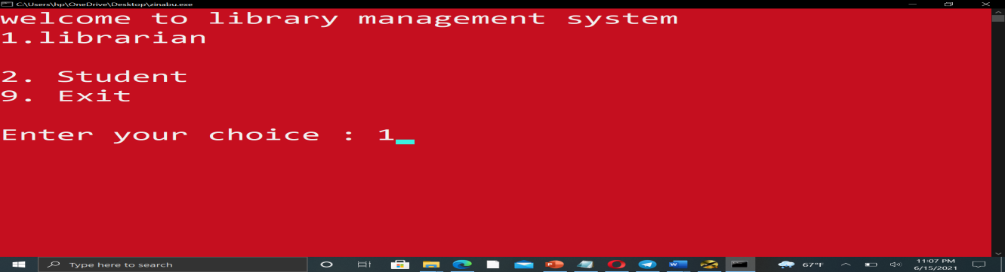

* If you logged in as a librarian then there will be access to different services like
* Add , Remove ,Update the books,search book,return book…

Also, there is an access to see the list of all the books. 

* If you click on add books then you can easily add the book by entering the book id, book name and author name.

You can also delete or update the books, just select the option from the list, that's it.

For further understanding you can refer the below source code output sample.

.

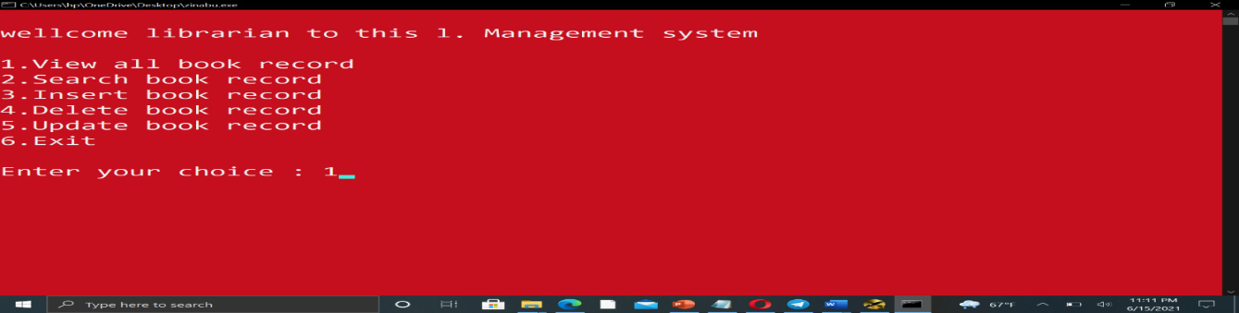

* If you logged in as a student then there will be access of different services like: View list of book ,Search a book ,Exit as you choose.
* If you click on view all book list then you can easily view the book entered by the library admin(librarian) .

You can also search the books, just by selecting the option from the list, that's it.

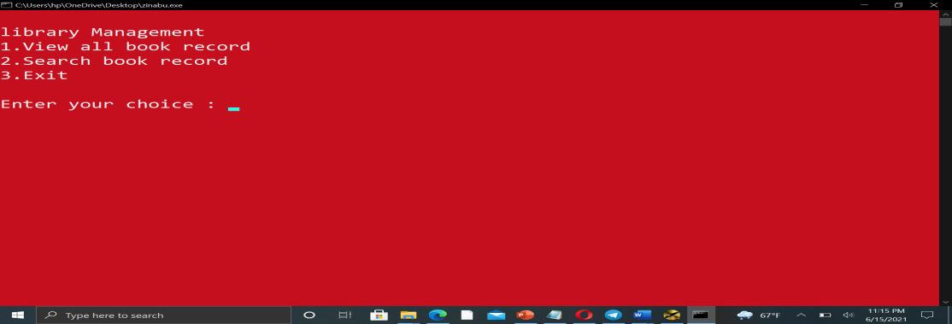

**CONCLUSION**

In this project we write a simple mini c ++ program that can used as a library management system for those who want to manage books digitally. As we explain above the project encompass all c ++ concept acquired so far and it provides different services for users including deleting, adding, updating book ,issue book,return book,and also viewing all recorded books.

Generally, this c ++ mini project t:-

* gives information about books for students and librarian in easy way and simple way
* It solve the problems of manually stored data limitation.
* It gives fast and secure data access.

**REFERENCE**

WE refer the following materials:- 1, [www.javatpoint.com](http://www.javatpoint.com).

2, Senior aau student project and also www.geeksforgeeks.com (with the help our teacher).