**Mongo-DB-Checkpoint**

* ***Create a database called "contact"***

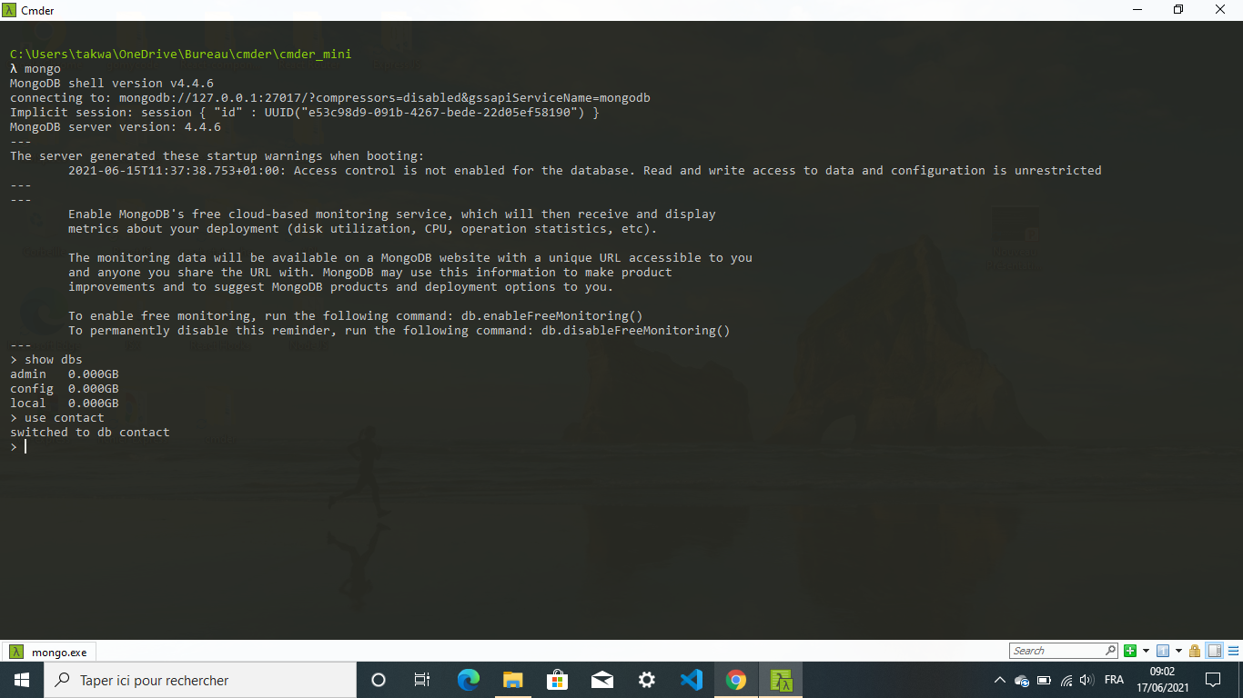

* ***Create a collection called "contactlist" + Insert these documents  in "contactlist"***

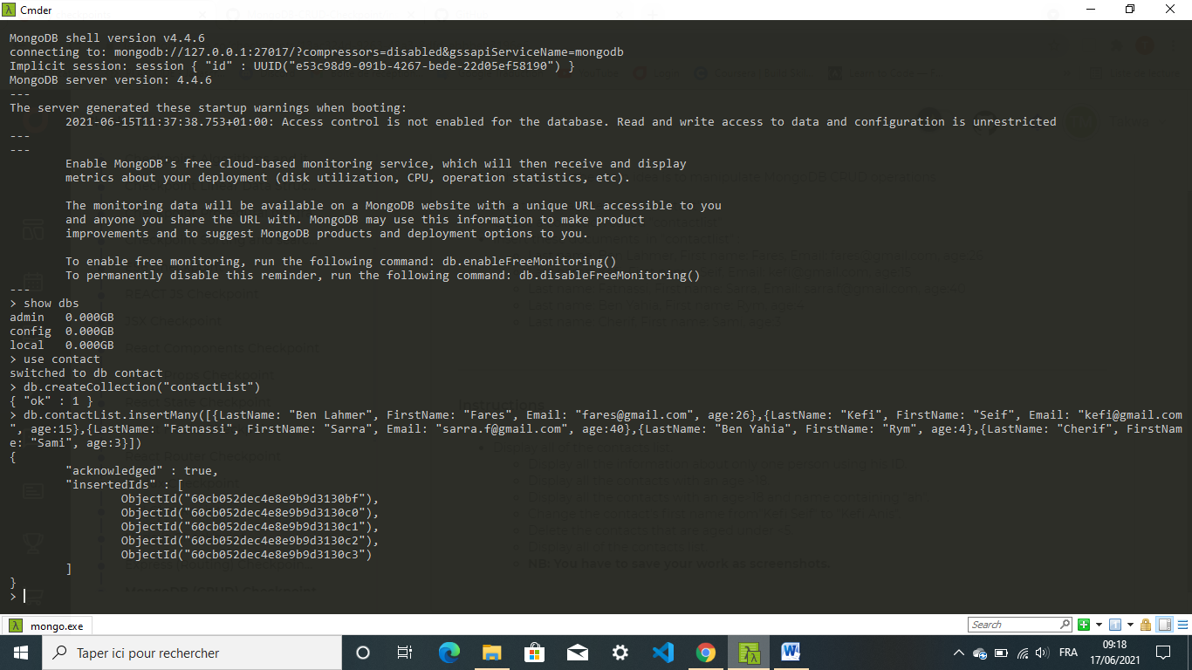

* ***Display all of the contacts list***

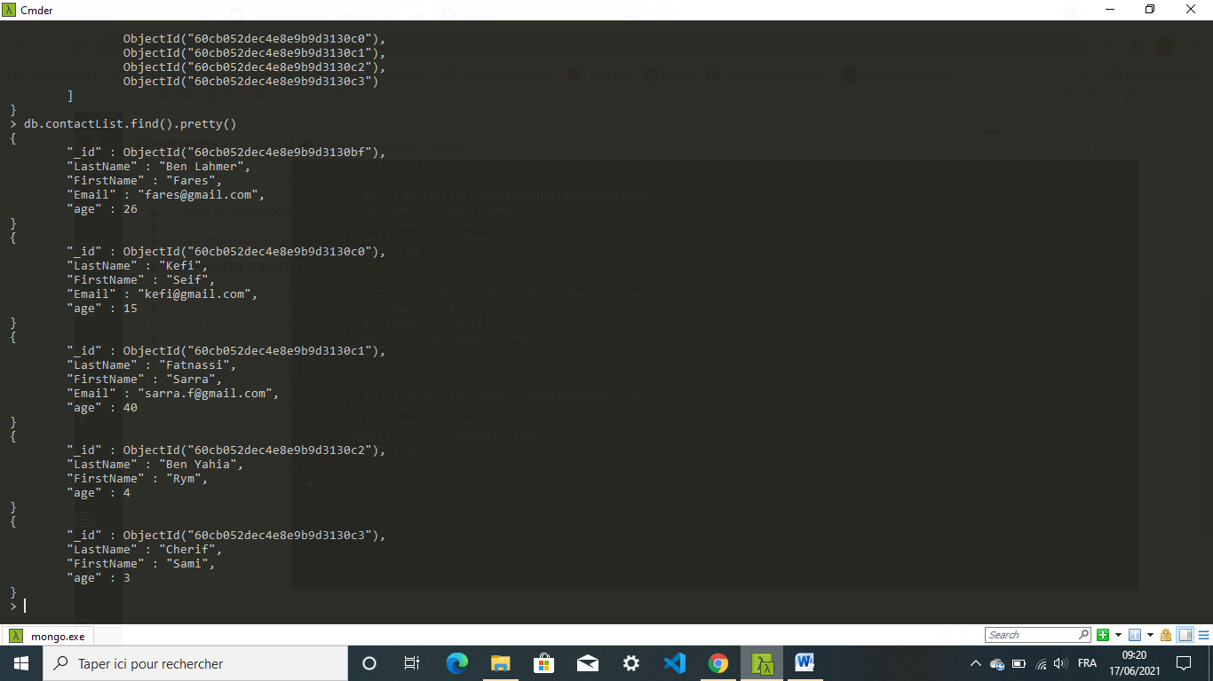

* ***Display all the information about only one person using his ID***

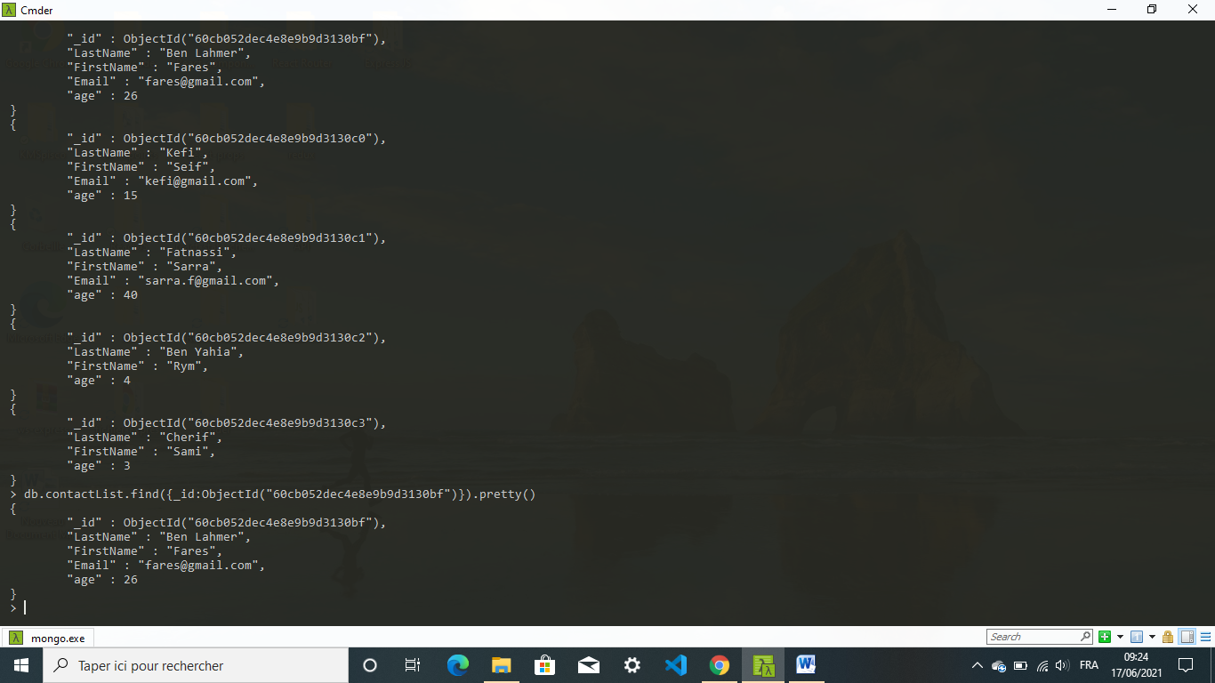

* ***Display all the contacts with an age >18***

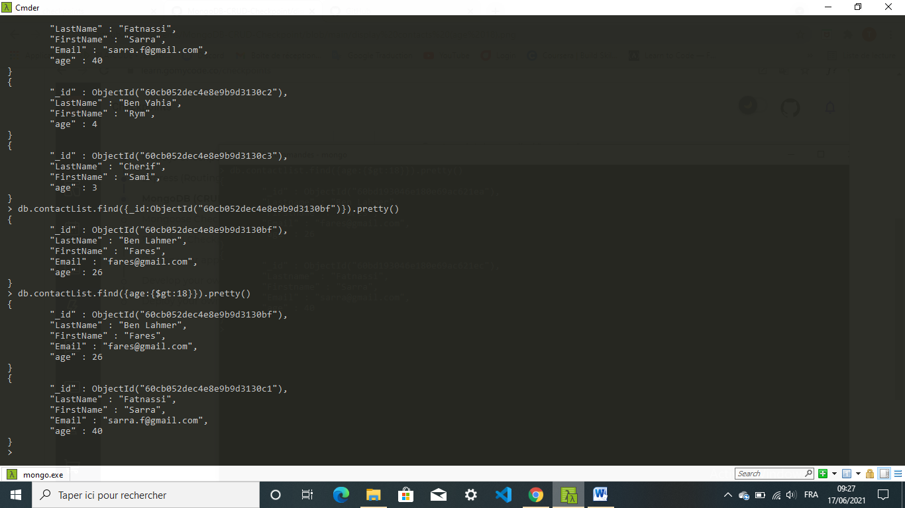

* ***Display all the contacts with an age>18 and name containing "ah"***

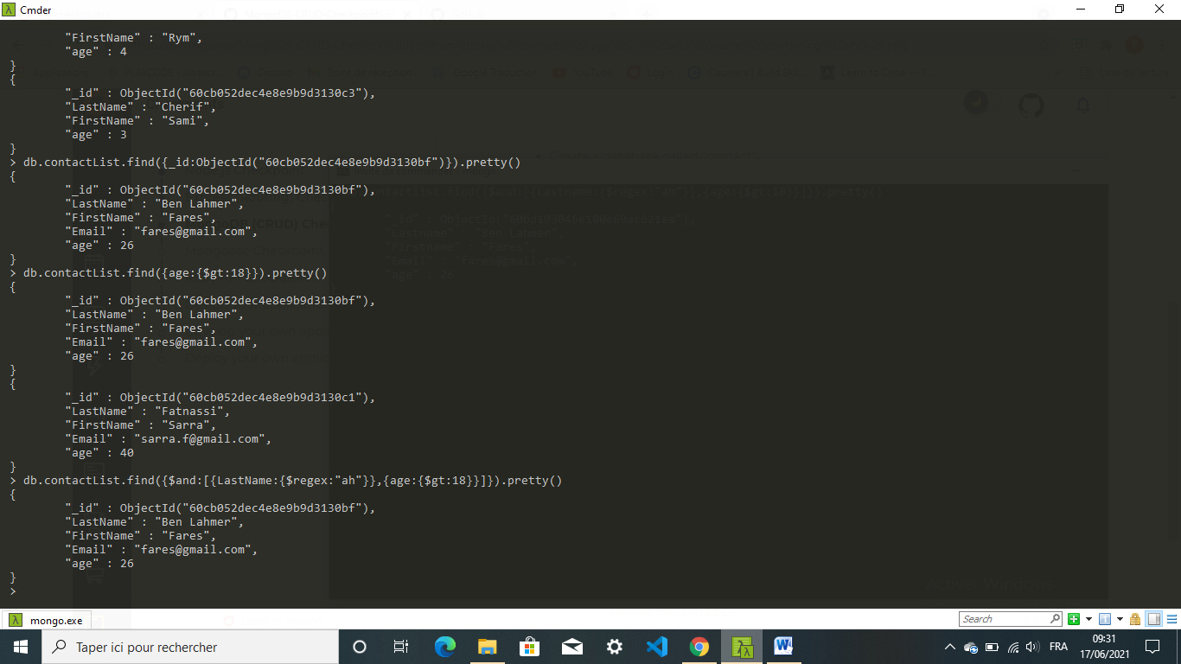

* ***Change the contact's first name from"Kefi Seif" to "Kefi Anis"***

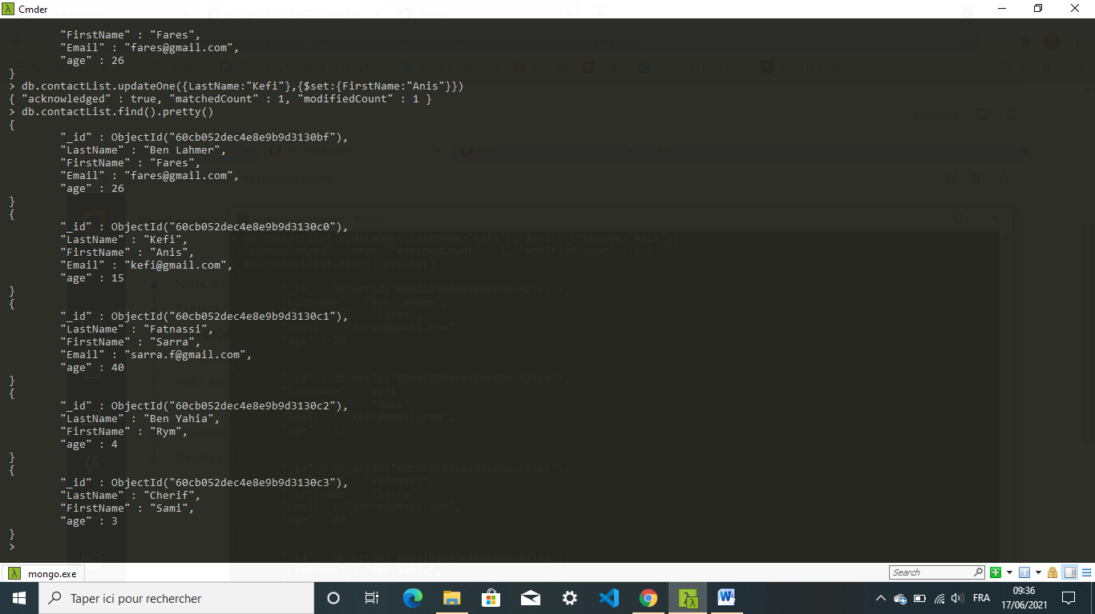

* ***Delete the contacts that are aged under <5***

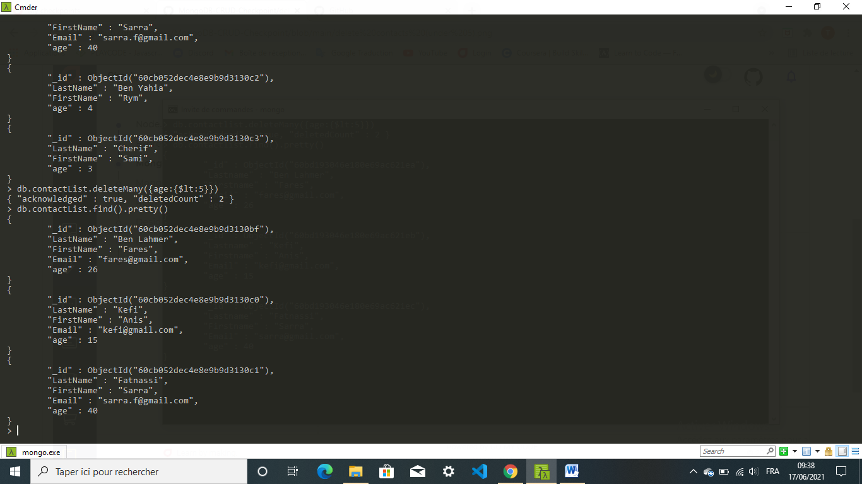

* ***Display all of the contacts list***

