2025-05-02
- Finished web scraping portion of project. I first navigate to login page to extract CSRF token because Ravelry.com requires user to login to view all page content. Then I navigate to the projects section on the pattern page where it lists all posted projects in cards. I am web scraping this data:
  - Username
  - Yarn name and colorway used for project
  - Project notes which act as “reviews” for this purpose of this project.
  - Status: Is the project completed or still unfinished?
  - Date: Date which project was started
  - Url: Link to project notes page for full details
- Contemplating whether to web scrape more data in future, for example: Date which project was completed (if completed)
2025-05-03
After accumulating data, I export as an excel file for later use such as uploading to a database in SQL Server. I also trained a NLP model to try and interpret human language using a guide written by Robert De La Cruz.
The data that used to train the model is an Amazon reviews dataset, “which consists of reviews from Amazon customers downloaded from Xiang Zhang’s Google Drive. The dataset spans 18 years, including ~35 million reviews up to March 2013. Reviews include product and user information, ratings, and a plaintext review. “
The guide trains the model to only predict ‘positive’ and ‘negative’ sentiments, but I decided to train my model with a third ‘neutral’ sentiment. The Amazon reviews dataset includes review ratings from 1-5 stars and Robert converts reviews with 1- star ratings as ‘negative’ and 2- star ratings as positive, although I am not sure why.

For my model, I converted 1- and 2-star ratings to negative, 3- star as neutral, and 4- and 5- star as positive. However, I am wondering if a 3- star rating is considered positive rather than neutral and I would imagine that it depends on an individual’s personal rating system, which adds some nuance. Regardless, I moved forward with this rating system and produced the following report:
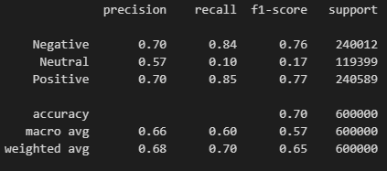
2025-05-04
The report for the model shows values lower than I anticipated, but I wanted to try and use the model anyway on the web-scraped data from Ravelry.com to predict sentiments. I added a new column, predictions, into the data frame and looked over the results. In general, I noticed that the model was quite inaccurate for this data. The model itself was not especially precise or accurate to begin with and it seems like I need to reevaluate how I plan to train the model. I also see a potential issue in how using an Amazon reviews dataset could cause problems for predicting sentiment in project notes of a knitting project since they are not extremely similar. It’s possible to create my own dataset to train the model but this would take an extremely long time.

