Supplemental Methods.
Table S1. Variable mapping table between R code with associated packages and manuscript labels. Raw variables used only in data preparation are indicated with a dash in the manuscript label column.
Manuscript term | R variable name | Description | Standardized?
DNA methylation | DNAm | Binary DNA methylation state at each CpG (0 = unmethylated, 1 = methylated) | No
Time, time during infection | timedayz | Time during infection, standardized | Yes — mean = 0, SD = 1
— | timeday | Raw time during infection in days; used prior to standardization | No
CpG | CGsite | CpG site identity in blood temporal model (reference: CG01 = CpG 1; levels: CG01–CG05) | No
CpG | SiteEuth | CpG site identity in tissue euthanasia model (reference: CG01 = CpG 1; levels: CG01–CG05) | No
EP | EP | Epigenetic potential category (reference: high; levels: high, low) | No
Sex | Stage | Sex (reference: adult female; levels: adult female, adult male, juvenile) | No
Body mass | BodyMassz | Body mass, standardized | Yes — mean = 0, SD = 1
— | BodyMass | Raw body mass; used prior to standardization only | No
Final Salmonella burden | FinalSBc | Final Salmonella burden, standardized | Yes — mean = 0, SD = 1
— | FinalSB | Raw final Salmonella burden; used prior to standardization only | No
Individual, bird | BirdID | Bird identity; random effect grouping factor | No
Tissue | Tissue | Tissue type (reference: blood; levels: blood, liver, spleen) | No
Slope | slope | Estimated change in DNA methylation probability per bird per CpG site, derived from posterior of Model 1, DNA methylation temporally over infection in blood; computed on the logit scale | No

Model 1: DNA methylation temporally over infection in blood
To estimate DNA methylation in the putative promoter of TLR4 while accounting for repeated measures across the infection period and CpGs nested within individuals, we used a hierarchical Bayesian generalized linear mixed model (GLMM) approach in ‘brms’ package (version 2.23.0; Bürkner, 2017) using ‘cmdstanr’ (version 0.8.0; Gabry et al., 2025) in R v4.5.0 (R Core Team, 2025; Nalborczyk et al., 2019). For all models, DNA methylation (“DNAm”) was the binary behavior for each CpG site at each time point through the infection period. “Time” represents the standardized time during infection in days (mean = 0, SD = 1). “Body mass” refers to the standardized body mass (in grams; mean = 0, SD = 1) upon capture (determined in Sheldon et al., 2023). “CpG site” refers to the categorical identifier of each CpG site in the putative promoter of TLR4, with CpG 1 representing the CpG site most upstream of the transcription start site (identified in Kilvities et al., 2019). Epigenetic potential (“EP”) refers to the categorical “High” or “Low” epigenetic potential status of the individual birds (determined in Sheldon et al., 2023). “Sex” refers to female, male, or juvenile classifications for each bird (determined in Sheldon et al., 2023). CpG (“CpG 1” reference), EP (“High” reference), and sex (“female” reference) were treated as a categorical predictors in model comparisons.
Prior to model specification, we compared candidate models with leave-one-out cross-validation information criterion with the ‘loo’ package (version 2.8.0; Vehtari et al., 2024) in R. We subset to complete cases (n=943, unique individuals = 31) for model comparison. We used the same prior specifications and ‘brms’ settings for model fitting for all models (Table S3).
Candidate models included: (i) DNAm ~ Time * CpG site + EP + Sex + Body Mass + (1+ Time | BirdID:CpG site), (ii) DNAm ~ Time * CpG site + EP + Stage + Body mass + (1 + Time | BirdID) + (1|BirdID: CpG site), (iii) DNAm ~ Time + CpG site + (1+Time|BirdID) + (1|BirdID: CpG site), and (iv) DNAm ~ Time * CpG site + (1+Time|BirdID) + (1|BirdID: CpG site). We assessed predictive fit with ELPD-LOO and standard error differences, such that a value more than 2 standard errors away from the lowest ELPD-LOO was considered significantly less informative than the lowest ELDP-LOO value (Vehtari et al., 2017).
We excluded the use of models including body mass, EP, and sex category as fixed effects. We elected to retain the interaction of time and CpG site a priori to model comparison, as this term allows for the extraction of derived slopes of change in DNA methylation for Model 2. However, predictive fit did not discriminate among candidate models that included the interaction of time and CpG site compared to the one that did not include the interaction term. We selected (iv) (DNAm ~ Time * CpGsite + (1+Time|BirdID) + (1|BirdID:CpGsite)) for refitting on the full dataset.
We modeled for binary DNA methylation, such that:
yᵢₜₛ ~ Bernoulli(pᵢₜₛ)
logit(pᵢₜₛ) = α + β₁Time_{t} + β₂CpG_{s} + β₃(Time_{t} × CpG_{s}) + uᵢ + vᵢTime_{t} + wᵢₛ
(uᵢ, vᵢ) ~ MVN(0, Σ)
logit(pᵢₜₛ) = α + β₁Timeₜ + Σⱼ β₂ⱼ I (CpGₛ=j) + Σⱼ β₃ⱼ (Timeₜ×I (CpGₛ=j)) + uᵢ + vᵢTimeₜ + wᵢₛ
wᵢₛ ~ Normal(0, σ²_{w})
Priors:
β₁...β₆ ~ Normal(0, 1)
α ~ Student-t(3, 0, 2.5)
σ_{u}, σ_{v}, σ_{w} ~ Student-t(3, 0, 1)
Σ ~ LKJ(η = 2),
where i = individual, t = time point (in days), s = CpG site. Our serially collected blood DNA methylation data had 147 missing values (12.7%). We left missing values as “NA” and excluded listwise at the observation level in ‘brms’.
We specified weakly informative priors. Standardized fixed effects were assigned Normal(0,1) priors, group-level standard deviations were assigned Student-t(3,0,1) priors, the intercept was assigned a Student-t(3,0,2.5) prior on the log-odds scale, and correlation matrices among random effects were assigned an LKJ(ƞ = 2) prior.

Prior definition code:
priors_dnam_sep <- c(
set_prior("normal(0, 1)", class = "b"),
set_prior("student_t(3, 0, 1)", class = "sd"),
set_prior("student_t(3, 0, 2.5)", class = "Intercept"),
set_prior("lkj(2)", class = "cor")
)

We then fit the hierarchical Bayesian GLMM to generate posterior distributions for DNA methylation across the infection period. Blood DNA methylation was modeled as a Bernoulli response with logit link (Chowdhury et al., 2025; Table S4). We used four Markov chain Monte Carlo (MCMC) chains (6000 iterations, warmup 3000), with adapt_delta = 0.98 and max_treedepth = 15.

Model definition and fitting code:
form_dnam_cgslopes <- bf(
DNAm ~ timedayz * CGsite +
(1 + timedayz | BirdID) + (1 | BirdID:CGsite),
family = bernoulli(link = "logit")
)
fit_dnam_sep <- brm(
formula = form_dnam_cgslopes,
data = df_blood,
prior = priors_dnam_sep,
backend = "cmdstanr",
chains = 4,
iter = 6000,
warmup = 3000,
threads = threading(2),
control = list(adapt_delta = 0.98, max_treedepth = 15),
seed = 1234,
refresh = 200
)

Model 2: Final Salmonella burden and slope of DNA methylation probabilities over infection in blood
To explore the temporal trajectories of DNA methylation probabilities across CpGs, we derived slopes from the posterior estimates of Model 1 and treated them as predictors in a final Salmonella burden model (Model 2). The individual- and CpG-specific slope, slopeᵢₛ, was derived from the posterior point estimates of Model 1 as:
slopeᵢₛ = β̂_{Time} + δ̂_{s} + γ̂_{i},
where β̂_{Time} is the posterior mean fixed effect of time, δ̂_{s} is the CpG-specific deviation in time (δ̂_{CpG 1} = 0 by reference constraint; δ̂_{s} = β̂_{{Time × CpG_s}} for s ≠ CpG 1), and γ̂_{i} is the individual-level posterior mean random slope for time extracted from the individual bird random effects. Slopes are on the logit scale.

Extracting slopes code:
# Extract random effects slopes from DNAm model
re_Bird <- ranef(fit_cgslopes)$BirdID
re_Site <- ranef(fit_cgslopes)$`BirdID:CGsite`
# Extract fixed effects
fe <- fixef(fit_cgslopes)
#Compute per-site slope
beta_time <- fe["timedayz","Estimate"]
# site-specific fixed-effect slope deviations
site_slopes_fixed <- c(
"CG01" = 0,
"CG02" = fe["timedayz:CGsiteCG02","Estimate"],
"CG03" = fe["timedayz:CGsiteCG03","Estimate"],
"CG04" = fe["timedayz:CGsiteCG04","Estimate"],
"CG05" = fe["timedayz:CGsiteCG05","Estimate"]
)
# random slope for each Bird
bird_slopes <- re_Bird[,,"timedayz"][,"Estimate"]
names(bird_slopes) <- rownames(re_Bird)
# Build Bird × Site dataset
df_slopes <- expand_grid(
BirdID = names(bird_slopes),
CGsite = names(site_slopes_fixed)
) %>%
mutate(
slope = beta_time +
site_slopes_fixed[CGsite] +
bird_slopes[BirdID]
)
#Merging slopes into bird level traits
df_slope_predictors <- df_slopes %>%
left_join(df_blood %>%
select(BirdID, FinalSBc, EP, Stage, BodyMassz) %>% distinct(),
by = "BirdID")

We performed model comparisons for Model 2 following the same guidelines as Model 1 comparisons in the ‘loo’ package (version 2.8.0; Vehtari et al., 2024; Table S5) in R. Final Salmonella burden was modeled as a Gaussian response in all candidate models and weakly informative priors were specified. Data was subset to n = 155, unique bird ID = 31 for model comparisons. Candidate models included: (i) Final Salmonella burden ~ slope * EP + (1|CpG site), (ii) FinalSBc ~ slope * EP + Stage + BodyMass + (1|CpGsite), (iii) FinalSBc ~ slope * EP + BodyMassz + (1|CGsite), and (iv) FinalSBc ~ slope * EP + Stage + (1|CGsite).
We excluded sex and body mass, as they were non-significant fixed effects in all candidate models. Predictive fit did not discriminate among candidate models that included EP, sex, and body mass. We selected (i) FinalSBc ~ slope * EP + (1|CGsite) for refitting on the full dataset.
Final Salmonella burden was standardized (mean = 0, SD = 1), and we specified weakly informative priors. Standardized fixed effects, including the slope term and its interaction with EP, were assigned Normal(0, 0.5) priors. The intercept, residual standard deviation (σ), and CpG-level random effect standard deviation were assigned Student-t(3, 0, 1) priors.

Prior specification code:
prior_finalSB_site <- c(
set_prior("normal(0, 0.5)", class = "b"),
set_prior("student_t(3, 0, 1)", class = "Intercept"),
set_prior("student_t(3, 0, 1)", class = "sigma"),
set_prior("student_t(3, 0, 1)", class = "sd", group = "CGsite")
)

Final Salmonella burden was modeled as a Gaussian response using a hierarchical Bayesian GLMM, such that:
yᵢₛ ~ Normal(μᵢₛ, σ²)
μᵢₛ = α + β₁EP_{i} + β₂slope_{is} + β₃(EP_{i} × slope_{is}) + uₛ
uₛ ~ Normal(0, σ²_{u})
Priors:
β₁...β₅ ~ Normal(0, 0.5)
α ~ Student-t(3, 0, 1)
σ ~ Student-t(3, 0, 1)
σ_u ~ Student-t(3, 0, 1),
where i = individual, s = CpG site. CpG was included as a random intercept to account for the non-independence of slope estimates derived from the same site, rather than to evaluate site-level differences in final Salmonella burden as a primary hypothesis. Residual among-site variance in the random intercept is reported for transparency. We used four MCMC chains (6000 iterations each, 3000 warmup), with adapt_delta = 0.99 (Table S6).

Model fitting code:
fit_FinalSB_slope_orig <- brm(
FinalSBc ~ EP * slope + (1 | CGsite),
data = df_slope_predictors,
family = gaussian(),
prior = prior_finalSB_site,
chains = 4,
iter = 6000,
warmup = 3000,
cores = 4,
threads = threading(2),
control = list(adapt_delta = 0.99),
seed = 777
)

Model 3: DNA methylation among tissues at euthanasia
To test whether DNA methylation in the putative promoter of TLR4 differs among tissues and CpGs while accounting for repeated measurements within individuals, we fit a hierarchical Bayesian GLMM with a Bernoulli distribution and logit link (Chowdhury et al., 2025), such that:
yᵢₛₜ ~ Bernoulli(pᵢₛₜ)
logit(pᵢₛₜ) = α + β₁Tissue + β₂CpG_{s} + β₃(Tissue × CpG_{s}) + β₄EP_{i} + β₅(Tissue × EP_{i}) + β₆Sex_{i} + β₇Body mass_{i} + uᵢ
uᵢ ~ Normal(0, σ²_{u})
Priors:
β₁...β₇ ~ Normal(0, 1)
α ~ Student-t(3, 0, 2.5)
σ_u ~ Student-t(3, 0, 1),
where i = individual, s = CpG site, tissue and EP are fixed categorical predictors.
We performed model comparisons for Model 2 following the same guidelines as for Model 1 in the ‘loo’ package (version 2.8.0; Vehtari et al., 2024; Table S7) in R. Candidate models included: (i) DNAm ~ Tissue * SiteEuth + Tissue*EP + Stage + BodyMassz + (1 | BirdID), (ii) DNAm ~ Tissue * SiteEuth + Tissue * EP + BodyMassz + (1 | BirdID), (iii) DNAm ~ Tissue * SiteEuth + Tissue * EP + Stage + (1 | BirdID), (iv) DNAm ~ Tissue * SiteEuth + EP + Stage + BodyMassz + (1 | BirdID), and (v) DNAm ~ Tissue * SiteEuth + (1 | BirdID). We subset the data to n=416, unique individuals = 34 to facilitate model comparison.
We excluded models including sex as a fixed effect based on predictive fit assessment. We included an interaction for tissue type and CpG site at euthanasia and for tissue type and EP. We selected the model DNAm ~ Tissue * SiteEuth + Tissue * EP + BodyMassz + (1 | BirdID) for refitting on the full dataset as it had the highest predictive fit estimates.
DNA methylation was modeled as a function of tissue (“blood” reference), CpG (“CpG 1” reference), EP (“high” reference), and standardized body mass, including interactions Tissue × CpG and Tissue × EP. Body mass and final Salmonella burden were standardized (mean = 0, SD = 1) prior to modeling to facilitate model convergence. CpG was modeled as a fixed effect rather than a random effect due to the absence of repeated observations per site within tissue. Bird identity was included as a random intercept (1|BirdID) to account for non-independence of multiple Tissue × CpG observations within individuals. Unlike the temporal blood DNA methylation dataset, DNA methylation was measured once per tissue per individual. We left missing values as NA (n = 109, 20.2%) and excluded listwise at the observation level.
We specified weakly informative priors to regularize parameter estimates. Fixed effects were assigned Normal(0, 1) priors, the intercept was assigned a Student-t(3, 0, 2.5) prior, and the standard deviation of the random intercept was assigned a Student-t(3, 0, 1) prior.
Prior specification code:
priors_dnam_tissue <- c(
set_prior("normal(0, 1)", class = "b"),
set_prior("student_t(3, 0, 2.5)", class = "Intercept"),
set_prior("student_t(3, 0, 1)", class = "sd")
)

We specified the model with a Bernoulli distribution and logit link (Chowdhury et al., 2025): DNAm ~ Tissue × CpG + Tissue × EP + Body Mass + (1 | BirdID). We used four MCMC chains (4000 iterations; 2000 warmup) and adapt_delta = 0.99 (Table S8).

Model fitting code:
fit_dnam_no_stage_final <- brm(
DNAm ~ Tissue * SiteEuth + Tissue*EP + Stage + BodyMassz +
(1 | BirdID),
data = df_tissue_centered,
family = bernoulli(link = "logit"),
prior = priors_dnam_tissue,
chains = 4,
iter = 4000,
warmup = 2000,
cores = 4,
control = list(adapt_delta = 0.99),
seed = 717
)

Post-hoc Comparisons
We used repeated measures correlations to compare within-individual variation in DNA methylation for paired CpG sites across tissues using ‘rmcorr’ package in R (version 0.7.0; Bakdash and Marusich 2017). Bird ID was the participant (grouping factor) and the repeated observation was CpG site. The two paired variables were binary DNA methylation at euthanasia, compared pairwise between tissues (blood-liver, blood-spleen, liver-spleen; Table 4).

rmcorr Code:
rmcorr_blood_liver <- rmcorr(participant = BirdID, measure1 = blood, measure2 = liver, dataset = df_tissue_wide)
rmcorr_blood_spleen <- rmcorr(participant = BirdID, measure1 = blood, measure2 = spleen, dataset = df_tissue_wide)
rmcorr_liver_spleen <- rmcorr(participant = BirdID, measure1 = liver, measure2 = spleen, dataset = df_tissue_wide)

We then compared DNA methylation from the posterior distribution as contrasts in ‘emmeans’ (version 1.11.2-8; Lenth et al., 2019) in R v4.5.0. This returns and compares the posterior median log-odds that a CpG is methylated in a given Tissue × CpG site, averaged over EP and sex, at the population level. For the pairwise tissue contrasts within each CpG site,
Δₜ₁,ₜ₂|ₛ ~ P(η̄ₜ₁ₛ − η̄ₜ₂ₛ | data),
where η̄ₜₛ is the marginal log-odds of methylation in tissue t at CpG site s, averaged over EP and sex at the population level, and Δₜ₁,ₜ₂|ₛ is the contrast between tissues t₁ and t₂ within site s. We reported the posterior median with 95% HPD intervals (Table SX; TableX). The marginal mean itself is:
η̄ₜₛ = E[logit(pᵢₜₛ) | Tissue = t, CpG = s],
averaged over EP ∈ {high, low} and Sex ∈ {female, male, juvenile}. We then back-transformed the log-odds ratio to probabilities in the contrasts for interpretability as:
p̄ₜₛ = logistic(η̄ₜₛ) = 1 / (1 + exp(−η̄ₜₛ)).

Contrasts code:
emm <- emmeans(
fit_dnam_term,
~ Tissue | SiteEuth,
re_formula = NA # population-level effects
)
#Probabilities contrasts
emmeans(
fit_dnam_term,
~ Tissue | SiteEuth,
type = "response",
re_formula = NA
)

Model Checks and Confirmation
We assessed convergence using R̂ (< 1.01) and effective sample sizes (Bulk and Tail ESSs). Model adequacy was evaluated via posterior predictive checks (pp_checks in ‘brms’). Posterior estimates are with 95% credible intervals (CrIs); effects were considered supported when the 95% CrI excluded zero.

DNA methylation and TLR4 gene expression
Gene expression data of TLR4 in proximal intestine, medial intestine, distal intestine, and caecum were available from the individuals used in experimental infection (Sheldon et al., 2023). We conducted Shapiro-Wilks tests to assess gene expression data in all tissues for normality with ‘shapiro.test()’ function in R (version 4.5.0; R Core Team, 2025). All gene expression data was non-normally distributed, and we standardized the expression values to produce normality (mean = 0, SD = 1). Medial and proximal intestine gene expression of TLR4 was log1p transformed (‘log(x + 1)’ in R version 4.5.0) to accommodate 15 measurements of zero in the relativized gene expression data. We excluded CpG 4 and CpG 5 from the regressions in blood and spleen, as these did not vary among individuals in DNA methylation at euthanasia. We compare gene expression of TLR4 in these tissues at euthanasia to DNA methylation of the blood, liver, and spleen at euthanasia using multiple linear regressions using the ‘lm()’ function in R (version 4.5.0; R Core Team, 2025) with ‘purrr’ (version 1.1.0; Wikham and Henry, 2025): tissue expression ~ blood DNAm at CpG 1 + blood DNAm at CpG 2 + blood DNAm at CpG 3; tissue expression ~ liver DNAm at CpG 1 + liver DNAm at CpG 2 + liver DNAm at CpG 3 + liver DNAm at CpG 4 + liver DNAm at CpG 5; and tissue expression ~ spleen DNAm at CpG 1 + spleen DNAm at CpG 2 + spleen DNAm at CpG 3. We corrected all p-values for the models with a False Discovery Rate (FDR; Benjamini and Hochberg, 1995).

Shapiro-Wilks tests for normality code:
shapiro.test(expr_bird_level_prox$TLR4_RQ_proximal_intestine)
shapiro.test(expr_bird_level_med$TLR4_RQ_medial_intestine)
shapiro.test(expr_bird_level_dist$TLR4_RQ_distal_intestine)
shapiro.test(expr_bird_level_cecum$TLR4_RQ_cecum)

Log-transformation code:
df_tissue_euthgex <- df_tissue_euthgex %>%
mutate(
TLR4_RQ_proximal_intestine_log = log(TLR4_RQ_proximal_intestine + 1),
TLR4_RQ_medial_intestine_log = log(TLR4_RQ_medial_intestine + 1),
TLR4_RQ_distal_intestine_log = log(TLR4_RQ_distal_intestine),
TLR4_RQ_cecum_log = log(TLR4_RQ_cecum)
)

Multiple Regressions code:
model_combos <- expand.grid(tissue_val = source_tissues, expr_col = expr_cols_log, stringsAsFactors = FALSE)
pattern_models <- purrr::pmap(model_combos, function(tissue_val, expr_col) {
sites_use <- sites_by_tissue[[tissue_val]]
dat <- wide_by_tissue[[tissue_val]] %>% tidyr::drop_na(all_of(c(sites_use, expr_col)))
lm(reformulate(sites_use, response = expr_col), data = dat)
})
names(pattern_models) <- paste(model_combos$tissue_val, model_combos$expr_col, sep = "_")

model_summary <- purrr::map2_dfr(pattern_models, names(pattern_models), function(mod, nm) {
f <- summary(mod)$fstatistic
tibble::tibble(
Model = nm,
n = nobs(mod),
R2 = summary(mod)$r.squared,
Overall_F = f[1], df1 = f[2], df2 = f[3],
Overall_p = pf(f[1], f[2], f[3], lower.tail = FALSE)
)
})

model_summary <- model_summary %>%
mutate(p_fdr = p.adjust(Overall_p, method = "BH"))

Supplemental Tables and Figures
Table S2. Characteristics of house sparrows experimentally infected with Salmonella enterica including: sex (male = M, female = F, or juvenile = J), High (H) or Low (L) epigenetic potential (EP), average Salmonella burden (Ave SB), final Salmonella burden (Final SB), daily rate of change in Salmonella burden (Change SB), daily rate of change in DNA methylation (Change DNAm), and average DNA methylation at euthanasia in liver (Liver DNAm), blood (Blood DNAm), and spleen (Spleen DNAm).
Bird | Sex | EP | Ave SB | Final SB | Change SB | Change DNAm | Liver DNAm | Blood DNAm | Spleen DNAm
3138 | F | H | 2.48 | 2.48 | NA | NA | 0.60 | 0.60 | 0.40
3139 | M | H | 2.12 | 2.32 | 0.03 | 0.13 | 0.60 | 0.40 | 0.20
3142 | M | H | 1.55 | 1.90 | 0.23 | NA | 0.60 | 0.40 | 0.60
3144 | J | L | 2.20 | 2.36 | 0.10 | 0.81 | 0.60 | 0.20 | NA
3145 | J | H | 1.26 | 1.20 | -0.02 | 0.07 | 0.60 | 0.60 | NA
3150 | F | H | 3.04 | 3.81 | 0.26 | -0.40 | 1 | 0.60 | NA
3153 | F | L | 1.23 | 1.30 | 0.05 | 0.50 | 0.40 | 0.20 | 0.20
3154 | M | L | 2.29 | 3.16 | 0.16 | 0 | 0.60 | 0.20 | NA
3155 | M | H | 1.93 | 0.84 | -0.50 | 0.87 | 1 | 0.40 | 0.60
3157 | M | H | 3.17 | 2.28 | -0.06 | -0.29 | 0.60 | 0.20 | NA
3158 | M | H | 2.82 | 3.58 | 0.14 | -1.39 | 0.60 | 0.20 | 0.20
3159 | NA | NA | 1.79 | 3.12 | NA | -0.87 | 0.60 | NA | NA
3160 | F | H | 1.43 | 1.53 | NA | -0.64 | 0 | 0 | NA
3162 | M | L | 1.35 | 2.79 | 0.11 | -0.53 | 0.60 | 0 | 0.20
3163 | F | L | 1.79 | 2.95 | 0.01 | NA | 0.40 | 0.40 | 0.40
3166 | F | L | 2.04 | 3.18 | 0.38 | 0.23 | 0.60 | 0.20 | NA
3167 | J | H | 1.49 | 1.88 | 0.06 | -0.50 | 0.80 | 0.60 | NA
3168 | M | L | 1.76 | 2.25 | 0.16 | 0.03 | 0.40 | 0.40 | 0.60
3170 | M | L | 2.28 | 3.66 | 0.31 | -0.03 | 0.60 | 0.40 | 0.20
3171 | J | H | 3.91 | 4.34 | 0.29 | -0.79 | 0.60 | NA | NA
3173 | F | L | NA | NA | NA | NA | 0.60 | NA | NA
3174 | M | H | 2.64 | 4.26 | 0.40 | -0.80 | 0.60 | 0.40 | 0.40
3176 | M | L | 1.95 | 3.15 | 0.28 | 1.56 | 0.60 | NA | 0
3178 | M | H | 2.07 | 3.22 | 0.17 | 0.30 | 0.80 | 0.40 | 0.20
3179 | M | H | 2.33 | 2.20 | -0.13 | 0.76 | 0.80 | 0.40 | 0
3180 | J | L | 2.41 | 2.85 | -0.03 | 1.36 | 0.60 | 0.20 | 0.40
3181 | J | L | 1.94 | 3.54 | 0.15 | -0.57 | 0.60 | 0.20 | 0.20
3182 | F | L | 2.83 | 5.05 | 0.55 | -1.50 | 0.40 | 0.40 | NA
3184 | F | H | 0.98 | 1.03 | 0.03 | 0.52 | 0.80 | 0.40 | 0
3185 | M | H | NA | NA | NA | NA | 0.60 | NA | NA
3186 | F | L | 2.94 | 3.13 | 0.18 | 0.64 | 0.60 | NA | NA
3187 | M | L | 2.86 | 4.13 | 0.41 | -0.05 | 0.60 | 0.20 | 0.60
3188 | J | L | 3.32 | 4.73 | NA | NA | 0 | NA | 0.40
3190 | M | H | 1.96 | 3.63 | 0.16 | -0.07 | 0.60 | 0.20 | 0.40
3191 | M | H | 2.44 | 2.15 | -0.14 | 0.29 | 0.60 | 0.20 | 0.60
3192 | F | L | 3.04 | 3.49 | 0.15 | -1.43 | 0.60 | 0.20 | 0.20

Table S3. Candidate models for DNA methylation temporally over infection in blood (Model 1) used in leave-one-out cross validation model comparison in ‘loo’ package of R (version 2.8.0; Vehtari et al., 2024). Candidate models are shown with their expected log pointwise predicted density (leave-one-out; ELPD-LOO) differences, associated standard error differences, ELDP-LOO estimates (and standard error), effective number of parameters (“p_loo” and standard error), and LOO-IC (and standard error). All models used a subset of the data (n = 943; unique individuals = 31) and weakly informative priors to ensure comparison metrics were consistent. Each model was run with 4 chains (6000 iterations, 3000 warm-up), adapt_delta = 0.98, and max_treedepth = 15. Binary DNA methylation was modeled as a Bernoulli distribution with logit-link function. Models were considered less predictive if their standard error difference was greater than 2.

Candidate Model | elpd_loo difference | SE difference | elpd_loo (SE) | p_loo (SE) | LOO-IC (SE)
DNAm ~ time*CpG site + EP + Sex + Body Mass +  (1+time|BirdID:CpG site) | -3.3 | 3.5 | -395.3 (13.7) | 58.6 (2.6) | 790.7 (27.4)
DNAm ~ time*CpG site + EP + Sex + Body Mass +  (1+time| BirdID) + (1|BirdID:CpG site) | -0.9 | 2.3 | -392.9 (13.8) | 52.2 (2.4) | 785.9 (27.7)
DNAm ~ time + CpG site + EP + Sex + Body Mass + (1+time|BirdID) + (1|BirdID:CpG site) | -0.8 | 1.1 | -392.8 (13.9) | 48.7 (2.2) | 785.5 (27.7)
DNAm ~ time * CpG site +  (1+time|BirdID) + (1|BirdID:CpG site) | -0.1 | 2.0 | -392.1 (13.6) | 50.0 (2.2) | 784.2 (27.1)
DNAm ~ time + CGsite +  (1+time| BirdID) + (1|BirdID:CGsite) | 0.0 | 0.0 | -392.0 (13.6) | 46.7 (2.0) | 784.0 (27.2)
Table S4. Model output for DNA methylation model (Model 1) over time and across CpGs in blood. Draws were sampled using sample(hmc). For each parameter, Bulk_ESS and Tail_ESS are effective sample size measures, and Rhat is the potential scale reduction factor on split chains (at convergence, Rhat = 1).

Family: bernoulli
Links: mu = logit
Formula: DNAm ~ timeday * CGsite + (1 + timeday | BirdID) + (1 | BirdID:CGsite)
Data: df_blood (Number of observations: 1008)
Draws: 4 chains, each with iter = 6000; warmup = 3000; thin = 1;
total post-warmup draws = 12000
Parameter | Estimate | SD | l-95% CrI | u-95% CrI | Rhat | Bulk ESS | Tail ESS
Multilevel Hyperparameters: ~BirdID (N levels = 33)
BirdID sd(intercept) | 0.55 | 0.19 | 0.12 | 0.92 | 1.00 | 2026 | 1519
BirdID sd(Time slope) | 0.23 | 0.14 | 0.01 | 0.53 | 1.00 | 4135 | 5898
BirdID cor(intercept, Time slope) ρ | -0.13 | 0.40 | -0.81 | 0.67 | 1.00 | 9882 | 8243
Multilevel Hyperparameters: ~BirdID × CpG (N levels = 165)
BirdID × CpG sd(intercept) | 0.59 | 0.21 | 0.12 | 0.97 | 1.00 | 1776 | 2025
Regression Coefficients (β)
Intercept | -0.50 | 0.21 | -0.93 | -0.10 | 1.00 | 9149 | 8392
Time | -0.29 | 0.15 | -0.59 | 0.01 | 1.00 | 100004 | 8837
CpG 2 | 0.93 | 0.26 | 0.43 | 1.47 | 1.00 | 9243 | 8041
CpG 3 | 0.98 | 0.26 | 0.49 | 1.51 | 1.00 | 8981 | 8564
CpG 4 | -3.69 | 0.50 | -4.72 | -2.78 | 1.00 | 14292 | 8846
CpG 5 | -3.41 | 0.46 | -4.38 | -2.55 | 1.00 | 13077 | 9342
Time × CpG 2 | -0.11 | 0.21 | -0.52 | 0.31 | 1.00 | 12290 | 9759
Time × CpG 3 | 0.26 | 0.21 | -0.15 | 0.66 | 1.00 | 12965 | 10341
Time × CpG 4 | -0.03 | 0.47 | -0.96 | 0.88 | 1.00 | 15511 | 9064
Time × CpG 5 | -0.30 | 0.45 | -1.20 | 0.54 | 1.00 | 14317 | 8812

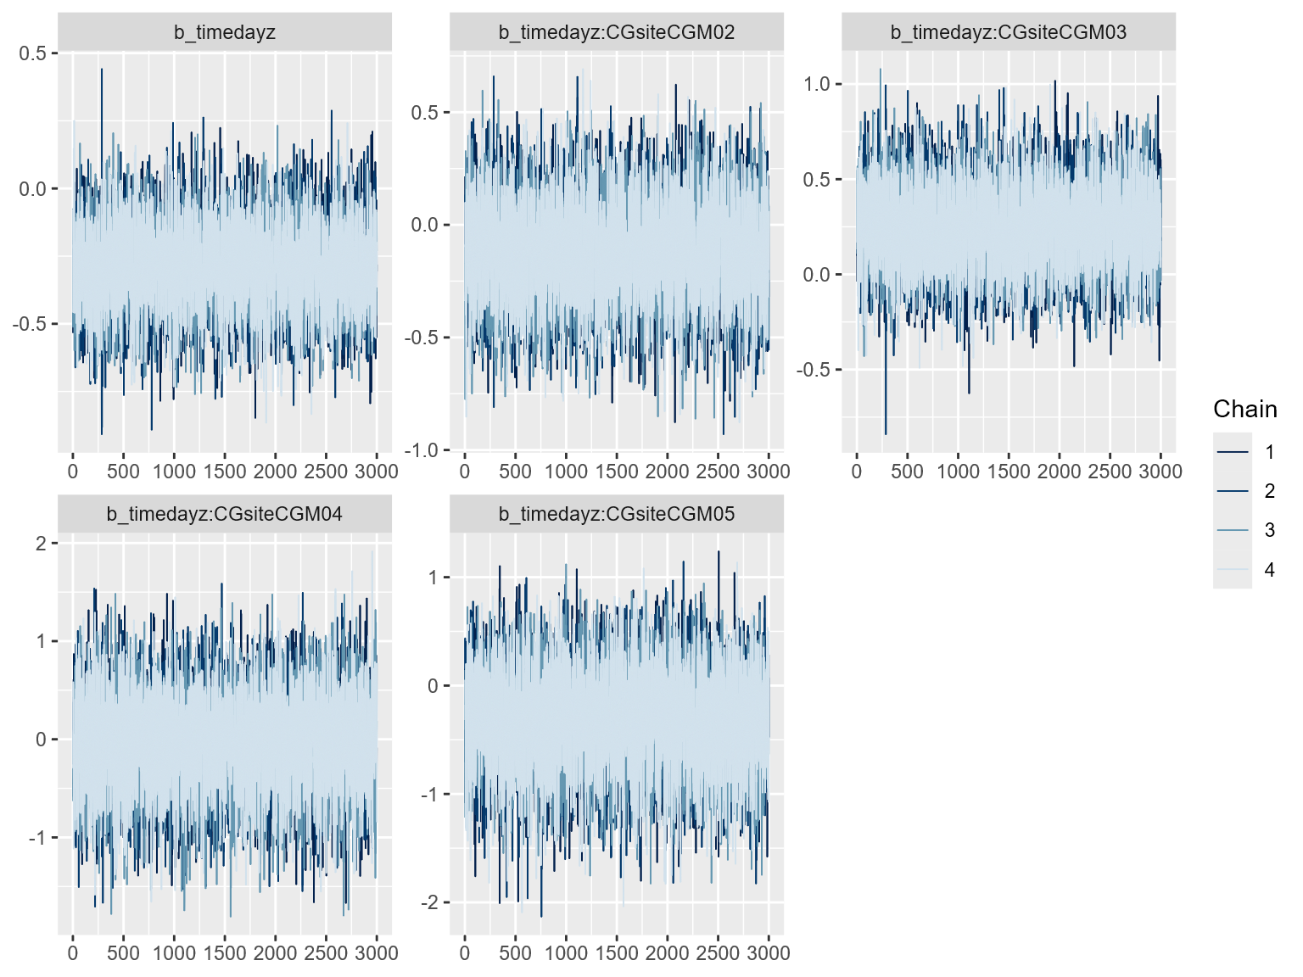Figure S1. MCMC plot shows model convergence of DNA methylation over CpG sites and time during infection in blood for DNA methylation model (Model 1). Code: mcmc_plot(fit_cgslopes, type = "trace")
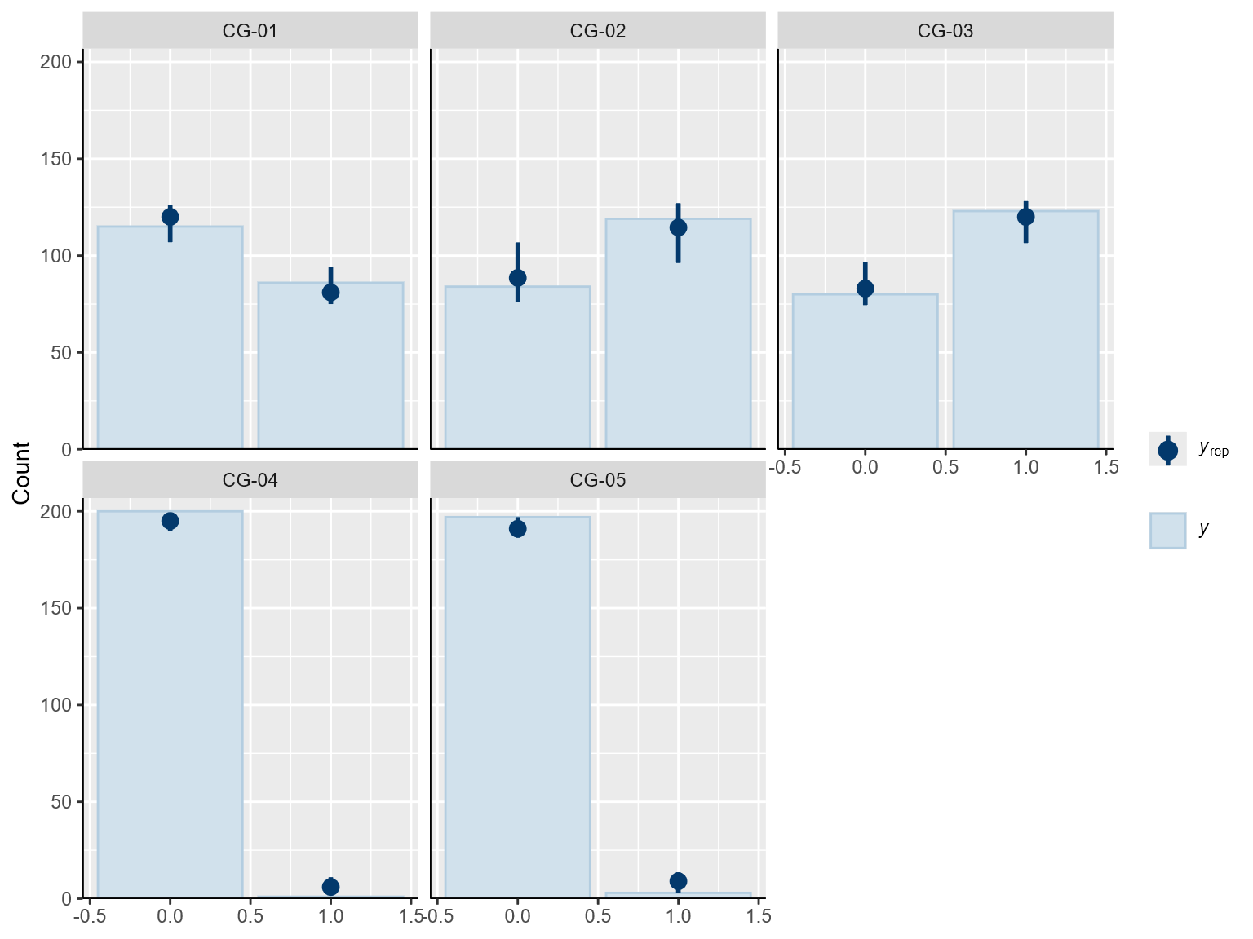
Figure S2. Posterior predictive check of CpG distributions of observed vs predicted counts of methylation (0 as unmethylated, 1 as methylated) for DNA methylation model (Model 1). Code: pp_check(fit_cgslopes, type = "bars_grouped", group = "CGsite").
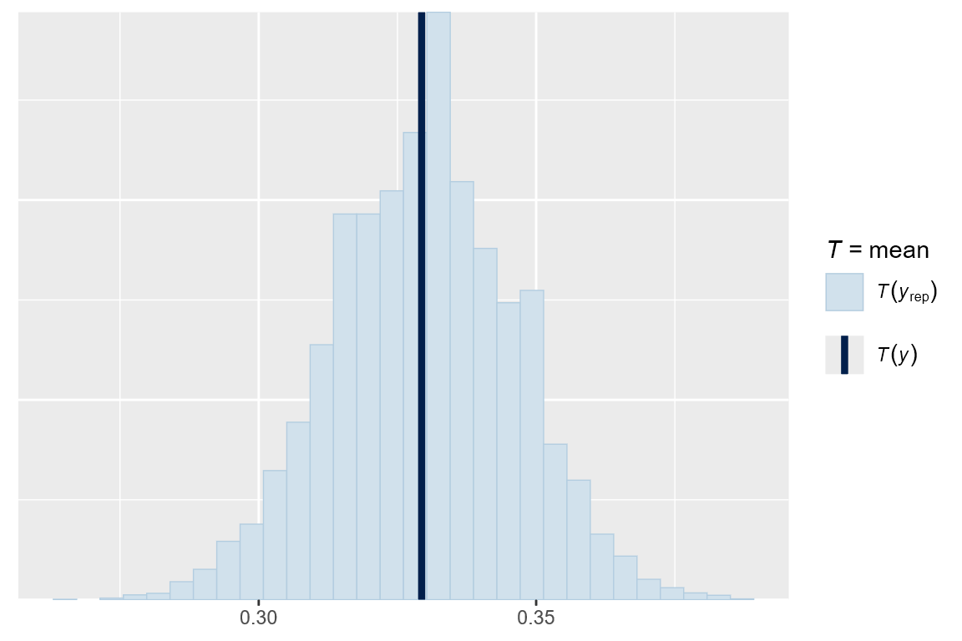
Figure S3. Posterior predictive check of mean DNA methylation probabilities for DNA methylation model (Model 1). Code: pp_check(fit_cgslopes, type = "stat", stat = "mean").
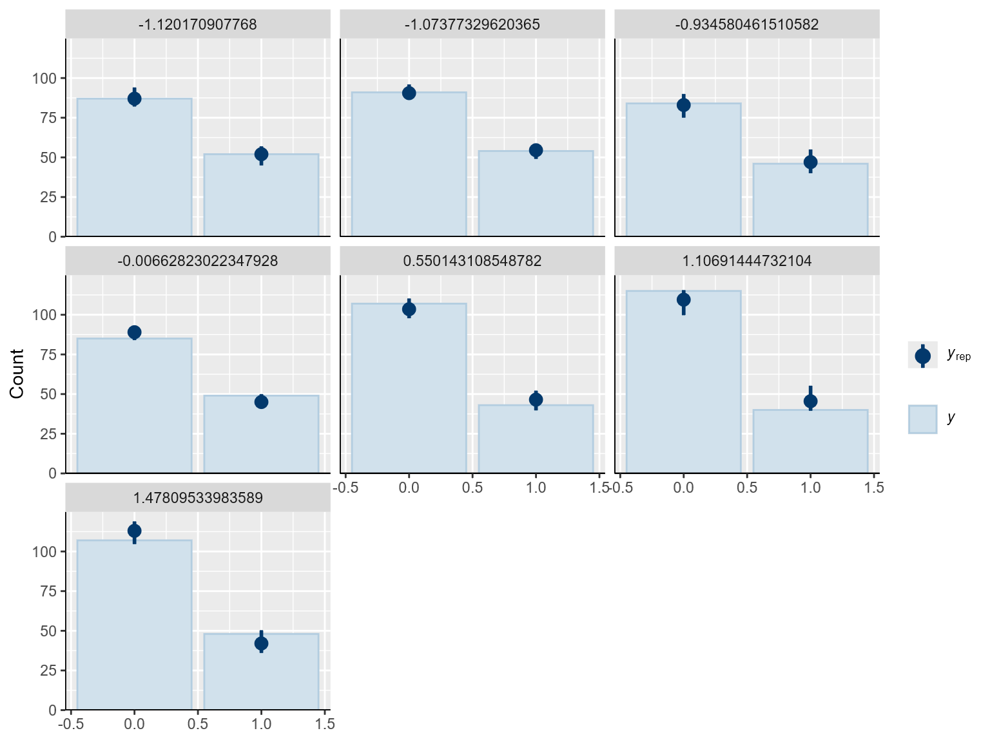
Figure S4. Posterior predictive check of DNA methylation at each time during infection, observed compared to predicted values for DNA methylation model (Model 1). Code: pp_check(fit_cgslopes, type = "bars_grouped", group = "timedayz").
Table S5. Candidate models used in model comparison for DNA methylation at euthanasia among tissues (Model 3) with leave-one-out cross validation in ‘loo’ package of R (version 2.8.0; Vehtari et al., 2024Candidate models are shown with their ELPD-LOO difference, standard error differences, ELPD-LOO estimates (and standard error, SE), parameter estimates for the LOO comparison (and SE), and LOO-IC estimate (and SE).All models used a subset of the data (n = 155, unique individuals = 31) to ensure comparison metrics were consistent.
Candidate Model | elpd_loo difference | SE difference | elpd_loo (SE) | p_loo (SE) | LOO-IC (SE)
FinalSBc ~ slope * EP + (1|CG site) | 0.0 | 0.0 | -216.2 (6.8) | 4.7 (0.4) | 432.5 (13.6)
FinalSBc ~ slope * EP + Stage + (1|CGsite) | -0.8 | 1.2 | -217.1 (6.8) | 6.6 (0.6) | 434.2 (13.6)
FinalSBc ~ slope * EP + BodyMassz + (1|CGsite) | -0.9 | 0.8 | -217.2 (6.6) | 5.8 (0.5) | 434.4 (13.1)
FinalSBc ~ slope * EP + Stage + BodyMassz + (1|CGsite) | -1.3 | 1.6 | -217.5 (6.6) | 7.5 (0.6) | 435.1 (13.1)

Table S6. Model output for Bayesian GLMM of slope compared to final Salmonella burden (Model 2). Draws were sampled using sample(hmc). For each parameter, Bulk_ESS and Tail_ESS are effective sample size measures, and Rhat is the potential scale reduction factor on split chains (at convergence, Rhat = 1).

Family: gaussian
Links: mu = identity
Formula: FinalSBc ~ slope * EP + (1 | CGsite)
Data: df_slope_predictors (Number of observations: 160)
Draws: 4 chains, each with iter = 6000; warmup = 3000; thin = 1;
total post-warmup draws = 12000
Parameter | Estimate | SD | l-95% CrI | u-95% CrI | Rhat | Bulk ESS | Tail ESS
Multilevel Hyperparameters: ~CpG (N levels = 5)
CpG (intercept) | 0.17 | 0.17 | 0.01 | 0.61 | 1.00 | 3002 | 4724
Regression Coefficients (β)
Intercept | -0.06 | 0.19 | -0.41 | 0.35 | 1.00 | 6329 | 4997
EP – low | 0.60 | 0.18 | 0.24 | 0.95 | 1.00 | 8931 | 8762
Slope | 0.79 | 0.39 | 0.06 | 1.60 | 1.00 | 6909 | 6893
EP – low × Slope | -0.05 | 0.39 | -0.81 | 0.70 | 1.00 | 8356 | 8696
Further Distributional Parameters (σ)
Residual variance | 0.95 | 0.05 | 0.85 | 1.06 | 1.00 | 11020 | 8804

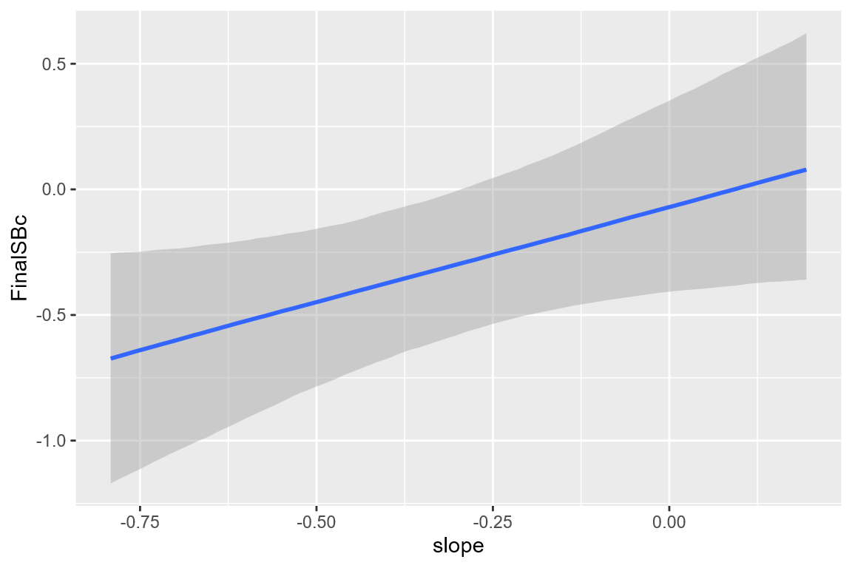
Figure S5. Conditional effects of slope of DNA methylation probabilities extracted from posterior distribution for birds over the infection period in blood (Model 2). Slope is positively related to final Salmonella burden. Slope represents the direction and magnitude of trajectory of DNA methylation probability across the infection period.
Code: ce_slope <- conditional_effects(fit_FinalSB_slope_orig, effects = "slope")
plot(ce_slope)
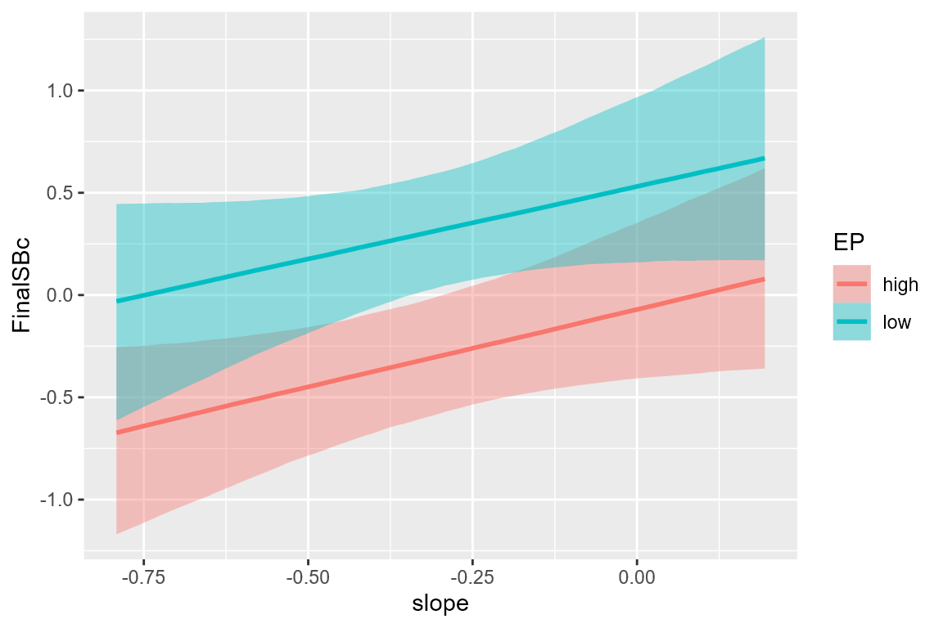
Figure S6. Conditional effects of the slope on final Salmonella burden faceted by EP levels (Model 2). EP did not show evidence of influencing the relationship between DNA methylation slope and final Salmonella burden. Code:
ce_slope_EP <- conditional_effects(fit_FinalSB_slope_orig, effects = "slope:EP")
plot(ce_slope_EP)
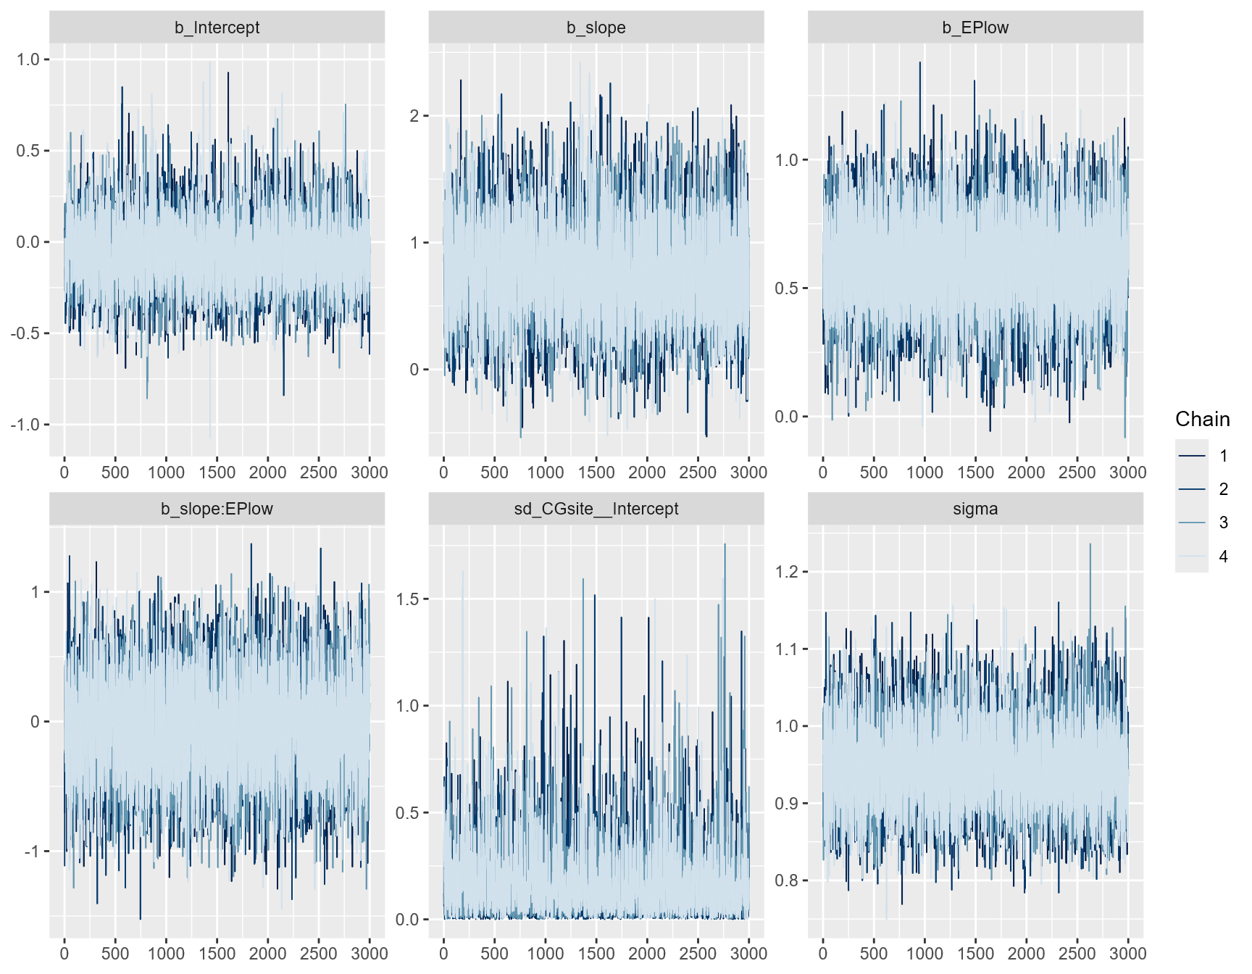
Figure S7. MCMC plot shows model convergence for final Salmonella burden model (Model 2). Code: mcmc_plot(fit_FinalSB_slope_orig, type = "trace").
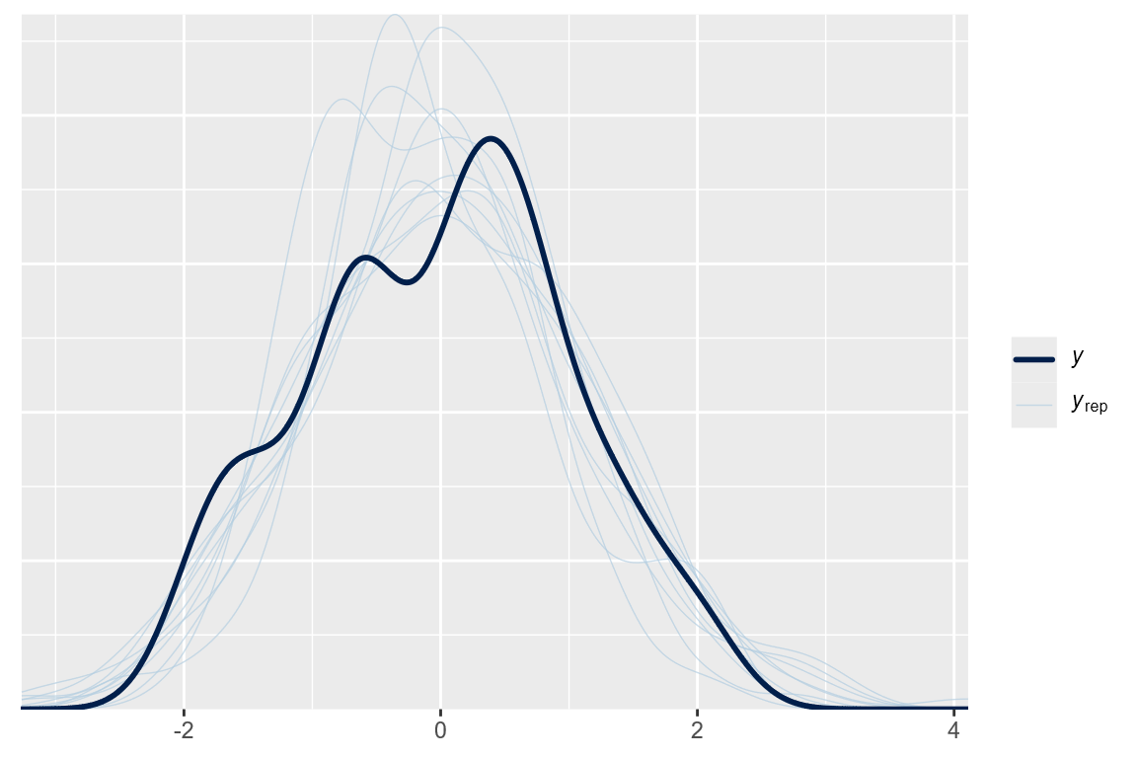
Figure S8. Posterior predictive check shows that the model adequately reproduced the observed distribution of final Salmonella burden (Model 2). Code: pp_check(fit_FinalSB_slope_orig)
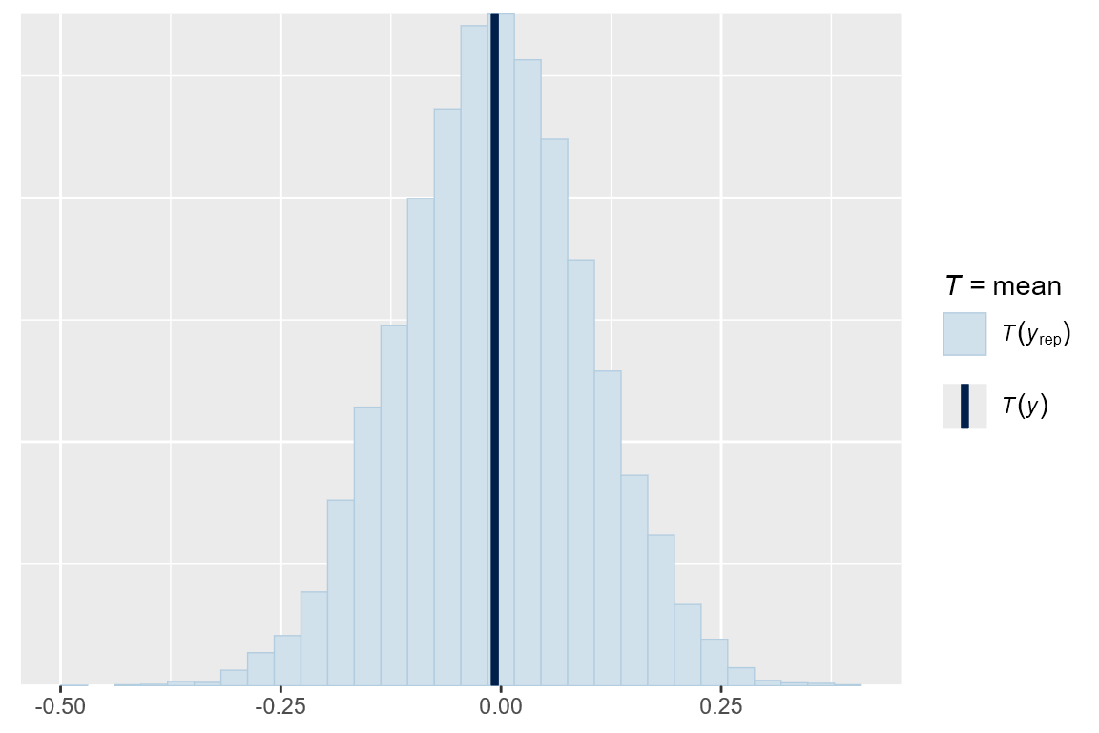
Figure S9. Posterior predictive check of mean of model for final Salmonella burden (Model 2). The observed mean for standardized final Salmonella burden falls within the predicted distribution, indicating adequate fit. Code: pp_check(fit_FinalSB_slope_orig, type = "stat", stat = "mean")
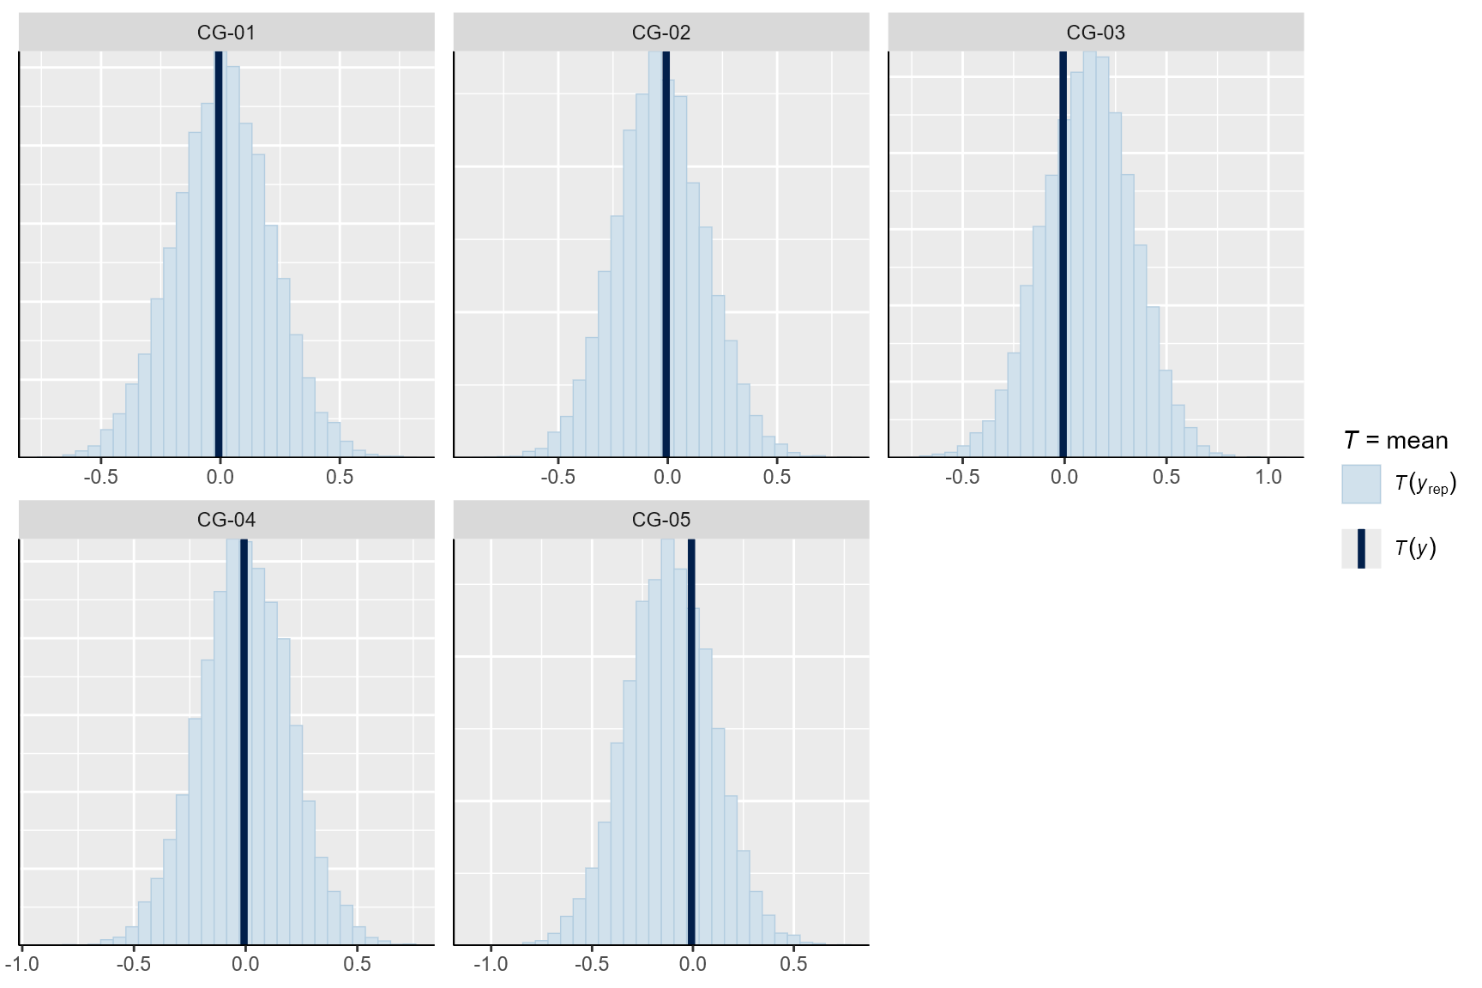
Figure S10. Posterior predictive check of CpG site probabilities for final Salmonella burden model (Model 2). CpG site was included as a structural random intercept rather than a primary predictor; check confirms the model adequately reproduced observed CpG-level means. Code: pp_check(fit_FinalSB_slope_orig, type = "stat_grouped", group = "CGsite", stat = "mean")
Table S7. Candidate models used in model comparison for DNA methylation at euthanasia among tissues (Model 3) with leave-one-out cross validation in ‘loo’ package of R (version 2.8.0; Vehtari et al., 2024). Candidate models are shown with their ELPD-LOO difference, standard error differences, ELPD-LOO estimates (and standard error, SE), parameter estimates for the LOO comparison (and SE), and LOO-IC estimate (and SE). All models used a subset of the data (n = 416; unique individuals = 34) to ensure comparison metrics were consistent.
Candidate Model | elpd_loo difference | SE difference | elpd_loo (SE) | p_loo (SE) | LOO-IC (SE)
DNAm ~ Tissue * SiteEuth + Tissue*EP + Stage + BodyMassz + (1 | BirdID) | -1.3 | 0.5 | -155.4 (9.4) | 16.1 (1.4) | 310.8 (18.8)
DNAm ~ Tissue * SiteEuth + Tissue * EP + BodyMassz + (1 | BirdID) | 0.0 | 0.0 | -154.1 (9.2) | 14.1 (1.2) | 308.2 (18.5)
DNAm ~ Tissue * SiteEuth + Tissue * EP + Stage + (1 | BirdID) | -0.8 | 0.7 | -154.9 (9.3) | 15.1 (1.3) | 309.9 (18.6)
DNAm ~ Tissue * SiteEuth + EP + Stage + BodyMassz + (1 | BirdID) | -3.5 | 1.5 | -157.6 (9.9) | 15.3 (1.3) | 315.2 (19.8)
DNAm ~ Tissue * SiteEuth + (1 | BirdID) | -4.1 | 2.3 | -158.1 (10.0) | 13.5 (1.2) | 316.4 (20.0)

Table S8. Model output from Bayesian GLMM on DNA methylation at euthanasia among tissues (Model 3). Draws were sampled using sample(hmc). For each parameter, Bulk_ESS and Tail_ESS are effective sample size measures, and Rhat is the potential scale reduction factor on split chains (at convergence, Rhat = 1).

Family: bernoulli
Links: mu = logit
Formula: DNAm ~ Tissue * SiteEuth + Tissue * EP + Stage + BodyMassz + (1 | BirdID)
Data: df_tissue_centered (Number of observations: 416)
Draws: 4 chains, each with iter = 4000; warmup = 2000; thin = 1;
total post-warmup draws = 8000
Parameter | Estimate | SD | l-95% CrI | u-95% CrI | Rhat | Bulk ESS | Tail ESS
Multilevel Hyperparameters: ~BirdID (N levels = 34)
BirdID (intercept) | 0.28 | 0.20 | 0.01 | 0.72 | 1.00 | 3050 | 4327
Regression Coefficients (β)
Intercept | -0.06 | 0.33 | -0.71 | 0.59 | 1.00 | 8700 | 6482
Tissue – liver | 2.41 | 0.48 | 1.48 | 3.35 | 1.00 | 8266 | 5705
Tissue – spleen | -0.45 | 0.47 | -1.35 | 0.44 | 1.00 | 8134 | 6282
CpG 2 | 0.62 | 0.41 | -0.18 | 1.43 | 1.00 | 8961 | 5909
CpG 3 | 1.03 | 0.42 | 0.23 | 1.85 | 1.00 | 8869 | 6171
CpG 4 | -2.89 | 0.58 | -4.08 | -1.79 | 1.00 | 9113 | 6117
CpG 5 | -2.89 | 0.57 | -4.05 | -1.82 | 1.00 | 9248 | 6203
EP – low | -0.69 | 0.37 | -1.41 | 0.03 | 1.00 | 8603 | 6442
Body Mass | 0.09 | 0.15 | -0.20 | 0.39 | 1.00 | 11834 | 5429
Tissue (liver) × CpG 2 | 0.86 | 0.70 | -0.50 | 2.31 | 1.00 | 11390 | 6179
Tissue (spleen) × CpG 2 | 0.02 | 0.58 | -1.11 | 1.16 | 1.00 | 9067 | 6092
Tissue (liver) × CpG 3 | 0.28 | 0.67 | -1.01 | 1.63 | 1.00 | 10936 | 6085
Tissue (spleen) × CpG 3 | 0.61 | 0.61 | -0.58 | 1.80 | 1.00 | 8584 | 6437
Tissue (liver) × CpG 4 | -0.90 | 0.68 | -2.23 | 0.44 | 1.00 | 8673 | 6175
Tissue (spleen) × CpG 4 | -0.58 | 0.86 | -2.30 | 1.08 | 1.00 | 13727 | 5399
Tissue (liver) × CpG 5 | -0.90 | 0.68 | -2.23 | 0.41 | 1.00 | 9348 | 6067
Tissue (spleen) × CpG 5 | -0.57 | 0.86 | -2.32 | 1.06 | 1.00 | 14091 | 6029
Tissue (liver) × EP – low | -0.64 | 0.54 | -1.71 | 0.40 | 1.00 | 8108 | 6262
Tissue (spleen) × EP – low | 0.61 | 0.54 | -0.44 | 1.66 | 1.00 | 8738 | 5908

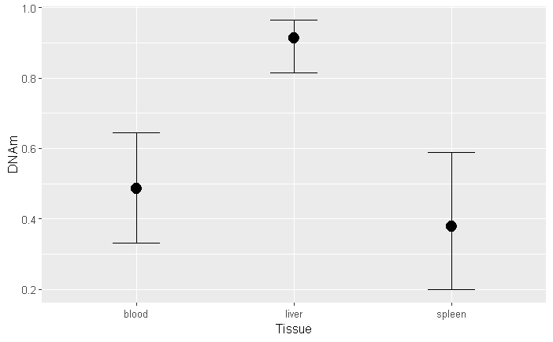
Figure S11. Conditional effects of tissue on DNA methylation probability at euthanasia (Model 3). Liver showed consistently higher DNA methylation probability than blood or spleen across CpGs. Code: conditional_effects(fit_dnam_term)
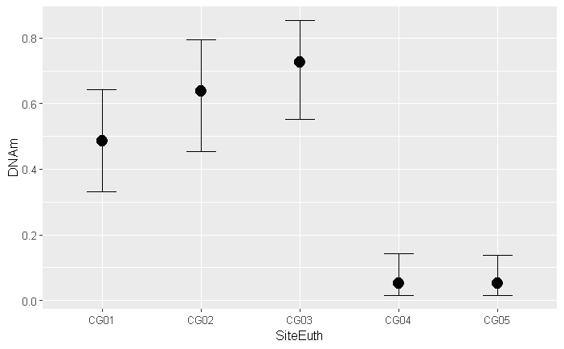
Figure S12. Conditional effects of CpG sites on DNA methylation probability at euthanasia (Model 3). CpG 1, 2, and 3 show intermediate to high DNA methylation probability, while CpG 4 and 5 show low DNA methylation probability. Code: conditional_effects(fit_dnam_term)
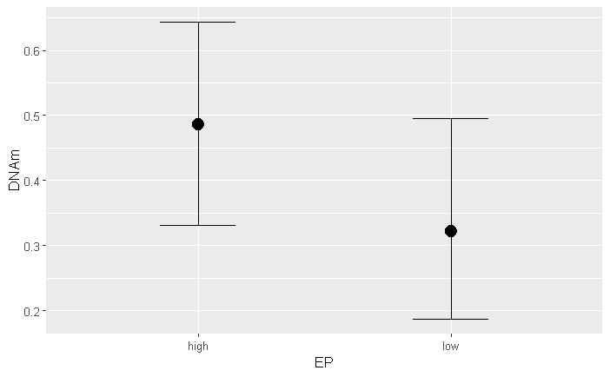
Figure S13. Conditional effects of EP category on DNA methylation probability at euthanasia (Model 3). EP did not show evidence of influencing DNA methylation probability. Code: conditional_effects(fit_dnam_term)
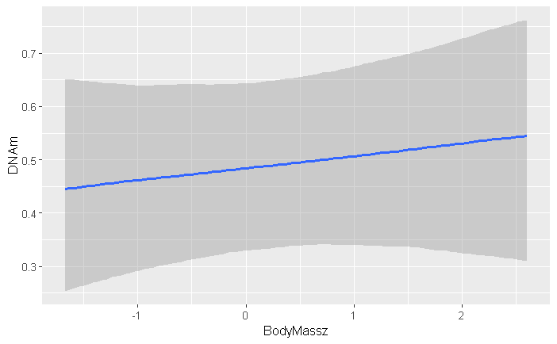
Figure S14. Conditional effects of body mass on DNA methylation probability at euthanasia (Model 3). Body mass did not show evidence of influencing DNA methylation probability. Code: conditional_effects(fit_dnam_term)
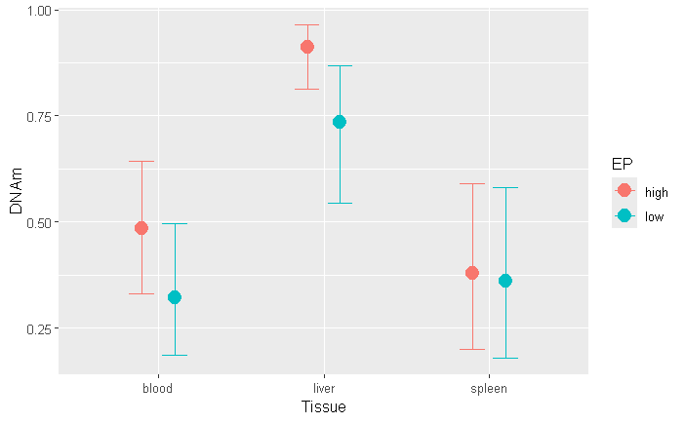
Figure S15. Conditional effects of the interaction between EP category and tissue on DNA methylation probability at euthanasia (Model 3). EP did not show evidence of influencing the relationship of DNA methylation probability across tissues at euthanasia. Code: conditional_effects(fit_dnam_term)
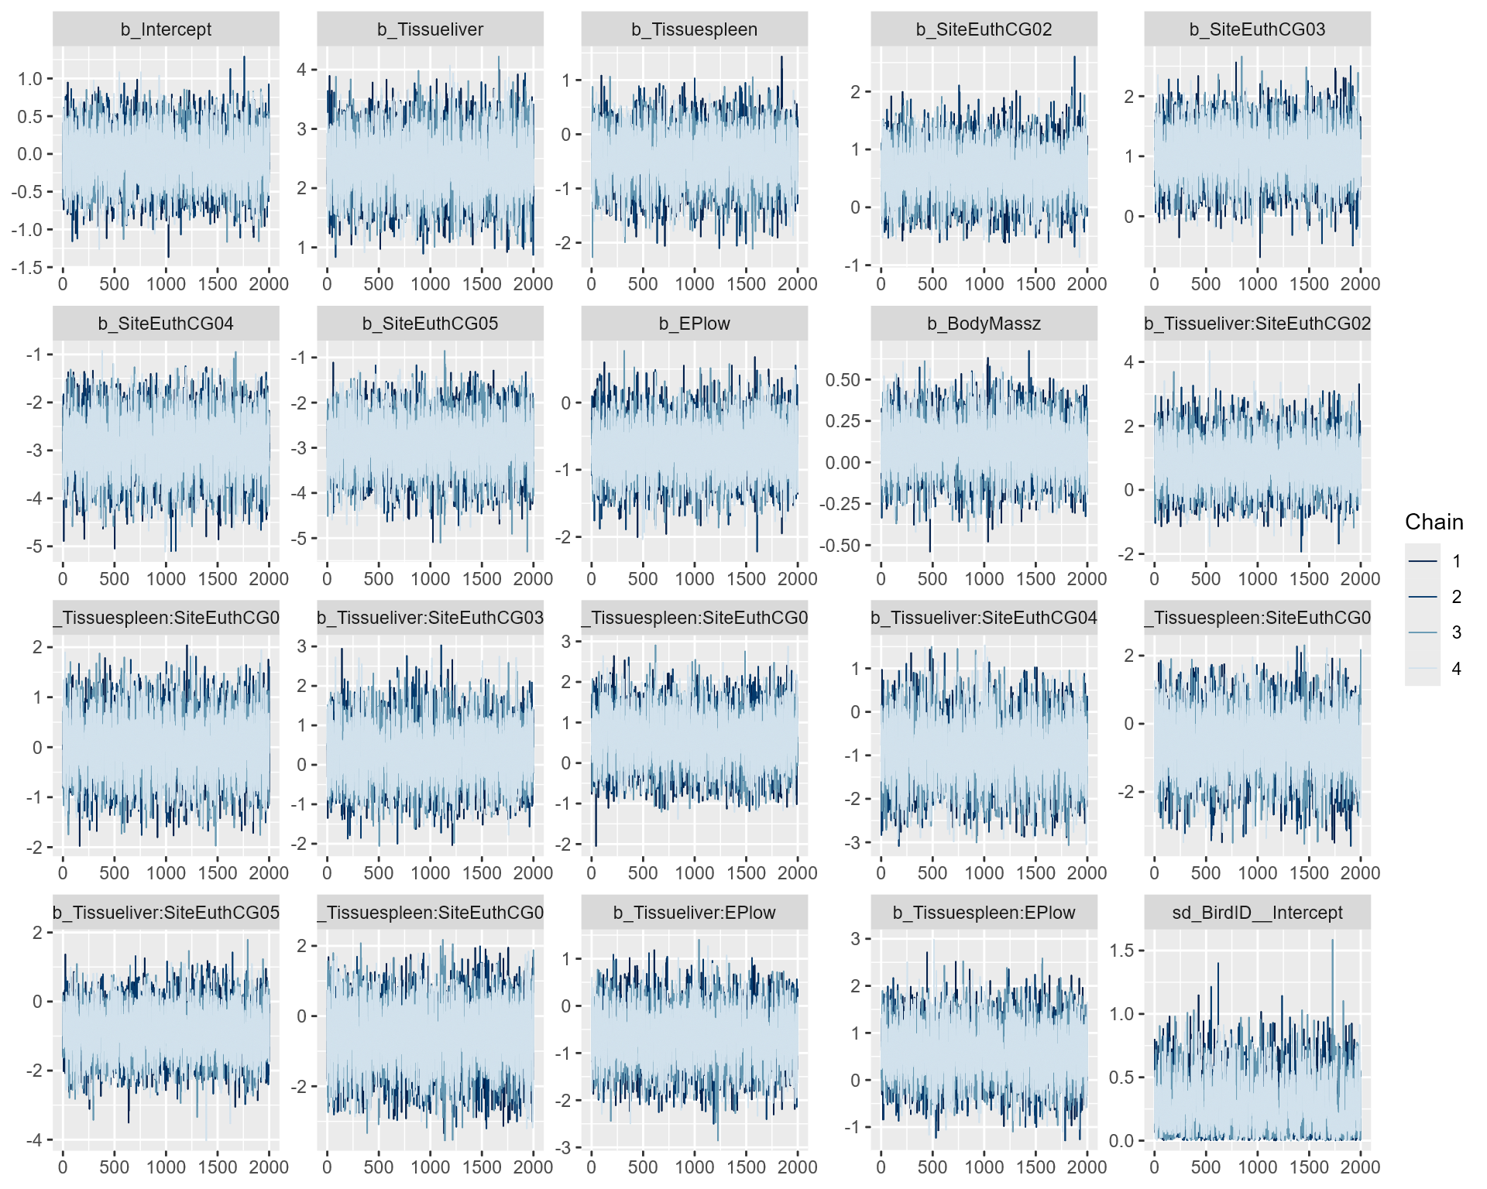Figure S16. MCMC plot shows model convergence for euthanasia tissue DNA methylation model (Model 3). Code: mcmc_plot(fit_dnam_term, type = "trace").
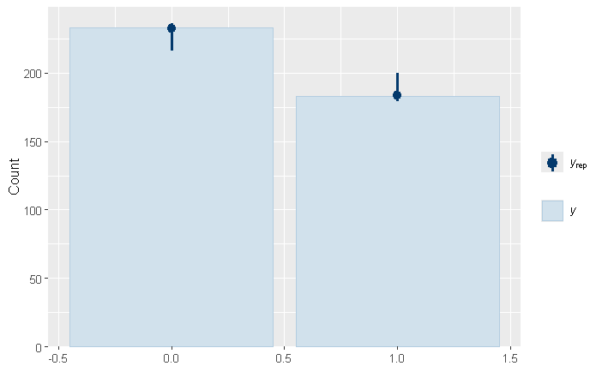Figure S17. Posterior predictive check of binary DNA methylation probabilities for euthanasia tissue DNA methylation model (Model 3). Model fitting adequately reproduced the observed distribution of binary DNA methylation data. Code: pp_check(fit_dnam_term, type = "bars")
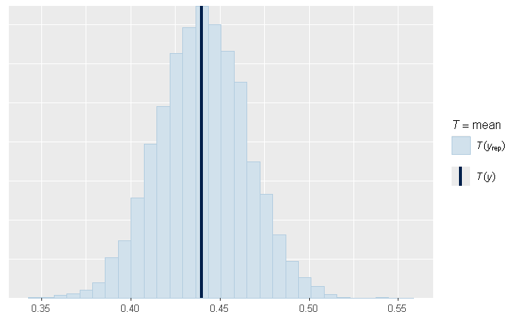
Figure S18. Posterior predictive check of mean for euthanasia tissue DNA methylation model (Model 3). The observed mean DNA methylation probability falls within the predicted distribution, indicating adequate model fit. Code: pp_check(fit_dnam_term, type = "stat", stat = "mean")
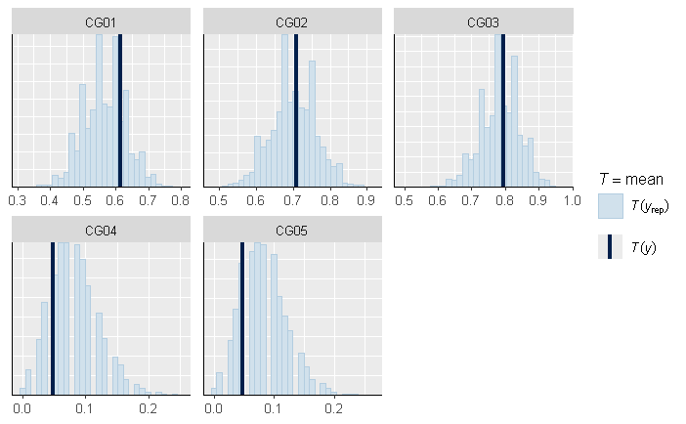
Figure S19. Posterior predictive check for CpG site identity for euthanasia tissue DNA methylation model (Model 3). CpG site-specific methylation frequencies were adequately reproduced by the model. Code: pp_check(fit_dnam_term, type = "stat_grouped", group = "SiteEuth")
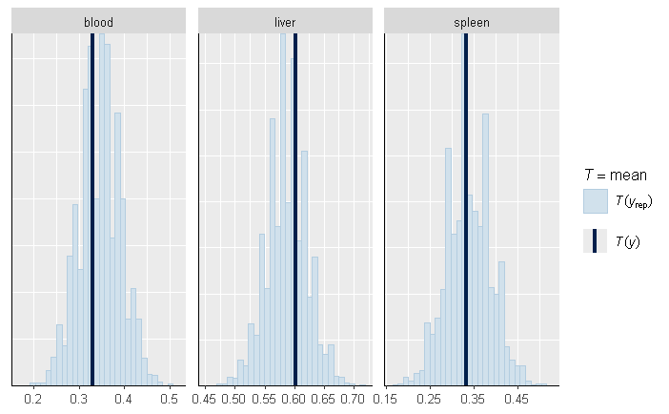
Figure S20. Posterior predictive check for differences in DNA methylation probabilities across tissues for euthanasia tissue DNA methylation model (Model 3). Tissue-specific DNA methylation probabilities were adequately reproduced by the model. Code: pp_check(fit_dnam_term, type = "stat_grouped", group = "Tissue")
Table S9. Bayesian posterior contrasts of DNA methylation as the pairwise differences between predicted draws for each CpG among tissues after 14-days of infection with Salmonella enterica in house sparrows. Contrasts include: blood minus liver, blood minus spleen, and liver minus spleen. Results are averaged over the levels of: EP, sex. Summaries of these contrasts are reported as medians and a 95% highest posterior density interval (HPD). Results are given on the log-odds ratio scale with 95% HPD in parentheses. Sign indicates the directionality of the contrast and an asterisk indicates contrasts that did not overlap 0 in 95% HPD.
CpG | Tissue | Blood | Liver
CpG 1
 | Liver | -2.08 (-2.91 to -1.29)*
 | Spleen | 0.14 (-0.66 to 0.98) | 2.24 (1.24 to 3.20)*
CpG 2
 | Liver | -2.92 (-4.34 to -1.61)*
 | Spleen | 0.12 (-0.86 to 1.14) | 3.04 (1.52 to 4.60)*
CpG 3
 | Liver | -2.34 (-3.77 to -1.18)*
 | Spleen | -0.46 (-1.57 to 0.61) | 1.89 (0.39 to 3.42)*
CpG 4
 | Liver | -1.18 (-2.49 to 0.16)
 | Spleen | 0.70 (-0.95 to 2.60) | 1.88 (-0.04 to 3.96)
CpG 5
 | Liver | -1.19 (-2.55 to 0.11)
 | Spleen | 0.70 (-1.02 to 2.49) | 1.88 (0.01 to 3.94)

Table S10. Posterior marginal predicted median probabilities of DNA methylation (DNA methylation probability) across CpGs in the putative promoter of TLR4 among tissues after 14-days of infection with Salmonella enterica in house sparrows. Results are averaged over EP. DNA methylation probabilities for each CpG in each tissue are reported with 95% highest posterior density interval (HPD). Probabilities were back-transformed from logit-scale by ‘emmeans’ with ‘type = “response”, re_formula = NA”.
CpG Site | Tissue | Estimate (median) | 95% HPD
CpG 1
 | Blood | 0.402 | 0.268 to 0.543
 | Liver | 0.843 | 0.737 to 0.929
 | Spleen | 0.369 | 0.199 to 0.539
CpG 2
 | Blood | 0.556 | 0.394 to 0.724
 | Liver | 0.958 | 0.891 to 0.995
 | Spleen | 0.524 | 0.329 to 0.727
CpG 3
 | Blood | 0.653 | 0.486 to 0.793
 | Liver | 0.951 | 0.879 to 0.991
 | Spleen | 0.747 | 0.567 to 0.902
CpG 4
 | Blood | 0.037 | 0.007 to 0.090
 | Liver | 0.111 | 0.032 to 0.217
 | Spleen | 0.019 | 0.000 to 0.072
CpG 5
 | Blood | 0.037 | 0.008 to 0.088
 | Liver | 0.112 | 0.036 to 0.220
 | Spleen | 0.019 | 0.001 to 0.072

Supplemental References
Bakdash, J.Z. and Marusich, L. R. (2017). Package ‘rmcorr’. R package version 0.7.0, https://lmarusich.github.io/rmcorr/index.html, doi:10.3389/fpsyg.2017.00456
Bürkner, P.C. (2017). brms: An R package for Bayesian multilevel models using Stan. J. Stat. Softw. 80:1-28.
Chowdhury, M.H., Khan, N.M. and Rahman, M.M. (2025). Analysing risk factors for diabetes in Bangladesh: a Bayesian hierarchical approach using a nationwide cross-sectional study. BMC Public Health. 25(1), 3252.
Gabry, J., Češnovar, R., Johnson, A., and Bronder, S. (2025). cmdstanr: R Interface to 'CmdStan'. R package version 0.9.0, https://discourse.mc-stan.org, https://mc-stan.org/cmdstanr/
Lenth, R., Singmann, H., Love, J., Buerkner, P. and Herve, M. (2019). Package ‘emmeans’. R package version 1(3.2). https://rvlenth.github.io/emmeans/, https://github.com/rvlenth/emmeans/
Kilvitis, H.J., Schrey, A.W., Ragsdale, A.K., Berrio, A., Phelps, S.M. and Martin, L.B. (2019). DNA methylation predicts immune gene expression in introduced house sparrows Passer domesticus. J. Avian Biol. 50(6), e01965.
Nalborczyk, L., Batailler, C., Lœvenbruck, H., Vilain, A. and Bürkner, P.C. (2019). An introduction to Bayesian multilevel models using brms: A case study of gender effects on vowel variability in standard Indonesian. J. Speech Lang. Hear. Res. 62(5), 1225-1242.
R Core Team. (2025). R: A Language and Environment for Statistical Computing. R Foundation for Statistical Computing. https://www.r-project.org/
Sheldon, E., Zimmer, C., Hanson, H., Koussayer, B., Schrey, A., Reese, D., Wigley, P., Wedley, A.L. and Martin, L.B. (2023). High epigenetic potential protects songbirds against pathogenic Salmonella enterica infection. J. Exp. Biol. 226(13), jeb245475.
Vehtari, A., Gelman, A., Gabry, J. and Yao, Y. (2024). Package ‘loo’. Efficient Leave-One-Out Cross-Validation and WAIC for Bayesian Models. R package version 2.8.0, https://ftp.sun.ac.za/ftp/CRAN/web/packages/loo/refman/loo.html
Wickham H. and Henry L. (2025). purrr: Functional Programming Tools. R package version 1.1.0, https://doi.org/10.32614/CRAN.package.purrr, https://CRAN.R-project.org/package=purrr.

