Academy Nova Course Cancellation Prediction
Final Project Report — Group 51
Course: Introduction to Machine Learning
Project: Nova Academy Course Cancellation Prediction
Group: 51
Submitted by: [Mellissa Ghandour — ID: 326541521] | [Ali Suliman — ID: 214247900]
Metric: ROC-AUC
Best known public leaderboard AUC: 0.889030 (2nd place)

1. Executive Summary
Nova Academy wants to predict the probability that a client will cancel or drop a course registration before the course starts. This is a binary classification problem where each registration receives a cancellation probability.
We followed a full machine-learning workflow based on CRISP-DM: business understanding, data exploration, preprocessing, feature engineering, model training, evaluation, explainability, and final submission generation.
The final submitted prediction file contains two columns: Client_ID and Drop_Probability. The final file was validated to ensure correct row count, no missing predictions, no duplicate IDs, valid probability values, and exact preservation of the test-set Client_ID order.
Our best known public leaderboard result for Group 51 was AUC = 0.889030, placing the group in 2nd place on the leaderboard.

2. Business Understanding
The business goal is to help Nova Academy identify registrations with high cancellation risk. Accurate cancellation probabilities can support operational decisions such as proactive customer support, better resource planning, course capacity management, and reducing financial loss from cancellations.
The evaluation metric is ROC-AUC. This metric is appropriate because the goal is not only to classify each client using a fixed threshold, but to rank clients by cancellation risk. The final submission therefore contains probabilities rather than hard labels.

3. Data Understanding and EDA
The training set contains 63,464 rows and 29 columns, including the target variable Dropped_Course. The test set contains 15,866 rows and 28 columns, with the same features but without the target.
The target distribution showed moderate class imbalance: approximately 41.4% of the training registrations were cancelled and 58.6% were not cancelled. Because of this, accuracy alone would be less informative than ROC-AUC.
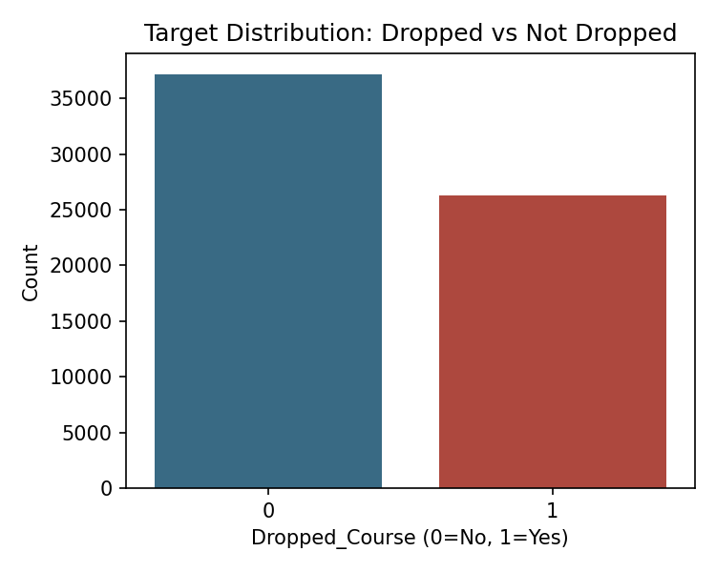
Figure 1. Target distribution in the training set (Dropped_Course).
Exploratory data analysis included numeric distributions, categorical distributions, target relationships, missing-value patterns, and date-based trends. The correlation heatmap below shows the relationships among numeric features, which informed which engineered ratios were likely to add independent signal.
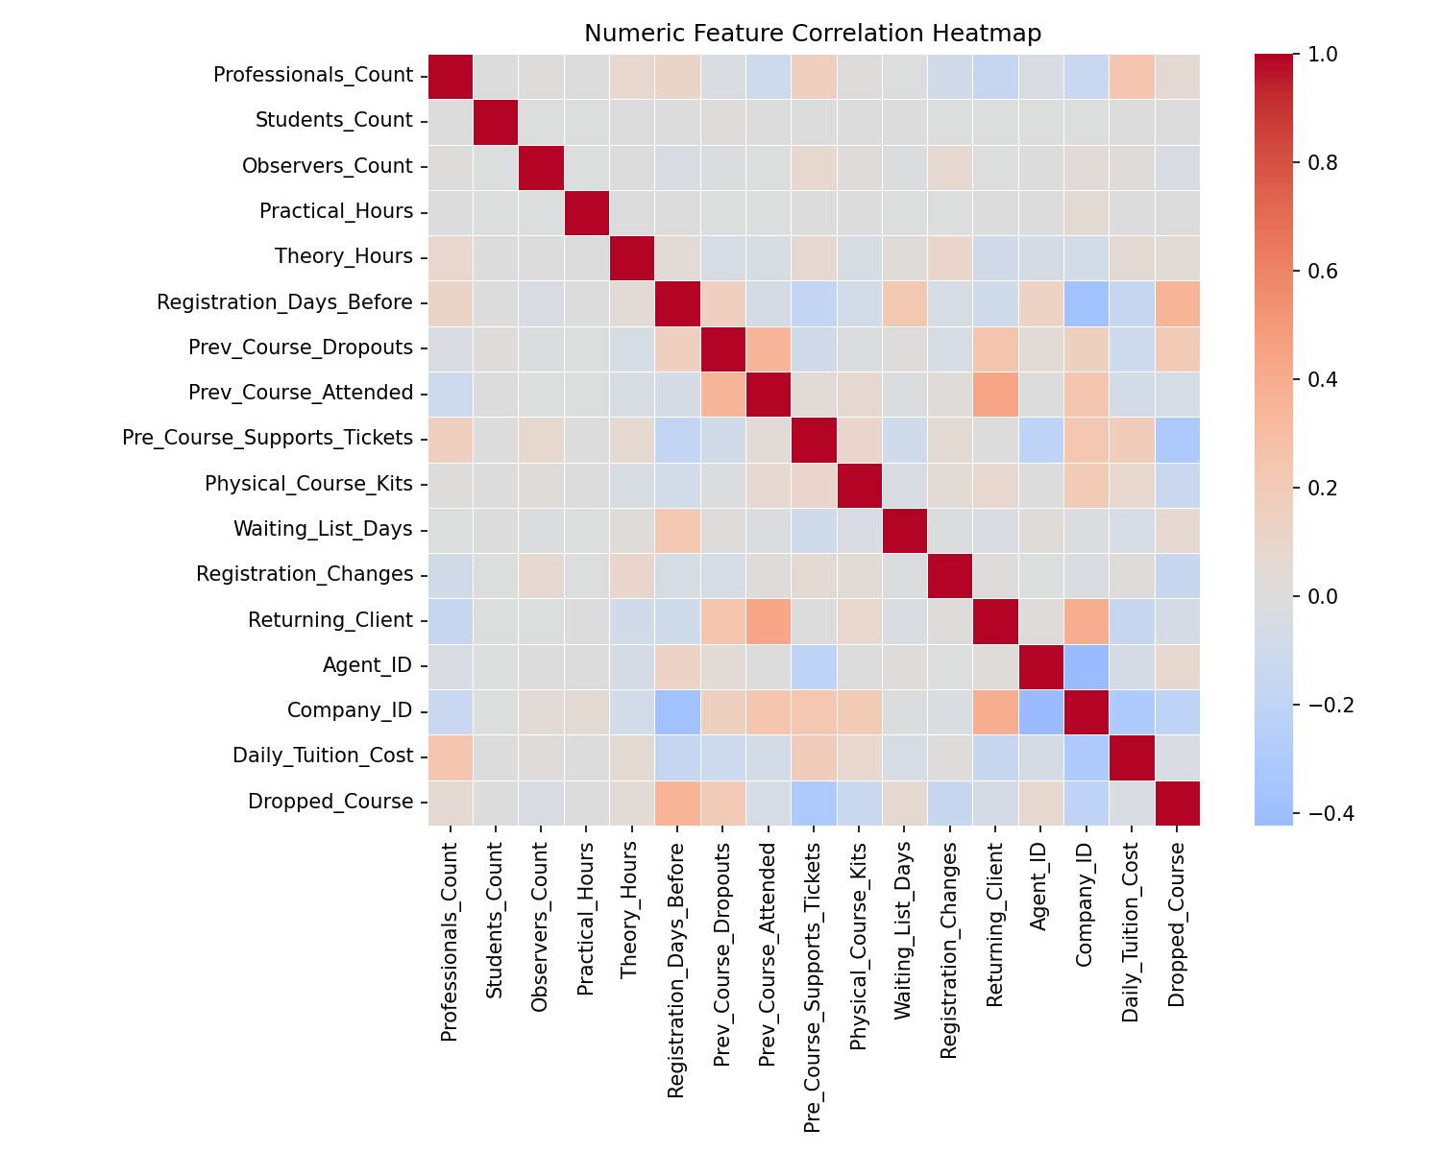
Figure 2. Correlation heatmap of numeric features (training set).
A key finding was that the train and test sets are temporally shifted. The training dates range from 2015-07-01 to 2017-04-26, while the test set starts around 2017-04-26 and continues until 2017-08-31. This suggests that random cross-validation may be optimistic, so a time-aware validation split was also evaluated (Section 6).

4. Missing Values and Preprocessing
Several columns contained missing values. Company_ID had very high missingness, while Agent_ID, Registration_Days_Before, Requested_Lab_Config, Physical_Course_Kits, and several categorical columns also had missing values.
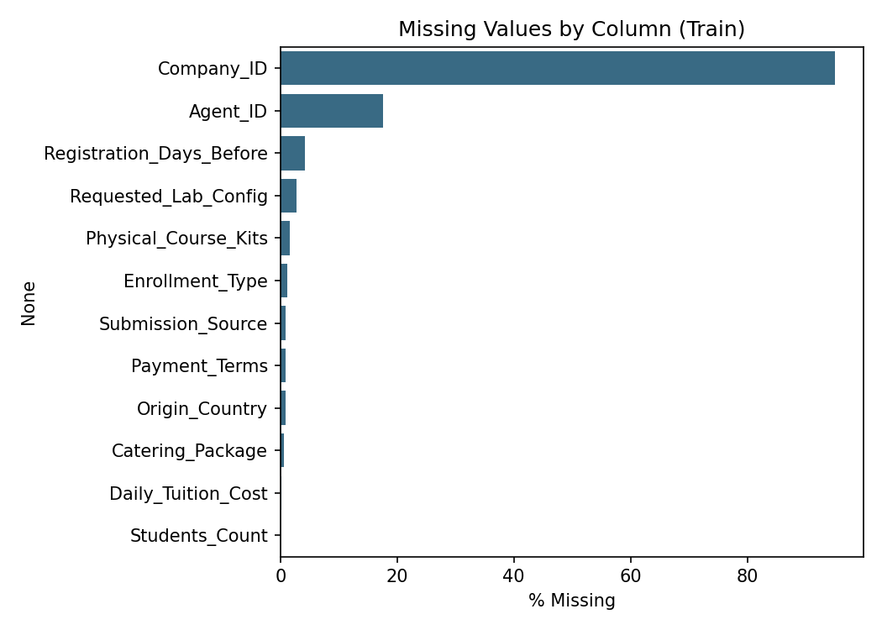
Figure 3. Percentage of missing values by column (training set).
Instead of simply removing rows or columns, we treated missingness as a potential predictive signal. Missing-indicator features were created for important columns, such as company, agent, registration timing, requested lab configuration, daily tuition cost, and participant count.
Numerical missing values were handled with median imputation, while categorical missing values were handled with a constant "Missing" category. Preprocessing was implemented inside a scikit-learn Pipeline / ColumnTransformer to avoid data leakage: the preprocessing pipeline is fit only on the training fold and then applied (transform only) to validation or test data.
Categorical variables were encoded using one-hot encoding with handle_unknown="ignore" to safely handle categories appearing in the test set but not in training.

5. Feature Engineering and Outlier Analysis
Feature engineering was based on the business logic of course registrations. We created participant-based, cost-based, previous-history, support-ticket, registration-change, missingness, lab-configuration, and date-based features. Important engineered features included:
- Total_Participants
- Active_Participants
- Observer_Ratio
- Student_Ratio
- Professional_Ratio
- Total_Hours
- Practical_Ratio
- Cost_Per_Hour
- Cost_Per_Participant
- Prev_Total_Courses
- Prev_Dropout_Rate
- Support_Per_Participant
- Changes_Per_Waiting_Day
- Lab_Config_Mismatch
- Has_Company
- Has_Agent
- date features (month, quarter, day of week, week of year)
Outliers were analyzed using distribution plots, boxplots, and IQR-based summaries. We avoided blindly deleting outliers because many extreme values may represent real business cases (e.g. a very large registration). Since the main models were tree-based, they handle nonlinear effects and extreme values more robustly than linear models would. Test rows were never removed.
Several categorical features have high cardinality (e.g. Origin_Country: 721 unique values, Client_Category: 505, Catering_Package: 321, Submission_Source: 328), which after one-hot encoding produces roughly 2,700 sparse columns feeding the model. This is a real instance of the "curse of dimensionality" discussed in the course: it increases variance and is a plausible additional contributor — beyond the temporal train/test shift discussed below — to the gap between random cross-validation AUC (~0.95) and both time-aware validation AUC (~0.90) and the leaderboard AUC (0.889). Grouping rare categories (e.g. keeping the top N per column and bucketing the rest as "Other") is listed as a future improvement in Section 10.

6. Modeling and Validation Strategy
We compared several model families:
- Logistic Regression
- Random Forest
- HistGradientBoosting
- LightGBM
The baseline models showed that gradient-boosting methods performed best. Logistic Regression gave a useful simple baseline, but boosting models captured nonlinear interactions more effectively.
The validation strategy included:
- Stratified K-Fold cross-validation
- Train AUC and validation AUC comparison (bias-variance / overfitting-gap check)
- Per-fold ROC curves
- Time-aware validation because of the temporal train/test shift
This allowed us to compare models not only by average validation AUC, but also by stability and overfitting behavior — i.e. the bias-variance tradeoff discussed in the course: a model with high random-CV AUC but a large train/validation gap (like our deeper LightGBM configuration) has higher variance and is more sensitive to distribution shift, while a lower-variance model may generalize more safely to the temporally-shifted test set.

7. Model Results and Hyperparameter Tuning
The main model comparison showed that LightGBM achieved the strongest validation performance. The tuned deeper LightGBM model achieved the highest random cross-validation AUC, while the baseline LightGBM had a slightly smaller train-validation gap.
Approximate validation results:
Model | Validation AUC | Notes
Logistic Regression | 0.9037 | Simple linear baseline
Random Forest | 0.8865 | Low overfitting but weaker performance
HistGradientBoosting | 0.9477 | Strong boosting baseline
LightGBM baseline | 0.9497 | Strong and stable
LightGBM tuned/deeper | 0.9523 | Highest random CV AUC

Although random cross-validation AUC was high, time-aware validation was lower, around 0.902. This supports the conclusion that the data has temporal distribution shift and that leaderboard performance may be lower than random CV performance. The final known public leaderboard AUC was 0.889030.
The per-fold ROC curves and per-fold AUC below (from a representative 5-fold LightGBM run on the full training set, same feature pipeline as the final model) show that performance is stable across folds, with no unusually weak fold:
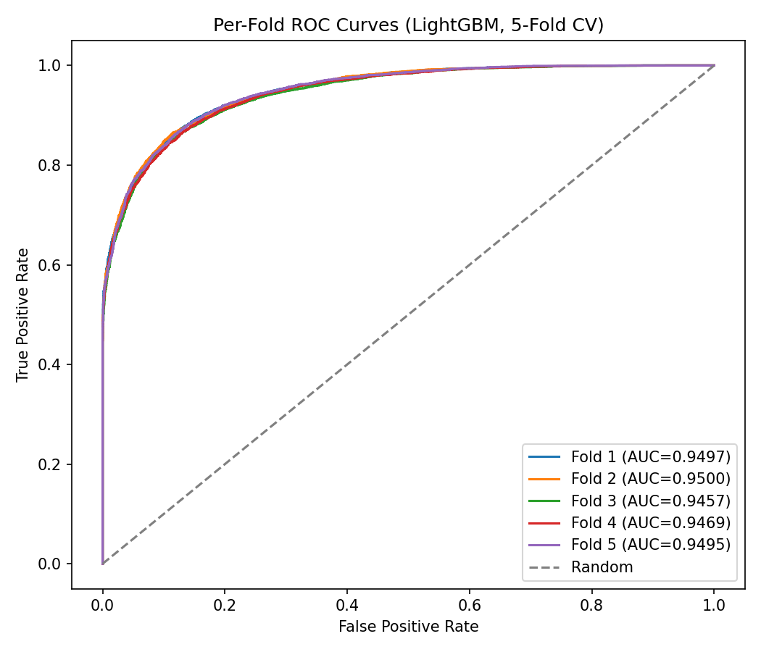
Figure 4. Per-fold ROC curves, 5-fold Stratified CV.
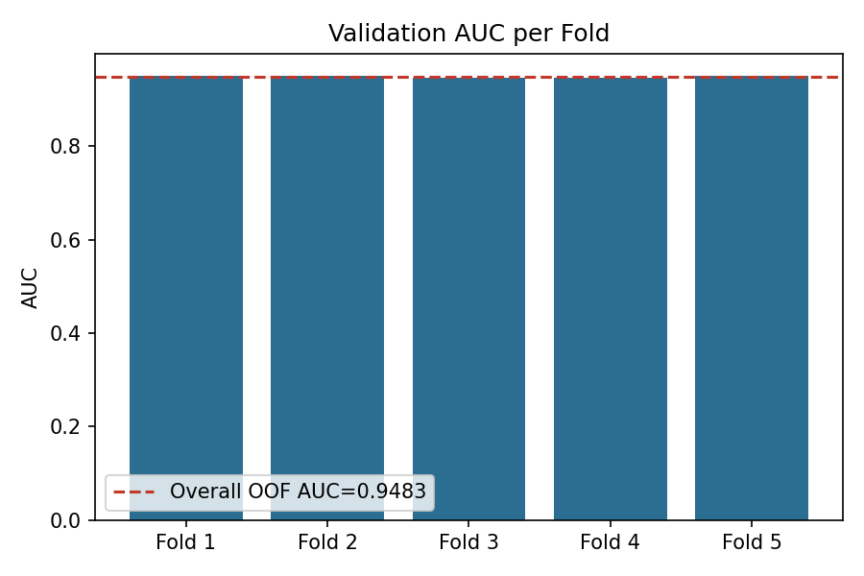
Figure 5. Validation AUC per fold (overall out-of-fold AUC = 0.9483).

8. Model Evaluation: Confusion Matrix and Explainability
Model evaluation focused primarily on ROC-AUC because the final output is a probability ranking rather than a hard classification, and ROC-AUC is threshold-independent. To also satisfy the project's requirement for threshold-based interpretation, we additionally computed a Confusion Matrix and precision/recall/F1 at a 0.5 decision threshold, using out-of-fold predictions (i.e. each prediction comes from a model that never saw that row during training, so this reflects genuine held-out performance rather than in-sample optimism):
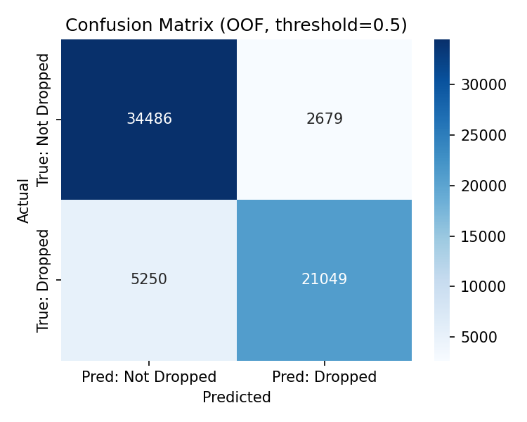
Figure 6. Confusion matrix, out-of-fold predictions, threshold = 0.5.
At this threshold: precision = 0.89 and recall = 0.80 for the "Dropped" class (F1 = 0.84); precision = 0.87 and recall = 0.93 for "Not Dropped" (F1 = 0.90); overall accuracy = 0.88. In this business setting, a false negative (a client who will drop but is predicted safe) is more costly than a false positive (a client flagged as at-risk who would have stayed), since a missed at-risk client receives no proactive outreach. Nova Academy could reasonably lower the decision threshold below 0.5 to prioritize recall on the "Dropped" class, accepting more false positives in exchange for catching more true dropouts — this is a threshold/business-policy choice separate from the ranking quality (AUC) of the model itself.
For explainability, we used SHAP (TreeExplainer) on the selected LightGBM configuration, in addition to the model's built-in gain-based feature importance, to understand which features drive individual predictions:
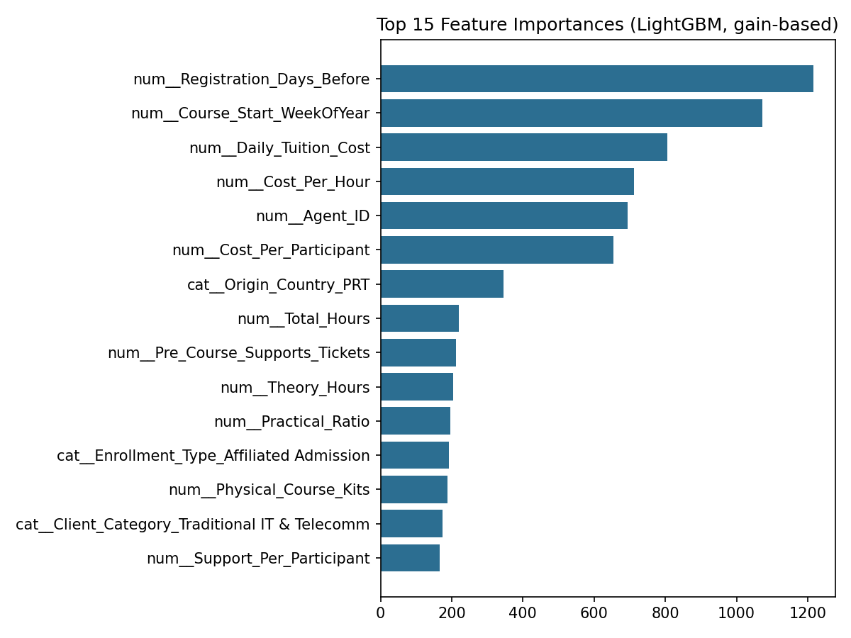
Figure 7. Top 15 features by gain-based importance (LightGBM).
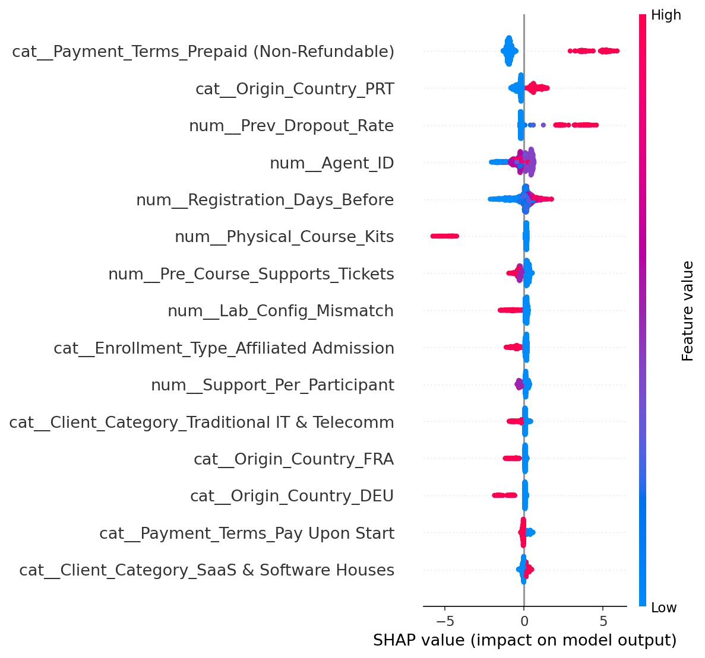
Figure 8. SHAP summary plot — top 15 features by mean |SHAP value|.
Both views agree on the most influential features: Payment_Terms (particularly prepaid, non-refundable registrations), Prev_Dropout_Rate, Agent_ID, Registration_Days_Before, Physical_Course_Kits, Pre_Course_Supports_Tickets, and Lab_Config_Mismatch. This matches the patterns observed during EDA and gives Nova Academy actionable, per-client reasoning behind each risk score rather than a black-box number: for example, clients with a higher previous-dropout rate, more pre-course support tickets, or a mismatch between requested and assigned lab configuration are pushed toward a higher predicted cancellation probability, while non-refundable prepayment is associated with a lower one.
Note on methodology: the confusion matrix, feature importance, and SHAP figures above were produced from a representative LightGBM configuration trained on the full engineered feature set with the same preprocessing pipeline as the final model, run specifically to generate these diagnostic and explainability outputs for this report. It is close to, but not numerically identical to, the exact tuned "deeper" configuration used to generate the final leaderboard submission, since re-tuning was not repeated here in order to avoid any risk of altering the already-validated, leaderboard-safe submission file.

9. Final Submission
The final submission file is: Group_51_Submission.csv
It contains exactly two columns:
- Client_ID
- Drop_Probability
The file was validated using the following checks:
- Row count equals the test set row count: 15,866
- Columns are exactly Client_ID and Drop_Probability
- No missing values
- No duplicate Client_ID values
- All probabilities are between 0 and 1
- Client_ID order exactly matches the original test file
The final submitted file uses the best known leaderboard-safe prediction file, which achieved AUC = 0.889030.

10. Limitations and Future Improvements
The main limitation is temporal distribution shift between training and test data. Random cross-validation likely overestimates performance because it mixes dates, while the test set represents a future time period. A secondary, compounding factor is the high cardinality of several categorical features (Section 5), which increases model variance beyond what temporal shift alone would explain.
Future improvements could include:
- stronger time-aware validation
- model retraining with more recent data
- grouping rare categories in high-cardinality columns (e.g. Origin_Country, Client_Category) instead of one-hot encoding every unique value
- more careful treatment of high-cardinality IDs
- safer target encoding inside cross-validation
- probability calibration
- additional ensemble/blending experiments
- deeper error analysis by client segment and course type
Overall, the project produced a validated, reproducible machine-learning pipeline, strong public leaderboard performance, and — with the confusion matrix and SHAP analysis added in Section 8 — genuinely interpretable insights into cancellation risk.

