Q1. Write a shell program to calculate the factorial of a number.

Source Code

#!/bin/bash

read n

a=1

while [ $n -gt 0 ]

do

a=`expr $a \\* $n`

n=`expr $n - 1`

done

echo "$a"

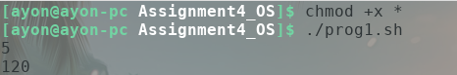

Q2. Write a shell menu driven program to do the following

1. Display the current working directory
2. Check whether an input number is even or odd
3. Display the number of counts of all the files in a directory
4. Print the long listing of all the files

Source Code

#!/bin/bash

read CHOICE

case $CHOICE in

1) pwd

;;

2)

echo "Enter number to check"

read a

if [ `expr $a % 2` -eq 0 ]; then

echo "Even"

else

echo "Odd"

fi

;;

3) ls -1q \* | wc -l

;;

4)ls -l

;;

esac

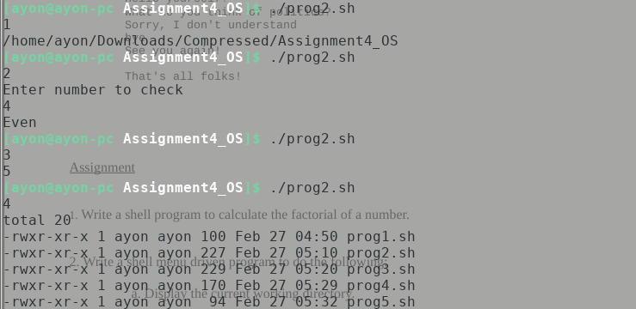

Q3. Write a shell program to display all the prime numbers between 1 to 100.

Source Code

#!/bin/bash

n=1

while [ $n -le 100 ]; do

count=0

for i in `seq 1 $n`; do

if [ `expr $n % $i` -eq 0 ]; then

count=`expr $count + 1`

fi

done

if [ $count -eq 2 ]; then

echo "$n is prime"

fi

n=`expr $n + 1`

done

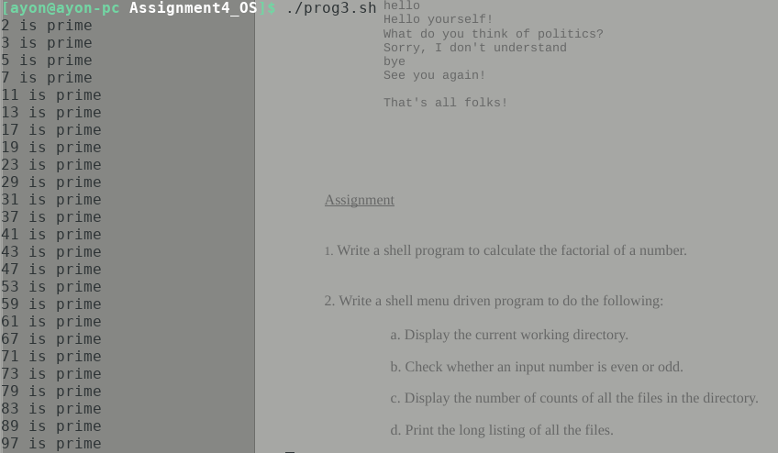

Q4. Write a menu program to find out whether a given program is vowel or not.

Source Code

#!/bin/bash

read TEXT

case $TEXT in

a) echo "Vowel" ;;

e) echo "Vowel" ;;

i) echo "Vowel" ;;

o) echo "Vowel" ;;

u) echo "Vowel" ;;

\*) echo "Consonent";;

esac

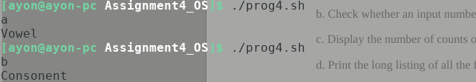

Q5. Write a shell script which displays the output as follows

\*

\*\*

\*\*\*

\*\*\*\*

Source Code

#!/bin/bash

for i in `seq 1 4`; do

for j in `seq 1 $i`; do

echo -n "\*"

done

echo

done

