**Institute of Engineering & Management**

**Department of Computer Science & Engineering**

**Operating System Lab for 3rd year 6th semester 2019**

**Code: CS 693**

**Date:** 06/02/19

**WEEK-2**

**Assignment-1**

**Problem Statement:** Complete the following-

1. Display the current time in 12-hour format.
2. With a user-specified date, display only the day of the week (e.g. Tuesday).

**CLI code:**

1. date +%r
2. date -d “2009-05-02” +%A

**Screen-Shot:**

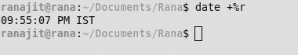

**Fig: 1-(a)**



**Fig: 1-(b)**

**Assignment-2**

**Problem Statement:** Write the command to find the square root of 4

**CLI code:** echo “sqrt(4)” | bc

**Screen-Shot:**



**Assignment-3**

**Problem Statement:** Show how we can calculate the following expression in the terminal of UNIX

A=5, b=6, z=15

Total = (A*b) + (z/A)

Display the Total.

**CLI code:**

A=5

b=6

z=15

echo “( $A * $b ) + ( $z / $A )”

**Screen-Shot:**

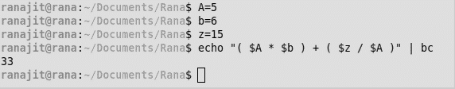

**Assignment-4**

**Problem Statement:** How can we sort a list of numbers in a file (both ascending and descending order)?

**CLI code:**

sort -n numbers.txt

sort -n numbers.txt

**Screen-Shot:**

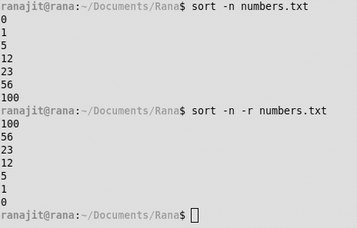

**Assignment-5**

**Problem Statement:** Create the file *student.dat* as follows:

Roll Name Dept Year

105 Anik CSE 1st

101 Debesh CSE 2nd

108 Aniket IT 1st

200 Mainak ECE 2nd

105 Anik CSE 1st

1. Sort the data according to Roll
2. Sort the data according to Dept.
3. Show only the records of students from the CSE Dept.

**CLI code:**

1. sort -k 1 students.dat
2. sort -k 2 students.dat
3. grep “CSE” students.dat

**Screen-Shot:**

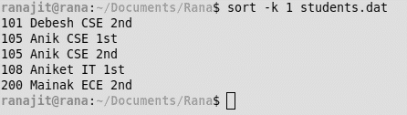

**Fig: 5-(a)**

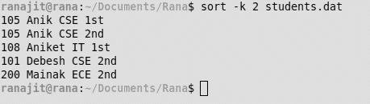

**Fig: 5-(b)**

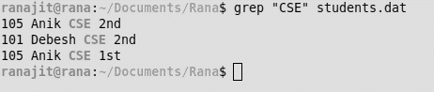

**Fig: 5-(c)**

**Assignment-6**

**Problem Statement:** Show the last 2 lines of the file *animals.txt*

**CLI code:** tail -2 animals.txt

**Screen-Shot:**

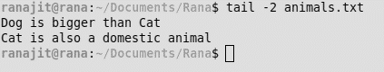

**Assignment-7**

**Problem Statement:** Show the first 3 lines of the file *animals.txt.*

**CLI code:** head -3 animals.txt

**Screen-Shot:**

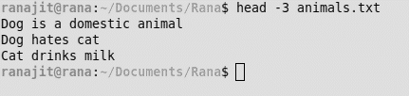

**Assignment-8**

**Problem Statement:** List only the directory files in your current directory.

**CLI code:** ls -d */

**Screen-Shot:**



**Assignment-9**

**Problem Statement:** Count the number of directories in your current directory.

**CLI code:** ls -d */ | wc -w

**Screen-Shot:**

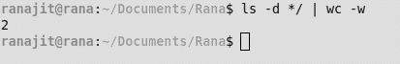

**Assignment-10**

**Problem Statement:** Create a file *animals.txt* with the following text-

Dog is a domestic animal

Dog hates cat

Cat drinks milk

Dog is bigger than Cat

Cat is also a domestic animal

1. Find the total number of lines contains the word ‘Dog’ in animals.txt.
2. Also find the total number of lines does not contain the word ‘Dog’ in animals.txt.
3. Display the lines in animals.txt that end with the word 'cat'.

**CLI code:**

1. grep “Dog” animals.txt | wc -l
2. grep -v “Dog” animals.txt | wc -l
3. grep -i “cat$” animals.txt

**Screen-Shot:**

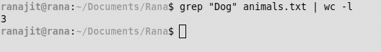

**Fig: 10-(a)**



**Fig: 10-(b)**

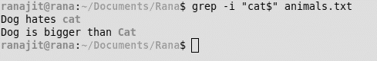

**Fig: 10-(c)**