**Institute of Engineering & Management**

**Department of Computer Science & Engineering**

**Operating System Lab for 3rd year 6th semester 2019**

**Code: CS 693**

**Date:** 13/02/19

**WEEK-3**

**Assignment-1**

**Problem Statement:** Write a shell program to display the content of a file after reading the file.

**Script:**

#!/bin/sh

cat who.txt

**Screen-Shot:**

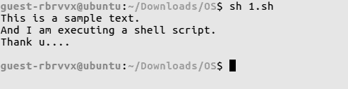

**Assignment-2**

**Problem Statement:** Write a shell program to display the first three lines of a file.

**Script:**

#!/bin/sh

head -3 who.txt

**Screen-Shot:**

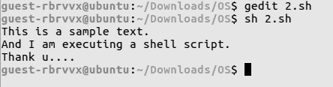

**Assignment-3**

**Problem Statement:** Write a shell program to perform the swapping between two numbers taken from user during run-time.

**Script:**

#!/bin/sh

echo "Enter: "

echo -n "a = "

read a

echo -n "b = "

read b

c=$a

a=$b

b=$c

echo "Value of \na = $a \nb = $b"

**Screen-Shot:**

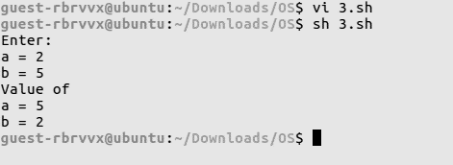

**Assignment-4**

**Problem Statement:** Write a shell program to print the largest among three numbers by passing the numbers through command line arguments.

**Script:**

#!/bin/sh

if [ $1 -gt $2 ]

then

if [ $1 -gt $3 ]

then

echo "1st argument: $1 is greatest"

else

echo "3rd argument: $3 is greatest"

fi

else

if [ $2 -gt $3 ]

then

echo "2nd argument: $2 is greatest"

else

echo "3rd argument: $3 is greatest"

fi

fi

**Screen-Shot:**

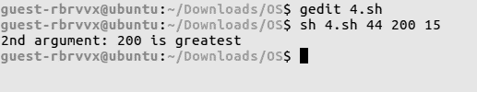

**Assignment-5**

**Problem Statement:** Write a shell program to display the following mark sheets of students by taking the input marks of student through the terminal

Marks range Grade

90>=M<=100 A

70>=M<=89 B

40>=M<=69 C

M<40 F

**Script:**

#!/bin/sh

echo " ----Marksheet----"

read -p "Enter the marks of the student: " m

echo " "

if [ $m -le 100 -a $m -ge 90 ]

then

grade="A"

elif [ $m -le 89 -a $m -ge 70 ]

then

grade="B"

elif [ $m -le 69 -a $m -ge 40 ]

then

grade="C"

else

grade="F"

fi

echo "Grade given: $grade \n\n"

**Screen-Shot:**

