The Chinese University of Hong Kong

Department of Financial Technology

FTEC5520 –Applied Blockchain & Cryptocurrency

Lab2-part1-report

Hyperledger Fabric Setup & Practice on AWS(Task1,2,3)

Please edit this file directly but submitted a PDF version to blackboard finally.

# 1 Questions Answering:

There will be 3 questions only for **task1,2 and 3**.

**Q1:** Basic concepts and knowledge about Hyperledger Fabric. (2 mark)

1. What’s the difference between member and peer node in Hyperledger fabric?
2. What’s the channel in Hyperledger Fabric? Why do we need it?
3. What’s chaincode in Hyperledger Fabric? What did you do in task 1~3 about chaincode?
4. What’s Membership Service Provider (MSP)? Why do we need it? What did you do about this component in task1~3?

**Hint:** You may refer to this [chapter of official docs of Hyperledger Fabric](https://hyperledger-fabric.readthedocs.io/en/release-1.4/key_concepts.html).

**Q2:** Please read step 1 ~ 7 of the [AmazonManagedBlockchain official documents](https://docs.aws.amazon.com/managed-blockchain/latest/managementguide/managed-blockchain-get-started-tutorial.html) and answer the following questions. (2 mark)

**Note:** Please describe the procedure in your own words and list the commands.

1. How to create blockchain network, member and node using AWS CLI instead of GUI?
2. What’s the CAEndpoint of here? How can we get the value in AmazonManagedBlockchain service dashboard? How to enroll an Admin User with admin permissions to your member’s CA? **Hint:** fabric-ca-client enroll
3. How to create a channel and join your peer node to the channel your created?
4. How to install, instantiate, query and invoke the Chaincode? Please use the example we used in task3.

**Q3:** What’s the difference between Hyperledger Fabric and Ethereum after you learnt about both the two frameworks including the hands-on lab sessions? (1 mark)

**Note:** Detailed answer expected but no more than 1 page. Please refer to the lecture slides the [article-1](https://medium.com/@philippsandner/comparison-of-ethereum-hyperledger-fabric-and-corda-21c1bb9442f6), [article-2](https://medium.com/quillhash/ethereum-or-hyperledger-fabric-259f3c9b8da6) and try to merge some contents of previous questions if necessary.

# 2 Screen Capture of Main Steps:

Please replace the sample photos with your own results.

Your screenshots must include these parts at least and detailed description of each screenshots:

1. Your Hyperledger Fabric blockchain network on AmazonManagedBlockchain dashboard:

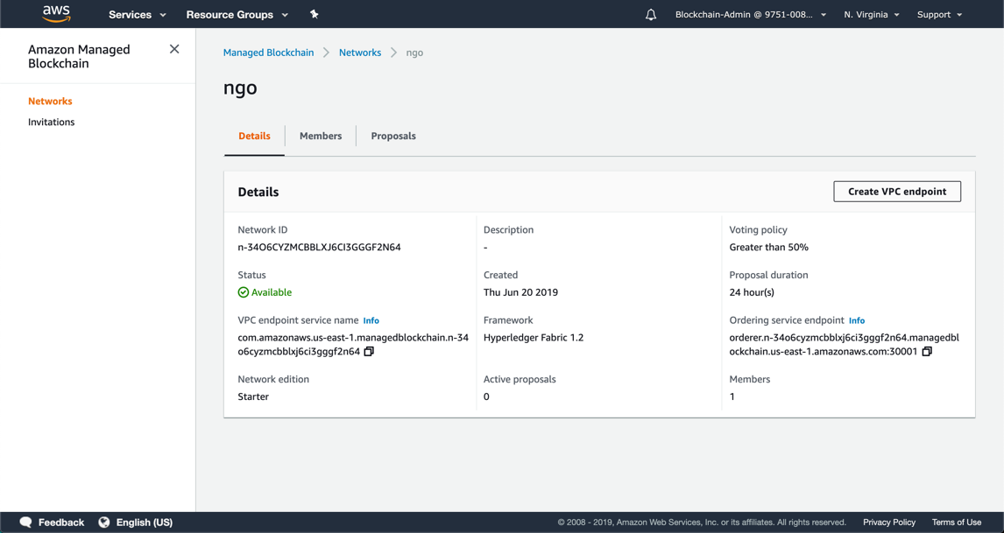

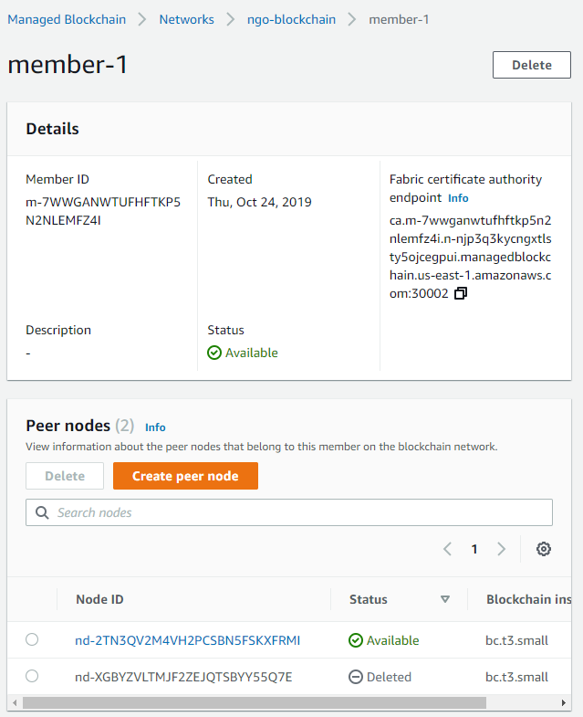

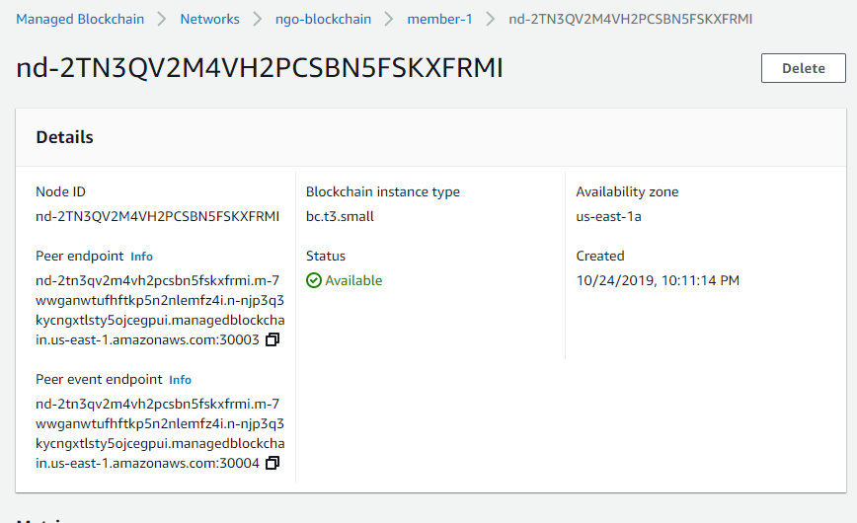

1. SSH from the Cloud9 IDE to peer node. You should know they are two VMs.

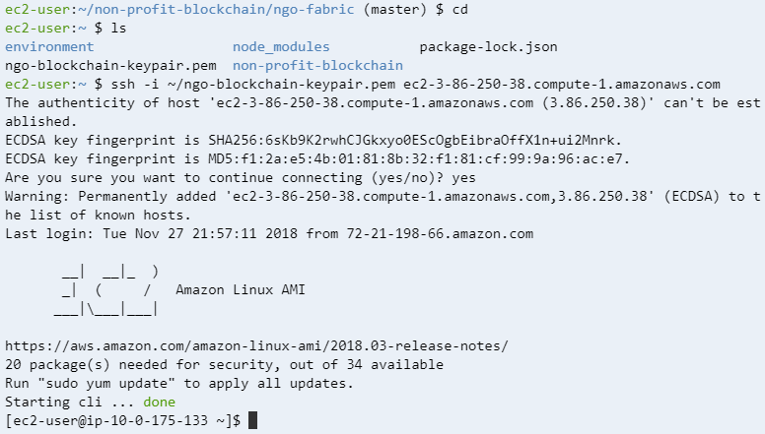

1. The content of **fabric-exports.sh** after insert your blockchain network information

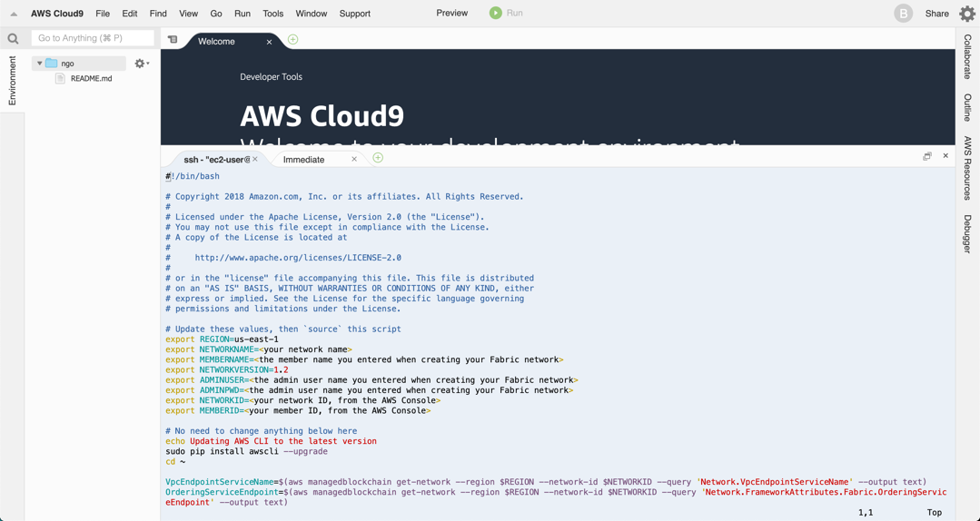

1. The useful information after you ran the command in task3 step 2.16

source fabric-exports.sh

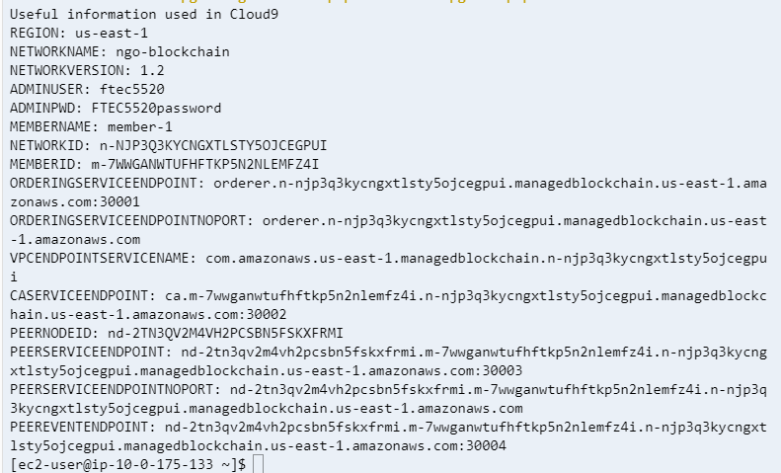

1. Use this command to check the peer export information:

cat ~/peer-exports.sh

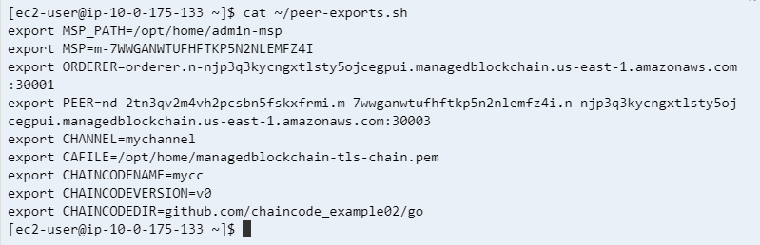

1. List the generated configuration using

ls -lt ~/$CHANNEL.pb



1. List the mychannel.block generated fabric channel in task3 step 4.1

ls -lt /home/ec2-user/fabric-samples/chaincode/hyperledger/fabric/peer

**

1. Query the chaincode on peer in the task3 step 8

docker exec -e "CORE_PEER_TLS_ENABLED=true" -e "CORE_PEER_TLS_ROOTCERT_FILE=/opt/home/managedblockchain-tls-chain.pem" -e "CORE_PEER_ADDRESS=$PEER" -e "CORE_PEER_LOCALMSPID=$MSP" -e "CORE_PEER_MSPCONFIGPATH=$MSP_PATH" cli peer chaincode query -C $CHANNEL -n $CHAINCODENAME -c '{"Args":["query","a"]}'

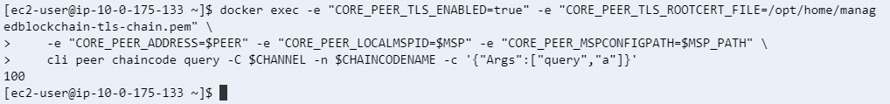

1. Invoke a transaction to transfer 10 dollars from Account a to Account b:

docker exec -e "CORE_PEER_TLS_ENABLED=true" -e "CORE_PEER_TLS_ROOTCERT_FILE=/opt/home/managedblockchain-tls-chain.pem" **\**

-e "CORE_PEER_ADDRESS=$PEER" -e "CORE_PEER_LOCALMSPID=$MSP" -e "CORE_PEER_MSPCONFIGPATH=$MSP_PATH" **\**

cli peer chaincode invoke -o $ORDERER -C $CHANNEL -n $CHAINCODENAME **\**

-c '{"Args":["invoke","a","b","10"]}' --cafile $CAFILE --tls

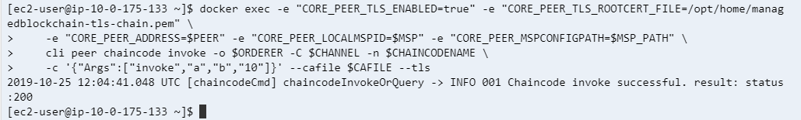

1. Query the balance of Account named ‘a’ again after transaction:

docker exec -e "CORE_PEER_TLS_ENABLED=true" -e "CORE_PEER_TLS_ROOTCERT_FILE=/opt/home/managedblockchain-tls-chain.pem" **\**

-e "CORE_PEER_ADDRESS=$PEER" -e "CORE_PEER_LOCALMSPID=$MSP" -e "CORE_PEER_MSPCONFIGPATH=$MSP_PATH" **\**

cli peer chaincode query -C $CHANNEL -n $CHAINCODENAME -c '{"Args":["query","a"]}'

