The Chinese University of Hong Kong

Department of Financial Technology

FTEC5520 –Applied Blockchain & Cryptocurrency

Lab2-part2-report

Hyperledger Fabric Setup & Practice on AWS(Task4,5,6)

Please edit this file directly but submitted a PDF version to blackboard finally.

Please replace the sample photos with your own results.

Your screenshots must include these parts at least and detailed description of each screenshots:

1. Mounts section

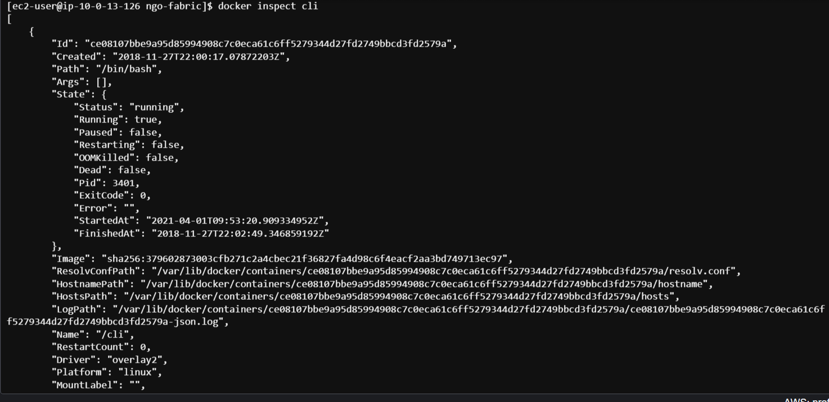

…

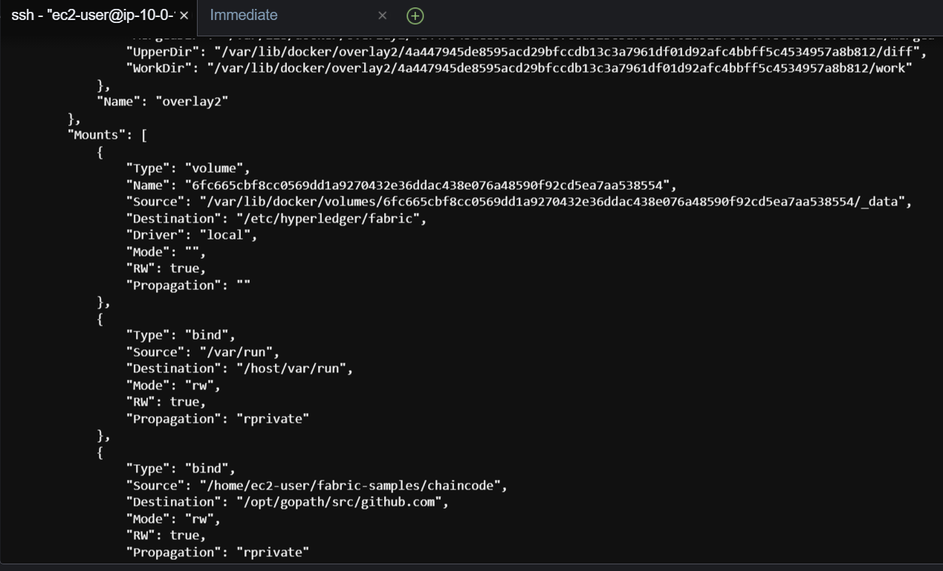

1. Copying the chaincode into fabric-samples directory will make it accessible inside the Fabric CLI container

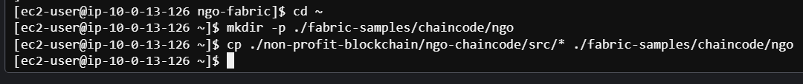

1. The chaincode installed on the peer node:

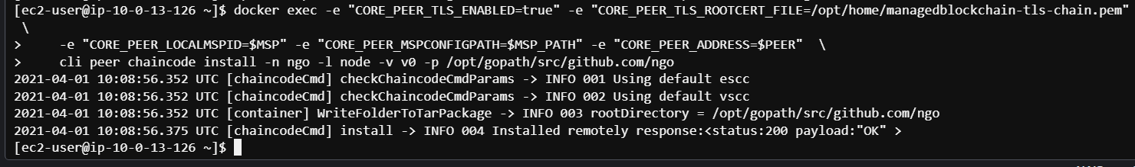

1. Instantiate chaincode on the channel:

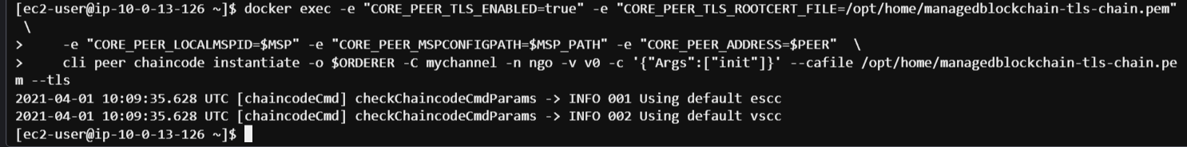

1. Query the chaincode

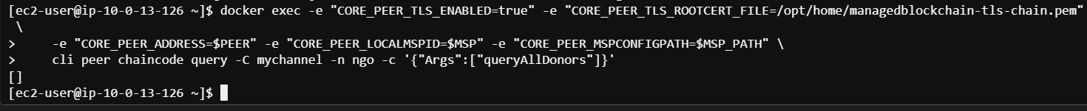

1. Add 2 donors, execute the transactions:

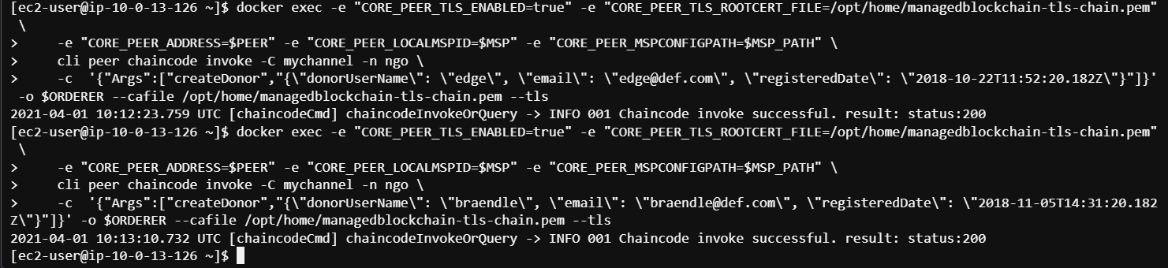

1. Query the chaincode, all users & specific users:

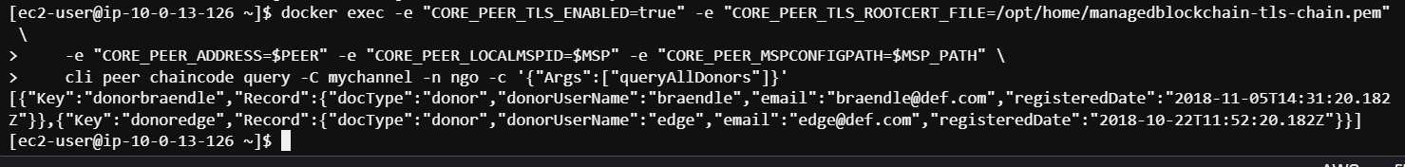

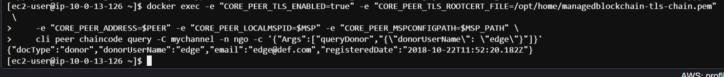

1. Run the RESTful API server, install Node.js on the Fabric client node:

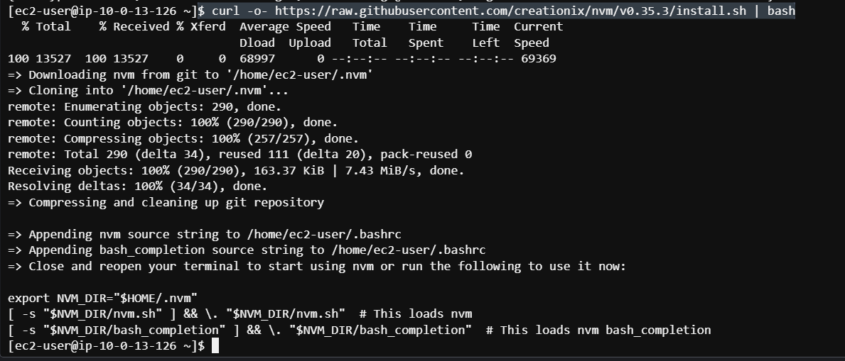

1. Install load version manager & g++:

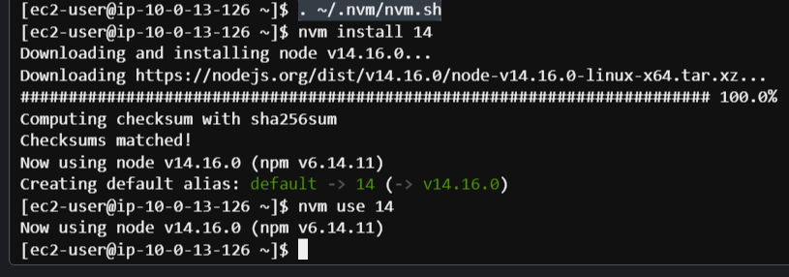 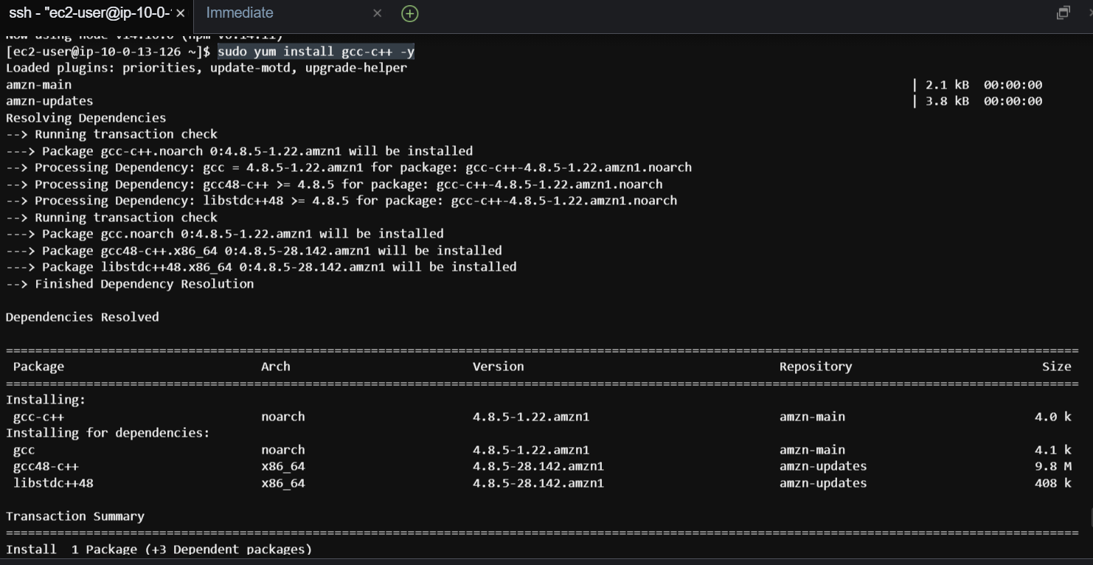

…



1. Install dependencies using npm:

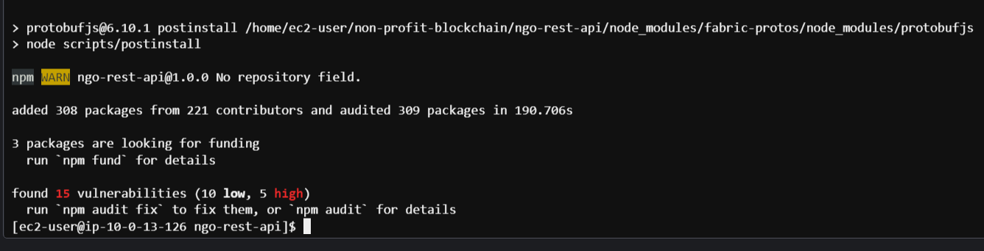

1. Generate connection profile:

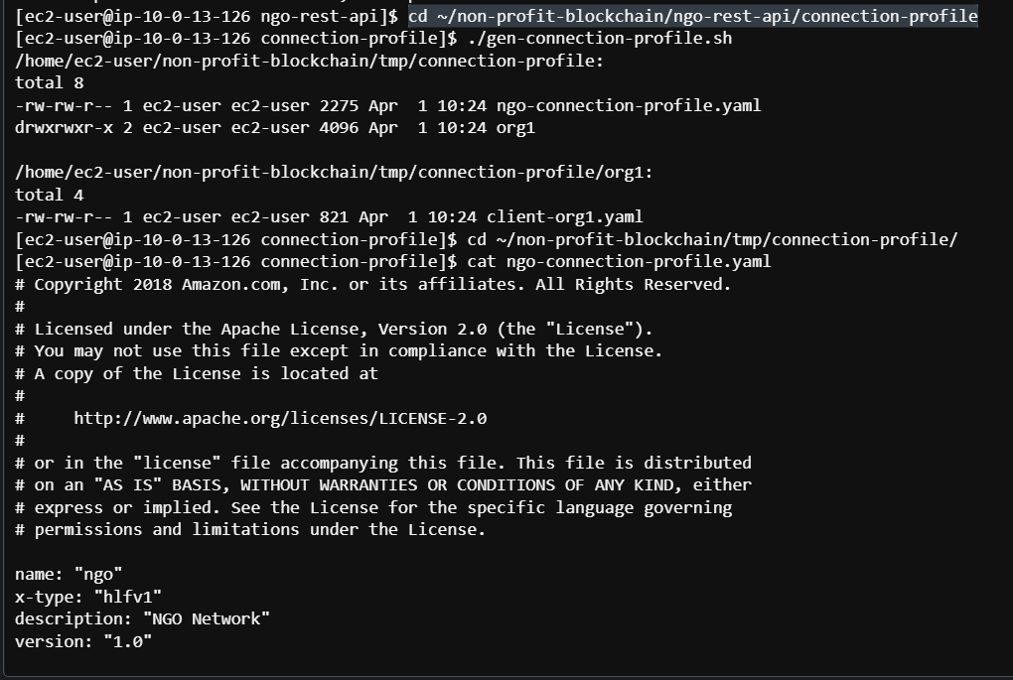

…

1. Check the config file using app.js:



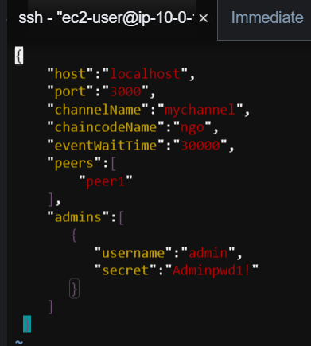

1. Run the app:

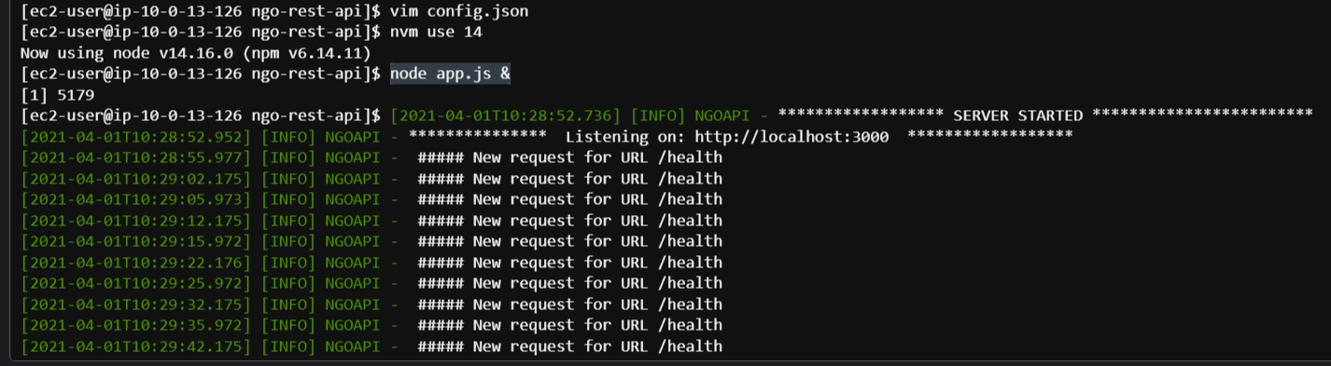

1. Open a new terminal window:

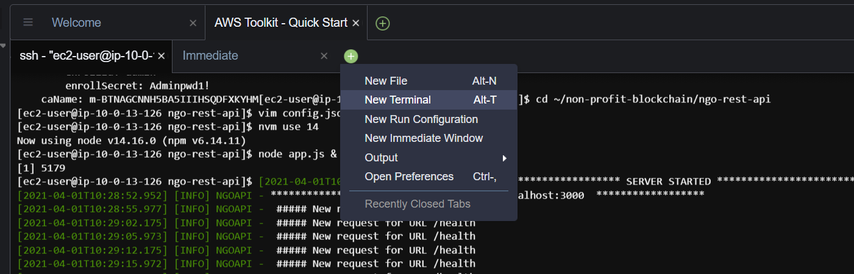

1. From the new terminal, SSH into the Fabric client node:

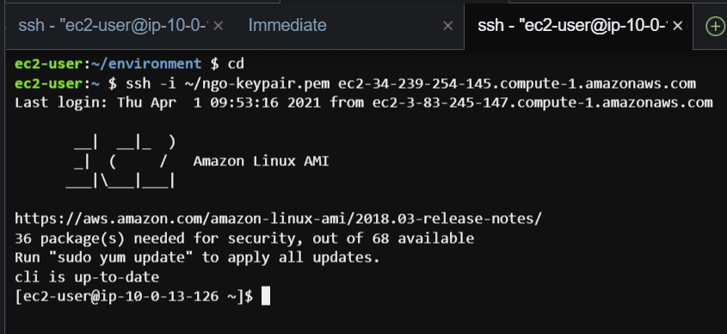

1. Enroll a new user & Post a donor:

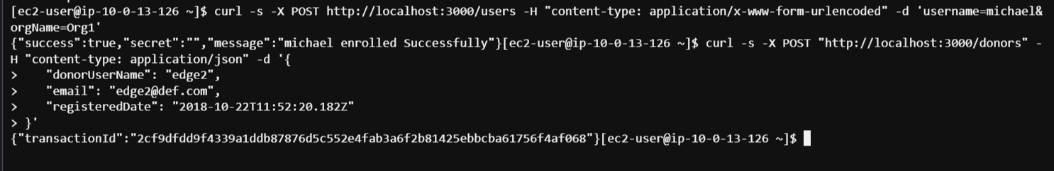

1. Get all donors:



1. Load the workshop test data:

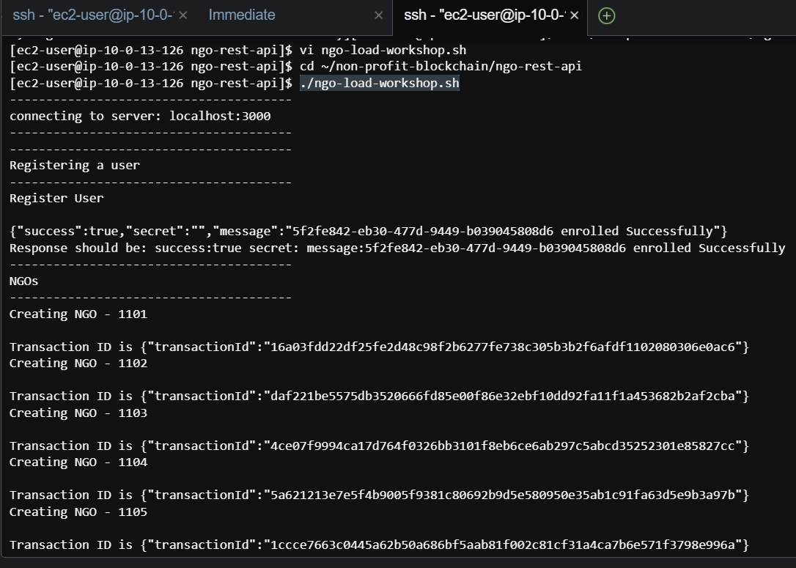

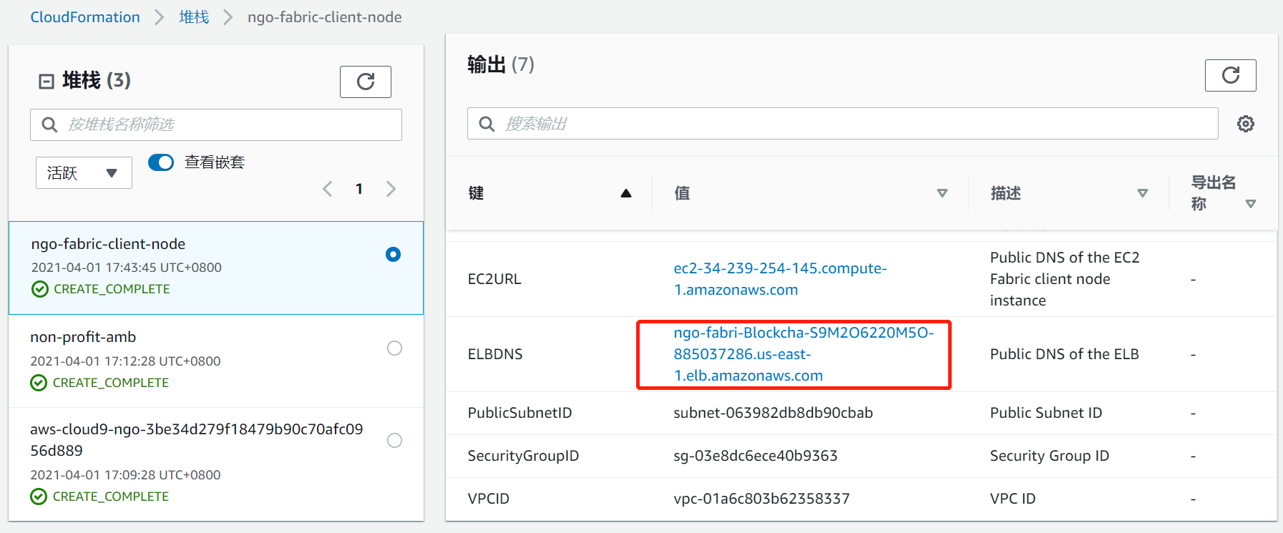

1. Run the script:



