**Model**

**Analysis**

During the implementation of this project, I try to divide the whole project into five steps, firstly, the main entities are ensured and established, then how to figure out the relationships between them, thirdly, how to use files to store some data. Simultaneously, we also need to design a friendly interface for interaction before testing the whole project and debugging. For the followings, I will employ figures to illustrate how the project is finished.

**Step 1, entities established**

For this project, there art two kinds of entities, school objects and human staff,

School objects, Course, Assignment, Scholarship

Human staff, Course Manager, Finance Manager, Teacher, Student

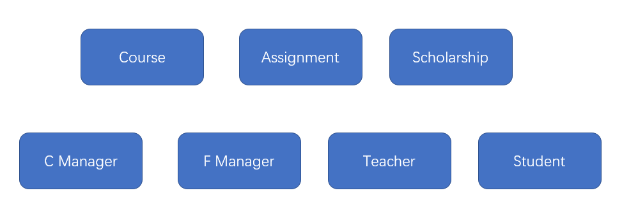

(figure 1)

**Step 2, connection between entities**

It is very clear that, there always several assignments contained in one course. Similarly, each teacher could teach more than one course, and one student could sign up for many courses.

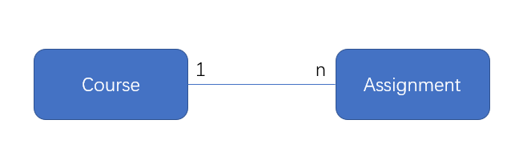

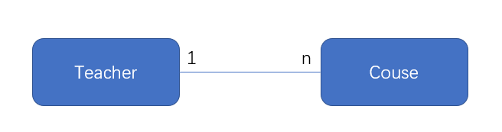

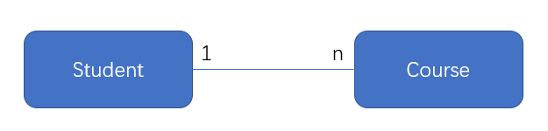

(figure 2)

Noticeably, for staff entities, Course Manager, Finance Manager, Teacher and Student, they share some common features, therefore, they could be grouped by inheritance of programming.

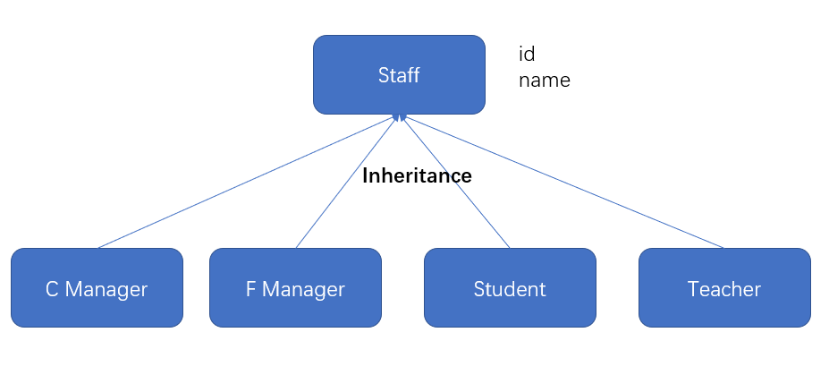

(figure 3)

On the other hand, assignment could be categorized into two types, essay assignment (write an essay) and choice assignment (answer several choices questions), and course also has two types which are online and offline, here it could be illustrated as below, so do scholarship

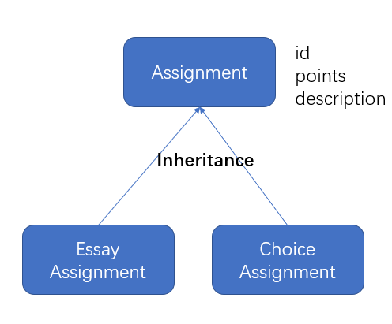

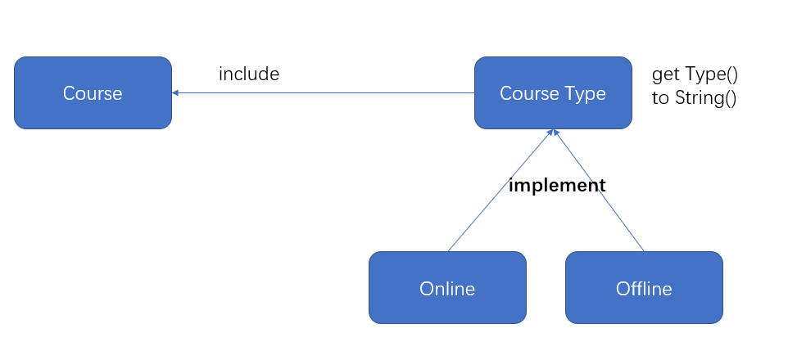

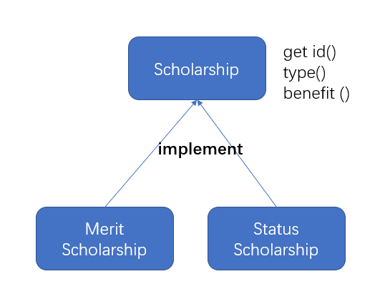

(figure 4)

For the whole relationships of different entities are the following:

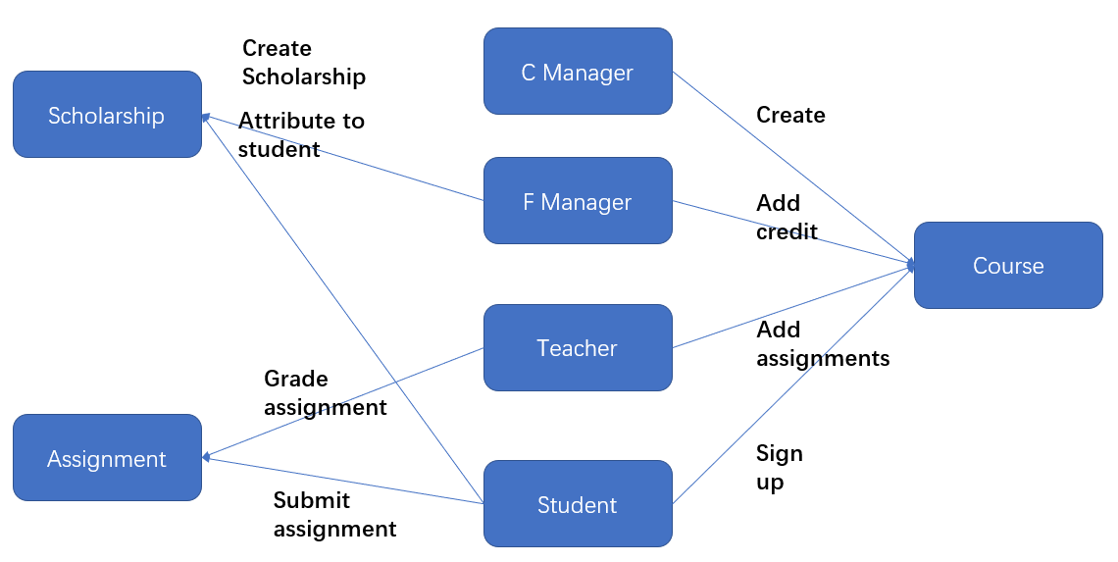

(figure 5)

1. Course Manager create Course with certain attributes such as id, name, capacity and type and so on, Finance Manager add credit for each course, and Teacher create assignments for the taught course, and then Student could sign up course or not.
2. Finance Manager create scholarship and could attribute scholarships to students.
3. For every course, if student sign up it, student needs to submit answer for every assignment of this course and teacher could grade it.

The above figure is for one kind of operation, while it is almost the same for the other types of operations, such as update, delete and browse.

**Step 3, storage of data**

Files are used to store data, because human entities could be grouped into staff List, and course could be stored in a List, and the same to assignment List,

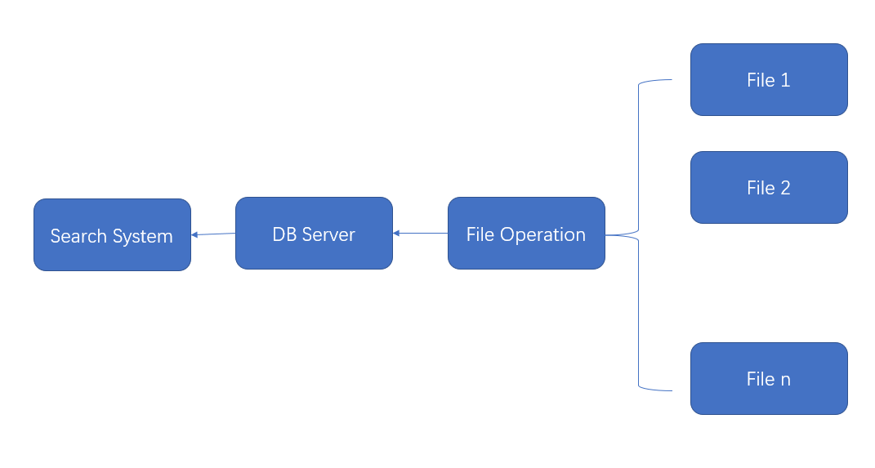

(figure 6)

File Operation is used to read and write data from and to files,

DB Server is used to store the whole data as lists,

And Search System is used to search certain entities by id, name or some other features, such as assignment, course, student.

This is the reason why almost every entity needs to be given an id.

**Step 4, interaction**

Because, the operation of Course Manager and Finance Manager are relatively simple and easy, therefore, command line interface used for these two.

For the Student operations and Teacher operations, GUI (Graphic User Interface) is better.

**Step 5, testing and debugging**

Software always needs to be tested and updated frequently.