HW 4 R

Melissa Lowe with assistance from Emma Jones, Kaci Pickett, and Jammay Winslow

10/3/2018

#### Maps:

#### This code is partially from class, partially from Jimmy and partially from Emma: (Thanks peeps).

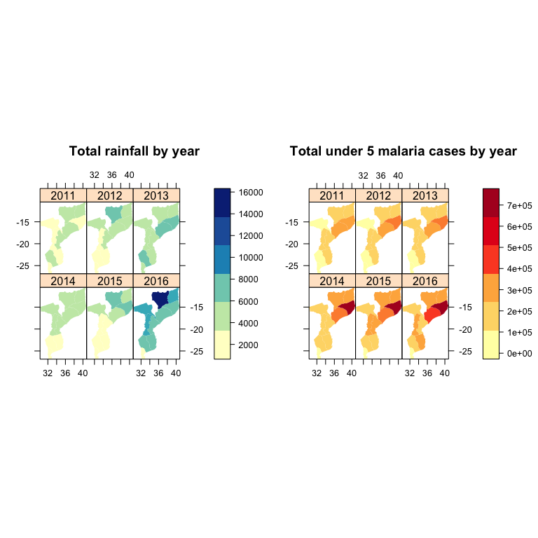

#### CODE:

#### #### **Maps**

#### ```{r, echo=F, message=F, warning=F}

#### op <- par()

#### options(width=80)

#### emptyenv()

#### rm(list=ls())

#### ### MAPPING PACKAGES ###

#### #install.packages(c("RColorBrewer", "sp", "maptools", "lattice", "latticeExtra", "rgdal"))

#### library(RColorBrewer)

#### library(sp)

#### library(maptools)

#### library(lattice)

#### library(latticeExtra) # For layer()

#### library(rgdal)

#### library(RColorBrewer)

#### library(classInt)

#### library(gridExtra)

#### library(grid)

#### ```

#### ##### Now we need to aggregate the malaria and climatic data over the districts to create a set of statistics for each district. Conveniently, this aggregation I perform results in the rownames of the dataframe being the district codes, which is required for creating what is called a spatial polygons dataframe (we'll create this below).

#### ```{r, echo=FALSE, message=T, warning=T}

#### # Note: because I started an Rproject, I can use relative files paths

#### # I just need to use './...' to access other folders within this project now

#### all2 <- read.csv("~/Desktop/MS YEAR 2/S1/R Class/R Class Notes/R-Class/MozSyntheticMalaria.csv")

#### all2$cpt <- (all2$malaria/(all2$Population_UN*all2$u5weight))*1000

#### all2.2 <- subset(all2, Epiyear < 2017)

#### ```

#### ```{r, echo=FALSE}

#### table(all2.2$Province)

#### all2.2 <- subset(all2.2, all2.2$Province != "MAPUTO CIDADE")

#### all2.2$admin_1 <- all2.2$Province

#### # Create means by province and epiyear

#### malProv <- tapply(all2.2$malaria, list(all2.2$Province, all2.2$Epiyear), mean)

#### rainProv <- tapply(all2.2$rainTot, list(all2.2$Province, all2.2$Epiyear), mean)

#### ```

#### ```{r, echo=FALSE}

#### #want to know statistics for district code and year, rows are distcode and columns are years

#### cpt <- as.data.frame(tapply(all2.2$malaria, list(all2.2$admin_1, all2.2$Epiyear), sum))

#### colnames(cpt) <- c("cpt10", "cpt11", "cpt12", "cpt13", "cpt14", "cpt15", "cpt16")

#### rainTot <- as.data.frame(tapply(all2.2$rainTot, list(all2.2$admin_1, all2.2$Epiyear), sum))

#### colnames(rainTot) <- c("rain10", "rain11", "rain12", "rain13", "rain14", "rain15", "rain16")

#### tavg <- as.data.frame(tapply(all2.2$tavg, list(all2.2$admin_1, all2.2$Epiyear), mean))

#### colnames(tavg) <- c("t10", "t11", "t12", "t13", "t14", "t15", "t16")

#### 

#### allStats <- as.data.frame(cbind(cpt, rainTot, tavg))

#### #rownames(allStats) #notice that the row names are the province names

#### #colnames(allStats)

#### allStats <- allStats[-6,]

#### ```

#### ```{r, echo=FALSE}

#### ##### Let's load the district-level administrative shape file for Mozambique.

#### # read in the Moz shape file for districts

#### poly1 <- readShapePoly('~/Desktop/MS YEAR 2/S1/R Class/R Class Notes/R-Class/Moz_admin2.shp', IDvar="DISTCODE")

#### #this is the polygon file. it's been developed with district codes. RStudio helps recall how to get things out of lists. They're shape files as R stores them

#### poly2 <- readShapePoly('~/Desktop/MS YEAR 2/S1/R Class/R Class Notes/R-Class/mozambique_admin1.shp', IDvar="admin_1")

#### #this is the polygon file. it's been developed with province codes. RStudio helps recall how to get things out of lists. They're shape files as R stores them

#### row.names(allStats) <- c("Cabo Delgado", "Gaza", "Inhambane", "Manica", "Maputo", "Nampula", "Nassa", "Sofala", "Tete", "Zambezia")

#### ##### Now let's combine the `allStats` dataframe we created above with the `poly2` shapefile so that we can plot the statistics on the map.

#### polydat <- SpatialPolygonsDataFrame(poly2, allStats)

#### ```

#### this code is paritally from class, partially from Jimmy and partially from Emma: (Thanks peeps)

#### ```{r, echo=F, message=T, warning=T, fig.height=8, fig.width=8}

#### par(mfrow=c(2,1))

#### # MULTIPLE #

#### tempPal <- brewer.pal(n = 7, name = "YlOrRd")

#### rainPal <- brewer.pal(n = 7, name = "YlGnBu")

#### my.palette <- brewer.pal(n = 7, name = "OrRd")

#### trellis.par.set(sp.theme(regions=list(col = rainPal)))

#### p2 <- spplot(polydat, c("cpt11", "cpt12", "cpt13", "cpt14", "cpt15", "cpt16"),

#### names.attr = c("2011", "2012", "2013", "2014", "2015", "2016"),

#### colorkey=list(space="right"), scales = list(draw = TRUE),

#### main = "Total under 5 malaria cases by year",

#### as.table = TRUE, col.regions = tempPal, col='transparent', cuts=5)

#### #invisible(dev.off())

#### p1 <- spplot(polydat, c("rain11", "rain12", "rain13", "rain14", "rain15", "rain16"),

#### names.attr = c("2011", "2012", "2013", "2014", "2015", "2016"),

#### colorkey=list(space="right"), scales = list(draw = TRUE),

#### main = "Total rainfall by year",

#### as.table = TRUE, col.regions = rainPal, col='transparent', cuts=5)

#### #invisible(dev.off())

#### grid.arrange(p1, p2, ncol = 2)

#### ```