Malaria in Mozambique

Melissa Lowe

10/22/2018

(Worked with Kaci Pickett and Emma Jones)

Malaria represents a major public health issue in much of sub-Saharan African including the country of Mozambique where Malaria is endemic. 42% of deaths in children under five are caused by malaria [1]. There is a seasonal peak in malaria which occurs from December to April. Our dataset included cumulative data from 2010 to 2016 based on epidemiology weeks. In general, epidemiology weeks follow from January to December with the first week ending on the first Saturday in January. Therefore, peak malaria periods bridge epidemiology years and full seasonality and climatic influences are better evaluated over multiple years.

Understanding the factors that contribute to increases in malaria cases allow for better planning, particularly at smaller community levels. A study done in Ethiopia indicated that malaria transmission correlates with higher continuous rainfall lagged by 8 weeks while items such as relative humidity have peak correlation somewhere between 8 and 12 weeks [3]. Availability of standing water is strongly linked to malaria transmission as standing water provides the breeding ground for mosquitos carrying the parasite. requires the development of standing water. Therefore, malaria case burdens peak during the rainy season (December to February) and are lowest during the dry season (June to August). In southeastern Mozambique, lags related to wet climates approached two-months [4]. Here, we evaluate the incidence of malaria over time as it relates to the climate of Mozambique regions and also, the appropriate lags that result in peak malaria cases in association with weekly total rainfall, relative humidity, and average temperature.

According to Table 1, below, malaria cases in the under-five population nearly doubled from 2010 to 2016. This increase is probably due to an increase in reporting, not incidence [1]. The Malaria Operational Plans for Mozambique indicate that surveillance, monitoring, training, and evaluation for malaria management in Mozambique will include training at a district-level suggesting that the level of focus for this analysis be at the district as opposed to province. Northern Mozambique does appear to have more malaria cases than other parts of the country, see Figure 1 [2]. However, contrary to potential expectation, total rainfall is does not correlate strongly with regional malaria incidence, Figure 2. However, it is possible that malaria will be elevated in the Central region in 2017 given the higher values of weekly rain that occurred in the area during 2016. Data from 2017 was incomplete and not used in this descriptive analysis. The trend in %relative humidity over time in all regions seems to be decreasing. However, this could be another effect of observation bias based on data gathering techniques over the past 7 years (Figure 3).

Following these initial summary data analyses, spatial analysis was conducted to see what the specific relative distributions of malaria cases were relative to rainfall and temperature at the district level. Recognizing that 2016 probably contained the most complete data, Figure 4 represents a detailed representation of malaria cases in 2016. Figure 4 specifically evaluates the maximum cases per thousand across the year in relationship to average temperatures and total rainfall. We see that there is some relationship between rainfall and malaria cases and a moderate indication that non-extreme temperatures may cultivate malaria-bearing mosquito populations. However, one district in Northern Mozambique does seem to defy those trends – indicating a potential area where climatic issues did not drive malaria incidence and possibly may be a location for further interventions.

Figure 5 further explores apparent lag time in association with heightened incidence of malaria cases. In particular, we see that temperature appears to have a 4-6 week lag that fits best with malaria cases. In contrast, rainfall appears to follow a minimum of 8 weeks of lag before malaria cases peak. Relative humidity does not follow very dramatic lag periods but also seems to fall somewhere in excess of four weeks of lag in association with an uptick in malaria cases.

We were further curious about whether there was spatial variation over time in malaria cases and/or in climatic events. Figures 6 through 12 represent yearly maps of the incidence of malaria cases overlaying rainfall and temperature values. Of interest is the moderate consistency in where malaria cases occur over time. While there is seasonal variation in malaria cases as seen in the lag charts, year to year variation in rainfall does not appear to drive changes in malaria incidence in the under-5 population in the following wet seasons.

In terms of further research and exploration, subsetting the data to evaluate the individual wet and dry seasons by year might illuminate the lack of apparent connection between years and changes in climatic regimes. Additonally, we can see that there are certain regions that deviate from a simple interaction between climate and malaria where further interventions could be targeted.

Table : Table of average or median weekly values across Mozambique each year. Malaria represents average weekly cases reported.

|  |  |  |  |  |
| --- | --- | --- | --- | --- |
| Year | Malaria (cases) | Median Rainfall (mm) | Average Temp(C) | Relative Humidity(%) |
| 2010 | 225.04 | 0.01 | 22.91 | 77.20 |
| 2011 | 212.09 | 0.00 | 22.89 | 75.08 |
| 2012 | 212.75 | 0.00 | 23.01 | 74.37 |
| 2013 | 256.93 | 0.01 | 22.93 | 74.17 |
| 2014 | 360.57 | 0.00 | 23.07 | 74.55 |
| 2015 | 377.12 | 0.00 | 23.80 | 67.78 |
| 2016 | 424.10 | 0.75 | 23.92 | 67.78 |

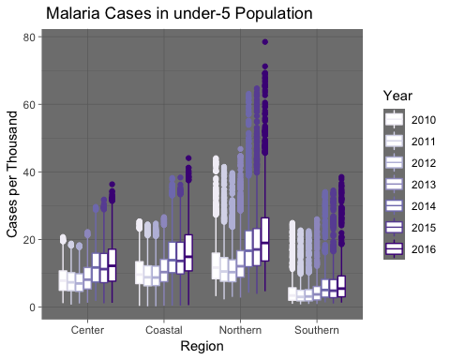

Figure 1: Malaria cases per thousand in the under-5 population in each region of Mozambique over a 7-year period.

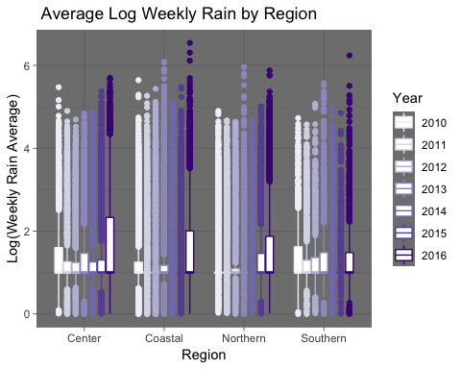

Figure : Log(Weekly rain averages) across regions.

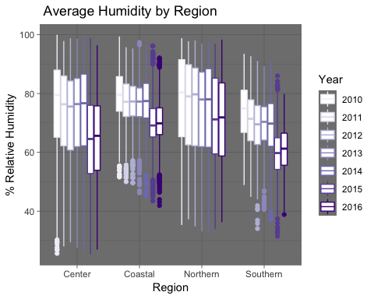

Figure : % Relative humidity across regions of Mozambique

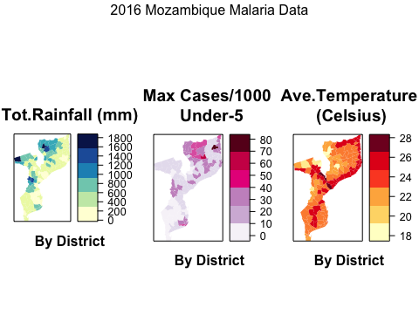

Figure : A focused look at 2016 spatial data by district showing the connection between heightened rainfall and malaria cases across a year.

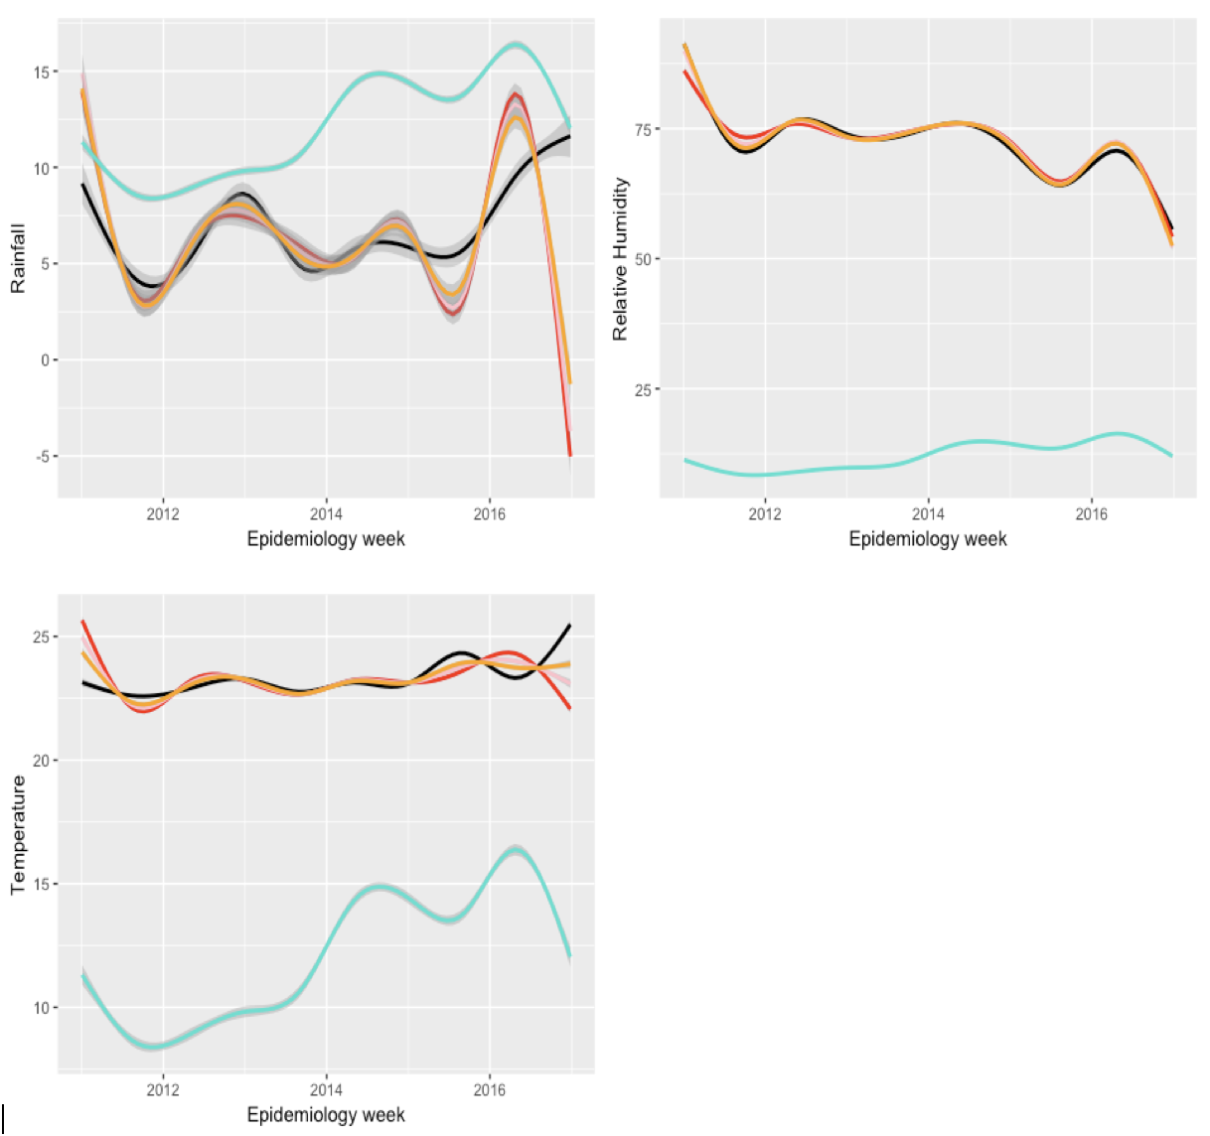

A

B

C

Cases per 1000

No lag

Lag8

Lag6

Lag4

Figure : Lagged climatic values relative to cases per thousand. A is rainfall total, B is % relative humidity, and C represents temperature.

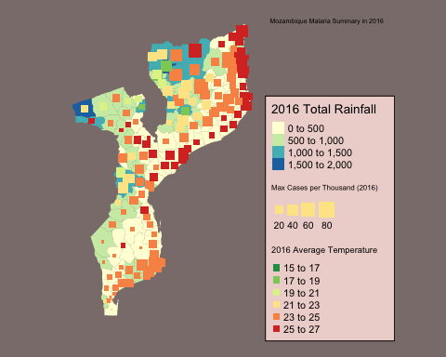

Figure : 2016 map of temperatures, rainfall, and cases per thousand

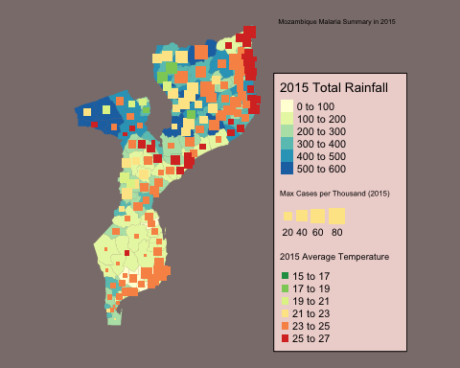

Figure : 2015 map of temperatures, rainfall, and cases per thousand

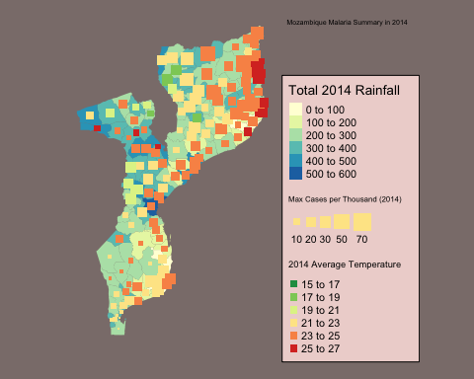

Figure : 2014 map of temperatures, rainfall, and cases per thousand

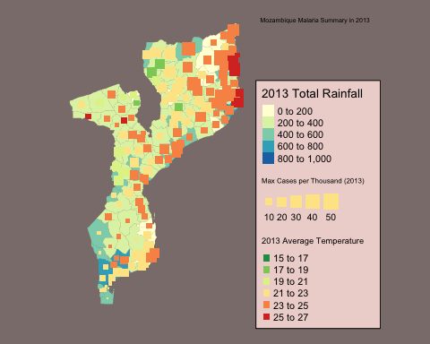

Figure : 2013 map of temperatures, rainfall, and cases per thousand

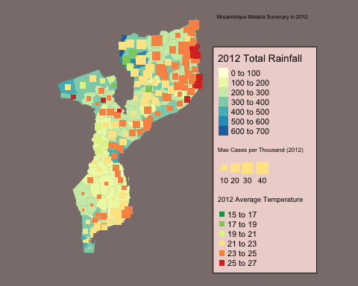

Figure : 2012 map of temperatures, rainfall, and cases per thousand

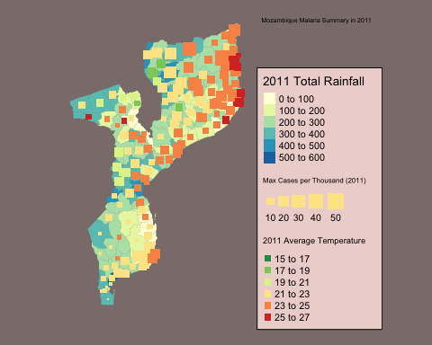

Figure : 2011 map of temperatures, rainfall, and cases per thousand

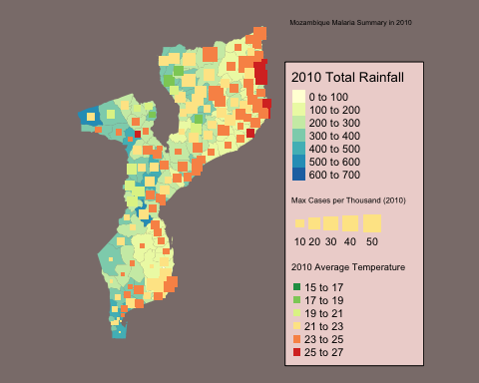

Figure : 2010 map of temperatures, rainfall, and cases per thousand

CITATIONS:

[1] CDC. “PMI, Mozambique Profile.” President’s Malaria Initiative, USAID, 2018, www.pmi.gov/where-we-work/mozambique.

[2] President’s Malaria Initiative. “Mozambique, Malaria Operational Plan FY 2018.” USAID, 2018, www.pmi.gov/docs/default-source/default-document-library/malaria-operational-plans/fy-2018/fy-2018-mozambique-malaria-operational-plan.pdf?sfvrsn=5.

[3] Sena, L., Deressa, W. & Ali, A. Correlation of Climate Variability and Malaria: A Retrospective Comparative Study, Southwest Ethiopia. *Ethiop. J. Health Sci.* **25**, 129–38 (2015).

[4] Weiss, D. J. *et al*. Air temperature suitability for *Plasmodium falciparum* malaria transmission in Africa 2000–2012: a high-resolution spatiotemporal prediction. *Malar. J.* **13**, 171 (2014).