Manu Manu
BH1
12/15/13 - 01/06/14
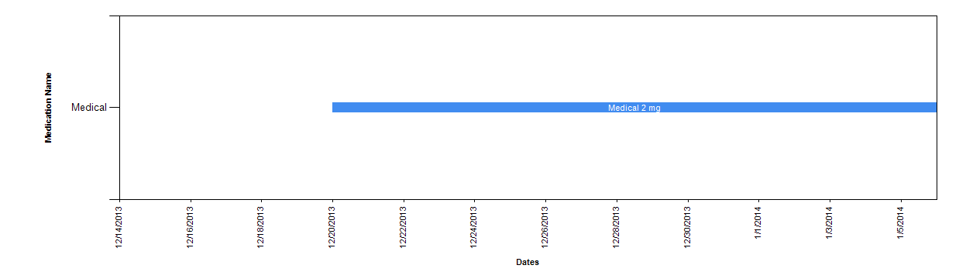

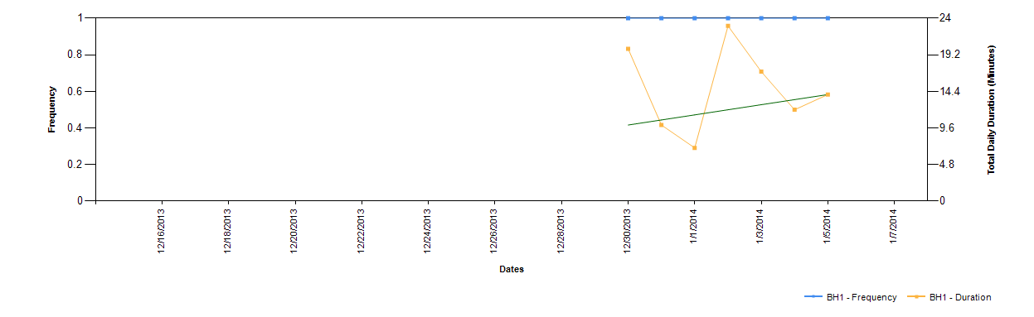
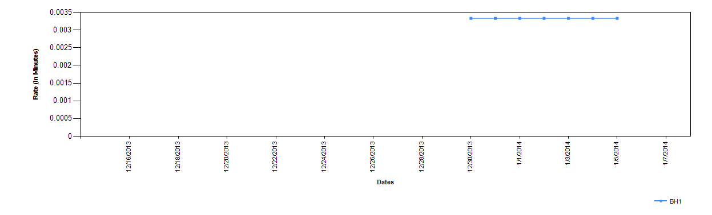

Manu Manu
BH2
12/15/13 - 01/06/14
