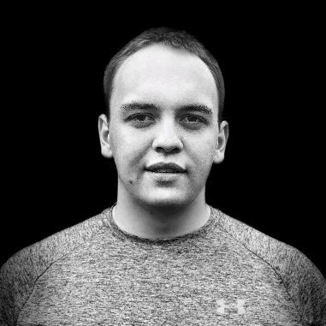

**MELNIK ALEXANDER**

**Phone: +375(29) 187-49-56**

**Email: mulleralex293@gmail.com**

**LinkedIn:** [**https://www.linkedin.com/in/melnikkk/**](https://www.linkedin.com/in/melnikkk/)

**GitHub**: [**https://github.com/melnikkk**](https://github.com/melnikkk)

**Objective**

Frontend Developer

**Summary**

I’m 21 years old. Besides studying on my own I am also taking courses on frontend development in the coding school TeachMeSkills. I am firm of purpose, responsible, and inquisitive. I learn quickly, capable of picking up on new skills and getting a grip of new technologies. I enjoy gaining insight and knowledge in a variety of fields throughout all my life.

**Skills**

|  |  |
| --- | --- |
| * JavaScript * HTML * CSS, Less, Sass * Webpack * GIT, GitHub, Bitbucket * Firebase | * NPM * React * Redux * React Router * TypeScript * Figma, Adobe Photoshop |

English language level: intermediate. I am capable of writing and reading (including non-complex technical literature), discussing different life topics and watching videos with subtitles.

**Education**

**2019**. **Coding School TeachMeSkills.**

Course: Frontend – developer.

Description: Development with JavaScript (and also React.js). On this course I studied HTML5, CSS3, preprocessor LESS, JavaScript (ES5, ES6 and higher), React. I also use some tools such as the GIT, GitHub, NPM, Webpack, VS code, Adobe Photoshop, Perfect Pixel, etc.

**2018-2019*.* Belarusian National Technical University.**

Engineering and pedagogy faculty (**extramural studies**).

Engineer - pedagogue.

**2014-2018*.* Belarusian National Technical University MSACC.**

Industrial and civil engineering.

Building technician.

**Work experience**

**February – May 2020. “Itransition”, Frontend developer.**

My team and I worked on a certificate project. But after pandemic began project ended.

**2020 – 2017. “Hollywood” fitness club, Personal trainer.**

I was quick to pick up on such fields of medicine as biomechanics, anatomy, dietology and biochemistry. My job was to socialize and assist people in acquiring the body of their dreams, without harming their health in the process. On top of that I greatly improved my social skills.

**2017. JSC “Dorstroymontazhtrest”, Bricklayer.**

Here I worked as part of my educational practices in the process of my studies. Acquired skills of a mason, gained knowledge in the field of geodesy, as well as insight into the process of this field of work.

**Additional information**

**Portfolio:** <https://github.com/melnikkk>

<https://melnikkk.github.io/>

**Professional interests:** Studying sources connected with the frontend technologies. Reading professional articles on Habr, Medium and VCru, on a daily basis. Additionally, I always reading up on literature in this field and MDN.

**Reason for applying for a job**

I become a frontend developer because this area of work is relatively young, constantly changing and does not stay in one place. I like to master new technologies and obtain new knowledge in this field. What’s more, I am certain of its long-term viability.

**References**

HTML5, CSS3 coach: <https://www.linkedin.com/in/tanya-labetskaya/>

Team Lead, mentor: +375(29) 547-01-53, Aleksey Khovbok

Project Manager: +375(29) 336-83-30, Yuri Nesterovich