

TDS-I project
Courier delivery from the restaurant

MEL0104
Melnikov Evgenii
Date: 20h June 2024

Obsah

1.DD S01 L02 3
2.DD S02 L02 3
3.DD S03 L01 5
4.DD S03 L02 7
5.DD S30 L04 8
6.DD S04 L01 9
7.DD S04 L02 9
8.DD S05 L01 + DD S05 L03: 9
9.DD S06 L01 10
10.DD S06 L02-04 10
11.DD S07 L01 11
12.DD S07 L02 11
13.DD S07 L03 12
15.DD S09 L02 13
16.DD S10 L01 14
17.DD S10 L02 14
18.DD S11 L01 15
19.DD S11 L02-04 16

1.DD S01 L02

Vysvětlete rozdíl mezi pojmem data a informace - příklad ve vašem projektu psáno anglicky

Data: Raw material that has not been processed or analyzed.
Information: Knowledge, intelligence, a particular piece of data with a special meaning or function

Data: Raw, unprocessed facts. Example: email in the USERY table like 'john@example.com'.

Information: Processed data that is meaningful. Example: Combining email and order details to determine that "John Doe ordered 'Steak' from 'Red Grill' on December 4th, 2023."

2.DD S02 L02

Entity, instance, atributy a identifikátory - popište v příkladech na vašem projektu

Entities: An entity is an object or thing that can have data stored about it. In our project, examples of entities include USERY, RESTAURANT, and ORDERS.
Instances: An instance is a single, specific occurrence of an entity. For example, a single row in the USERY table, such as: (1, 'john@example.com', 'John', 'Doe', 'New York', 'USA', '123-456-7890', TO_DATE('2023-12-04', 'YYYY-MM-DD'), 'U').
Attributes: Attributes are the properties or characteristics of an entity. For the USERY entity, attributes include id_user, email, name, surname, city, country, phone, last_visit, and role.
Identifiers: Identifiers are attributes that uniquely distinguish instances of an entity. For the USERY entity, the primary identifier is id_user.

3.DD S03 L01

Popište všechny vztahy ve vaší databázi v angličtině, včetně kardinality a povinnosti členství - každý vztah dvěma větami (stránka 10)

Relationship Descriptions

1. Relationship: USERY - ORDERS
Name: User_orders
Cardinality: 1
Optionality: Not optional
Description: One user can have many orders. Each order must be associated with a user.

2. Relationship: RESTAURANT - ORDERS
Name: Restaurant_orders
Cardinality: 1
Optionality: Not optional
Description: One restaurant can have many orders. Each order must be associated with a restaurant.

3. Relationship: COURIER - ORDERS
Name: Courier_orders
Cardinality: 1
Optionality: Optional
Description: One courier can deliver many orders. An order may not have a courier assigned.

4. Relationship: RESTAURANT - MENU
Name: Restaurant_menu
Cardinality: 1
Optionality: Not optional
Description: One restaurant can have many menus. Each menu must be associated with a restaurant.

5. Relationship: MENU - FOOD
Name: Menu_food
Cardinality: 1
Optionality: Not optional
Description: One menu can contain many food items. Each food item must be associated with a menu.

6. Relationship: ORDERS - ORDER_DETAILS
Name: Order_details
Cardinality: 1
Optionality: Not optional
Description: One order can have many order details. Each order detail must be associated with an order.

7. Relationship: FOOD - ORDER_DETAILS
Name: Food_order_details
Cardinality: 1
Optionality: Not optional
Description: One food item can appear in many order details. Each order detail must be associated with a food item.

8. Relationship: ORDERS - PAYMENT
Name: Order_payment
Cardinality: 1:1
Optionality: Not optional
Description: One order can have one payment record. Each payment record must be associated with an order.

9. Relationship: ORDERS - DISCOUNT_CODES
Name: Order_discount_code
Cardinality: M:1
Optionality: Optional
Description: Many orders can use one discount code. An order may not have a discount code.

10. Relationship: ORDER_DETAILS - PROMOTION
Name: Order_detail_promotion
Cardinality: M:1
Optionality: Optional
Description: Many order details can be part of one promotion. An order detail may not have a promotion.

4.DD S03 L02

Nakreslete ER diagram dle konvencí
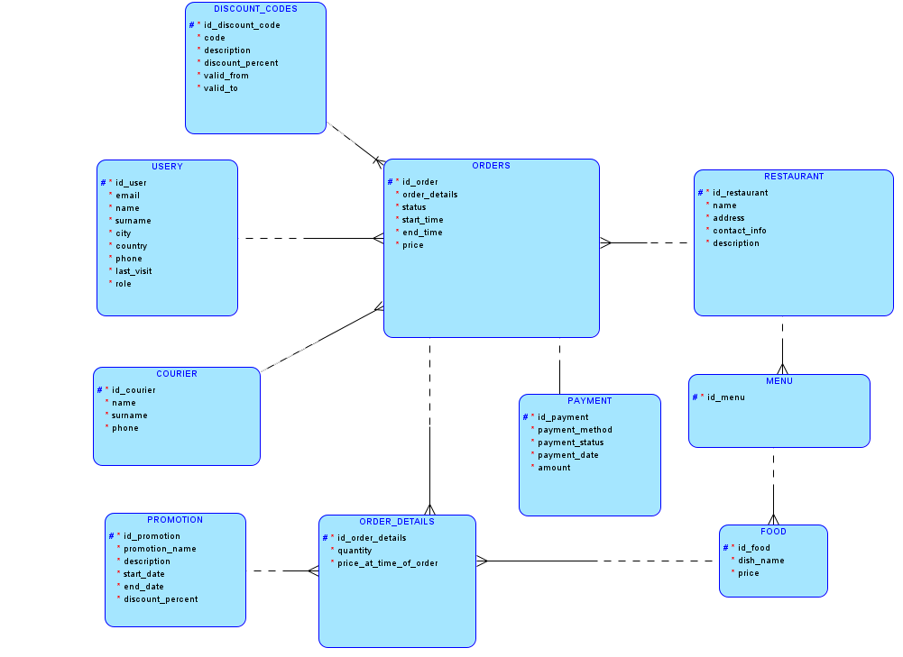

5.DD S30 L04

Maticový diagram se vztahy, nakreslete pro vaše řešení (stránka 5)

Entity | USERY | RESTAURANT | COURIER | ORDERS | MENU | FOOD | ORDER_DETAILS | DISCOUNT_CODES | PAYMENT | PROMOTION
USERY |  |  |  | Places
RESTAURANT |  |  |  | Prepares | Has
COURIER |  |  |  | Delivers
ORDERS | Placed by | Prepared by | Delivered by |  |  |  | Contains | Uses | Has payment
MENU |  | Belongs to |  |  |  | Contains
FOOD |  |  |  |  | Part of |  | In details
ORDER_DETAILS |  |  |  | Part of order |  | Contains food |  |  |  | Has promotion
DISCOUNT_CODES |  |  |  | Used by orders
PAYMENT |  |  |  | Payment for order
PROMOTION |  |  |  |  |  |  | Applies to details

6.DD S04 L01

Supertypy a podtypy – definujte minimálně jeden případ supertypu a subtypu ve Vašem projektu
In the project, the USERY table can serve as a supertype with subtypes such as CUSTOMER and ADMIN. The CUSTOMER subtype would include additional attributes like loyalty_points, while the ADMIN subtype could include attributes like admin_level.

7.DD S04 L02

Popis obchodních pravidel k vašemu projektu

• Order statuses: "In Progress", "Delivered", "Cancelled", "Pending".
• Food rating: Ranges from "1" to "5".
• Discount code validity: valid_from ≤ valid_to.
• User roles: 'A' - administrator, 'U' - user, 'C' - customer.
• Unique email: Must be unique for each user.
• Restaurant menu: Each restaurant must have at least one menu.
• Order details association: Must be linked to an existing order and food item.
• Promotion discount range: Between "0" and "100".
• Payment amount: Must be ≥ 0.
• Last visit date: Must be ≤ current date.

8.DD S05 L01 + DD S05 L03:
Zakomponujte do vašeho projektu alespoň jednu přenositelnou a jednu nepřenositelnou vazbu
1. Without additional information:
A relationship between the RESTAURANT and MENU tables, where each menu is associated with a restaurant.

2. With additional information (With Information):
A relationship between the FOOD and PROMOTION tables, where each promotion can have additional information such as a description of the promotion and the discount percentage.

9.DD S06 L01
Incorporate at least one 1
identifying relationship into your project, with the fact that the transferred foreign key will also be the key in the new table
The ORDER_DETAILS table has an identifying relationship with the ORDERS table. The id_order is both a foreign key and part of the primary key in ORDER_DETAILS.

10.DD S06 L02-04
Have your schema in first normal form - no non-atomic attributes
- All attributes in the schema are atomic.
In second normal form – no subkey bindings
- All tables in the schema are in 2NF, with no partial dependencies.
In third normal form - no links between secondary attributes
- All tables in the schema are in 3NF, with no transitive dependencies.

11.DD S07 L01

Vyzkoušejte ve vašem projektu definovat ARC (lze definovat v ORACLE SQL Developeru Data Modeleru)

For my database, let's say that ORDERS can reference either USER or COURIER, but not both tables at the same time.

12.DD S07 L02

Zkuste ve vašem projektu definovat hierarchické a rekurzivní relace

• Hierarchical: The MENU and FOOD relationship can be visualized hierarchically with MENU as the parent and FOOD as the child.
• Recursive: Adding a parent_food_id in the FOOD table to create a recursive relationship.

13.DD S07 L03

Historical data is recorded using audit tables and triggers. For example, ORDERS_AUDIT table stores all changes to the ORDERS table, with triggers to capture INSERT, UPDATE, and DELETE operations.

14.DD S09 L01

Demonstrujte na vašem projektu ukládání změn v čase

Changes over time can be demonstrated using the created_at and updated_at timestamps in the ORDERS table. Each change to an order is recorded with these timestamps.

15.DD S09 L02

Journaling is implemented using audit tables. For example, USERY_HISTORY table records all changes to user details, capturing historical data such as changes in email, phone number, etc./

16.DD S10 L01

Revidujte váš návrh podle konvencí pro čitelnost vašeho schématu

The design follows standard naming conventions, and relationships are clearly defined to ensure readability and maintainability.

17.DD S10 L02

Generic modeling – consider, possibly describe or use a generic model of data structures in your solution, how this approach is more advantageous compared to traditional data structure design methods
Generic modeling can be used to abstract common attributes into supertype tables. For example, USERY table can serve as a generic model for different types of users like ADMIN and CUSTOMER. This approach reduces redundancy and improves maintainability by centralizing common attributes.

18.DD S11 L01

Popište na vašem projektu příklady integritních omezení pro entity, vazby, atributy a uživatelsky definované integrity

NO. | TABLE | ATTRIBUTE | CONSTRAINT
1. | User | type | Type must be 'c', 'h', 'o', or 'l'
2. | User | rating | Rating must be between 1 and 5
3. | User | create_date | create_date <= last_update
4. | User | role | Role must be 'A', 'U', or 'C'

19.DD S11 L02-04

Generujte relační schéma z vašeho konceptuálního modelu a uvědomte si změny, které ve schématu nastaly a proč

