AngleEye A.I. Quick-Start Guide

As the name suggests, we use artificial intelligence to find the angles your body parts make relative to one another. We use a simple email interface to quickly get you an angle assessment. The data we provide can be used for (but is not limited to): analyzing flexibility, fitting your bicycle, interpreting running form, any many more applications!

To use the email interface, simply send an image to angleeye.ai@gmail.com. To get the best possible results follow some of these best practices:

- Make sure you are the only person in the image.
- Avoid clothing with a baggy fit.
- Include your full body in the image.
- Use a front view or side view image, other orientations might give inaccurate results.
- Send only one image per email.

What can you use AngleEye for?

- Bike Fits. Check out this helpful link depicting some of the angles your legs and torso make when riding a properly fit bike.
- Tracking flexibility over time. Take and send in a photo of you performing a stretch every day for a week and see how your angles change over time.
- Running gait analysis. See the differences in your gait during the toe-off phase for varying speeds.

There are tons of applications, and if you come up with something cool we’d love to hear about it!

Example Output and Analysis

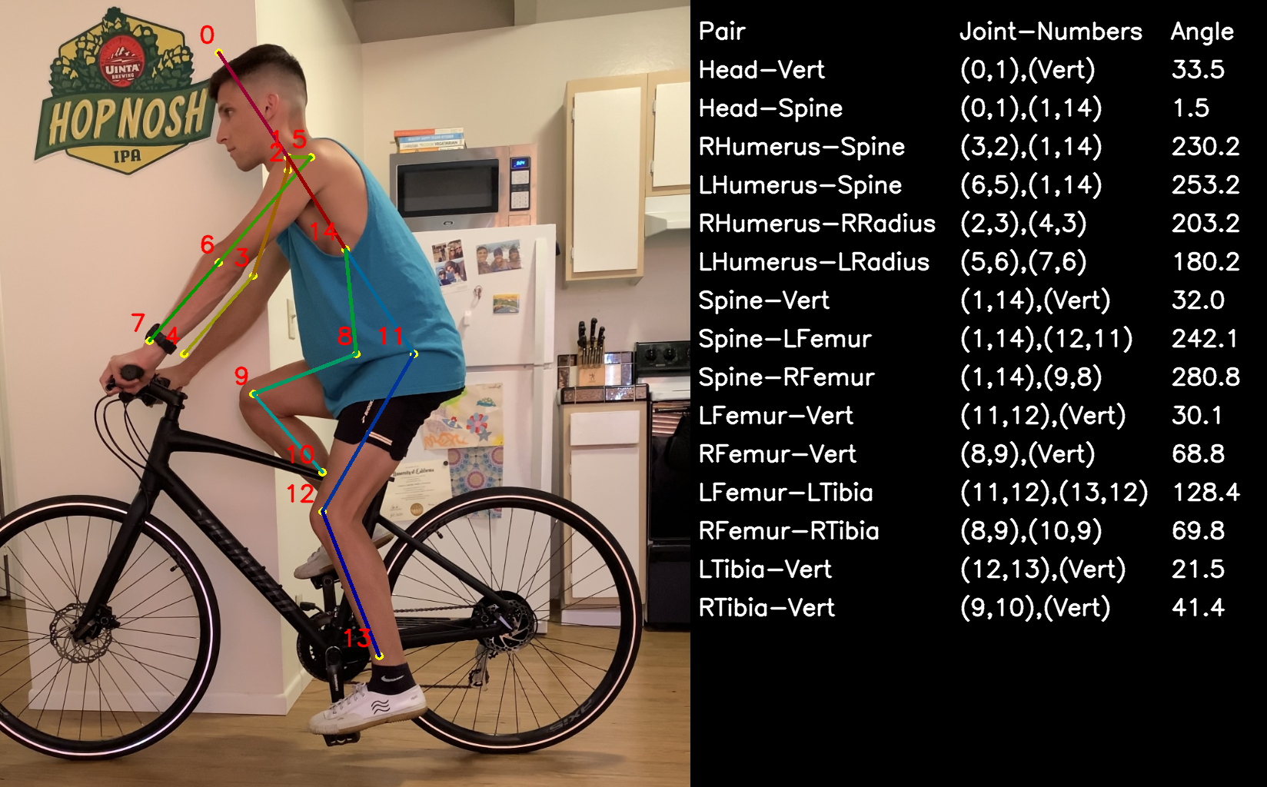
In this example, I’m going to use AngleEye to help me get a proper saddle height for my bike. Some of the online literature suggest an angle of ~140 degrees between you Femur and Tibia when your foot is at the bottom. We can see that I currently have a bend of 128.4 degrees here, meaning that I might want to move the saddle up. We can also look at the angle that my arms form with my back. Looking at the Left Humerus and Spine angle, we can see that it is at 253.2 degrees. This is so large because of how the vectors are defined. The spine vector for this calculation points up and to the left (1,14). Some online literature uses a vector that points down the back instead of up, so to better interpret our results, we can simply subtract 180 degrees from our result. This means we use a vector for our spine of (14,1), which points down and to the right. Using the new result, the angle is interpreted as 73.2 degrees.

FAQ
Q: How are my angles calculated? What do they represent?
A: The angles we calculate represent how your limbs are positioned relative to one another. We depict the vectors using the to-from format, meaning a vector going to point 1 from point 2 would be written as (1,2). In general, the angles are calculated by rotating counter-clockwise from the first vector to the second vector.

Q: How do I interpret the data?
A: There are many use cases for biometric data analysis, and the examples provided in the quick start guide are only the tip of the iceberg.

Q: My data points are way off, what’s going on?
A: Artificial intelligence isn’t perfect. Try some of the suggestion in the quick start guide to improve the accuracy of your results. We’re continually improving our algorithms and processing so expect to see better results in the near future.

Q: Do you support video analysis?
A: Not yet! This feature will be incorporated soon.

Q: I want an angle that you currently do not provide information for. Can you calculate that for me?
A: We can try! Send us an email with the specific angle you’re looking to analyze, and we’ll give it a shot.

Feel free to email us and ask more questions, and provide any feedback you may have.

Because this application is still in development, any image sent to angleeyeai@gmail on a local computer. The images will not be distributed anywhere else, and will be used for AngleEye purposes only!

