CV

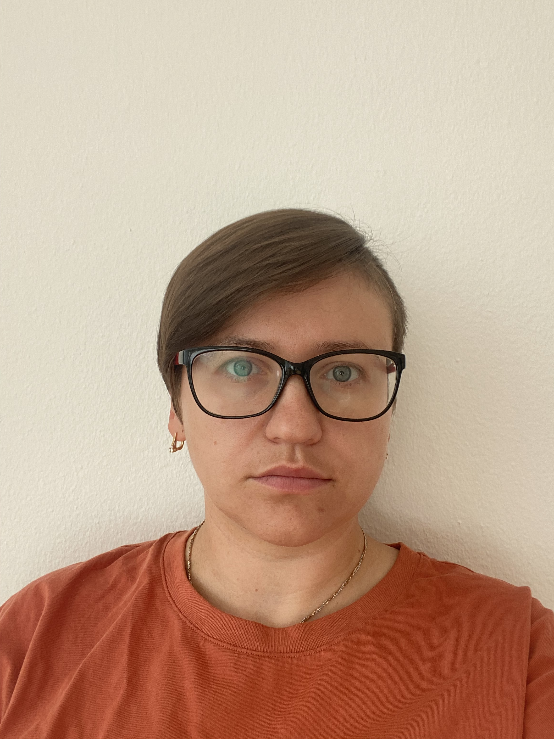  **Yuliia Kotenko**

23.02.1989 Ukraine

Ved Ungdomsboligerne 36 Gentofte 2820

71674269

Email:g_julija_777@mail.ru

# Experience

### Job Title, Company Name: salesman in Roshen shop Ukraine

* Key tasks and responsibilities
* Get product advice,placing goods on shelves,cashier work, take inventory

## Dates From–To 2019-2020

### Job Title, Company Name: casino-croupier Carnival Cruise Line USA

* Key tasks and resposibilities
* Deal the game such as roulette,poker,Bj.Make guest service.Make safety guest on the board

Dates From–To

**Job Title, Company Name: casino-croupier Casino Atlantic Palec country Morocco**

* Key tasks and resposibilities
* Deal the game such as roulette,poker,Bj.Make guest service.

Dates From–To **2013-2015**

**Job Title, Company Name: casino-croupier Casino Ukraine**

* Key tasks and resposibilities
* Deal the game,make a gues service be nice with a client

Dates From–To **2010-2014**

# Education

* Kharkov national academy of municipal economy master’s degree in management,2007-2011 Kharkiv Ukraine
* Housing and Communal College junior specialist in commercial activity.2004-2007 Kharkiv Ukraine

# Languages

English – Upper intermediate

Ukraine-native speaker

French-beginner

# Course

# Front Development SheCodes Fondation certificate

# Introduction to coding SheCodes Fondation certificate

# KINESIOTAPING MASTER - FACE TAPING certificate

# IT Skills

Excel/Word – Basic

Novice developer

# Personal Qualities

* Responsible – I always complete the task on time
* Plain — I work well with others
* Diligent – I always work my best
* Friendly – it’s easy to work with me
* Resolute — I’m motivated

# Hobbies

* I love to dance bachata
* I love to embroider pictures
* Travelling