MELODIESPARK INC

DOCKER → UNREAL
TOTAL BUILD & TRANSFER RUNBOOK
PATH OF MELODIE — MAAKARAS PROTOCOLS
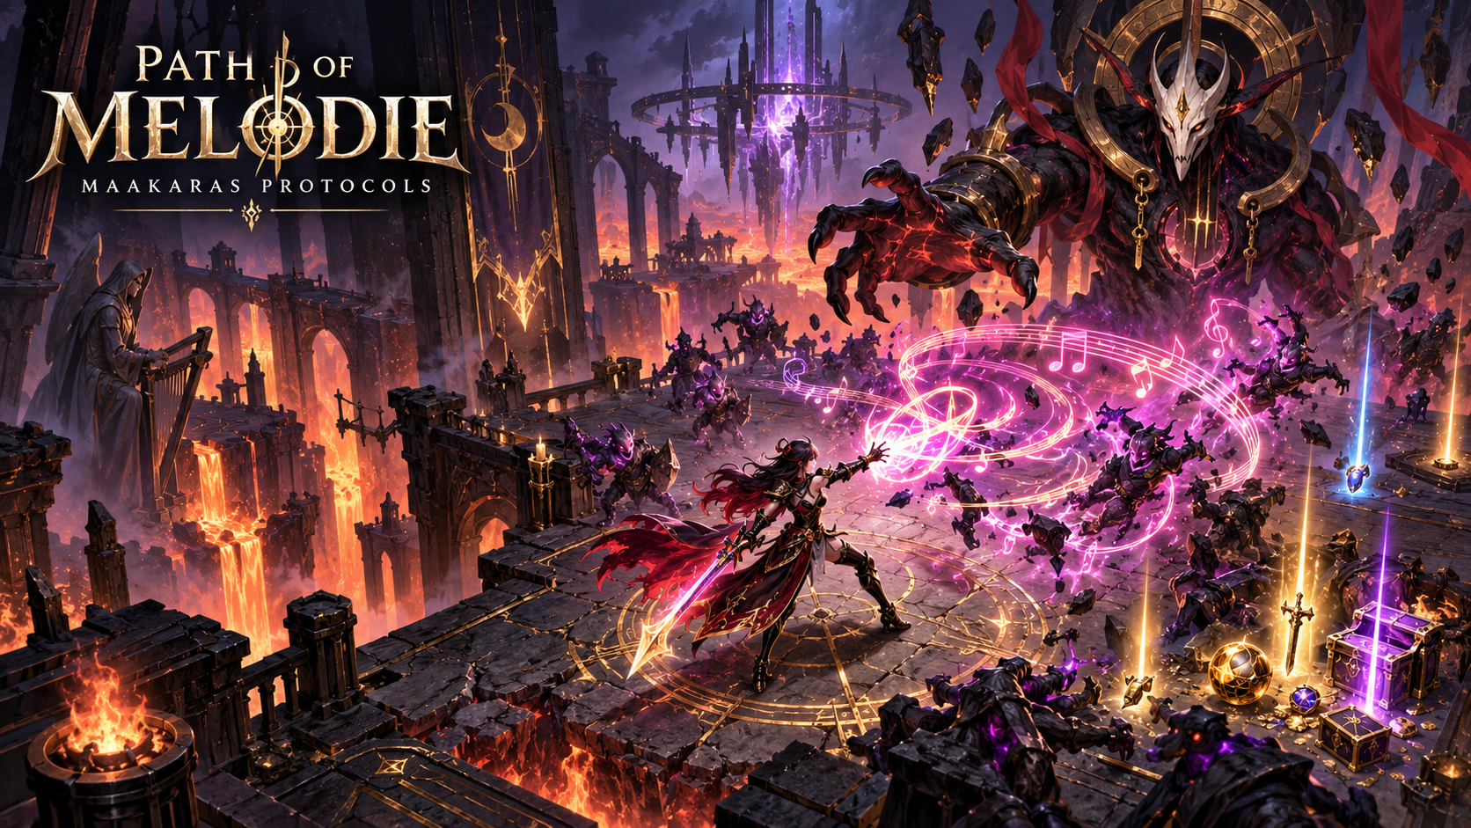
OPERATING TRUTH Docker coordinates reproducible tools, services, checks, transfers and evidence. Windows compiles and packages the Windows Unreal game using UE 5.8 and MSVC. A Linux container does not replace the native Unreal Windows toolchain.

Canonical root | Unreal root | Shell | Target
C:\MelodieCLI\PathOfMelodie | D:\UE_5.8 | PowerShell 7.6.5 | Win64 Shipping

1. Mission and Non-Negotiable Boundary
This runbook defines the controlled transfer from the Melodiespark Docker/WSL2 orchestration environment into the Windows-native Unreal Engine build path. The purpose is repeatability: one command should discover the project, validate dependencies, prepare generated data, start required services, invoke the correct Unreal tools, package the game, hash outputs, and publish an evidence report without inventing success.
Workload | Docker / WSL2 | Windows host
Source checks | Allowed and recommended | Allowed
PostgreSQL, Redis, NATS, APIs | Primary execution location | Optional native fallback
Code generation / manifests | Allowed | Authoritative write location
Unreal Header Tool / UBT | Not for Win64 Shipping | Required
Cooking / packaging | Not authoritative for Windows release | Required through AutomationTool
GPU editor validation | Not dependable in container | Required
Evidence aggregation | Allowed | Final signer and artifact owner

FAIL-CLOSED RULE If an engine, compiler, SDK, plugin, test, cook, package, hash or runtime check is missing, report BLOCKED or NOT_RUN. Never relabel file presence as verification.

2. Unified Build Topology
Layer | Components | Responsibility | Output
Experience | PathOfMelodie.uproject, C++, Blueprints, content | Game runtime and presentation | Win64 packaged build
Host build | UE 5.8, UBT, UAT, MSVC, Windows SDK | Compile, cook, stage, package | Executable, PAK/IoStore, logs
Docker services | PostgreSQL, Redis, NATS, gateways | Deterministic backend dependencies | Health evidence and API contracts
Factory | 30,000 deterministic briefs and records | Data/content specification pipeline | JSONL, CSV, prompts, hashes
Trust | MERA evidence ledger | Provenance, gate state, checksums | Machine-readable release report
Orchestration | Phoenix/KAYLA/KIMINI/MelodieCLI | Sequencing, retries, policy | Single-command workflow

Data flow
- Windows source root is the system of record.
- Docker receives a controlled read/write mount only for required project paths.
- Generated files return through a staging directory, never by replacing the entire project.
- Windows validates each transfer manifest before Unreal compilation.
- Packaged artifacts are written outside source folders and hashed immediately.

3. Required Host Layout
Path | Purpose | Mutation policy
C:\MelodieCLI\PathOfMelodie | Canonical Unreal project | Preserve; no destructive mirroring
C:\MelodieCLI\PathOfMelodie\Source | C++ source | Only controlled code-generation changes
C:\MelodieCLI\PathOfMelodie\Content | Unreal assets | Imported by Unreal, not raw-copy fabrication
C:\MelodieCLI\PathOfMelodie\MelodiesparkAssetFactory | 30,000-record factory | Regenerable manifests and evidence
C:\MelodieCLI\build-evidence\path-of-melodie | Build reports and hashes | Append-only per timestamp
C:\MelodieCLI\release\PathOfMelodie | Packaged builds | Versioned output
D:\UE_5.8 | Unreal Engine installation | Read-only from orchestration

Required tools
Dependency | Verification command | Gate
PowerShell 7.6.5 | $PSVersionTable.PSVersion | ≥ 7.2
Docker Desktop | docker version | Client and server healthy
Compose | docker compose version | V2 available
Unreal Editor Cmd | Test-Path D:\UE_5.8\Engine\Binaries\Win64\UnrealEditor-Cmd.exe | File exists
UnrealBuildTool | Test-Path D:\UE_5.8\Engine\Binaries\DotNET\UnrealBuildTool\UnrealBuildTool.exe | File exists
AutomationTool | Test-Path D:\UE_5.8\Engine\Build\BatchFiles\RunUAT.bat | File exists
MSVC + Windows SDK | vswhere + compiler discovery | Compatible installation

4. Safe Docker Transfer Contract
The transfer is manifest-driven. Every transferred file carries relative path, byte length, SHA-256, producer, timestamp, and intended consumer. Secrets, intermediate build outputs and user-specific caches are excluded.
Include | Exclude
Source, Config, Plugins, Scripts | Binaries, DerivedDataCache, Intermediate, Saved
Content source files and approved imports | .env, private keys, wallet seeds, credentials
Factory manifests and Unreal Python | node_modules, venv, caches, logs
Dockerfiles, compose definitions, health checks | Packaged release output from previous runs
Schemas, migrations and test fixtures | Unreviewed arbitrary downloads

Transfer manifest fields
Field | Example | Validation
relative_path | Source/PathOfMelodie/Combat.cpp | No traversal; project-relative only
sha256 | 64 hexadecimal characters | Recomputed after transfer
length | 18432 | Exact byte match
classification | SOURCE / CONFIG / DATA / EVIDENCE | Allowed policy value
producer | docker:generator-v1 | Known build component
status | STAGED | Promoted only after validation

SECRET PROTECTION Never overwrite .env files. Docker receives secrets through configured runtime variables or secret mounts; manifests must never contain secret values.

5. Single-Command Build Sequence
Gate | Action | Success evidence | Failure state
G00 | Resolve project and UE paths | Exact paths recorded | BLOCKED
G01 | Verify UE, UBT, UAT, MSVC, SDK | Version/tool inventory | BLOCKED
G02 | Validate Docker and compose | Daemon + service health | READY / BLOCKED
G03 | Inventory and secret scan | Census + zero exposed secrets | PASS / BLOCKED
G04 | Generate project files | Generation log and exit 0 | PASS / FAIL
G05 | Build Development Editor | UBT exit 0 + binaries | PASS / FAIL
G06 | Run automation tests | Structured test report | PASS / FAIL
G07 | Build Shipping | UBT exit 0 + target binaries | PASS / FAIL
G08 | Cook and package | UAT exit 0 + staged artifact | PASS / FAIL
G09 | Runtime smoke test | Process start + expected marker | PASS / FAIL
G10 | Hash and seal | SHA256SUMS + release report | VERIFIED / BLOCKED

Authoritative Windows command skeleton
pwsh -NoProfile -File C:\MelodieCLI\scripts\PATH-OF-MELODIE-TOTAL-BUILD.ps1 `
-ProjectRoot C:\MelodieCLI\PathOfMelodie `
-UEPath D:\UE_5.8 `
-Configuration Shipping `
-Platform Win64 `
-RunDockerServices `
-RunTests `
-Package `
-EvidenceRoot C:\MelodieCLI\build-evidence\path-of-melodie
The launcher should be idempotent and resumable. It may regenerate safe manifests, but it must not delete user source, rewrite credentials, force Git history, or mark downstream gates PASS after an upstream failure.

6. Unreal Build Commands

Project-file generation
& "D:\UE_5.8\Engine\Build\BatchFiles\GenerateProjectFiles.bat" `
-project="C:\MelodieCLI\PathOfMelodie\PathOfMelodie.uproject" -game -engine

Development Editor compilation
& "D:\UE_5.8\Engine\Binaries\DotNET\UnrealBuildTool\UnrealBuildTool.exe" `
PathOfMelodieEditor Win64 Development `
-Project="C:\MelodieCLI\PathOfMelodie\PathOfMelodie.uproject" -WaitMutex -NoHotReload

Automation test execution
& "D:\UE_5.8\Engine\Binaries\Win64\UnrealEditor-Cmd.exe" `
"C:\MelodieCLI\PathOfMelodie\PathOfMelodie.uproject" `
-ExecCmds="Automation RunTests PathOfMelodie;Quit" -unattended -nop4 -nosplash -stdout

Shipping package
& "D:\UE_5.8\Engine\Build\BatchFiles\RunUAT.bat" BuildCookRun `
-project="C:\MelodieCLI\PathOfMelodie\PathOfMelodie.uproject" `
-noP4 -platform=Win64 -clientconfig=Shipping -build -cook -stage -pak -archive `
-archivedirectory="C:\MelodieCLI\release\PathOfMelodie" -utf8output
TARGET-NAME WARNING If the project target is not exactly PathOfMelodieEditor or PathOfMelodie, discover names from Source/*.Target.cs and record the resolved target. Do not guess.

7. Docker Service and CI Layer
Service | Purpose | Health proof | Release dependency
PostgreSQL | Profiles, progression or evidence persistence | pg_isready + query | Only if runtime uses it
Redis | Caching, queues or sessions | redis-cli PING | Only if runtime uses it
NATS | Event transport | Server health endpoint | Only if runtime uses it
API gateway | Game-service boundary | /health and contract tests | Required for connected features
Evidence worker | Collect logs, hashes and state | Ledger append test | Required for evidence seal

Compose policy
- Pin container image versions; do not use floating latest tags for release evidence.
- Mount the project minimally and prefer read-only mounts except explicit staging paths.
- Attach health checks to every required service.
- Use named volumes for state; do not hide persistence in anonymous volumes.
- Export sanitized logs and test reports to the Windows evidence root.
- A running container is not a healthy service; verify the actual protocol.

Windows ↔ Docker path mapping
Windows | Container | Access
C:\MelodieCLI\PathOfMelodie | /workspace/PathOfMelodie | Read-only by default
...\docker-staging | /workspace/staging | Read/write
...\build-evidence | /workspace/evidence | Read/write append
D:\UE_5.8 | Not mounted | Host-only Unreal toolchain

8. Evidence Ledger and Gate State
Artifact | Required content | Claim supported
preflight.json | Paths, tool versions, timestamps | Environment detected
docker-health.json | Container IDs and protocol health | Services verified
source-inventory.json | Counts, extensions and exclusions | Scope inventoried
secret-scan.json | Sanitized findings only | Secret gate evaluated
ubt-development.log | Command, exit code, compiler output | Editor build result
automation-report.json | Suites, tests, failures, duration | Tests executed
uat-shipping.log | Cook/package command and exit code | Shipping pipeline result
runtime-smoke.json | Launch marker, duration, exit behavior | Packaged runtime tested
SHA256SUMS.txt | Hashes of final artifacts | Integrity sealed
release-gates.json | Final machine-readable gate matrix | Release posture

Allowed status vocabulary
Status | Meaning
DEFINED | Requirement/specification exists
IMPLEMENTED | Code or configuration exists
NOT_RUN | No execution evidence
PASS | One named check passed
FAIL | One named check failed
BLOCKED | Prerequisite prevents execution
VERIFIED | Required checks and evidence agree
RELEASED | Approved artifact was distributed through an identified channel

EVIDENCE INVARIANT SourceFiles=61,951, CPP=98, Headers=127 and TODO=142 describe inventory only. They do not prove compilation, tests, packaging, playability or release.

9. Recovery and Failure Isolation
Symptom | Diagnosis | Safe response
UE not detected | Wrong path or missing engine binary | Validate D:\UE_5.8 and pass explicit -UEPath
Deprecated UBA setting | Stale BuildConfiguration.xml option | Record warning; remove deprecated option only after review
UBT compilation error | Source/API/toolchain mismatch | Preserve full log; fix first compiler error
Cook failure | Missing asset, redirector, plugin or map | Resolve named asset/plugin; rerun cook
Docker unhealthy | Daemon, port, volume or service issue | Inspect service health; do not continue dependent gates
Hash mismatch | Transfer corruption or unexpected mutation | Quarantine staging output and regenerate
Runtime opens then exits | Crash, missing dependency or bad default map | Collect Saved/Logs and crash evidence
Long silent phase | Hashing, asset discovery or cook may be active | Check process CPU, log growth and timestamps before stopping

Never perform automatically
- Delete the project, Saved data, Git history, credentials or release evidence.
- Run git reset --hard or overwrite unrelated user changes.
- Copy arbitrary binaries into the Unreal Engine installation.
- Disable tests or lower release gates to obtain PASS.
- Broadcast financial or blockchain transactions.
- Call a generated module, image or file “verified” without the relevant execution evidence.

10. Release Acceptance Matrix
Area | Minimum acceptance | Evidence
Toolchain | UE 5.8, UBT, UAT, MSVC and SDK resolved | preflight.json
Docker | Every required runtime dependency healthy | docker-health.json
Source | Secret scan acceptable; project generation succeeds | scan + generation logs
Compilation | Editor and Shipping targets exit 0 | UBT logs
Tests | Required suites execute with no blocking failures | automation report
Content | Required maps/assets cook without missing dependencies | UAT log
Package | Versioned Win64 artifact exists outside source | archive manifest
Runtime | Packaged game launches and reaches expected marker | smoke report
Integrity | Hashes recompute exactly | SHA256SUMS.txt
Golden Path | Download → install → first run is reproducible | FIRSTRUNCOMPLETED evidence

Current authoritative posture
Capability | Status
30,000 asset records and briefs | GENERATED / BRIEF_READY
Imported source artwork | 0 in reported factory run
Unreal preflight in factory | Project path detected; import not requested
Development build | NOT PROVEN BY FACTORY RUN
Automation tests | NOT PROVEN BY FACTORY RUN
Shipping package | NOT PROVEN BY FACTORY RUN
Runtime smoke test | NOT PROVEN BY FACTORY RUN
Release | BLOCKED pending complete evidence

NORTH STAR One Windows command orchestrates Docker dependencies and the native Unreal toolchain, produces a playable Genesis Prototype, and leaves a complete evidence trail from source state to first run.

