PATH OF MELODIE
MAAKARA PROTOCOLS
Phoenix Elevated - Arc-Angels Souls Core - Guardians - Karma Economy
Master Design & Content Specification Package
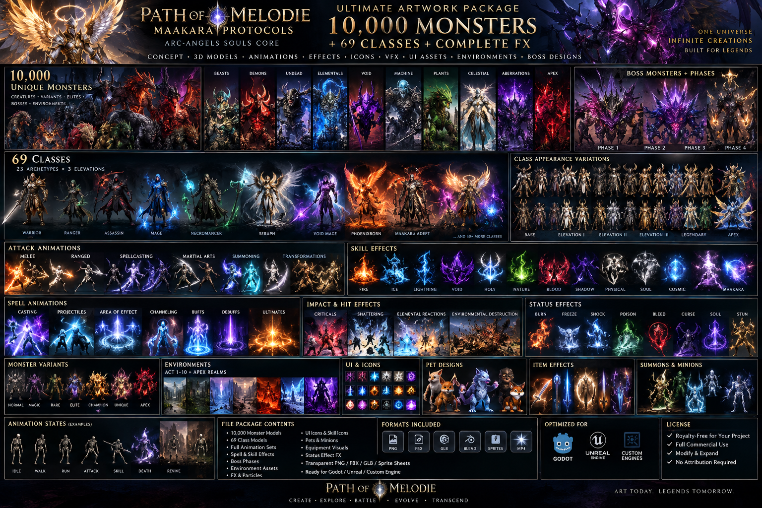
Package status: DESIGN SPECIFICATION. The document distinguishes planned content from implemented/verified production assets.

1. Product Identity
Path of Melodie: Maakara Protocols is an original isometric loot/action-RPG universe centered on Maakara energy, Soul Cores, Guardian invocation, class Elevation, shattering combat and the replayable Maakara APEX endgame.
The flagship expansion is Arc-Angels Souls Core. Its signature transformation is Phoenix Elevated: build Resonance, invoke a Guardian, expose Soul Cores, trigger Maakara Shatter and enter an elevated combat form.

2. Core Gameplay Continuum
Create character -> choose archetype -> campaign Acts 1-10 -> skills/items/passives -> Elevation Sector -> Soul Core -> Guardian invocation -> Act 10 -> Maakara APEX -> Celestial/APEX progression.
Combat includes Q/W/E/R/T skills, dodge, life/mana resources, precision hitboxes, hurtboxes, weapon traces, armor break, poise/stagger, status effects, shattering, boss phases, loot and build-changing legendary effects.

3. 69-Class Elevation System
Twenty-three base archetypes each branch into three Elevations, yielding 69 elevated class identities. Elevation is earned through an original multi-stage Sector challenge rather than being a simple menu purchase.

4. Passive & Build System
Design target: a large Maakara Constellation with minor nodes, notables, keystones, mastery choices and class starting sectors. Items, skills, passives and Elevations communicate through shared tags such as MELEE, SPELL, FIRE, FROST, LIGHTNING, VOID, SOUL, PHOENIX, MAAKARA, MINION, BLOCK, WARD, LIFE and GUARDIAN.
Balance should compare encounter capability across single-target damage, area damage, burst, effective health, recovery, mobility, control, resource sustainability, boss uptime and clear speed - not tooltip DPS alone.

5. Phoenix Elevated
Phoenix Elevated is the Phoenixborn apex specialization. Resonance is accumulated through skilled combat and spent on Guardian fusion. Elevated skills can include Phoenix Talon, Solar Ascension, Guardian Dash, Soul Nova and the Phoenix Elevated transformation.
Presentation stack: precise collision -> hit emphasis -> core fracture -> radial reality crack -> armor fragments -> shockwave -> Soul extraction -> Phoenix explosion -> loot feedback.

6. Arc-Angels Souls Core
Twelve original Arc-Angel domains cover Flame, Frost, Storm, Void, Blood, Light, Shadow, Time, Gravity, Life, Death and Phoenix themes. Soul fragments are forged into Soul Cores, attuned, awakened and eventually transformed into APEX Souls.
Design targets include 12 major Arc-Angel bosses, 36 minibosses, 72 Soul abilities, 144 Soul passive nodes, 120 Soul fragments, 60 Soul Cores, 24 Awakened Cores and 12 APEX Souls.

7. Guardians
Guardians are combat companions/transformations connected to Soul Cores and Elevation. Proposed families include Phoenix Sovereign, Storm Seraph, Void Sentinel, Frost Archon, Blood Warden and Maakara Guardian.
Guardian mechanics must alter gameplay - skills, movement, hitboxes, defensive layers or resource rules - rather than functioning only as cinematic effects.

8. Shattering Combat & Effects
Every attack resolves through animation timing, hitbox activation, continuous traces, hit validation, damage/poise/element resolution and an impact event. Break thresholds can fracture armor, expose weak points, destroy environmental objects or open Soul-Core execution windows.
Elemental destruction languages differentiate physical, fire, frost, lightning, void, blood, Phoenix, Soul and Maakara impacts. Visual intensity scales independently from authoritative gameplay for low-spec performance.

9. Items, Loot, Crafting & Storage
Content targets: 15 equipment slots, 90 functional currency/crafting resources, 200+ build-changing legendary items, procedural affixes, sockets, quality/corruption and APEX crafting.
Player inventory target: 150 slots. Maakara Vault: up to 100 sparse/unlockable tabs with specialized storage. Ten free gathering pets can collect eligible drops according to player loot-filter rules.

10. World & Endgame
Campaign target: 10 acts with hubs, regions, dungeons, quests, enemy families, elites, minibosses, act bosses, waypoints, crafting unlocks and cinematics. The campaign feeds Maakara APEX, a replayable realm system combining biome, monster, modifier, objective, boss and reward configurations.

11. Karma Economy
Karma Points represent verified community/game reward records; they are not money. Good-deed claims move through evidence, duplicate/fraud checks and verification before becoming eligible for any reward program.
Game Gold, Karma, and blockchain assets must remain separate ledgers. A real blockchain balance exists only when independently observed and reconciled on-chain.

12. Wallet & MA Token Boundary
MetaMello can provide a read-only portfolio/wallet observer and transaction preparation interface. Any MA token issuance or swap functionality requires actual deployed contracts, liquidity, supported routes, external signing, confirmations and reconciliation.
No autonomous treasury transfers. Pending or failed blockchain activity must not be credited as verified revenue or verified token balance.

13. Competitor / Genre Reference
Reference set: Path of Exile 1/2, Torchlight: Infinite, Last Epoch and Diablo II/III/IV. These titles are reference points for ARPG category coverage - build diversity, itemization, endgame loops, combat readability, crafting and replayability.
Path of Melodie should not copy proprietary characters, lore, maps, art, logos, exact skills, item names, dialogue or source assets. Its differentiators are Maakara, Phoenix Elevated, Soul Cores, Guardians, the Elevation Sector, Shattering and the Karma/Evidence architecture.

14. Art Direction & Picture Package
The current package includes the generated Ultimate Artwork Package key-art collage. Artwork folders are prepared for Phoenix Elevated, Arc-Angels, Soul Cores, Guardians, Karma and competitor-reference material.
No claim is made that 10,000 individual monster images or all class/animation frames exist in this package. Those remain production targets until generated/imported and verified.

15. Production Evidence Gates
Every subsystem should move through: DEFINED -> IMPLEMENTED -> TESTED -> VERIFIED -> AUDITED -> RELEASED.
A release is not complete because documentation or placeholder assets exist. The playable gate must prove movement, combat, hit detection, loot, inventory, equipment, passives, quests, bosses, save/load, Elevation, Soul Cores, Guardian invocation, Act progression and APEX.

Appendix A - 69 Elevations
Base Class | Elevation I | Elevation II | Elevation III
Vanguard | Colossus | Aegis Prime | War Sovereign
Berserker | Blood Titan | Ravager | Doomheart
Duelist | Blade Saint | Tempest Edge | Executioner
Sentinel | Iron Seraph | Bulwark | Eternal Guard
Lancer | Star Piercer | Dragon Spear | Astral Phalanx
Reaver | Soul Reaper | Void Cleaver | Deathbringer
Ranger | Windstrider | Deadeye | Star Hunter
Gunslinger | Arcshot | Storm Gunner | Nova Marshal
Assassin | Nightblade | Phantom | Soulkiller
Shadow | Umbral Walker | Void Dancer | Eclipse Lord
Beastmaster | Pack Alpha | Spirit Caller | Primal Sovereign
Engineer | Machinist | Siege Architect | Omega Artificer
Pyromancer | Infernal Heart | Solar Weaver | Phoenix Lord
Cryomancer | Frostborn | Crystal Sage | Absolute Zero
Stormcaller | Thunderborn | Tempest Sage | Storm Seraph
Arcanist | Spell Weaver | Mana Sovereign | Arcane Infinite
Necromancer | Gravecaller | Soul Shepherd | Death Archon
Blood Mage | Hemomancer | Crimson Oracle | Blood Seraph
Chronomancer | Time Weaver | Epoch Walker | Eternal One
Void Mage | Riftwalker | Gravity Lord | Event Horizon
Seraph | Lightbringer | Celestial Warden | Arc-Angel
Phoenixborn | Ember Soul | Rebirth Herald | Phoenix Elevated
Maakara Adept | Reality Shaper | Soul Architect | Maakara Ascendant

Appendix B - Package Contents
- Documentation/Path_of_Melodie_Master_Design.docx
- Artwork/Key_Art/Path_of_Melodie_Ultimate_Artwork_Package.png
- Artwork category directories for future verified assets
- Data/69_class_elevations.csv
- Data/package_manifest.json
- Implementation/README.md
- Licensing/NOTICE.txt

