**Test Script for Replace Picture**  
  
Copyright © 2021 Charles Weir   
Released under open source licence.

To allow you to work on the VBA, you need to set ImageAndTableSupport.dotm to be this document’s template. Use Developer – Add-ins - Word Add-Ins - Attach – Show all word files - [Choose ImageAndTableSupport.dotm]’

If a version of ImageAndTableSupport is already installed, use the toolbar set on the *right.*

Alt-F11 to go to the VBA



Figure 2: Placeholder

1. **Basic change and Undo:**  
   In Figure 1, select Placeholder, RP,   
   *Shows folder containing this document*  
   Chose Images folder, then WordAttachmentScreenshot.png  
   *Image now shows new attachment*Undo  
   *Returns to original*

Figure 1: Placeholder

1. **Cropping preserved, remembers folder:**In Figure 2, Select it, RP,   
   *Now shows Images folder.*

Chose BlueRectangleCrop.png  
*Image unchanged.*

1. **Dimensions preserved:**Select picture, drag to halve its height.  
   select it, RP, Chose BlueRectangleCrop.png  
   *Image unchanged.*
2. **Undo:**Undo 3*.*  
   *Should be back to blue rectangle.*
3. **Border kept.**In Figure 2 above, Select Image, RP - BlueRectangleCrop.png  
   *Border should remain large and blue.*Undo



Figure 2: Placeholder

1. **Replace Picture keeps width**In Figure 2 above, Select Image, RP - BlueRectangleCropPortrait.png  
   *New image should be same width as old, but portrait, so longer. Border should remain large and blue.*Undo
2. **(NIF) Works with picture not in frame.*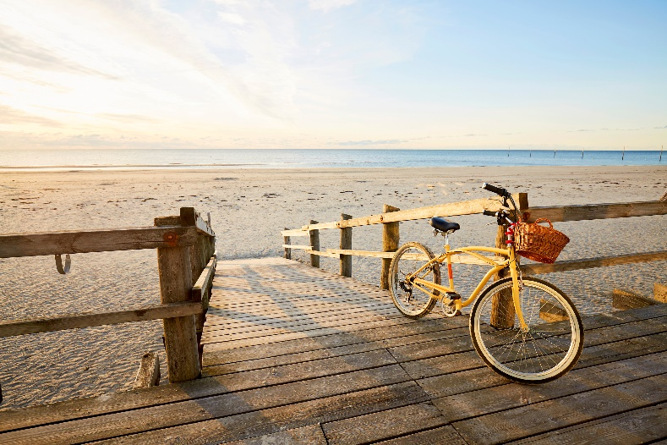***Select the bike on beach picture below. RP - BlueRectangleCrop.png  
   *Should permit the replacement; resulting picture remains laid out at bottom right of page.*Undo