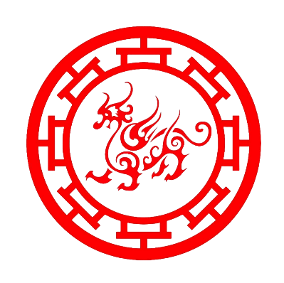

**天玉館(誠玉)**

TIAN YU MUSEUM