Exploring and Comparing venues in Downtown and Back bay of Boston

# 1. Introduction

Boston is the capital and most populous city of Massachusetts in the United States. Boston has a total area of 49 square miles. The most popular places in Boston are Back Bay and Downtown. There are many venues (especially restaurants, hotels and cafes) which can be explored. Let's explore the venues in Back Bay and Downtown in Boston. We will also compare these two popular places and make recommendations for tourists, residents and businessmen as to where to go and where to open a business.

# 2. Data

Kaggle is a free website to find various data. I have got the information of neighborhood and coordination data in Boston from Kaggle. From the Boston Neighborhood dataset, we can clip the neighborhood information for Downtown and Back Bay.

The Foursquare API has the explore API which allows us to find venue recommendations within a given radius from the given coordinates. We will use this API to find all the venues we need in Downtown and Back Bay. With the number of each venue counted, we can provide recommendations to tourists, residents and businessmen.

# 3.Metholodolgy

This project aims at identifying the venues Downtown and Backbay. This would enable any visitor/residnets to identify the venues he/she wants to visit, or businessman to identify where to open a store/restaurant.

As a first step, we found the neighborhood data of Boston from Kaggle. We did data clipping and data cleaning to get the neighborhood and coordination information of Back Bay and Downtown.

Secondly, we retrieved the data from Foursquare API. We extract venue information using the neighborhood information from above. The data from the two sources is carefully combined based on the name, latitude and longitude values from the two sources.

Next, we'll analyse the data that we created based on the number of each venue. We'll identify places where many venues are located so that any visitor can go to one place and enjoy the option to choose amongst many venue options.

Finally, we'll discuss and conclude which venues to be explored based on visitors/residents/businessmen requirement.

# 4.Result

## 4.1 The position of Downtown and Back bay in Boston

The geograpical coordinate of Back Bay are 42.3507067, -71.0797297.

The geograpical coordinate of Downtown are 42.3554309, -71.0605001.

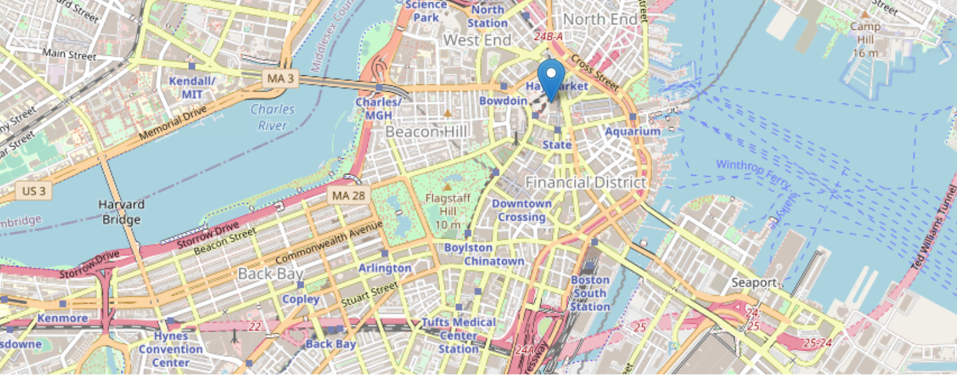

## 4.2 The Neighborhood information in Downtown and Back Bay

Kaggle is a free website to find various data. I have got the information of neighborhood and coordination data in Boston from Kaggle. From the Boston Neighborhood dataset, we can clip the neighborhood information for Downtown and Back Bay. I also did data cleaning in order to further processing.

Table 1 Neighborhood information in Boston

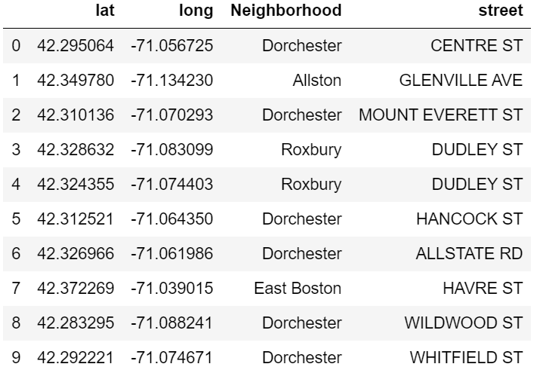

Table 2 Neighborhood information in Downtown Table 3 Neighborhood information in Back Bay

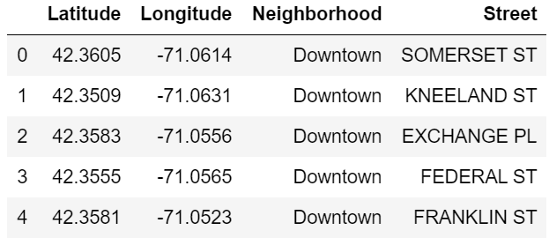 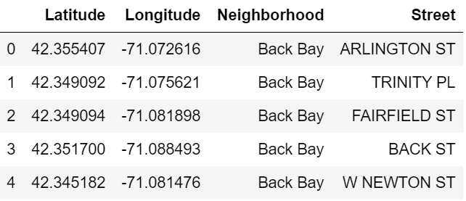

## 4.3 Use Foursquare API to get venue information

Then we fetched a total of all venues in Downtown and Back Bay using the Foursquare API. The Foursquare API has the explore API which allows us to find venue recommendations within a given radius from the given coordinates. We will use this API to find all the venues we need.

Table 4 Venue information in Downtown

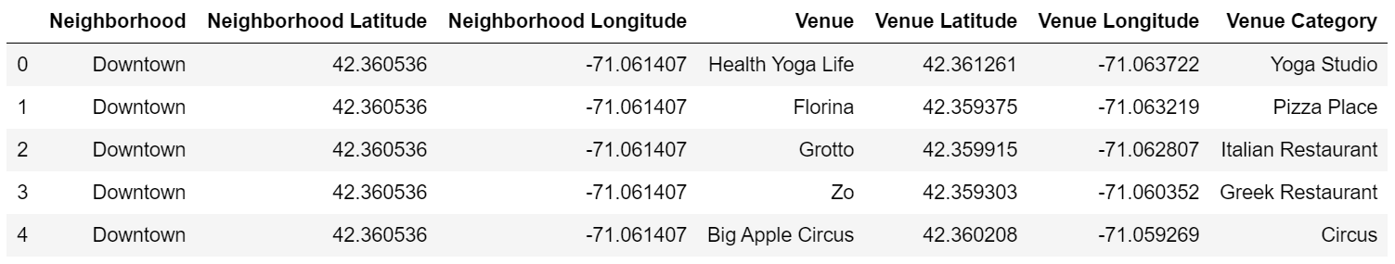

Table 5 Venue information in Back Bay

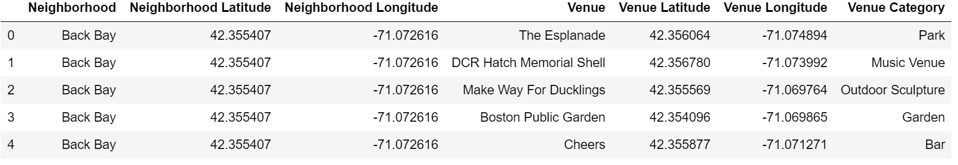

# 5.Discussion

We have various types of venues in the final Downtown and Back Bay dataset. We will take a look at the venues and check which are the majority venue categories in the list.

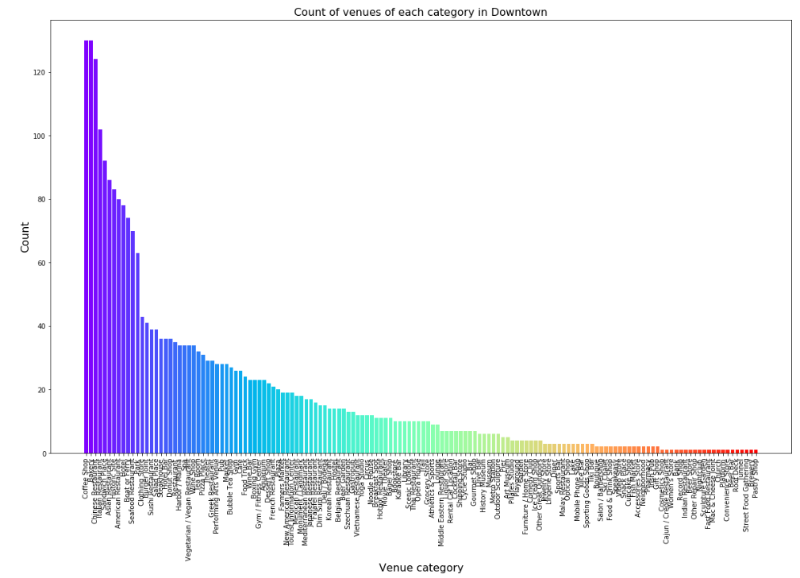

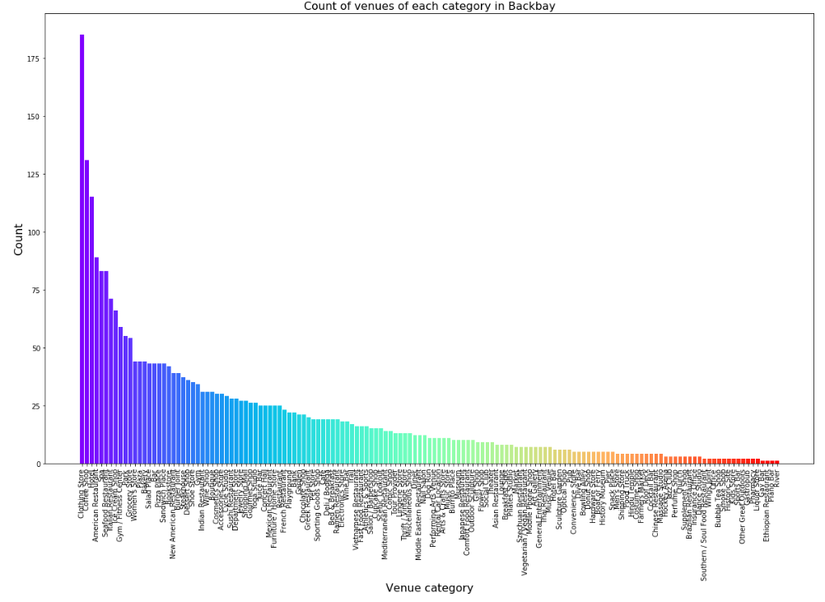

Based on our analysis above, we can draw a number of conclusions that will be useful to aid any visitor/resident/businessman.

After collecting data from the **Foursquare** and **Kaggle**, we got a list of 2673 venues in Downtown and Back Bay. There are 145 kinds of venues.

As we can see the majority venues in Downtown are 'Coffee Shop' ,'Bakery', 'Chinese Restaurant' and 'Italian Restaurant'; in Back Bay are 'Clothing Store', 'Coffee Shop', 'Hotel'. The number of each venues are also shown above.

If someone wants to buy clothes, then Back Bay is a good choice. If someone wants to eat Chinese food, then Downtown is a good choice. If a businessman wants to open a Italian Restaurant, it will be very competitive if he/she chooses the place at Back Bay.

A company can use this information to build up an online website/mobile application, to provide users with up to date information about various venues in the city based on the search criteria .

# 6.Conclusion

As we can see the majority venues in Downtown are 'Coffee Shop', 'Bakery', 'Chinese Restaurant' and 'Italian Restaurant'; in Back Bay are 'Clothing Store', 'Coffee Shop', 'Hotel'. The number of each venues are also shown above. If someone wants to buy clothes, then Back Bay is a good choice. If someone wants to eat Chinese food, then Downtown is a good choice.