**Firmware burning**

1.Connect the development board to the computer, please make sure the serial port driver has been installed, win10 installs automatically

2.Open the burning tool, the storage path:Doiting_BL\bl_iot_sdk\tools\flash_tool

3.Chip type selection：BL602/604

4.Select Interface as Uart, and select the corresponding serial port of the development board

5.Select firmware

* 1. Tick the Partition Table, Boot2 Bin, Firmware Bin tabs
  2. Add files to Partition Table, click Browse behind Partition Table and select partition_cfg_2M.toml
  3. Click Browse after Boot2 Bin and select blsp_boot2.bin
  4. Click Browse behind Firmware Bin, find build_out under the sdk_app_helloworld directory, and select sdk_app_helloworld.bin

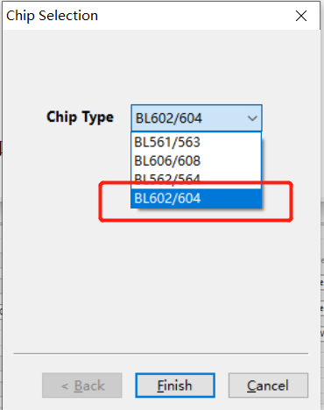

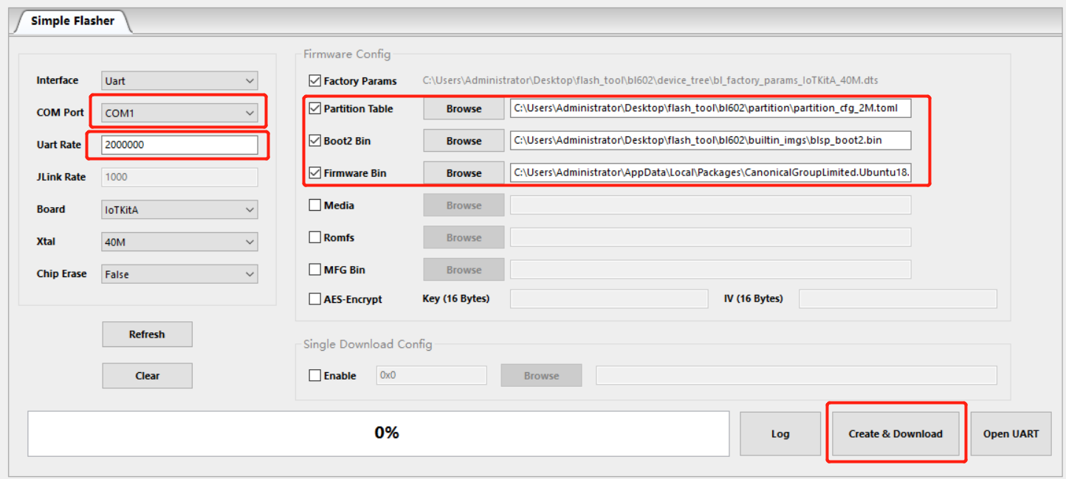

6. Put the development board into programming mode, press and hold the D8 (GPIO8) button, press the EN button again, and then release the D8 button

7. Click Create&Download, the progress bar will turn green, and if it displays Success, it means successful

**Firmware test**

Adjust the baud rate to 115200, send AT to return OK, AT firmware is running normally

