**Firmware burning**

1.Connect the development board to the computer, please make sure the serial port driver has been installed, win10 installs automatically

2.Open the burning tool, the storage path:Doiting_BL\bl_iot_sdk\tools\flash_tool

3.Chip type selection：BL602/604

4.Select Interface as Uart, and select the corresponding serial port of the development board

5.Select firmware

* 1. Tick the Partition Table, Boot2 Bin, Firmware Bin tabs
  2. Add files to Partition Table, click Browse behind Partition Table and select partition_cfg_2M.toml
  3. Click Browse after Boot2 Bin and select blsp_boot2.bin
  4. Click Browse behind Firmware Bin, find build_out under the dolphin directory, and select dolphin.bin

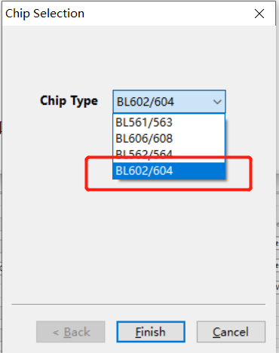

6. Put the development board into programming mode, press and hold the D8 (GPIO8) button, press the EN button again, and then release the D8 button

7. Click Create&Download, the progress bar will turn green, and if it displays Success, it means successful

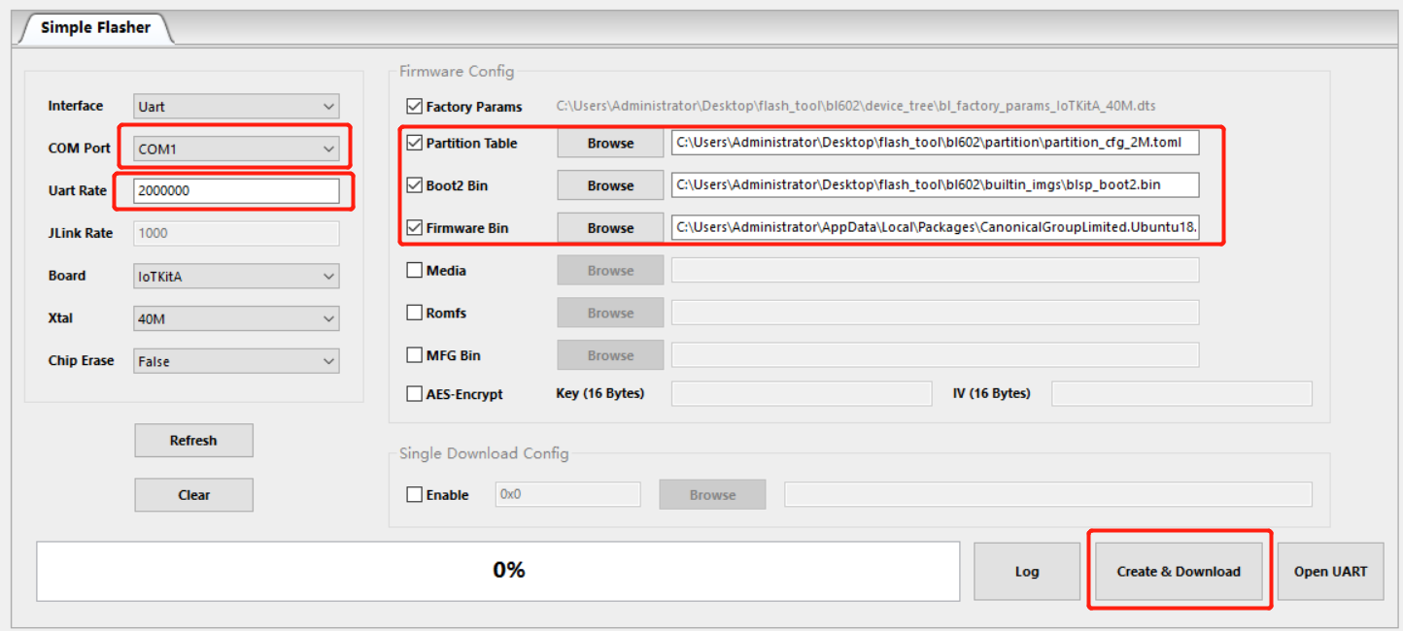

**Firmware test**

1.Scan the code to download the APP

2.Enter the APP and click the upper right corner to enter the connection

3.Tap the searched device to connect

